PROGRAM
YUCATAN Y MUNDO MAYA
12 days/11 nights

(Cancún, Valladolid, Rio lagartos, Chichén Itzá, Uxmal, Becal, Campeche, Edzna, Chicanná, Calakmul,Kohunlich, Bacalar, Playa del Carmen)

Minimum 4 persons.
Daily Departures

ITINERARY

DAY 01 – IN / CANCUN - VALLADOLID
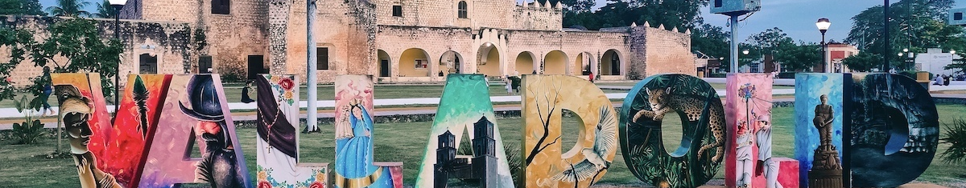 Arrival at Cancun airport and transfer to Valladolid. Reception and transfer to hotel.
Check in at hotel. Welcome drink and rest of the day at leisure.
Free lunch.
Lodging

DAY 02 – VALLADOLID – Río Lagartos

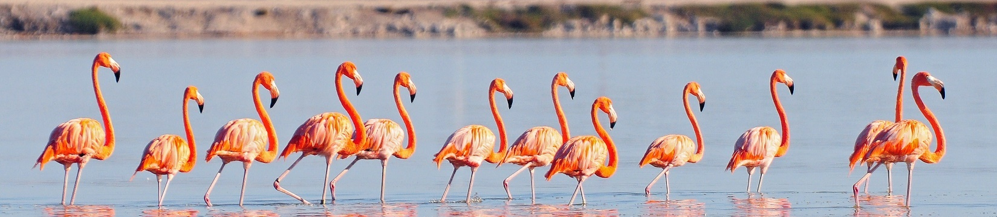
Breakfast at the hotel.

Departure to the north of the Yucatan Peninsula and the coasts of the Gulf of Mexico to explore the biosphere reserve of Rio Lagartos, a small paradise for local flora and fauna. Your day will be under the sign of nature! Arrival at the fishing village, board a boat for an excursion to the reserve (6 people per boat), in order to try to get as close as possible. Renowned for its huge colony of flamingos, Rio Lagartos is also home to hundreds of bird species (multicolored egrets, white ibis, etc.) that thrive in the rich, warm waters of the region. Travel through the lagoon and then dive into the mangroves, another facet of this beautiful natural park. Next, we will discover the Las Coloradas lagoon. This is the site of Mexico's second largest salt mine. On a sunny day, the lagoon turns pink, this comes from the red roots found there, as well as chemicals released by the shrimp and red plankton that live here in this place. Lunch of grilled fish in a small typical restaurant of the village. Return to Valladolid and visit this city built over the ancient Mayan ceremonial center of Zací. The center is occupied by the Francisco Cantón Rosado Park, where the San Servacio Church is located. In fact, Valladolid has seven churches from that period: the splendor of its colonial riches earned the city the nickname "Sultan of the Orient". Southwest of the central park, you will discover the 16th century church and convent of San Bernardino de la Sierra. The church and convent of San Bernardino are one of the most beautiful colonial architectural ensembles in Valladolid.

Dinner at the hotel.
Lodging

DAY 03 – VALLADOLID – Chichen Itzá – MÉRIDA

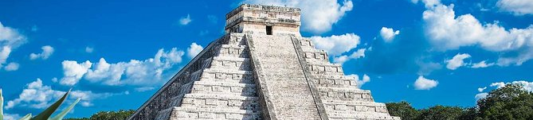

Breakfast at the hotel.

Departure for a visit to the archaeological site of Chichen Itza. This ancient city stretched over more than 300 ha and was founded around 540 BC by Mayan tribes who came from the south. You can contemplate the pyramid of Kukulkon, the temple of the warriors, the tomb of Chac Mol, the famous sacred cenote (place of sacrifices) and the courtyard of the ball game. Return to Valladolid in the late morning. Lunch at the Selva Maya restaurant. You will discover one of the natural features of Yucatan: the cenotes. These fresh water wells were considered by the Mayas as sacred places. There are hundreds of them in the area, but this is probably one of the most beautiful. Its view is breathtaking in an open-air natural environment covered with lianas descending into a clear blue sacred pool. Free time to enjoy the joys of swimming.

Continuing on to Merida, capital of the state of Yucatan, the city was founded in 1542 on the ruins of a Mayan city. This business center, called "White City" has the charm of a provincial city where you can still ride in a horse-drawn carriage. Stroll through the city center: the Cathedral, which stands on the site of an ancient Mayan temple, part of the stones of the temple were also reused during its construction, the Zocalo, lined by venerable colonial buildings. Then, you will end the day with the market offering sisal fiber items, but also embroidered huipiles, jewelry and weavings (except Sundays). Tasting of exotic fruits (mango, pineapple, papaya, guava, tamarind, passion fruit or passion fruit, pitaya or dragon fruit, etc.) Transfer to your hotel and welcome drink. Afterwards, we will go to dinner at Market 60, a hipster market where Thai (rice paste wok), Argentinean (grilled meat), Italian and French (crepes) cuisine stores come together.

We will eat at wooden tables in the open air, listening to a blues or rock concert. atmosphere is pleasant and attracts a lot of people! Transfer to the hotel.

Lodging.

DAY 04 – MÉRIDA – Uxmal – Becal – CAMPECHE

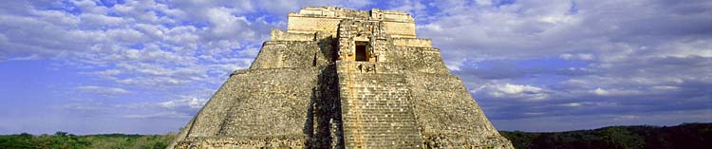

Breakfast at the hotel.

Departure to southern Yucatan through the many small Mayan villages. Visit the site of Uxmal, considered by some as one of the Seven Wonders of the World due to its location in the midst of an exceptional natural environment. You will notice the excellent preservation of all the buildings of the classic Mayan civilization. Lunch in Yucatan (possibility to try pollo pibil: chicken cooked on the ground drowned in banana leaves). Continuation to Becal, known as the cradle of jipi and palm hats. Jipi-japa is a species of plant that belongs to the Cyclanthaceae family. It is not a palm as such since it measures between 1.5 and 2.5 m and does not have a large stem. However, it is very resistant because it is used to make baskets and hats. After three years of cultivation, it is harvested and worked.
Basketry was of great importance in the Maya culture, the manufacture of hats is done in warehouses, as they maintain the freshness and humidity required to work. This activity is performed by most of the inhabitants of the city; In each house there is a cellar in the garden to develop these products that require on average an hour and a half of braiding, depending on the size of the articles. You will discover how the artisans work by exploring a bodega dedicated to hat making and then visit a store with hand-woven hats made from 100% ecological palm. It's not too late to protect yourself from the sun while contributing to development! Departure to Campeche, Mexico's only walled city, recently declared a World Heritage Site by Unesco. Strolling through the alleys gives the impression of contemplating a giant watercolor artist's palette. During your walk along the multicolored walls of the low houses, a feast for the eyes we will go in search of old mansions framing Moorish courtyards. Arrival at the hotel and welcome drink. You will have dinner at a local restaurant where you can taste the traditional dish of Campeche: the "Pan de cazón" (Tortillas with red beans, covered with fresh tomato sauce). Transfer to the hotel.

Lodging.

DAY 05 – CAMPECHE – Edzna – Hacienda Uayamon

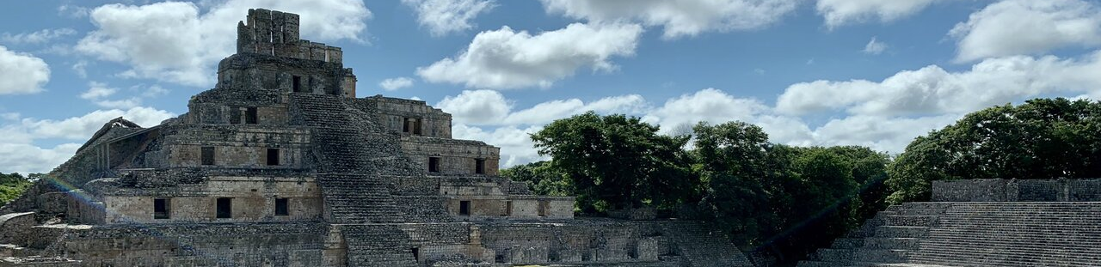

Breakfast at the hotel.

Departure to the archaeological site of Edzna, founded in 400 BC, its heyday was between 600 and 1000 and at that time was home to about 25,000 inhabitants. A mighty city of 25 km² with ingenious subway systems to capture and retain rainwater. Edzna and its more than 20 buildings was consequently an important regional capital of the Maya civilization. Edzna means "House of Itzas". Archaeologists believe the Itzas were a powerful family at the time. It contains one of the few examples of a Maya pyramid whose floors have vaulted rooms. In the temple of the "house of grimaces" there are five successive levels.

Continuation to Hacienda Uayamon, built in 1700. Magnificently renovated, it has retained many of its 18th century architectural features, such as wrought iron elements, stone walls and beautiful tiled floors. Lunch of local specialties at the hacienda restaurant. Return to Campeche and visit the fort of San Miguel which, for its size and history, is one of the most representative buildings of the city. Together with the fort of San José El Alto and the city wall, it incorporates all the fortified buildings built between the 17th and 18th centuries to defend the city from a possible pirate attack. Construction of the fort began in 1771 and the work was completed in 1801. It has a central courtyard, with a well in the center, and side ramps leading to the roof, where twenty cannons have been placed in the building's niches, thus fulfilling its defensive mission.

Today, the fort houses the Archaeological Museum of Campeche, which has important pieces of the remains of the Mayan civilization that were found in the state. In the late afternoon, walk along the Malecon, a 3.5 km long avenue located on the waterfront facing the Gulf of Mexico. This is undoubtedly the most beautiful place in the city to watch the sunset!

Dinner at the hotel.
Lodging.

DAY 06 – CAMPECHE – CHICANNÁ

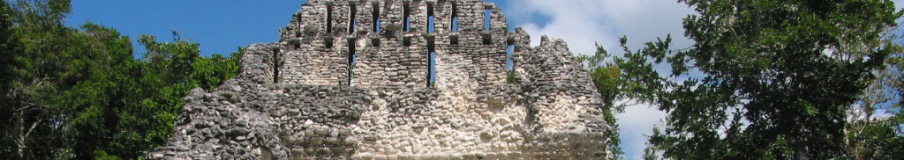

Breakfast at the hotel.

Departure for the huge and dense biosphere reserve of Calakmul, surrounded by a tropical forest, this reserve is home to more than 250 species of birds and you will have every chance to see wild turkeys, parrots and toucans. Other protected species include jaguar, spider monkey, puma, ocelot and white-lipped peccary. Lunch on the way. Continue to Chicanná and visit the archaeological site.
The main building is characteristic of the architectural style of Rio Bec with its towers and sculptures where the themes of the main god of the Mayas and the great masks of the god Itzamna appear. This building was decorated with painted stucco, of which many traces remain. The walls and crest ornament above this temple were also painted, in red, but perhaps with some touches of blue paint. Arrival at the hotel and welcome drink.
Dinner at the hotel.
Lodging.

DAY 07 – CHICANNÁ - Calakmul

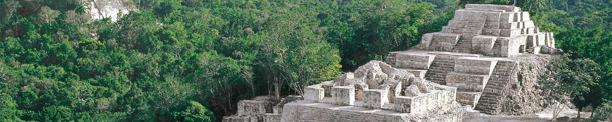

Breakfast at the hotel.

Departure to the archaeological site of Calakmul: "among the hills, another mound covered with vegetation rises... In reality, it is an ancient Mayan pyramid, bathed by an intense light. We are in one of the most important cities of the Mayan civilization". "Two adjacent mounds" is what the name Calakmul means. We are in one of the most important cities of the Mayan civilization, for its extension and its population, since it reached up to 50,000 inhabitants.
The chronology of the city dates back to the Preclassic period (300-250 B.C.). Its period of glory took place in Classic times when the Kaan kingdom allied with other states forming a confederation called "Cuchcabal". It has been demonstrated that at the end of the Postclassic period, ceremonial activities continued to take place. Calakmul was discovered by biologist Cyrus Longworth Lundell who, working in the chewing gum industry, arrived on the scene in 1931.

The monumental zone has an area of about 2 square kilometers and has a thousand structures. According to the most recent studies, Calakmul was the capital of the Kingdom of the Serpent or Kingdom of Kaan, the main rival of Tikal in the struggle for hegemony in the central Mayan zone during the Classic period. Because of its importance, the site was declared a World Heritage Site by UNESCO on July 4, 2002. Lunch during the excursion.
Dinner at the hotel.
Lodging.

DAY 07 – CHICANNÁ - Calakmul

Breakfast at the hotel.

Departure to the archaeological site of Calakmul: "among the hills, another mound covered with vegetation rises... In reality, it is an ancient Mayan pyramid, bathed by an intense light. We are in one of the most important cities of the Mayan civilization". "Two adjacent mounds" is what the name Calakmul means. We are in one of the most important cities of the Mayan civilization, for its extension and its population, since it reached up to 50,000 inhabitants.
The chronology of the city dates back to the Preclassic period (300-250 B.C.). Its period of glory took place in Classic times when the Kaan kingdom allied with other states forming a confederation called "Cuchcabal". It has been demonstrated that at the end of the Postclassic period, ceremonial activities continued to take place. Calakmul was discovered by biologist Cyrus Longworth Lundell who, working in the chewing gum industry, arrived on the scene in 1931.
The monumental zone has an area of about 2 square kilometers and has a thousand structures. According to the most recent studies, Calakmul was the capital of the Kingdom of the Serpent or Kingdom of Kaan, the main rival of Tikal in the struggle for hegemony in the central Mayan zone during the Classic period. Because of its importance, the site was declared a World Heritage Site by UNESCO on July 4, 2002. Lunch during the excursion.
Dinner at the hotel.

Lodging.

DAY 08 – CHICANNÁ – Kohunlich – CHETUMAL

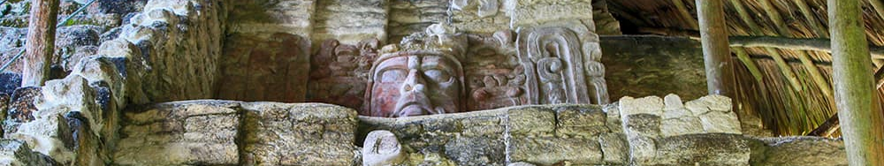

Breakfast at the hotel.

Departure to the archaeological site of Kohunlich, covering an area of 2 km² and surrounded by a tropical forest. The design of the buildings and the remains of water pipes and cisterns suggest that Kohunlich was once an important city. There are almost 200 mounds, although many of them are still buried underground and covered. You will discover the Pyramid of the Masks: on either side of a staircase leading to the top of a four-step pyramid are six large masks, modeled in polychrome stucco. Their excellent state of preservation is due to the later construction of a pyramid, of which there are still some remains at the foot of the staircase, which covered the first building dated 500 A.D. Facing the setting sun, these masks are representations of the lords of Kohunlich under the appearance of the sun god Kinich Ahau coming out of the mouth of the underworld. The available archaeological information supposes that Kohunlich welcomed its first inhabitants around 200 AD. Abandoned around the 12th century, this Mayan city would have reached its peak in the 5th and 4th centuries. Lunch at a local restaurant. Continuation to the port city of Chetumal, capital of the state of Quintana Roo. Visit the Museum of Mayan Culture with 8 rooms, very didactic, and that allow you to become familiar with the Mayan civilization through some interactive modules or reconstructions and models of very good quality.

The place exhibits many pieces (or reproductions) that have been found in archaeological sites in the region and gives an overview of the customs and practices of the civilization. Arrival at the hotel and welcome drink.

Dinner at the hotel.

Lodging.

DAY 09 – CHETUMAL – Laguna de Bacalar – PLAYA DEL CARMEN

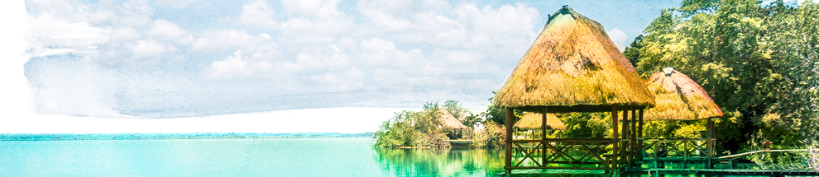 Breakfast at the hotel.

Departure to Bacalar Lagoon, 42 km long from north to south and less than 2 km at its widest width. The lake is famous for its bright blue color and clear waters, resulting in part from a white limestone bottom. Like most bodies of water in the Yucatan Peninsula, the lake is fed by subway rivers, whose open basins are cenotes. Visit to Cenote Azul (with the possibility of swimming). Departure to take a kayak ride on the shores of the Bacalar Lagoon which are surrounded by mangroves, a true jewel of turquoise tones in the middle of the jungle. We will drive through the Bacalar Lagoon for about an hour and then enter the mangrove area of Laguna Escondida. We will float in silence to observe the birds that live in the mangroves, see the footprints of tapirs or if we are lucky we will see a crocodile. The channel leads to a large lagoon. Just at the entrance you are welcomed by a beautiful white sand beach and crystal clear turquoise Waters and crystal clear turquoise waters. Here you will have time to swim and play in the water. Lunch during the excursion. Continuation to Playa del Carmen.

Dinner at the hotel.
Lodging in All Inclusive plan.

DAY 10 & 11 – PLAYA DEL CARMEN

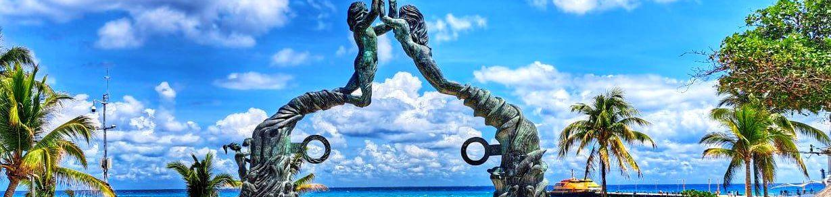

Breakfast at the hotel.

Free days in all inclusive plan to enjoy the joys of the beach.

Accommodation in All Inclusive plan.

DAY 12 – PLAYA DEL CARMEN – CANCÚN /

Breakfast at the hotel.

Free day at leisure to enjoy the joys of the beach (depending on flight schedule) and transfer to Cancun International Airport for your flight back home.

END OF SERVICES

NOTE: The day of operation of the tours may vary.

**VALIDATE RATES WITH YOUR TRAVEL AGENT

CITY | NIGHTS | HOTELS 4*
Valladolid | 02 | Meson del Marques
Mérida | 01 | Casa Lucia
Campeche | 02 | Plaza Campeche
Chicanná | 02 | Chicanná Ecovillage
Chetumal | 01 | Fiesta Inn
Playa del Carmen | 03 | Viva Maya Wyndhan

INCLUDED:
- TRANSPORTATION: Air-conditioned touristic unit
- ACCOMMODATION: Hotels according to your choice
- MEALS: Daily breakfasts, food and beverage tastings. All-inclusive in Playa del Carmen
- VISITS: Those mentioned in the program.
- ESCORT GUIDE: Bilingual, certified by the Ministry of Tourism
NOT INCLUDED:

- Air tickets
- Food or services not mentioned
- Taxes at the airport
- Tips to guides or drivers.

IMPORTANT OBSERVATIONS:
- Due to the multiple changes that occur daily in tourism, these prices must be confirmed at the time of requesting the reservation.
- Rates subject to availability and changes without prior notice.
- Credit card payments are subject to a % commission.
- Please contemplate the schedule of Check in 15:00 hrs and Check Out 12:00 hrs.
- TRIPLE rooms only have 2 double beds.
- Transfers airport-hotel-airport are quoted in shared service, please consider flights arriving and departing between 06:00 and 22:00 hrs, otherwise it must be provided in private service and it will be necessary to re-quote.
- The waiting time for arrival transfers is 2 hours and 15 minutes. Once this time has elapsed, the passenger must transfer at his/her own expense.
- The tolerance time for departure transfer is 10 minutes, after this time the unit is withdrawn and you must transfer on your own to the apartment. * Under no circumstances are we responsible for any extra expenses that may arise from this situation.
- Tours may change order according to the operations of the correspondent.

