PROGRAM
UNA AVENTURA EN NAYARIT
06 days/05 nights

(San Blas, Isla del Coral, Compostela, Huicholes Sierra del Nayar, Laguna de Santa Maria el Oro)

Minimum 2 persons.
Daily Departures

ITINERARY

DAY 01 – IN / TEPIC – NAYARIT
 Arrival at Tepic Airport. Reception and transfer to your hotel.
Check in at hotel. Rest of the day at leisure.
Lunch and dinner at your leisure.
Lodging

DAY 02 – NAYARIT– San Blas Jungla Tour

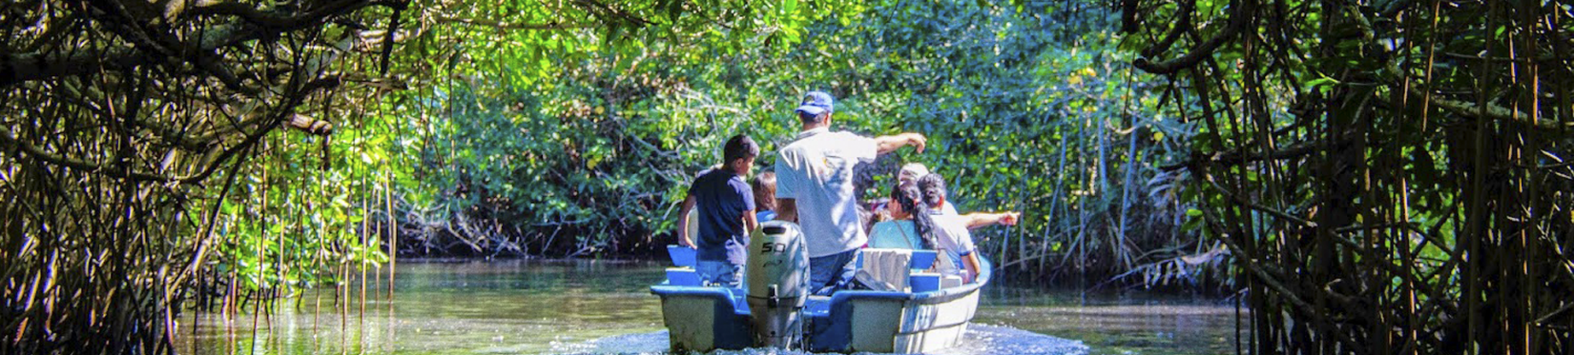

Breakfast at the hotel.

At the beginning of your tour your guides will be waiting for you in the lobby of your hotel to start the tour to San Blas, Nayarit, where we will visit the main attractions of the town. You will have a boat ride through the mangroves of the ecological park La Tovara where you will see crocodiles, birds and river turtles as well as admire species such as mangroves, bromeliads, ferns and palms, you will also visit a fresh water spring and have the opportunity to see a crocodile farm. Later, you will enjoy a guided tour of the Cerro de la Contaduría and the Fort of San Blas. Lunch is ready, you will enjoy an a la carte Nayarit style meal. At the end of the tour you will learn about the elaboration of banana bread and typical desserts of the region and you will also visit the pier of Nuevo San Blas and then return to your hotel to rest.

Lunch and dinner at your leisure.
Lodging

DAY 03 – NAYARIT– Snorkel Isla del Coral y Visita a la Señorial Ciudad de Compostela

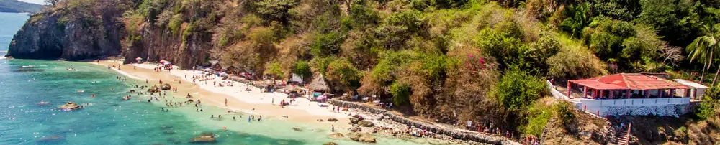
Breakfast at the hotel.

All aboard! Back in the lobby of your hotel, the guides will welcome you and then you will travel to Rincon de Guayabitos where you will enjoy a relaxing boat ride through the Bay of Rincon de Guayabitos, admiring the scenery, the beaches of this beautiful place and Crab Island. Then we will visit Coral Island, where you will receive a snorkeling class to immerse yourself in an adventure through the reefs of this wonderful ecosystem. Later, you will taste an exquisite a la carte dish based on fish and seafood at the edge of the beach. At the end of the day you will visit the stately and historical city of Compostela, where you will visit the main square, the parish of Santiago Apostle and some historical monuments of this beautiful place. Finally, you will return to Tepic after a great adventure.

Lunch and dinner at leisure.
Lodging

DAY 04 – NAYARIT– Huicholes Sierra del Nayar

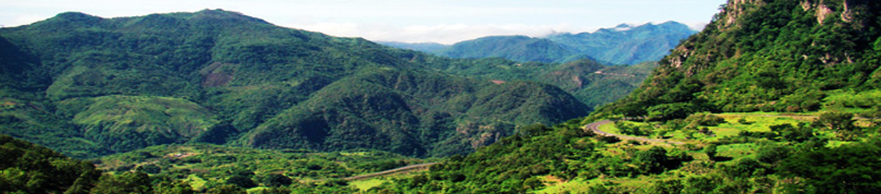

Breakfast at the hotel.

A mystical journey awaits us! At the beginning of your tour your guides will be waiting for you in the lobby of your hotel to start the tour to travel to the Aguamilpa dam, the largest of its kind in Latin America, where you will take a boat ride on the river admiring the flora and fauna, as well as the impressive mountains and rock formations that characterize the Sierra del Nayar. You will visit the sacred islet Anaki, continue with the boat ride until you reach the community of Potrero de la Palmita, where you will enjoy a pedestrian tour through the community and admiring the lifestyle of the ancient culture, you will visit a ceremonial center and a ritual in the sacred temple Cali - huey. You will receive a cleansing by the Marakame (religious leader of the site) and admire a dance by the community. You will also learn about the diversity of handicrafts that express the sacred trilogy in an exhibition of community craftswomen. In the afternoon we will have our typical lunch prepared by Wixarika women. At the end of the tour you will visit the former Bellavista textile factory with a tour of the facilities and then return to your hotel to rest.

Lunch and dinner at leisure.
Lodging

DAY 05 – NAYARIT– Eco Aventura Laguna de Santa Maria del Oro

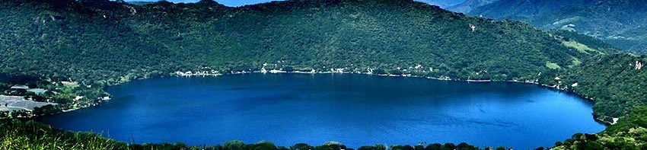

Breakfast at the hotel.

Once again in the lobby of your hotel, you will be met by our guides to go to the town of Santa Maria del Oro. In the main square you will visit the Parish of the Lord of the Ascension and travel back in time to the colonial era. You will also visit the viewpoint of the Santa Maria del Oro lagoon where you can appreciate it from the top and take an impressive picture. Continuing our tour you will arrive at a wonderful resort on the shore of the lagoon where you will enjoy a relaxing boat ride, admiring the natural beauty of the landscapes of this enchanting place, and then rest freely on a deck chair, take a dip in an infinity pool or practice kayaking accompanied by one of the expert guides. Lunch time, you will enjoy a 3 course gourmet meal in the Nayarita style that characterizes this place. At the end you will return to Tepic after a great adventure.

Lunch and dinner at leisure.
Lodging

DAY 06 – NAYARIT / OUT

Breakfast at the hotel.

At a convenient time transfer from your hotel to the airport to take your flight to your destination.

END OF SERVICES

**VALIDATE RATES WITH YOUR TRAVEL AGENT

INCLUDED:
- TRANSPORTATION: Air-conditioned touristic unit
- ACCOMMODATION: Hotels according to your choice
- MEALS: 05 Breakfast
- VISITS: Those mentioned in the program.
- ESCORT GUIDE: Bilingual, certified by the Ministry of Tourism

NOT INCLUDED:

- Air tickets
- Food or services not mentioned
- Taxes at the airport
- Tips to guides or drivers.

IMPORTANT OBSERVATIONS:
- Due to the multiple changes that occur daily in tourism, these prices must be confirmed at the time of requesting the reservation.
- Rates subject to availability and changes without prior notice.
- Credit card payments are subject to a % commission.
- Please contemplate the schedule of Check in 15:00 hrs and Check Out 12:00 hrs.
- TRIPLE rooms only have 2 double beds.
- Transfers airport-hotel-airport are quoted in shared service, please consider flights arriving and departing between 06:00 and 22:00 hrs, otherwise it must be provided in private service and it will be necessary to re-quote.
- The waiting time for arrival transfers is 2 hours and 15 minutes. Once this time has elapsed, the passenger must transfer at his/her own expense.
- The tolerance time for departure transfer is 10 minutes, after this time the unit is withdrawn and you must transfer on your own to the apartment. * Under no circumstances will we be responsible for any extra expenses arising from this situation.
- Tours may change order according to the operations of the correspondent.

