PROGRAM
TRADICIONES DE JALISCO
04 days/03 nights

(Chapala, Ajijic, Amatitán, Tequila)

Minimum 2 persons.
Daily Departures

ITINERARY

DAY 01 – IN / GUADALAJARA

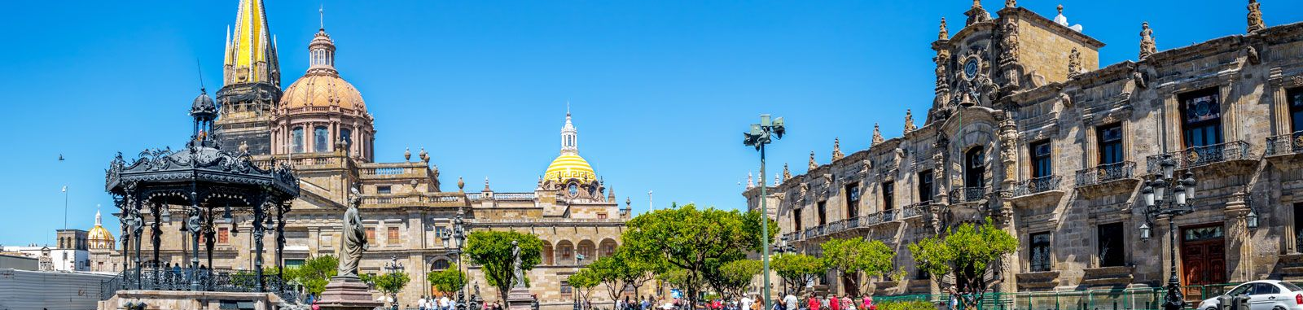

Arrival at Guadalajara's international airport. Reception and transfer to your hotel.

Check in at the hotel. Rest of the day at leisure.

Lunch and dinner on your own. Lodging.

DAY 02 – GUADALAJARA – Chapala + Ajijic

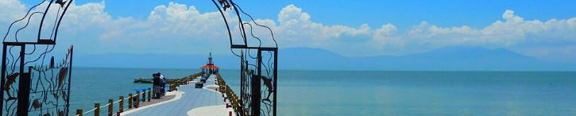

Breakfast at the hotel.

Departure to the Chapala riverside, we pass by the outside of Vicente Fernandez's ranch, we have time to visit the biggest cowboy store in Mexico. We arrive to the town of Chapala, this town was baptized as the little corner of love for being the honeymoon place of several personalities of the Mexican golden cinema among them Mrs. Maria Felix. We visit the malecon of Chapala and we will have time for shopping, we will tell the history of the island of Mezcala where one of the most important battles in the Mexican war of independence took place. Free time to explore the surroundings and shop at the handicraft market. At the time indicated by the guide, we continue to Ajijic, this town was named Pueblo Magico by the Mexican Secretary of Tourism, typical village of cobblestone streets and adobe houses, we will have a pedestrian tour, we will visit the boardwalk, art galleries, wall of the dead, free time for lunch, then at the agreed time return to Guadalajara.

Lunch and dinner on your own. Lodging.

DAY 03 – GUADALAJARA – Amatitán + Tequila

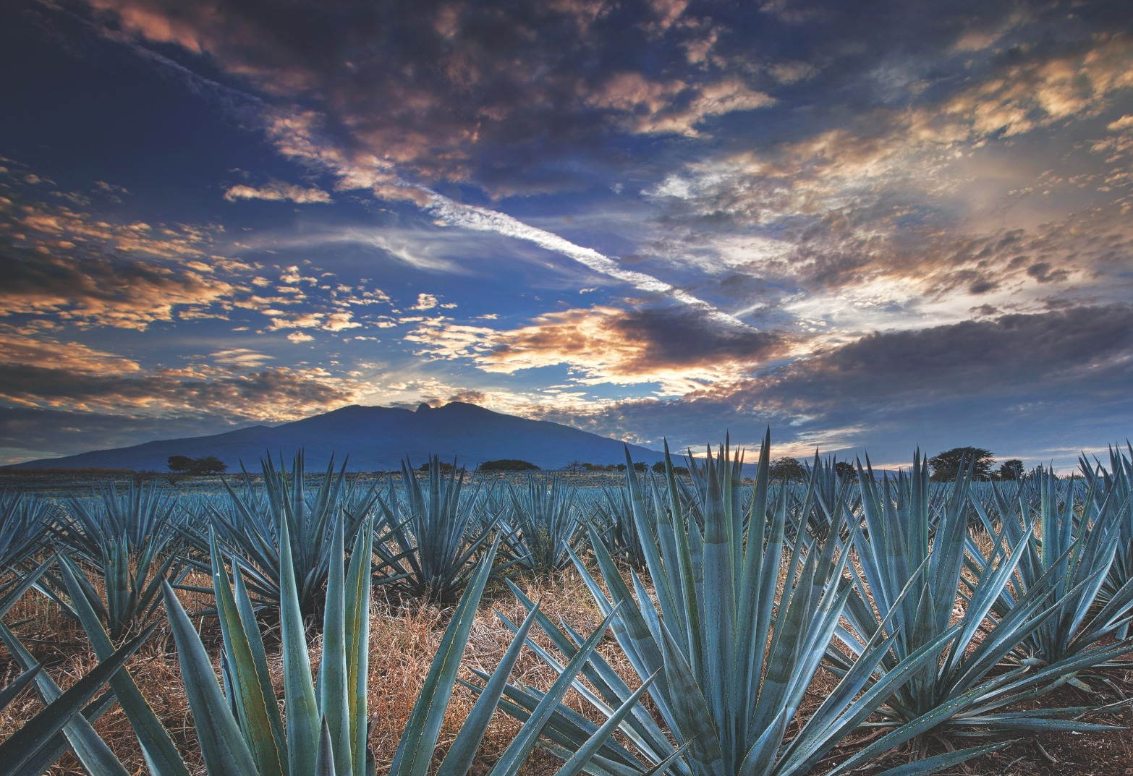

Breakfast at the hotel.

In the morning we will travel to the tequila route to learn more about the history and origin of our traditional Mexican drink. Our first point is Amatitán, we will visit the viewpoint of the agave landscape and our guide will give us a complete explanation about the blue agave Tequilana Weber. We will have a professional organoleptic tasting of Tequila with pairing of Tequilas produced in the region in an exclusive set up, then we will move to the magical town of Tequila we will visit its downtown area and its most iconic streets, we continue to a distillery of greater tradition in tequila called Casa Cofradia, we will have an explanation of the process of making tequila in its production line, tasting of cooked agave and tequila at 55 degrees of alcohol, also we will taste tequilas produced on site. We will have lunch (included) in the subway restaurant "La Taberna del Cofrade" with the "Treasures of Mexico" Distinctive "pre-established menu". At the agreed time we will return to Guadalajara.

Dinner on your own. Lodging

DAY 04 – GUADALAJARA / OUT

Breakfast at the hotel.

At a convenient time transfer from your hotel to the airport to take your flight to your destination.

END of SERVICES

NOTE: The day of operation of the tours may vary.
** VALIDATE RATES WITH YOUR TRAVEL AGENT

CITY | NIGHTS | HOTELS 3* | HOTELS 4*
Guadalajara | 03 | Casino Plaza | Morales / Doubletree Centro Histórico

INCLUDED:
- TRANSPORTATION: Air-conditioned touristic unit
- ACCOMMODATION: Hotels according to your choice
- MEALS: 03 Breakfast in Guadalajara, 01 Lunch in Tequila
- VISITS: Those mentioned in the program.
- ESCORT GUIDE: Bilingual, certified by the Ministry of Tourism

NOT INCLUDED:

- Air tickets
- Food or services not mentioned
- Taxes at the airport
- Tips to guides or drivers.

IMPORTANT OBSERVATIONS:
- Due to the multiple changes that occur daily in tourism, these prices must be confirmed at the time of requesting the reservation.
- Rates subject to availability and changes without prior notice.
- Credit card payments are subject to a % commission.
- Please contemplate the schedule of Check in 15:00 hrs and Check Out 12:00 hrs.
- TRIPLE rooms only have 2 double beds.
- The waiting time for arrival transfers is 2 hours and 15 minutes. Once this time has elapsed, the passenger must transfer at his/her own expense.
- The tolerance time for departure transfer is 10 minutes, after this time the unit is withdrawn and you must transfer on your own to the apartment. * Under no circumstances will we be responsible for any extra expenses arising from this situation.
- Tours may change order according to the operations of the correspondent.

