PROGRAM
TIJUANA Y SUS RINCONES
04 days/03 nights

(Ciudad, Rosarito, Ensenada, La Bufadora)

Minimum 2 persons.
Daily Departures

ITINERARY

DAY 01 – IN / TIJUANA
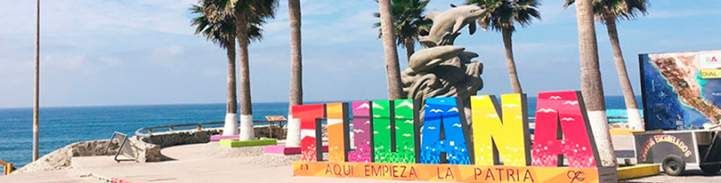

Arrival at Tijuana International Airport. Reception and transfer to your hotel.

Check in at hotel. Rest of the day at leisure.

Lunch and dinner at leisure. Lodging

DAY 02 –TIJUANA – Visita de Ciudad - Rosarito



Breakfast at the hotel.

This tour takes you to enjoy the best of two Baja California cities Tijuana, the busiest border city in the world, a young city with less than 150 years of history; cosmopolitan and an excellent location ideal for business and tourism.
Rosarito is a city with emerging art, here you will find beautiful beaches and you can also taste one of the dishes that have given worldwide fame to this city: Puerto Nuevo style lobster. Lunch (Drinks not included)

Dinner on your own. Lodging.

DAY 03 – TIJUANA – Ensenada – La Bufadora

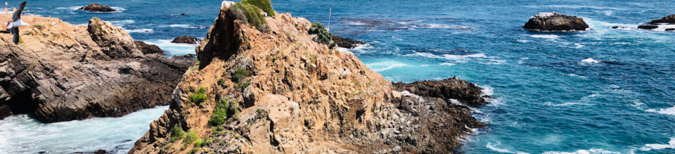

Breakfast at the hotel.

Explore Ensenada, the first capital of the state and enjoy the view of a marine geyser Ideal for: Families and friends, looking forward to having a fun ride. The Ensenada City Tour allows you to discover this magical spot in the Mexican Pacific on a boat tour of the bay. Let yourself be carried away by the natural beauty of this wonderful city and explore one of the most important ports in Mexico. Also get to know the fascinating natural phenomenon known as La Bufadora, a marine geyser that only occurs in three parts of the world.

Experience how the pressure of the waves with the air trapped in a cave, make the water explode upwards reaching an average height of 20 meters. While enjoying the Ensenada City Tour, shop for regional gourmet products, such as breads, wines and cheeses, as well as arts and crafts. Visit the renowned Black Market and various food stands, with a great variety of fish and seafood and typical dishes made with fresh seafood.

Lunch and dinner on your own. Lodging.

DAY 04 – TIJUANA/ OUT

Breakfast at the hotel.

At a convenient time transfer from your hotel to the airport to take your flight to your destination.

END of SERVICES

NOTE: The day of operation of the tours may vary
** VALIDATE RATES WITH YOUR TRAVEL AGENT

CITY | NIGHTS | HOTELS 3* | HOTELS 4*
Tijuana | 03 | City Express Tijuana | Marriott Tijuana

INCLUDED:
- TRANSPORTATION: Air-conditioned touristic unit
- ACCOMMODATION: Hotels according to your choice
- MEALS: 03 Breakfast, 01 Lunch
- VISITS: Those mentioned in the program.
- ESCORT GUIDE: Bilingual, certified by the Ministry of Tourism
NOT INCLUDED:

- Air tickets
- Food or services not mentioned
- Taxes at the airport
- Tips to guides or drivers.

IMPORTANT OBSERVATIONS:
- Due to the multiple changes that occur daily in tourism, these prices must be confirmed at the time of requesting the reservation.
- Rates subject to availability and changes without prior notice.
- Credit card payments are subject to a % commission.
- Please contemplate the schedule of Check in 15:00 hrs and Check Out 12:00 hrs.
- TRIPLE rooms only have 2 double beds.
- Transfers airport-hotel-airport are quoted in shared service, please consider flights arriving and departing between 06:00 and 22:00 hrs, otherwise it must be provided in private service and it will be necessary to re-quote.
- The waiting time for arrival transfers is 2 hours and 15 minutes. Once this time has elapsed, the passenger must transfer at his/her own expense.
- The tolerance time for departure transfer is 10 minutes, after this time the unit is withdrawn and you must transfer on your own to the apartment. * Under no circumstances will we be responsible for any extra expenses arising from this situation.
- Tours may change order according to the operations of the correspondent.

