PROGRAM
TABASCO ES UN EDÉN
05 days/04 nights

(Tabasco, Tapijulapa, Teapa, Grutas de Coconá)

Minimum 2 persons.
Daily Departures

ITINERARY

DAY 01 – IN / TABASCO
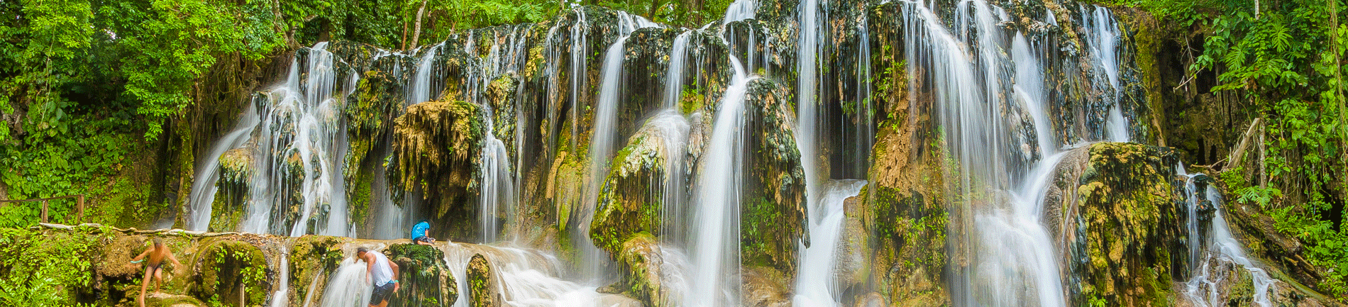
Arrival at Villahermosa International Airport. Reception and transfer to your hotel.

Check in at hotel. Rest of the day at leisure.

Lunch and dinner at leisure. Lodging

DAY 02 – TABASCO - Visita de Ciudad

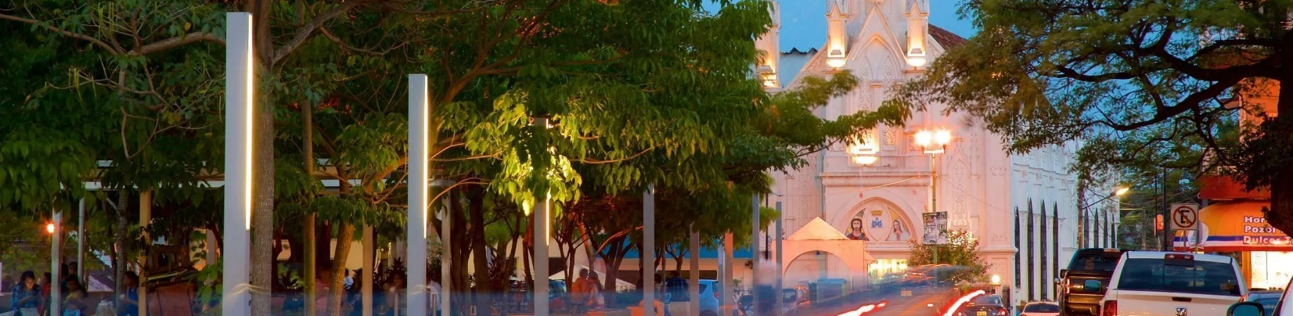

Breakfast at the hotel.

Villahermosa, Capital of the State of Tabasco known as the “Emerald of the Southeast”, offers countless attractions to the visitor in an environment of exuberant natural beauty represented in the vegetation of its parks and its flowing rivers and beautiful lagoons and to know one of the oldest cultures of Mesoamerica, the Olmec Culture. It is home to the La Venta Park-Museum, an open-air museum on one side of the lake with artifacts of the Olmec Civilization, including altars and stone heads. Exhibits tracing the history of Mexico and Tabasco fill the Casa de los Azulejos, an elegant building with blue tiles. Tomas Garrido Canabal Park has features inspired by pre-Hispanic and colonial architecture.

Lunch and dinner at leisure. Lodging

DAY 03 – TABASCO -Tapijulapa

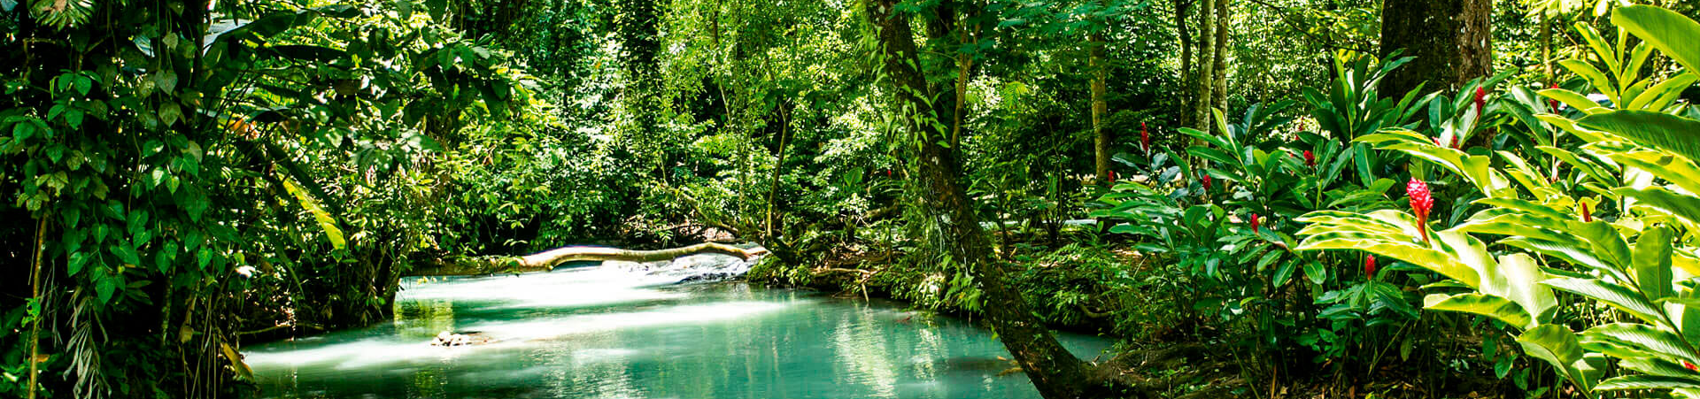
Breakfast at the hotel.

Among the thicket that the Tabasco mountains are, Tapijulapa is located; a town of Zoque origin, with cobblestone streets that wind until they get lost in the vegetation of the hill. The calmness of its appearance is accompanied by houses painted in white and red, roofs and flowery balconies. Protected by the generosity of nature, its surroundings invite you to take a deep breath, to enter the vegetation of its parks and to look at them from the perspective of a canopy tour, or to know them from the bowels of its caves and grottos. Its harmony with nature It is flanked by the Oxolotán and Amatán rivers. It is one of the entrances to the Sierra Madre del Sur.
Its handicrafts, architecture and gastronomy conserve the seal of the genuine. Visit the Church of Santo Domingo, next to the main square of the town.

Lunch and dinner at leisure. Lodging

DAY 04 – TABASCO – Teapa – Grutas de Coconá

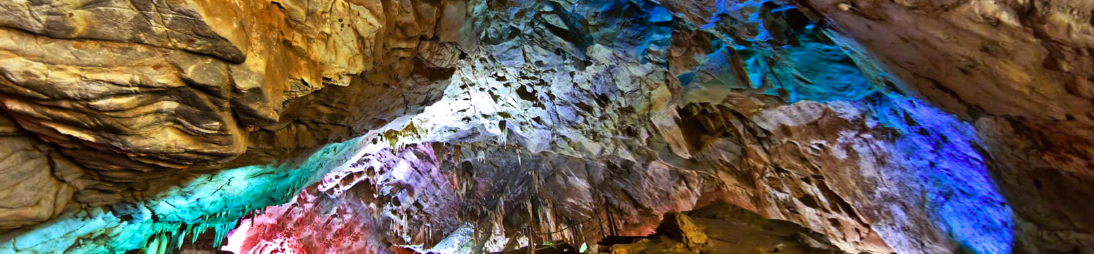

Breakfast at the hotel.

The first settlers of Teapa were Zoques of Mayan origin, in its mountainous lands you can still breathe the legacy of this ethnicity. This Magical Town of Tabasco is characterized for being a destination framed by amazing mountains and green areas, where you can get lost and connect with nature. And if that were not enough, it also stands out for being one of the main banana producers in the country. In the communities, baskets are made from bejucos, layers of blankets with hevea rubber and leather armchairs. Precious woods are carved here, which later give life to chests, trunks and closets. Not only will you fall in love with its wonderful scenery, you will also have the chance to soak up and live unique experiences in this land of Tabasco. In addition, you will experience the adrenaline and excitement of visiting the Coconá Caves, which are a protected natural area and national monument.
Explore the Coconá Caves. Some amazing subway rock formations, with some stretches of water, so you must wear appropriate clothing and footwear; the tour is done with local guides.

Lunch and dinner at leisure. Lodging

DAY 05 – TABASCO / OUT

Breakfast at the hotel.

At a convenient time transfer from your hotel to the airport to take your flight to your destination.

END of SERVICES

** VALIDATE RATES WITH YOUR TRAVEL AGENT

INCLUDED:
- TRANSPORTATION: Air-conditioned touristic unit
- ACCOMMODATION: Hotels according to your choice
- MEALS: 04 Breakfast
- VISITS: Those mentioned in the program.
- ESCORT GUIDE: Bilingual, certified by the Ministry of Tourism
NOT INCLUDED:

- Air tickets
- Food or services not mentioned
- Taxes at the airport
- Tips to guides or drivers.
IMPORTANT OBSERVATIONS:
- Due to the multiple changes that occur daily in tourism, these prices must be confirmed at the time of requesting the reservation.
- Rates subject to availability and changes without prior notice.
- Credit card payments are subject to a % commission.
- Please contemplate the schedule of Check in 15:00 hrs and Check Out 12:00 hrs.
- TRIPLE rooms only have 2 double beds.
- Transfers airport-hotel-airport are quoted in shared service, please consider flights arriving and departing between 06:00 and 22:00 hrs, otherwise it must be provided in private service and it will be necessary to re-quote.
- The waiting time for arrival transfers is 2 hours and 15 minutes. Once this time has elapsed, the passenger must transfer at his/her own expense.
- The tolerance time for departure transfer is 10 minutes, after this time the unit is withdrawn and you must transfer on your own to the apartment. * Under no circumstances will we be responsible for any extra expenses arising from this situation.
- Tours may change order according to the operations of the correspondent.

