PROGRAM
SONORA, HISTORIA, ARQUEOLOGIA Y NATURALEZA
09 days/08 nights

(Hermosillo, Magdalena de Kino, Caborca, Puerto Peñasco, San Carlos, Nuevo Guaymas, Valle del Yaqui, Álamos, Navojoa, Bahía de Kino,)

Minimum 2 persons.
Daily Departures

ITINERARY

DAY 01 – IN / HERMOSILLO - Pueblo Mágico de Magdalena y Ruta de las Misiones del Padre Kino - CABORCA
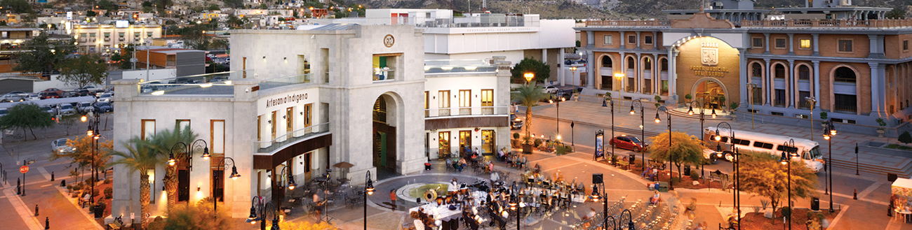

Arrival at Hermosillo airport. Flight before 8:30 a.m. Reception and transfer to your hotel.
9:30 a.m. Departure from Hermosillo A 2 hour drive north of Hermosillo is the magical town of Magdalena de Kino, home to the remains of one of the most important evangelists in history, Father Kino. This Jesuit was the only one capable of establishing permanent missions in the Sonora desert, one of the most difficult regions for the Spanish empire to colonize. This day we visit the missions established since the end of the 17th century, where Father Kino was able to found the towns of San Ignacio de Caborica, Tubtama, Oquitoa, Pitiquito and Caborca. A fascinating tour where the legend of Father Kino and the architectural and cultural legacy of the towns of the Sonoran desert come together. Arrival to Caborca, visit to Pueblo Viejo and check in hotel Caborca.

Lunch and dinner at leisure.

Lodging

DAY 02 – CABORCA – El Pinacate patrimonio de la humanidad – PUERTO PEÑASCO

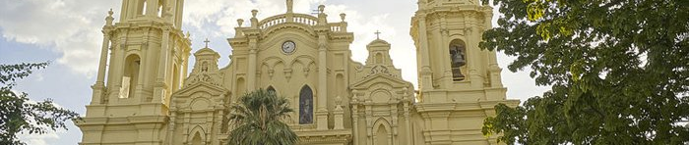
Breakfast at the hotel.

El Pinacate is one of the most impressive natural formations in the world in the most beautiful desert. The great biosphere reserve of “El Pinacate and Gran Desierto de Altar”, is a unique ecosystem on a planetary level. In its impressive landscapes there are more than 10 large craters and 400 lava outflows, violent explosions and lava rivers left their traces in the impressive volcanic shield in the middle of the Sonoran desert and next to the dunes of the Gran Desierto de Altar. The visit to Pinacate takes about 3 hours, on a well-preserved 72 km dirt road. Several stops are made to observe different natural formations, among which stands out the impressive crater “El Elegante”.
The impressive crater “El Elegante” with its almost 5 kilometers in diameter and the Cerro Colorado of a very particular beauty for its shape and color. Transfer to Puerto Peñasco and check in at the hotel.

Lunch and dinner at leisure.
Lodging

DAY 03 – PUERTO PEÑASCO – Gran Desierto de Altar

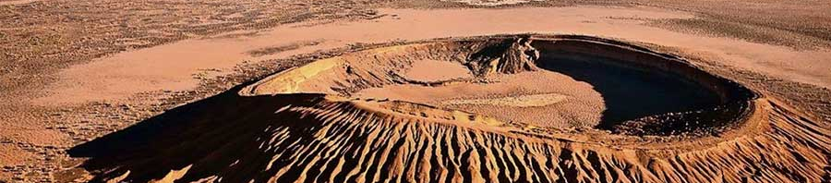
Breakfast at the hotel.

Early departure to the Gran Desierto de Altar, just 15 minutes from Puerto Peñasco. This desert is the largest dune system in North America, some of the dunes are up to 200 meters high. In order to appreciate these impressive landscapes we hiked almost 5 kilometers. The large sand formations, the volcanic shield in the distance and the Sierra Blanca on the horizon, accompany us in this journey that lasts a couple of hours (it is recommended that if someone does not have enough condition to do this walk, wait for us at the Visitor Center) after the walk, we have time to visit the Pinacate Schuk Toak Visitor Center, a museum that has valuable information to understand the importance of having this natural heritage in Sonora territory, it is also the largest self-sustaining public building in Mexico. After the tour, in the afternoon we have time to relax on the beach of Puerto Peñasco.

Lunch and dinner at leisure.
Lodging

DAY 04 – PUERTO PEÑASCO – La Proveedora - HERMOSILLO

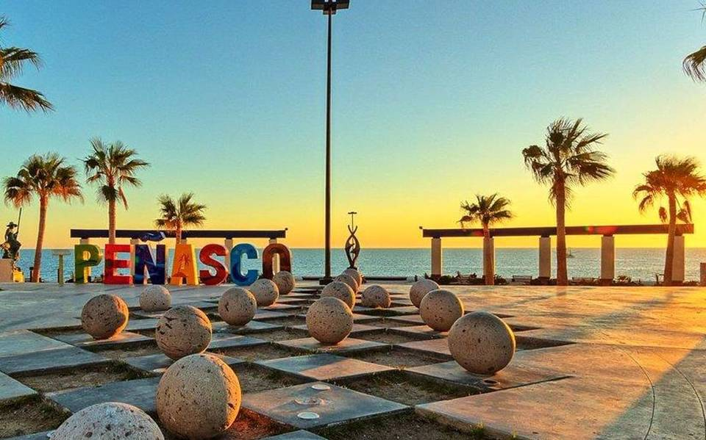 Breakfast at the hotel.

La Proveedora is one of the most important and least known archaeological sites in Mexico, on the slopes of the hills near Caborca, the ancient inhabitants of the desert carved an endless number of signs in stone, more than 6,000 petroglyphs whose meaning is still a mystery but represent a unique heritage in our country. It is an archaeological zone guarded by the community of Caborca, whose visit requires previous reservation. In the afternoon we arrive at the capital of the state of Sonora, Hermosillo is a modern city full of traditional and modern places.

Lunch and dinner at leisure.
Lodging

DAY 05 – HERMOSILLO - San Carlos Nuevo Guaymas

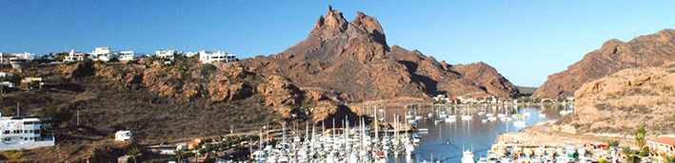 Breakfast at the hotel.

The area of San Carlos Nuevo Guaymas is located only 130 kilometers from Hermosillo, it has some of the most beautiful beaches of the Sea of Cortez. Spectacular landscapes where the mountains, the Sonoran desert and the different colors of the sea come together, that is why important publications such as National Geographic have said that here is the best ocean view in the world. The Estero del Soldado is a natural reserve where you can do ecotourism activities such as kayaking, biking and hiking, a site of great importance for the conservation of the species that inhabit the Sea of Cortez also called “The Aquarium of the World” Check In Hotel San Carlo.

Lunch and dinner at leisure.
Lodging

DAY 06 – SAN CARLOS – Valle del Yaqui Álamos

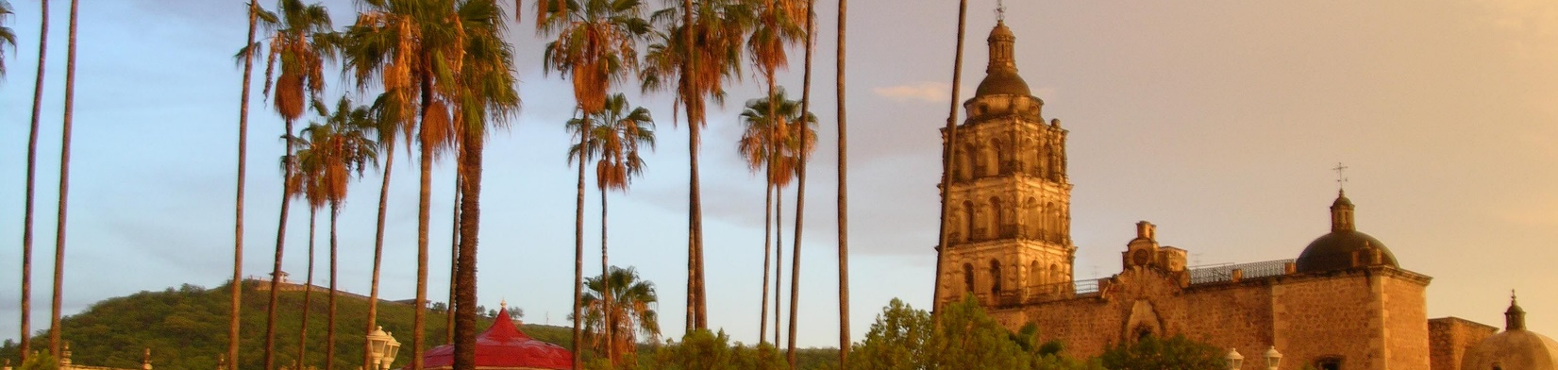
Breakfast at the hotel.

Alamos is the only colonial city in Sonora, currently declared a magical town, it was a prosperous mining town with beautiful alleys and colonial mansions that show the richness of the region. Alamos was the birthplace of personalities such as Dr. Alfonso Ortiz Tirado and Maria Felix, in this tour we will travel through this beautiful colonial city transporting us to the colonial era in its streets stopped in time. Check In Hotel in Alamos

Lunch and dinner at leisure.
Lodging

DAY 07 – ALAMOS – Álamos Pueblo Mágico y Navojoa - HERMOSILLO

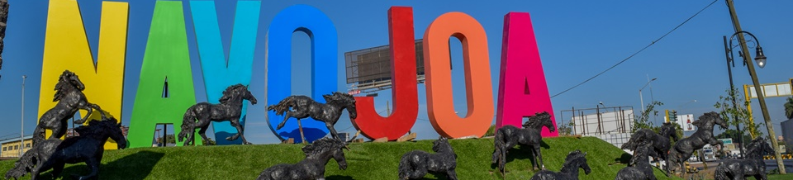
Breakfast at the hotel.

Navojoa is a treasure of the state of Sonora hidden in the Mayo Valley, between the mountains and the coast of the Sea of Cortez. The place of the nopales or prickly pear cactus, is one of the oldest enclaves in the region occupied by the Mayo Indians; since then it was distinguished by the fertility of its soil, the beauty of the landscapes, the richness of its flora and fauna, the transparency of the air and its strategic location, at the foot of the mountains and near the coast.

To all these values it has now added a vast culture, indigenous and mestizo, beautiful traditions and handicrafts, a great variety of products and tourist services, which are offered with the proverbial hospitality of its people.

The Sacred Heart Church, Pueblo Viejo, the Municipal Palace, are samples of its many cultural attractions, which are joined to its natural conditions for the development of ecotourism and hunting tourism, which make Navojoa an attractive tourist destination, with extraordinary possibilities of development. Check In Hotel in Hermosillo

Lunch and dinner at leisure.
Lodging

DAY 08 – HERMOSILLO – Bahía de Kino

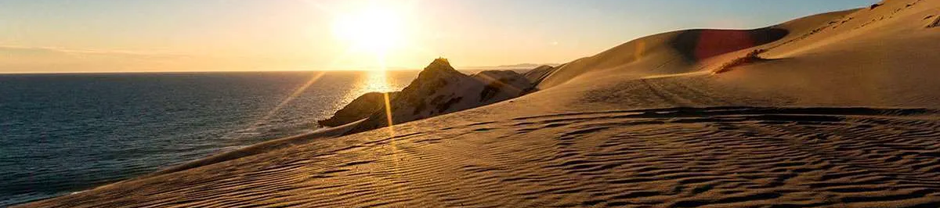
Breakfast at the hotel.

Bahía de Kino was originally a small fishing village, where you can visit its pier and the seafood market in the “Kino Viejo” part, to later enjoy the extensive beach in the “Kino Nuevo” area. It is the closest beach to the city of Hermosillo and one of the jewels of the sea of cuts.

Lunch and dinner at leisure.
Lodging

DAY 09 – HERMOSILLO / OUT

Breakfast at the hotel.

At a convenient time transfer from your hotel to the airport to take your flight to your destination.

END OF SERVICES

** VALIDATE RATES WITH YOUR TRAVEL AGENT

INCLUDED:
- TRANSPORTATION: Air-conditioned touristic unit
- ACCOMMODATION: Hotels according to your choice
- MEALS: 05 Breakfast
- VISITS: Those mentioned in the program.
- ESCORT GUIDE: Bilingual, certified by the Ministry of Tourism
NOT INCLUDED:

- Air tickets
- Food or services not mentioned
- Taxes at the airport
- Tips to guides or drivers.

IMPORTANT OBSERVATIONS:
- Due to the multiple changes that occur daily in tourism, these prices must be confirmed at the time of requesting the reservation.
- Rates subject to availability and changes without prior notice.
- Credit card payments are subject to a % commission.
- Please contemplate the schedule of Check in 15:00 hrs and Check Out 12:00 hrs.
- TRIPLE rooms only have 2 double beds.
- Transfers airport-hotel-airport are quoted in shared service, please consider flights arriving and departing between 06:00 and 22:00 hrs, otherwise it must be provided in private service and it will be necessary to re-quote.
- The waiting time for arrival transfers is 2 hours and 15 minutes. Once this time has elapsed, the passenger must transfer at his/her own expense.
- The tolerance time for departure transfer is 10 minutes, after this time the unit is withdrawn and you must transfer on your own to the apartment. * Under no circumstances will we be responsible for any extra expenses arising from this situation.
- Tours may change order according to the operations of the correspondent.

