PROGRAM
SABORES DE YUCATAN
05 days/04 nights

(Comida Callejera Local, Clase de Cocina, Cantinas Meridianas)

Minimum 2 persons.
Daily Departures

ITINERARY

DAY 01 – IN / MÉRIDA
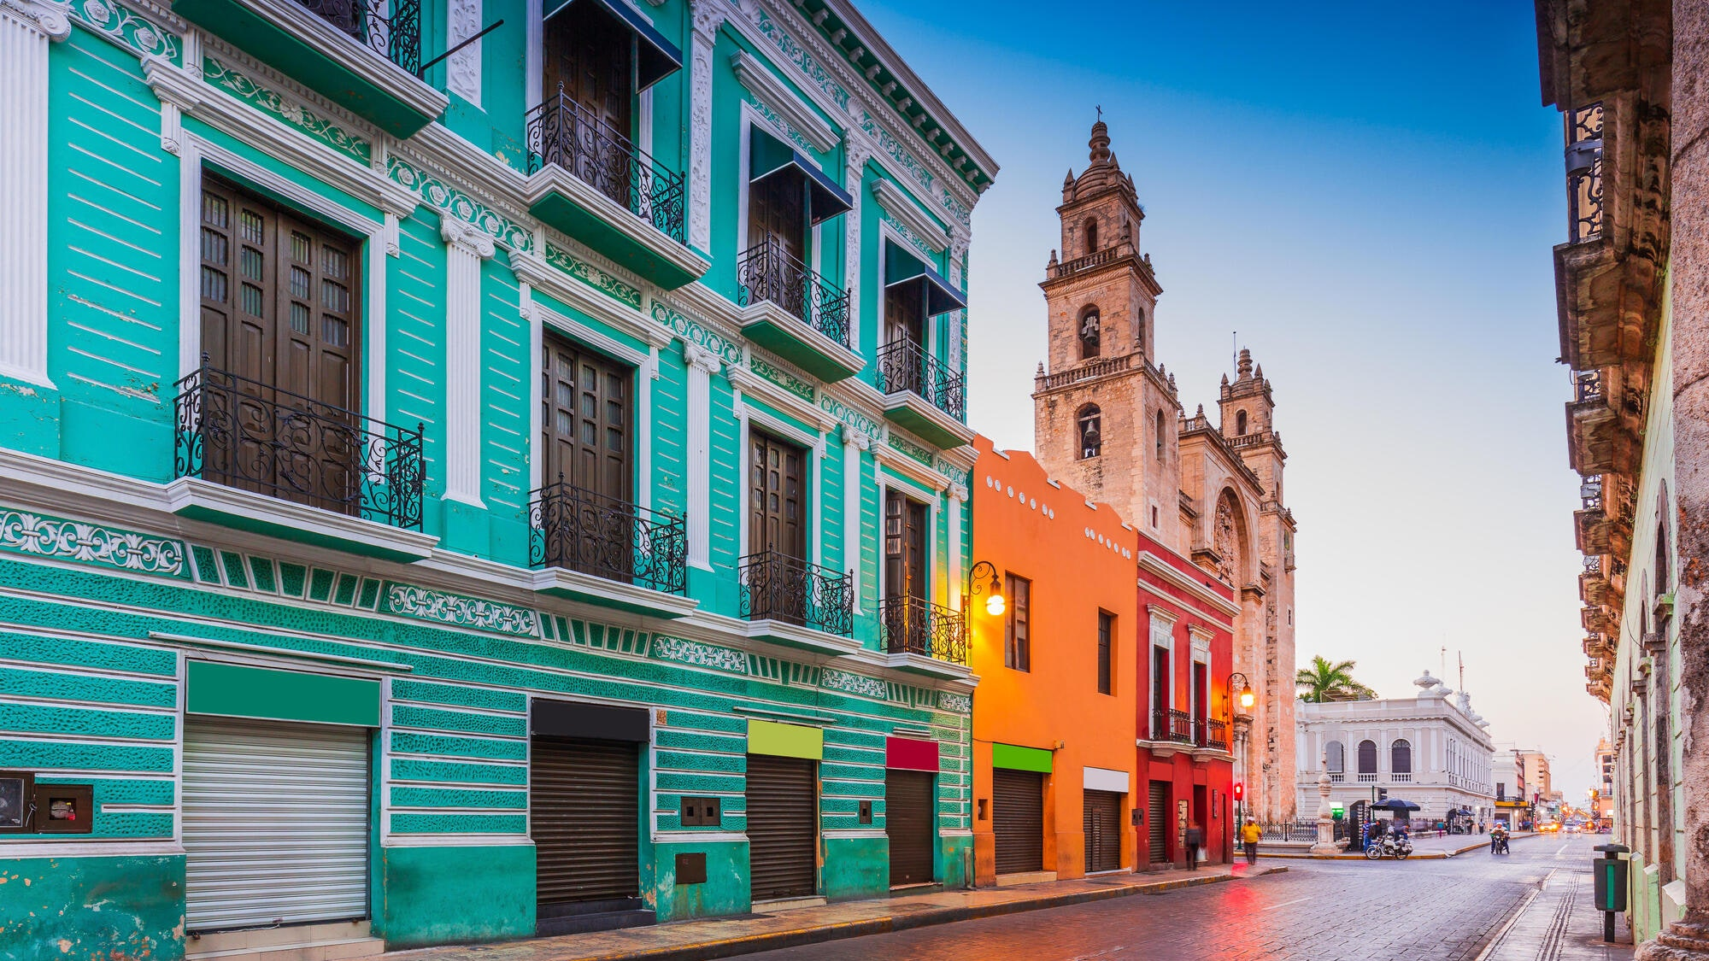

Arrival at Merida airport. Reception and transfer to hotel.

Check in at hotel. Rest of the day at leisure.

Lunch and dinner at leisure.
Lodging

DAY 02 – MÉRIDA – Sorprendente Comida Callejera Local

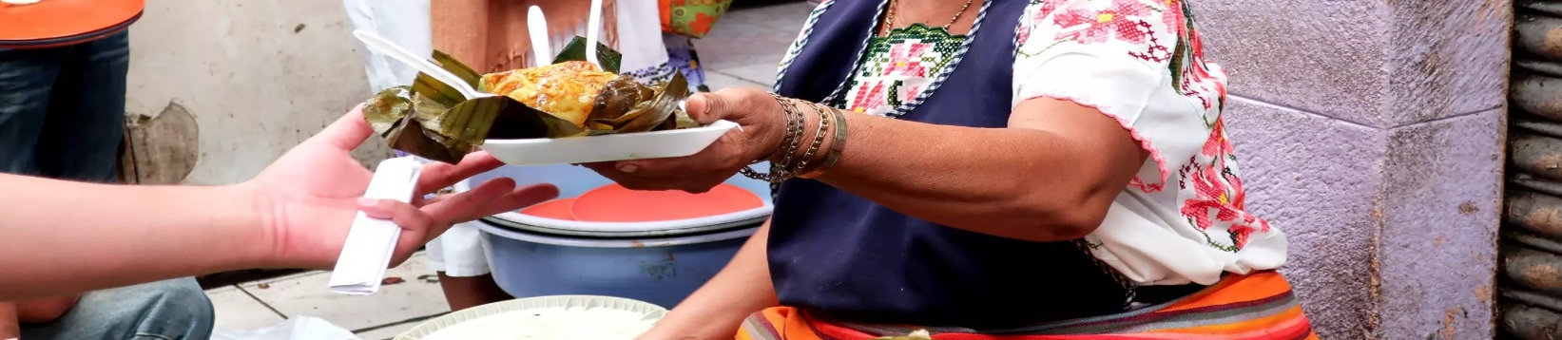

Breakfast at the hotel.

Definitely one of the things that most define Yucatan is its gastronomy, which is why this service was born to take you to live the culinary experience in local style, in picturesque and popular places from years ago until today for every good Yucatecan. We will walk through the streets of the city until we enter its most popular markets, the Garcia Rejon where you will also find a wide variety of handicrafts of all kinds, and taste the flavor of the antojitos of this region (tacos, panuchos, salbutes, cochinita to chicharra or blood sausage), finish in the Lucas de Galvez market, a place that is defined by having very local products such as flowers, fruits, vegetables, food condiments, seafood areas, handicrafts among other areas that arouse the curiosity of its visitors, as well as Yucatecan sweets to close this culinary experience could not miss the delicious taste of a sorbet or seasonal ice cream.

Lunch and dinner on your own.
Lodging.

DAY 03 – MÉRIDA – Clase de Cocina Yucateca

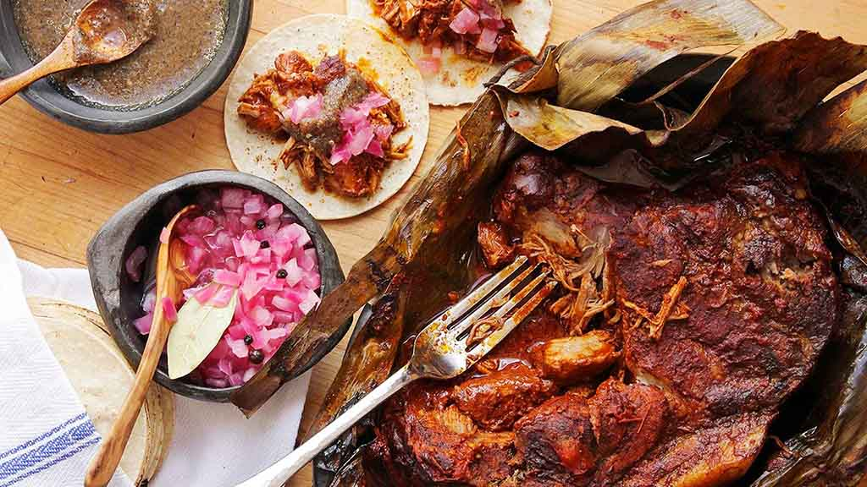
Breakfast at the hotel.

Starting as a meeting point in one of the most emblematic parks, which are part of the historic center of the city, the park of the hidalgos, known as hidalgo park, we will walk through the streets of downtown towards the Lucas de Galvez market where in addition to having the opportunity to know one of the most popular and colorful markets in the city, we will buy the ingredients for the preparation of the food of the day. Once we have found the products needed for the Yucatecan cooking class we will head to the host's house where we will live the experience, at the end of the activity, the drop off will be at the closest point to your hotel, this complete activity can take us between 5 to 6 hours.

Lunch and dinner on your own.
Lodging.

DAY 04 – MÉRIDA – Pintorescas Cantinas Meridianas

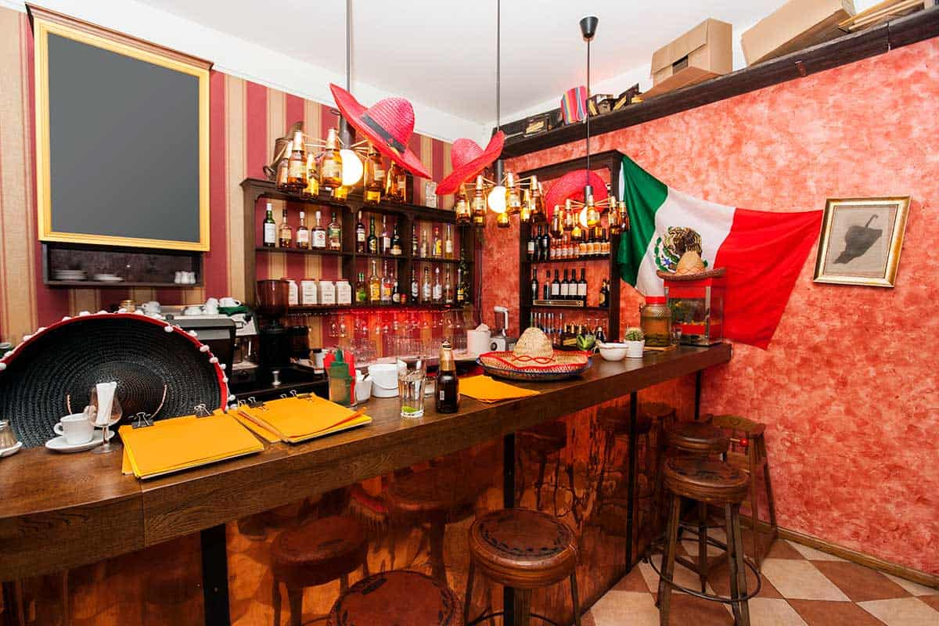
Breakfast at the hotel.

Our appointment, in the park of Santa Ana, in the second square of this city, from there we will walk to a cantina called "el gallito" just 150 meters away we can enjoy a beer and local atmosphere, typical snacks of these places, in a traditional atmosphere, with very particular decorations of each owner, and at the bar always a friendly smile that invites to a warm conversation. As a second stop we will go to the cantina "La Negrita" where we will taste a national craft beer, nowadays this place is very visited by local people, they usually have different types of events for their public, and they liven up their nights with live music. As a final stop we will visit the lucero de alba, botanero center with its wide variety of flavors, at this point we will end this experience, really culinary experiences in popular and modern cantinas. this tour does not apply for children under 18 years old.

Lunch and dinner on your own.
Lodging.

DAY 05 – MÉRIDA / OUT
Breakfast at the hotel.

At a convenient time transfer from your hotel to the airport to take your flight to your destination.

END OF SERVICES

NOTE: The day of operation of the tours may vary.
** VALIDATE RATES WITH YOUR TRAVEL AGENT

CITY | NIGHTS | HOTELS 3* | HOTELS 4** | HOTEL SP
Mérida | 04 | Marionetas | Villa Mercedes Curio | Rosas & Xocolate

INCLUDED:
- TRANSPORTATION: Air-conditioned touristic unit
- ACCOMMODATION: Hotels according to your choice
- MEALS: Daily breakfasts, food tastings and beverages
- VISITS: Those mentioned in the program.
- ESCORT GUIDE: Bilingual, certified by the Ministry of Tourism
NOT INCLUDED:

- Air tickets
- Food or services not mentioned
- Taxes at the airport
- Tips to guides or drivers.

IMPORTANT OBSERVATIONS:
- Due to the multiple changes that occur daily in tourism, these prices must be confirmed at the time of requesting the reservation.
- Rates subject to availability and changes without prior notice.
- Credit card payments are subject to a % commission.
- Please contemplate the schedule of Check in 15:00 hrs and Check Out 12:00 hrs.
- TRIPLE rooms only have 2 double beds.
- Transfers airport-hotel-airport are quoted in shared service, please consider flights arriving and departing between 06:00 and 22:00 hrs, otherwise it must be provided in private service and it will be necessary to re-quote.
- The waiting time for arrival transfers is 2 hours and 15 minutes. Once this time has elapsed, the passenger must transfer at his/her own expense.
- The tolerance time for departure transfer is 10 minutes, after this time the unit is withdrawn and you must transfer on your own to the apartment. * Under no circumstances will we be responsible for any extra expenses arising from this situation.
- Tours may change order according to the operations of the correspondent.

