PROGRAM
QUERETARO - VINOS Y PUEBLOS MAGICOS
05 days/04 nights

(Visita de Ciudad, Mitos y Leyendas, Ruta Vino y Queso, Pueblos Mágicos)

Minimum 2 persons.
Daily Departures

ITINERARY

DAY 01 – IN / QUERÉTARO
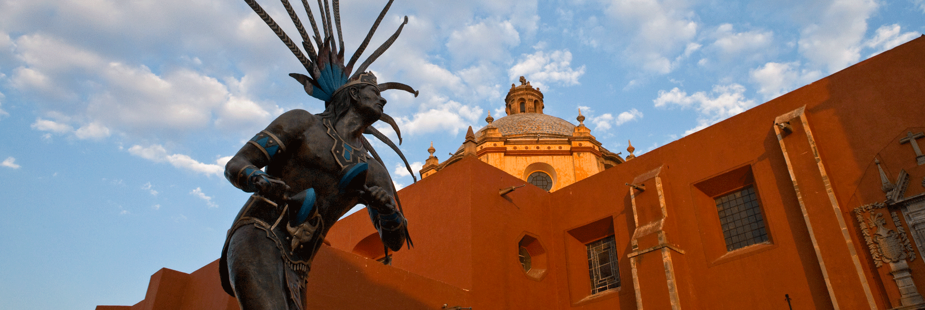 Arrival at the airport or bus station in Queretaro. Reception and transfer to hotel.
Check in at hotel. Rest of the day at leisure.
Lunch and dinner at leisure.
Lodging

DAY 02 – QUERÉTARO – Visita de Ciudad + Mitos y Leyendas (Pedestrian Night Tour) Thu - Sat

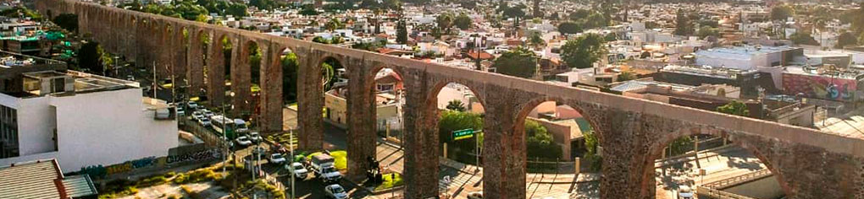
Breakfast at the hotel.

They say that to know a place you have to walk its streets and undoubtedly enjoy its gastronomy, besides living an extraordinary experience to know churches, monuments, mansions, avenues and gardens that have transcended in the history and foundation of this beautiful city of Queretaro, among the most important to visit we have the aqueduct, which was built between 1726 and 1735 and houses a romantic legend, the Plaza de Armas and the Casa de la Corregidora of the eighteenth century. In the afternoon you will tour the mansions and alleys of the city of Queretaro, where you will learn about the most impressive stories of fear and mysteries. During the tour, professional actors will bring to life the characters that became legends, such as Don Bartolo, La Llorona, Los dos fríos, El Marqués, La Zacatecana, among others, and will take you back to many years ago, making this an unforgettable experience.

Lunch and dinner on your own.
Lodging.

DAY 03 – QUERÉTARO – Ruta Vino y Queso

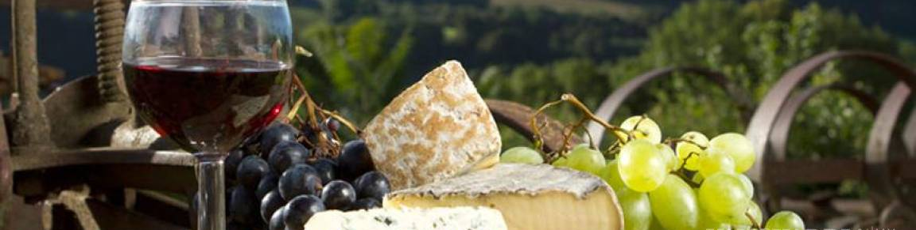

Breakfast at the hotel.

The state of Querétaro is a destination for wine tourism, grape harvests, artisanal and winery wines of great variety and quality; with an important production of artisanal cow, goat and sheep cheeses.

Lunch and dinner on your own.
Lodging.

DAY 04 – QUERÉTARO – Pueblos Mágicos

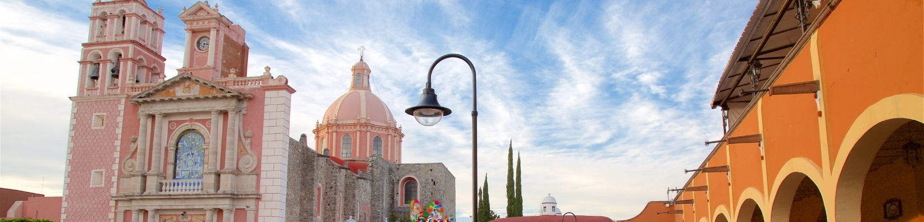

Breakfast at the hotel.

In this charming tour we will visit the town of Peña de Bernal where the third largest monolith in the world is located, and the delicious gorditas de maíz quebrado. Later we will visit Tequisquiapan, a picturesque town where you can enjoy the colonial charm of Queretaro.

Lunch and dinner on your own.
Lodging.

DAY 05 – QUERÉTARO / OUT

Breakfast at the hotel.

At a convenient time transfer from your hotel to the airport to take your flight to your destination.

END OF SERVICES

NOTE: The day of operation of the tours may vary.

** VALIDATE RATES WITH YOUR TRAVEL AGENT

CITY | NIGHTS | HOTELS 3** | HOTELS 4* | HOTELS 5*
Querétaro | 04 | Señorial | NH Queretaro | Gran Hotel  (Desayunos de lunes a viernes)

INCLUDED:
- TRANSPORTATION: Air-conditioned touristic unit
- ACCOMMODATION: Hotels according to your choice
- MEALS: Daily Breakfast
- VISITS: Those mentioned in the program.
- ESCORT GUIDE: Bilingual, certified by the Ministry of Tourism
NOT INCLUDED:

- Air tickets
- Food or services not mentioned
- Taxes at the airport
- Tips to guides or drivers.

IMPORTANT OBSERVATIONS:
- Due to the multiple changes that occur daily in tourism, these prices must be confirmed at the time of requesting the reservation.
- Rates subject to availability and changes without prior notice.
- Credit card payments are subject to a % commission.
- Please contemplate the schedule of Check in 15:00 hrs and Check Out 12:00 hrs.
- TRIPLE rooms only have 2 double beds.
- The waiting time for arrival transfers is 2 hours and 15 minutes. Once this time has elapsed, the passenger must transfer at his/her own expense.
- The tolerance time for departure transfer is 10 minutes, after this time the unit is withdrawn and you must transfer on your own to the apartment. * Under no circumstances will we be responsible for any extra expenses arising from this situation.

