PROGRAM
QUERATARO VINO Y NATURALEZA
05 days/04 nights

(Visita de Ciudad, Bernal o Tequisquiapan, Sierra Gorda)

Minimum 2 persons.
Daily Departures

ITINERARY

DAY 01 – IN / QUERÉTARO
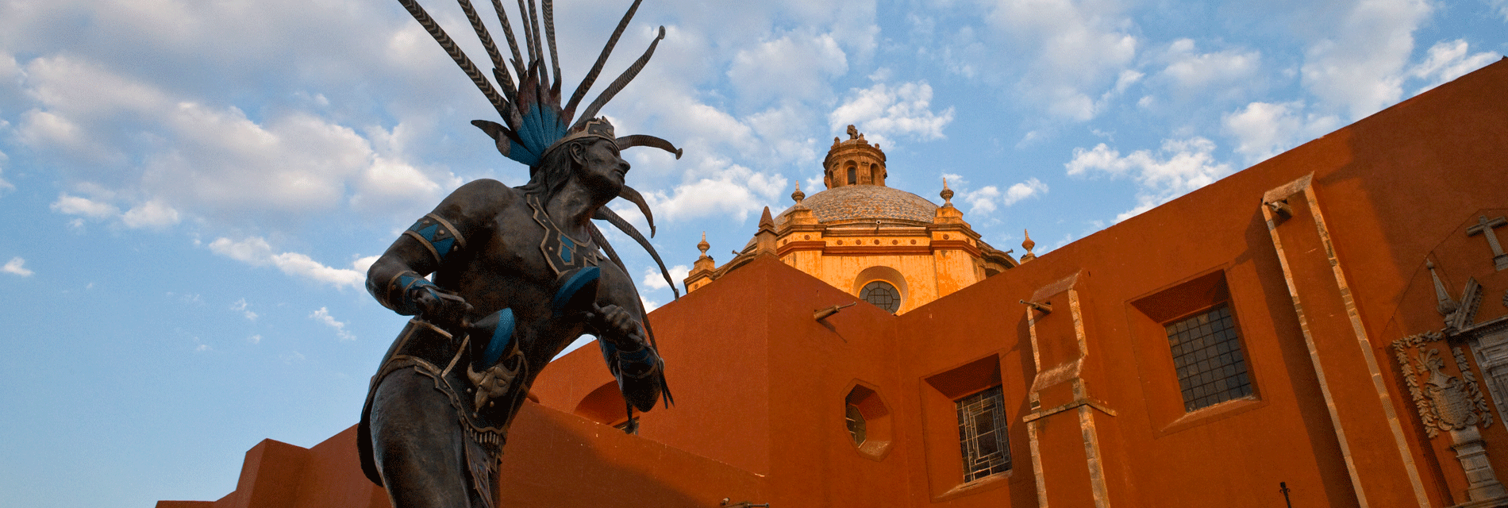
Arrival at the airport or bus station in Queretaro. Reception and transfer to hotel.
Check in at hotel. Rest of the day at leisure.
Lunch and dinner at leisure.
Lodging

DAY 02 – QUERÉTARO – Visita de Ciudad

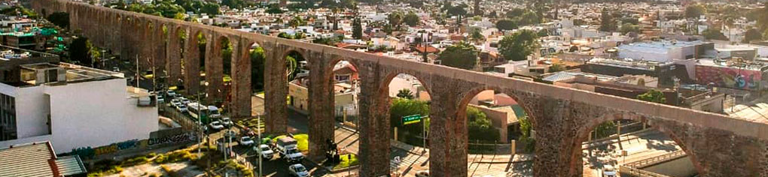

Breakfast at the hotel.

They say that to know a place you have to walk its streets and undoubtedly enjoy its gastronomy, besides living an extraordinary experience to know churches, monuments, mansions, avenues and gardens that have transcended in the history and foundation of this beautiful city of Queretaro, among the most important to visit we have the aqueduct, which was built between 1726 and 1735 and houses a romantic legend, the Plaza de Armas and the Casa de la Corregidora of the eighteenth century.

Lunch and dinner on your own.
Lodging.

DAY 03 – QUERÉTARO – Arte y Vino en Bernal o Tequisquiapan



Breakfast at the hotel.

The state of Queretaro is a destination for wine tourism, grape harvests, artisanal and winery wines of great variety and quality, with an important production of artisanal cow, goat and sheep cheeses. In addition to the Art, Wine and Cheese Route, this tour will visit the Magic Town of Bernal, where some nationally renowned movies have been filmed and where the third largest monolith in the world is located, or Tequisquiapan, known for its well-preserved Spanish buildings on cobblestone streets and for its hot springs spas.

Lunch and dinner on your own. Lodging.

DAY 04 – QUERÉTARO – Sierra Gorda

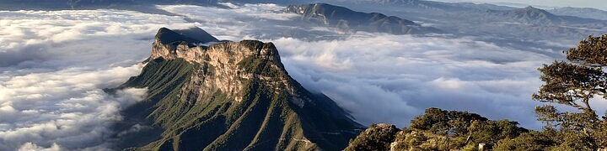

Breakfast at the hotel.

The Sierra Gorda Queretana has been designated as a Biosphere Reserve. It has a variety of flora and fauna endemic to the area. In addition to enjoying the beautiful scenery, the trip to the Sierra Gorda will be an ecological adventure to know its waterfalls and rivers. In this tour you will visit the Jalpan Mission and the Concá Mission, one of the most representative and important in Sierra Gorda, besides visiting the interesting Historical Museum located there.

Lunch and dinner on your own.
Lodging.

DAY 05 – QUERÉTARO / OUT
Breakfast at the hotel.

At a convenient time transfer from your hotel to the airport to take your flight to your destination.

END OF SERVICES

NOTE: The day of operation of the tours may vary.

** VALIDATE RATES WITH YOUR TRAVEL AGENT

CITY | NIGHTS | HOTELS 3** | HOTELS 4* | HOTELS 5*
Querétaro | 04 | Señorial | NH Queretaro | Grand Hotel (breakfasts from Monday to Friday)

INCLUDED:
- TRANSPORTATION: Air-conditioned touristic unit
- ACCOMMODATION: Hotels according to your choice
- MEALS: Daily Breakfast
- VISITS: Those mentioned in the program.
- ESCORT GUIDE: Bilingual, certified by the Ministry of Tourism
NOT INCLUDED:

- Air tickets
- Food or services not mentioned
- Taxes at the airport
- Tips to guides or drivers.

IMPORTANT OBSERVATIONS:
- Due to the multiple changes that occur daily in tourism, these prices must be confirmed at the time of requesting the reservation.
- Rates subject to availability and changes without prior notice.
- Credit card payments are subject to a % commission.
- Please contemplate the schedule of Check in 15:00 hrs and Check Out 12:00 hrs.
- TRIPLE rooms only have 2 double beds.
- The waiting time for arrival transfers is 2 hours and 15 minutes. Once this time has elapsed, the passenger must transfer at his/her own expense.
- The tolerance time for departure transfer is 10 minutes, after this time the unit is withdrawn and you must transfer on your own to the apartment. * Under no circumstances will we be responsible for any extra expenses arising from this situation.

