PROGRAM
PUEBLOS MAGICOS DE SINALOA
05 days/04 nights

(Cosalá, El Rosario, San Ignacio)

Minimum 2 persons.
Daily Departures

ITINERARY

DAY 01 – IN / SINALOA
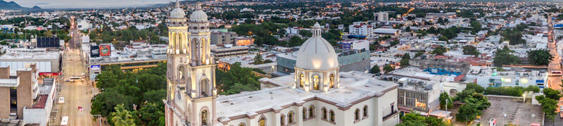
Arrival at Sinaloa International Airport. Reception and transfer to your hotel.

Check in at hotel. Rest of the day at leisure.

Lunch and dinner at leisure. Lodging

DAY 02 – SINALOA - Cosalá

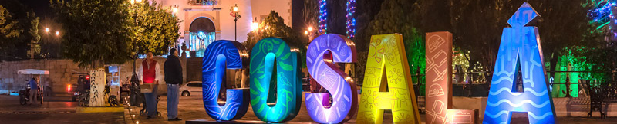

Breakfast at the hotel.

This northwestern Mexican town has a very special atmosphere that comes from its mining past. Its centuries-old traditions and ghost legends will fascinate you. The Guadalupe de los Reyes Mine is the largest mine in the western part of the country. In the 19th century it produced the enormous amount of one million pesos of silver per year. Its owner was one of the precursors that made Sinaloa separate from Sonora (the western state). It closed in 1943, during World War II. Take as souvenirs minerals from the Guadalupe Mine, which are sold at the Mining Museum. Visit the Mining and History Museum. Stroll through the Mineral Ecological Reserve. Taste a stew with machaca.

Lunch and dinner at leisure. Lodging

DAY 03 – SINALOA – El Rosario

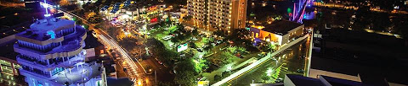

Breakfast at the hotel.

Founded in 1655 after its mining potential was discovered, it became one of the most prosperous towns in northern Mexico, with electricity and political participation during the 17th century. Today, it is a pleasant walk from Mazatlan, with a surprising gastronomy. Its gastronomy and its fresh seafood abound with fresh or stewed shrimp. The zarandeado fish with shrimp chicharrón is a specialty of the area, and you can also find it with octopus and shrimp. El Caimanero Lagoon is one of the most abundant shrimp producing beaches in the world. It is advisable to ask for the catch of the day, as sometimes these options are not on the menu or are seasonal, such as callo de hacha. There are also restaurants with meat cuts and tamales colorados (whose dough is prepared with Palo de Brasil). Savor the shrimp aguachiles and fresh callo de hacha in salad, with locally produced vegetables. Admire the main altarpiece of the Parish of Our Lady of the Rosary. Pay homage to Lola Beltrán in her museum. Take pictures in the ruins of the old parish.

Lunch and dinner at leisure. Lodging

DAY 04 – SINALOA – San Ignacio

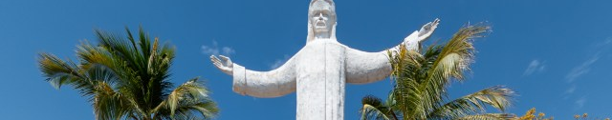

Breakfast at the hotel.

San Ignacio is a beautiful town full of museums, monuments and churches, surrounded by rivers and surrounded by hills. From its colonial beauty to its natural attractions, this Magical Town of Sinaloa has everything to enchant any type of traveler. Discover cave paintings, walk through the Plazuela de la Constitución, explore a mysterious archeological zone and take home a unique piece of pottery. This and more is possible in San Ignacio, an unexpected corner in the heart of Sinaloa. The archaeological zone of Las Labradas, which holds ancient secrets in the form of fascinating petroglyphs. This archaeological tourist development has a museum and services to make visitors' stay more pleasant.
The regional gastronomy, with dishes such as casserole and beef stew, colachi, fish and seafood dishes such as aguachile, zarandeado fish and oysters in their shells. In addition, exquisite desserts such as capirotada, rice pudding and jamoncillos. The Jaguar Museum is the first museum about this emblematic species in Mexico. Here you will find information about this feline and the importance of rescuing this majestic species native to Central and North America.

Lunch and dinner at leisure. Lodging

DAY 05 – SINALOA / OUT

Breakfast at the hotel.

At a convenient time transfer from your hotel to the airport to take your flight to your destination.

END of SERVICES

** VALIDATE RATES WITH YOUR TRAVEL AGENT

INCLUDED:
- TRANSPORTATION: Air-conditioned touristic unit
- ACCOMMODATION: Hotels according to your choice
- MEALS: 04 Breakfast
- VISITS: Those mentioned in the program.
- ESCORT GUIDE: Bilingual, certified by the Ministry of Tourism
NOT INCLUDED:
- Air tickets
- Food or services not mentioned
- Taxes at the airport
- Tips to guides or drivers.
IMPORTANT OBSERVATIONS:
- Due to the multiple changes that occur daily in tourism, these prices must be confirmed at the time of requesting the reservation.
- Rates subject to availability and changes without prior notice.
- Credit card payments are subject to a % commission.
- Please contemplate the schedule of Check in 15:00 hrs and Check Out 12:00 hrs.
- TRIPLE rooms only have 2 double beds.
- Transfers airport-hotel-airport are quoted in shared service, please consider flights arriving and departing between 06:00 and 22:00 hrs, otherwise it must be provided in private service and it will be necessary to re-quote.
- The waiting time for arrival transfers is 2 hours and 15 minutes. Once this time has elapsed, the passenger must transfer at his/her own expense.
- The tolerance time for departure transfer is 10 minutes, after this time the unit is withdrawn and you must transfer on your own to the apartment. * Under no circumstances will we be responsible for any extra expenses arising from this situation.
- Tours may change order according to the operations of the correspondent.

