PROGRAM
PUEBLOS MAGICOS DE PUEBLA
05 days/04 nights

(Ciudad de Puebla, Atlixco, Zacatlán de las Manzanas, Chignahuapan)

Minimum 2 persons.
Daily Departures

ITINERARY

DAY 01 – IN / PUEBLA
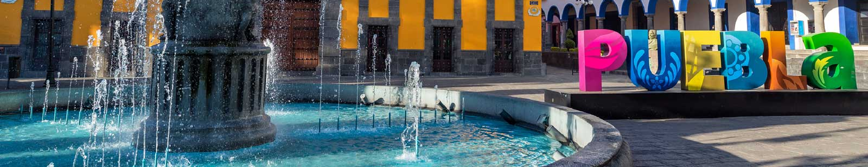

Arrival at CAPU Bus Station. Reception and transfer to your hotel.

Check in at hotel. Rest of the day at leisure.

Lunch and dinner at leisure.
Lodging

DAY 02 – PUEBLA– Puebla Centro y Zona de los Fuertes

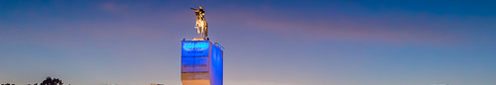

Breakfast at the hotel.

During this pedestrian tour we will visit the Cathedral, which has the tallest towers in the country, also the Palafoxiana Library, which was the first public library on the continent. We will continue through the facade of the Municipal Palace, a historic monument of Renaissance characteristics; the Chapel of the Rosary, admiring its decoration covered with 23k gold laminate; the Street of Sweets, where we will find various stores offering popular and rich traditional sweets and the Craft Market "Parián", where we can buy beautiful typical crafts of Puebla. We will finish in the Historical Zone of the Forts, site of the Battle of Puebla, where we will admire great panoramic views of the city, as well as the Mausoleum dedicated to General Ignacio Zaragoza.

Lunch and dinner at leisure.
Lodging

DAY 03 – PUEBLA – Atlixco Pueblo Mágico

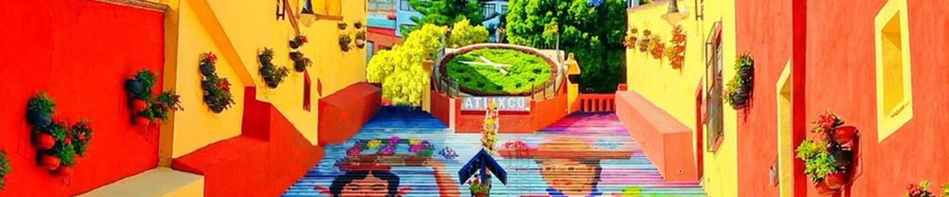

Breakfast at the hotel.

During this tour we will visit the Bonsai Museum, a space dedicated specifically to this wonderful ancient art. We will continue to the center of Atlixco, where we will visit the main square and the murals of the Municipal Palace. We will advance to the "escales anchas", where local painters painted an incredible mural alluding to the typical costumes of Atlixco. We will begin our ascent to the Cerro de San Miguel, in the middle is the Franciscan Convent; if you wish, we will reach the top where we will know the swing of the hill, with an excellent panoramic view of the valley.

Lunch and dinner at leisure.
Lodging

DAY 04 – PUEBLA – Zacatlan de las Manzanas – Chignahuapan Pueblos Mágicos

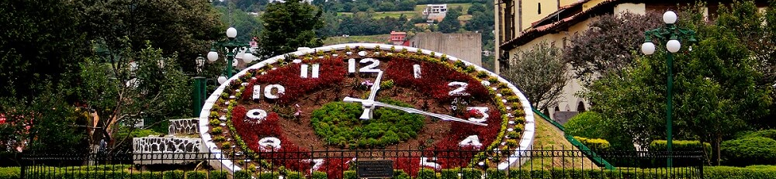

Breakfast at the hotel.

We will enter the Sierra Norte de Puebla to visit the Pueblo Mágico de Zacatlán de las Manzanas, a wonderful place where we will admire the Barranca de los Jilgueros in its glass viewpoint. We will also enjoy its floral clock, Franciscan Convent and Parish of San Pedro and San Pablo. Later we will arrive to Chignahuapan, where we will know the process of elaboration of typical Christmas spheres of the site, besides admiring the monumental image of 13 meters high of the Virgin of the Immaculate inside its temple. We will finish visiting the Mudejar kiosk and the monument to Capulina, as it was the birthplace of this famous comedian.

Lunch and dinner at leisure.
Lodging

DAY 05 –PUEBLA / OUT

Breakfast at the hotel.

At a convenient time transfer from your hotel to the CAPU bus station.

END OF SERVICES

NOTE: The day of operation of the tours may vary.

** VALIDATE RATES WITH YOUR TRAVEL AGENT

CITY | NIGHTS | HOTELS 3* | HOTELS 4*
Puebla | 04 | Colonial Puebla | NH Puebla Centro Histórico

INCLUDED:
- TRANSPORTATION: Air-conditioned touristic unit
- ACCOMMODATION: Hotels according to your choice
- MEALS: 04 Breakfast
- VISITS: Those mentioned in the program.
- ESCORT GUIDE: Bilingual, certified by the Ministry of Tourism
NOT INCLUDED:

- Air tickets
- Food or services not mentioned
- Taxes at the airport
- Tips to guides or drivers.

IMPORTANT OBSERVATIONS:
- Due to the multiple changes that occur daily in tourism, these prices must be confirmed at the time of requesting the reservation.
- Rates subject to availability and changes without prior notice.
- Credit card payments are subject to a % commission.
- Please contemplate the schedule of Check In 15:00 hrs and Check Out 12:00 hrs.
- TRIPLE rooms only have 2 double beds.
- The tours may change order according to the operations of the correspondent.

