PROGRAM
PROGRAM 1
04 days/03 nights

(City, Plaza de las 3 Culturas, Basilica of Guadalupe, Pyramids of Teotihuacán)

Minimum 2 persons.
Daily Departures

ITINERARY

DAY 01 – IN / CIUDAD DE MÉXICO

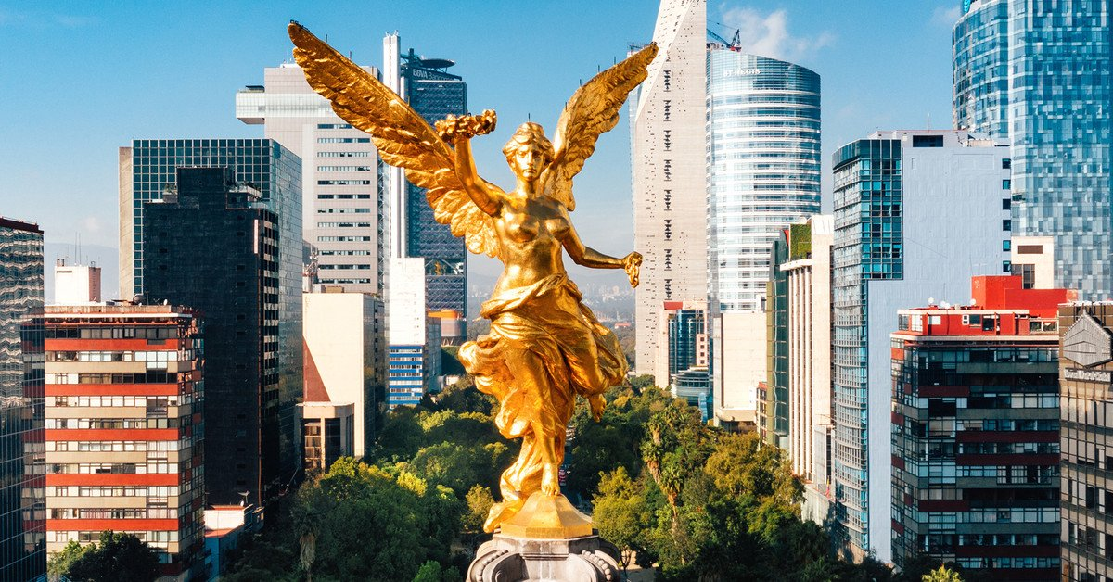
Arrival at the international airport in Mexico City. Reception and transfer to your hotel.

Check in at the hotel. Rest of the day at leisure.

Lunch and dinner at leisure. Lodging

DAY 02 – CIUDAD DE MÉXICO – City Tour

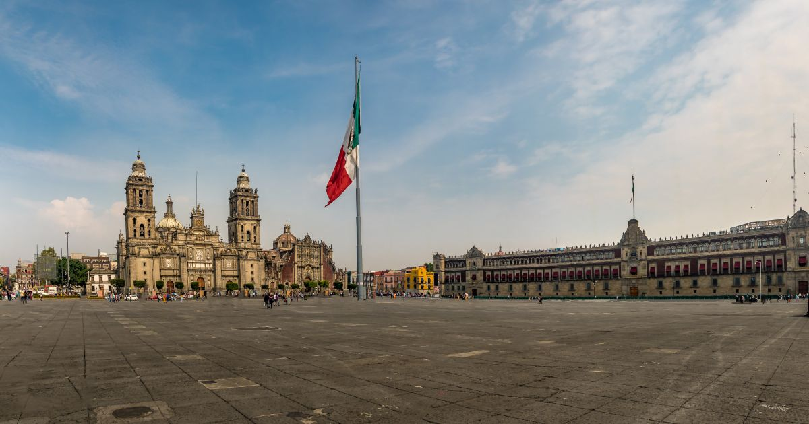

Breakfast at the hotel.

We will visit the Zocalo, the National Palace (outside view). We will see the ruins of what was the Templo Mayor of the Aztecs and the Metropolitan Cathedral. We will take you to the historic Chapultepec forest surrounded by residential areas such as Las Lomas; where you will see the residences of famous artists.

Lunch and dinner at leisure. Lodging

DAY 03 – CIUDAD DE MÉXICO – Basílica + Pyramids

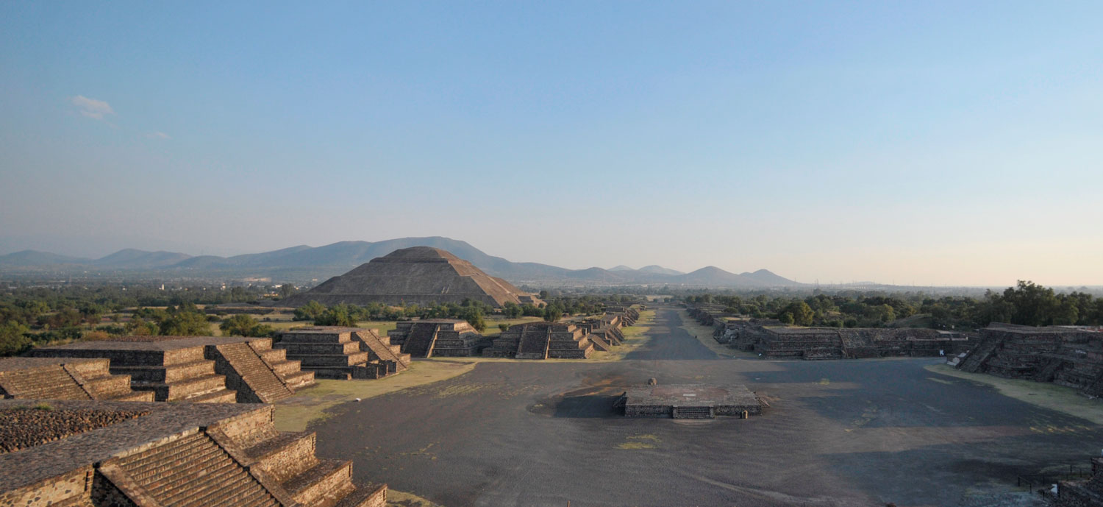

Breakfast at the hotel.

Panoramic visit to the Plaza de las Tres Culturas; historical site where the last fight between Aztecs and Spaniards was fought and which symbolizes the fusion of 3 cultural eras represented by the Aztec ruins; the church of Tlatelolco and the building of the Ministry of Foreign Affairs. After a short stop, we will continue to the Basilica of Guadalupe, where we will see the original image of the Virgin of Guadalupe. You will learn the story of how she was captured on the mantle of the native Juan Diego and see the ancient basilica at the foot of the Tepeyac hill. By a modern highway we will go directly to the archaeological zone of Teotihuacan; the city of the gods; 50 km away where we will be able to admire the impressive pyramids of the sun and the moon; walk along the avenue of the dead; we will visit an obsidian workshop for the demonstration of obsidian and maguey.

Lunch and dinner on your own. Lodging

DAY 04 – CIUDAD DE MÉXICO / OUT

Breakfast at the hotel.

At a convenient time transfer from your hotel to the airport to take your flight to your destination.

END of SERVICES

CITY | NIGHTS | HOTELS 3** | HOTELS 4* | HOTELS 4**
Ciudad de México | 03 | Premier / Regente / Estoril | Casa Blanca / PF / Royal Reforma / Novotel | Laila / Galería Plaza

PRICES PER PERSON IN USD

HOTEL | PLAN ALIMENTOS |  |  |  | CAT. HABITACIÓN | SGL | DBL | TPL | CHD
PREMIER | AMERICAN BREAKFAST
 | 01/01/2026 |  | 31/12/2026 |  | Standard | 348 | 237 | 216 | 89
HOTEL ESTORIL | AMERICAN BREAKFAST
 | 01/01/2026 |  | 31/12/2026 |  | Standard | 372 | 240 | 213 | 98
HOTEL REGENTE CITY | BUFFET BREAKFAST
 | 01/01/2026 |  | 31/12/2026 |  | Standard | 375 | 249 | 219 | 91
ROYAL REFORMA | BUFFET BREAKFAST
 | 01/01/2026 |  | 31/12/2026 |  | Standard | 478 | 292 | 274 | 147
CASA BLANCA | BUFFET BREAKFAST
 | 01/01/2026 |  | 31/12/2026 |  | Deluxe | 453 | 291 | 282 | 92
PF HOTEL | BUFFET BREAKFAST
 | 01/01/2026 |  | 31/12/2026 |  | Standard | 414 | 264 | 243 | 128
NOVOTEL MEXICO CITY CENTRO HISTORICO | BUFFET BREAKFAST
 | 01/01/2026 |  | 31/12/2026 |  | Standard | 426 | 288 | 264 | 125

NOT APPLICABLE on FIFA World up, Formula 1 or Day of the Dead dates.
**Restrictions on occupancy with minors at Hotel Casa Blanca, please consult with your executive.

INCLUDED:
- TRANSPORTATION: Air-conditioned touristic unit
- ACCOMMODATION: Hotels according to your choice
- MEALS: Daily Breakfast
- VISITS: Those mentioned in the program.
- ESCORT GUIDE: Bilingual, certified by the Ministry of Tourism

NOT INCLUDED:

- Air tickets
- Food or services not mentioned
- Taxes at the airport
- Tips to guides or drivers.

IMPORTANT OBSERVATIONS:
- Rates subject to availability and subject to change without notice.
- Credit card payments are subject to a % commission.
- If flights arrive or depart from and to the new Felipe Angeles airport, a supplement will be charged.
- Please consider the check in time 15:00 hrs and check out time 12:00 hrs.
- The waiting time for arrival transfers is 2 hours and 15 minutes. Once this time has elapsed, the passenger will have to transfer at his/her own expense.
- The tolerance time for departure transfer is 10 minutes, after this time the unit is withdrawn and you will have to transfer to the apartment on your own. * Under no circumstances will we be responsible for any extra expenses that may arise from this situation.
- We will NOT be able to provide services if a previous reservation is not made 7 days before the tour starts.
- Tours may change order depending on the operations of the correspondent.

