CIRCUIT
POR EL CORAZÓN DE MÉXICO EXT. PUERTO VALLARTA
12 days/11 nights

(Ciudad de México, Museo de Antropología, Plaza de las 3 Culturas, Basílica de Guadalupe, Pirámides de Teotihuacan, Querétaro, San Miguel de Allende, Guanajuato, Zacatecas, Guadalajara, Tlaquepaque, Tequila y Puerto Vallarta)

Minimum 2 people.
02 monthly departures

Departure dates 2026:

JANUARY | 05 y 19 | JULY | 20
FEBRUARY | 02 y 16 | AUGUST | 03 y 17
MARCH | 02 y 16 | SEPTEMBER | 07 y 21
APRIL | 06 y 20 | OCTOBER | 05
MAY | 04 y 18 | NOVEMBER | 16
JUNE | N/A | DECEMBER | 07 y 14
** Ask your executive if there are more people registered on the date you are interested in.

ITINERARY

DAY 01 (monday) – IN / CIUDAD DE MÉXICO

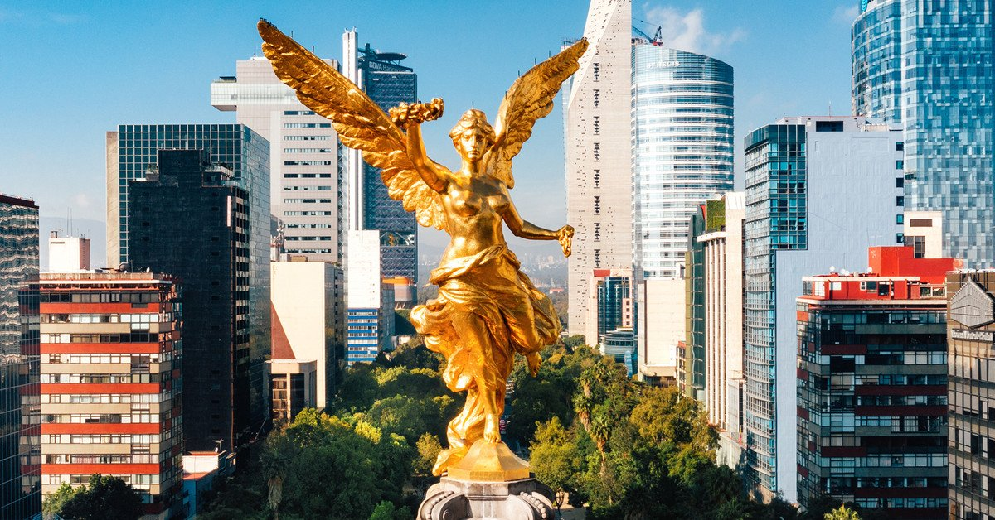
Arrival at Mexico City International Airport. Reception and transfer to your hotel.
Check in at the hotel. Rest of the day at leisure.
Lunch and dinner on your own. Lodging.

DAY 02 (tuesday)–CIUDAD DE MÉXICO-Basílica de Guadalupe – Pirámides de Teotihuacan

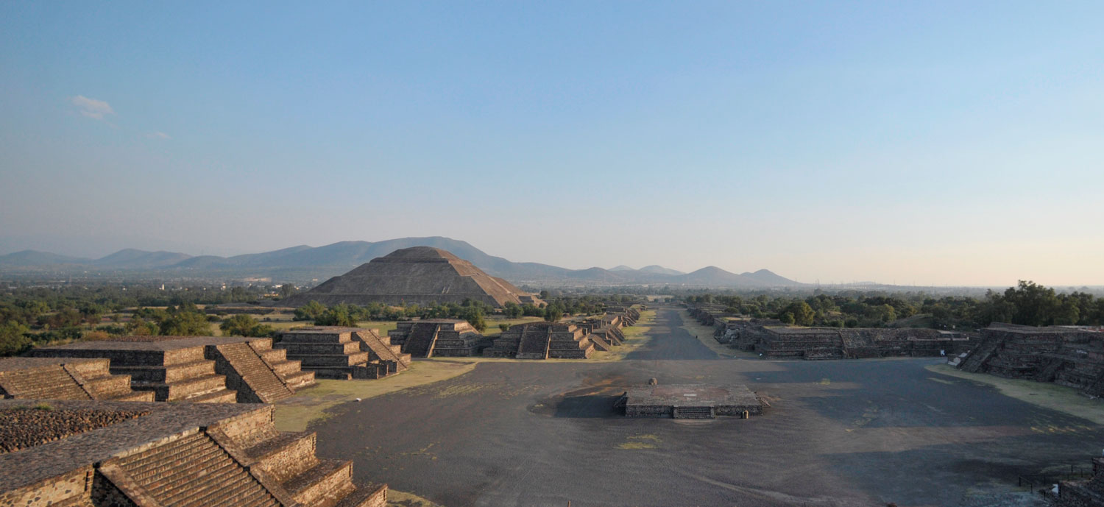

Breakfast at the hotel.

Panoramic visit to the Plaza de las Tres Culturas; historical site where the last fight between Aztecs and Spaniards was fought and which symbolizes the fusion of 3 cultural eras represented by the Aztec ruins; the church of Tlatelolco and the building of the Ministry of Foreign Affairs. We will continue to the Basilica of Guadalupe, where we will see the original image of the Virgin of Guadalupe.

You will learn the story of how it was captured in the mantle of the indigenous Juan Diego and see the ancient basilica at the foot of the Tepeyac hill. By a modern highway we will go directly to the archaeological zone of Teotihuacan; the city of the gods; 50 km away where we can admire the impressive pyramids of the sun and the moon; walk along the avenue of the dead, we will visit an obsidian workshop for the demonstration of obsidian and maguey. Buffet lunch (without drinks).

Dinner at leisure. Lodging.

DIA 03 (wednesday)–CIUDAD DE MÉXICO-Visita de Ciudad – Museo de Antropología
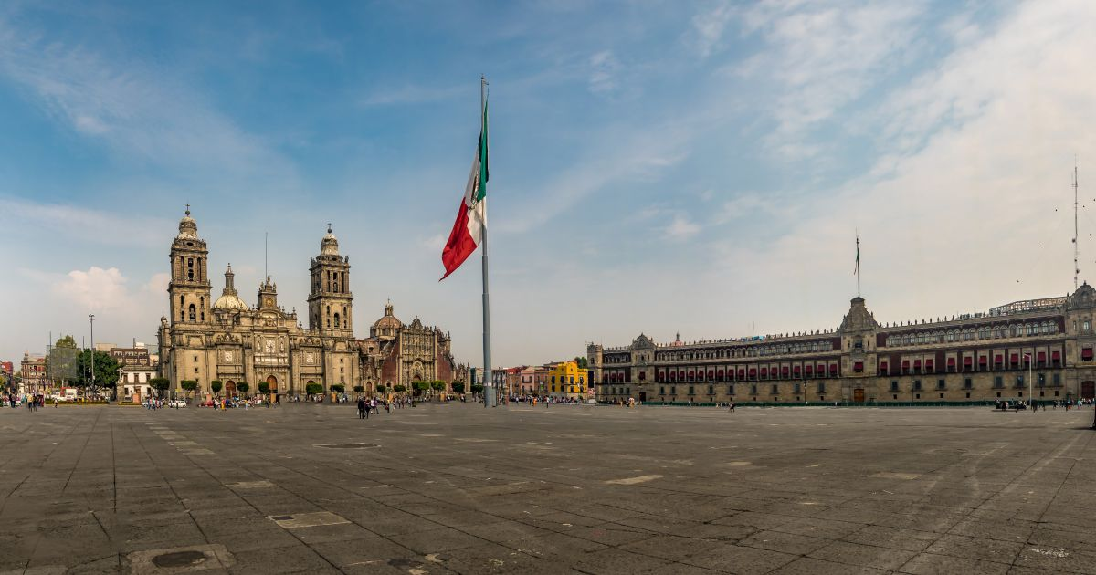

Breakfast at the hotel.

We will visit the Zócalo, the National Palace and a panoramic view. We will see the ruins of what was the Templo Mayor of the Aztecs and the Metropolitan Cathedral. We will take you to the historic Chapultepec forest surrounded by residential areas such as Las Lomas, where you will see the residences of famous artists. Visit the National Museum of Anthropology, where you will appreciate a mosaic of the most important cultures of the country. You can stay at the museum to visit it completely or be transferred to your hotel.

Lunch and dinner on your own. Lodging.

DAY 04 (thursday)–CIUDAD DE MÉXICO-Querétaro – San Miguel de Allende

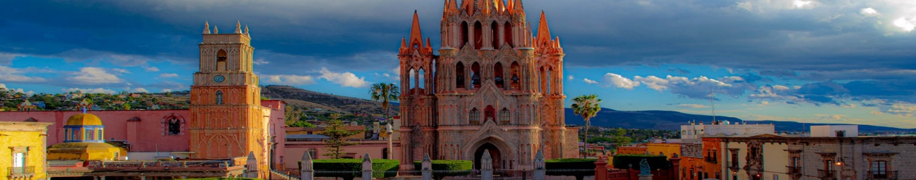
Breakfast at the hotel.

Departure to Queretaro, a World Heritage City, where we will visit the Aqueduct, the Ex-Convent of the Cross and the Historic Center. We will continue on to San Miguel de Allende. Afternoon to visit this peaceful city where the great comedian Mario Moreno "Cantinflas" lived and a place of residence for artists and intellectuals. Highlights include the Parish of San Miguel Arcangel, the Chapel of the Holy House, the Convent of the Conception, the Church of San Francisco and the Allende House and Institute. You will find a wide variety of cafes and restaurants to choose from.
Lunch and dinner on your own. Lodging.
.

DAY 05 (friday)–SAN MIGUEL DE ALLENDE – Dolores Hidalgo GUANAJUATO

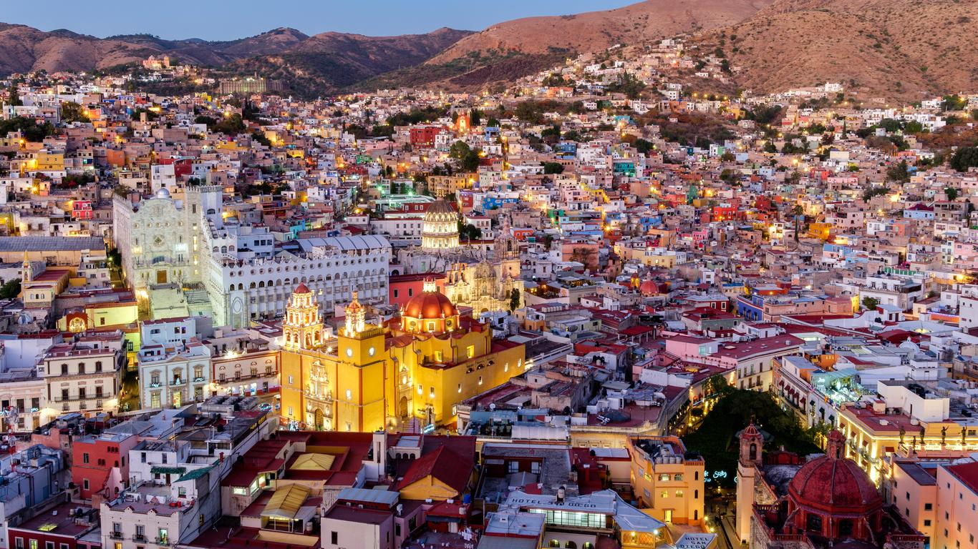
Breakfast at the hotel.

Departure to Dolores Hidalgo, where the priest Don Miguel Hidalgo gave the "Cry of Independence" of Mexico in 1810. There we will find the house-museum of this national hero. We will continue to Guanajuato, a World Heritage City, home of the annual Cervantino International Festival. In the afternoon we will enjoy this beautiful city, full of alleys and squares, which offers us very interesting places such as the University, the Juarez Theater, the Kiss Alley, the house-museum of the muralist Diego Rivera, husband of Frida Kahlo. Its streets and subway avenues are unique in the country. Other attractive options are: the "callejoneada" accompanied by a musical estudiantina or tuna valenciana, the house of Jorge Negrete, the museum of Don Quixote and the Mummies. (not included).

Lunch and dinner on your own. Lodging.

DAY 06 (saturday)–GUANAJUATO – ZACATECAS

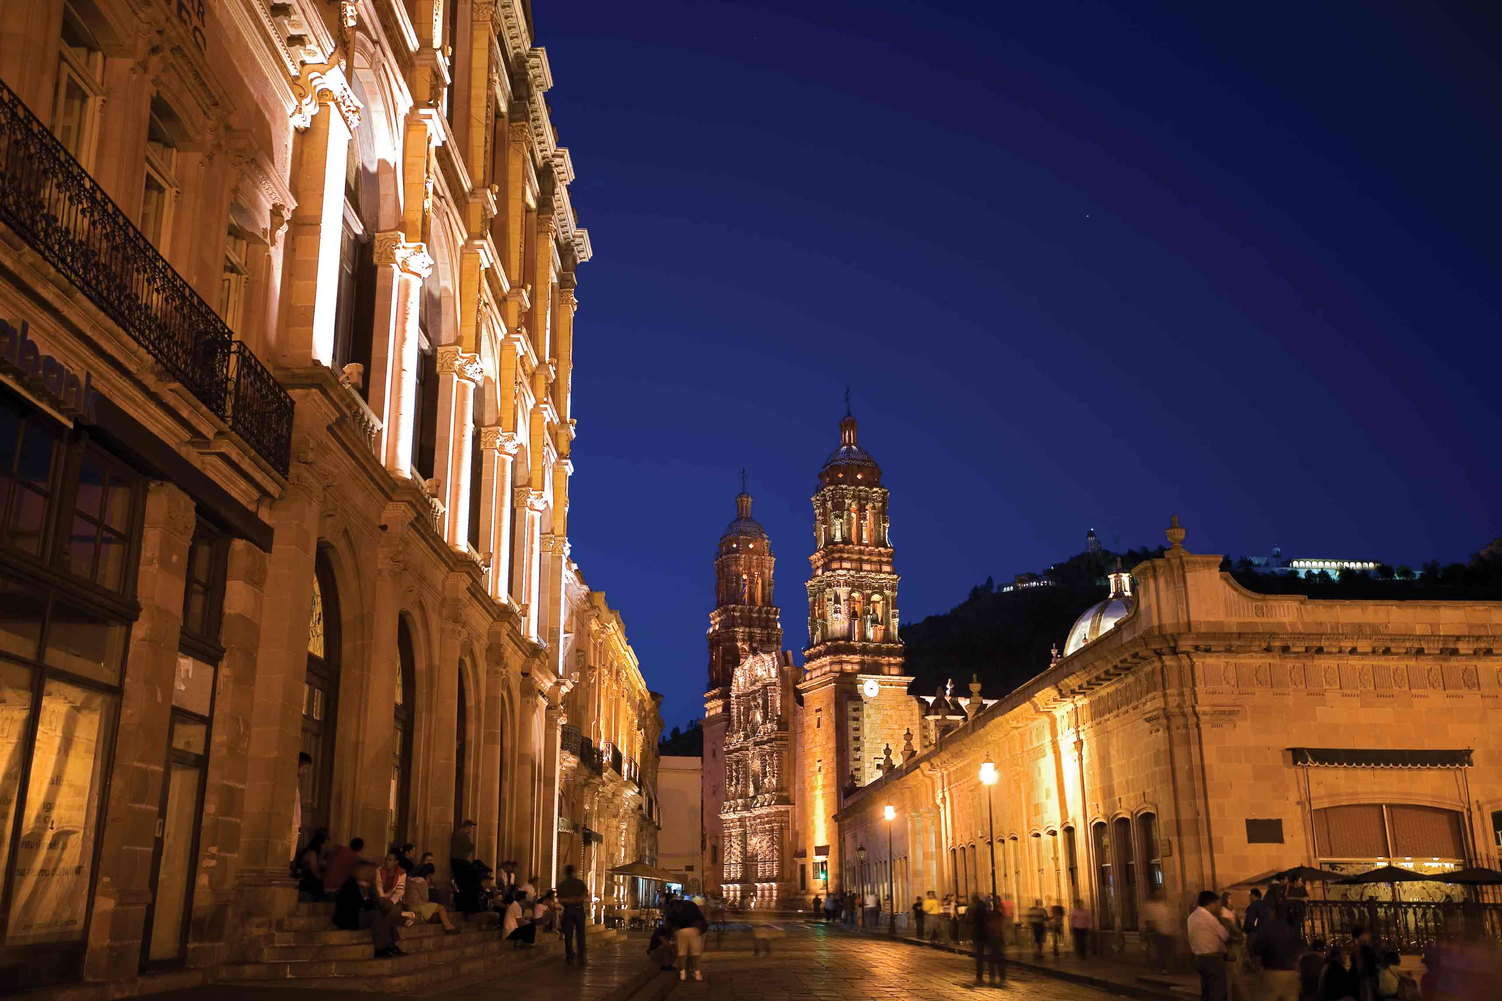
Breakfast at the hotel.

Departure to Zacatecas, beautiful mining city declared a World Heritage Site, beautiful facades carved in pink quarry, whose cathedral is the most outstanding example of Mexican baroque. Panoramic view of the city from the Cerro de la Bufa, descent by cable car and educational visit to the Eden Mine. Possibility of witnessing a musical "callejoneada" with Tambora. Other attractive options in the city are the Rafael and Pedro Coronel and Francisco Goitia museums. (not included).

Lunch and dinner on your own. Lodging.

DAY 07 (sunday) – ZACATECAS - GUADALAJARA

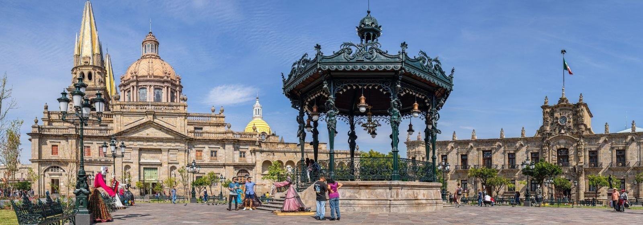
Breakfast at the hotel.

Departure to the city of Guadalajara, birthplace of Mariachi and Tequila, which distinguish Mexico in the world. Visit to the district of Tlaquepaque, famous for making the best handicrafts in the state. Here you will find the famous gallery of Sergio Bustamante. Possibility to have lunch in one of the typical restaurants accompanied by a mariachi band.

Check in at the hotel.
Lunch and dinner on your own. Lodging.

DAY 08 (monday) – GUADALAJARA - TEQUILA

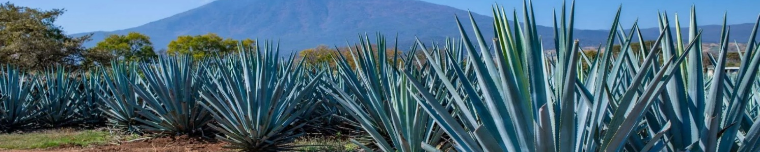

Breakfast at the hotel.

In the morning we will visit the city where we will observe points of interest such as the teatro degollado, the cathedral, the rotunda of illustrious men, the government palace that houses splendid murals by Orozco, the plaza tapatía and a panoramic view of the hospicio cabañas. We continue to Tequila, a typical town where the main distilleries of this world-renowned liquor are located. We will visit the agave fields, the plant from which the "jimadores" extract the pineapple to obtain tequila. We will visit a distillery to learn in detail the production process of this drink. Return to Guadalajara.

Lunch and dinner on your own. Lodging.

DAY 09 (tuesday) – GUADALAJARA – PUERTO VALLARTA

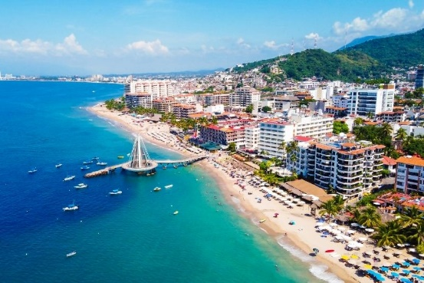

Breakfast at the hotel.

Transfer from the hotel to the bus terminal (Ticket bus included) to board the bus to Puerto Vallarta, a destination full of warmth, a picturesque place full of history where you can enjoy relaxing beaches, world-class restaurants, ecotourism and extreme adventures. Its wonderful historic center will fascinate you and you can have a great time in its numerous cafes and nightclubs. A magnificent end to this beautiful tour through one of the most representative states of the country. Arrival and transfer to the hotel.

Lodging in All-Inclusive Plan.

DAY 10 and 11 (Wednesday and thursday) – PUERTO VALLARTA

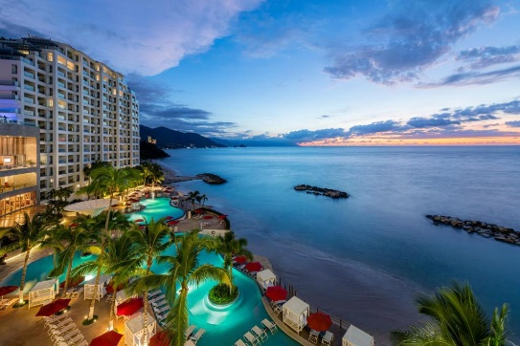

As we know that when you get there you won't want to leave soon, we offer you two days off to enjoy this wonderful place in the way you prefer.

Lodging in All-Inclusive Plan.

DAY 12 (friday) – PUERTO VALLARTA

Breakfast at the hotel.

Free time until the transfer and assistance to the airport is provided.

END of SERVICES

HOTELS 4*

City | Nights | Hotels
Ciudad de México | 03 | Casa Blanca or similar
San Miguel de Allende | 01 | Real de Minas or similar
Guanajuato | 01 | Holiday Inn or similar
Zacatecas | 01 | Santa Rita or similar
Guadalajara | 02 | Morales or Similar
Puerto Vallarta | 03 | Friendly Fun Puerto Vallarta

PRICES PER PERSON IN USD

VALIDITY | DBL | TPL | SGL | MNR
Jan 03 – Mar 15, 2026 | 2,205 | 2,110 | 2,970 | 1,035
Mar 16 – 28, Apr 12 -Dec 21, 2026 | 2,040 | 1,955 | 2,725 | 1,035
Mar 19 – Apr 11, 26 | 2,255 | 2,160 | 3,045 | 1,035
Rates do not apply during Easter and Formula 1.

PRICE includes:
- Tourist transportation with air conditioning.
- Bus ticket Guadalajara - Puerto Vallarta route.
- Bilingual guide
- 11 nights of lodging in the mentioned hotels.
- 08 breakfasts in hotel and all-inclusive plan in Puerto Vallarta.
- 01 Buffet lunch without beverages
- Visits mentioned with the corresponding entrance fees
- Local and lodging taxes

NOT INCLUDED:

- Air tickets
- Extra visits or not mentioned in the program
- Airport taxes
- Meals not mentioned in the program
- Drinks
- Extras for passengers
- Tips to guide and driver

IMPORTANT REMARKS:

1. Please note that prices for children are as long as they are under 11 years old and share room with 2 adults, otherwise, they will have to enter in 1 TRIPLE room paying as an adult.
2. TRIPLE rooms have only 2 double beds.
3. Please contemplate the schedule of Check in 15:00 hrs and Check Out 12:00 hrs.
4. Ask your executive if there are more people enrolled on the date you are interested.

