PROGRAM
PARAISO VALLARTA
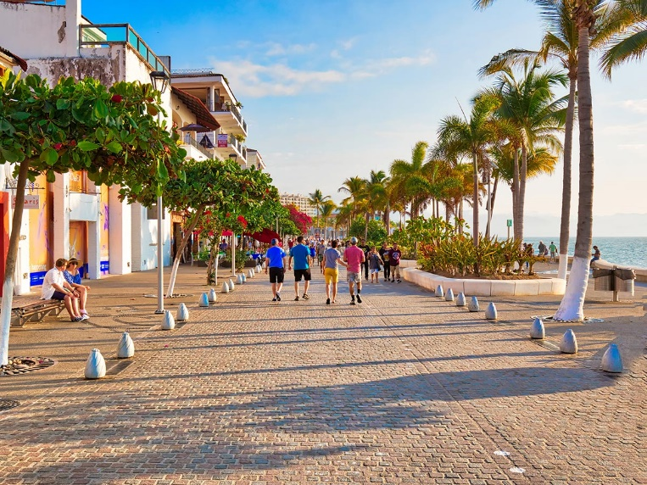
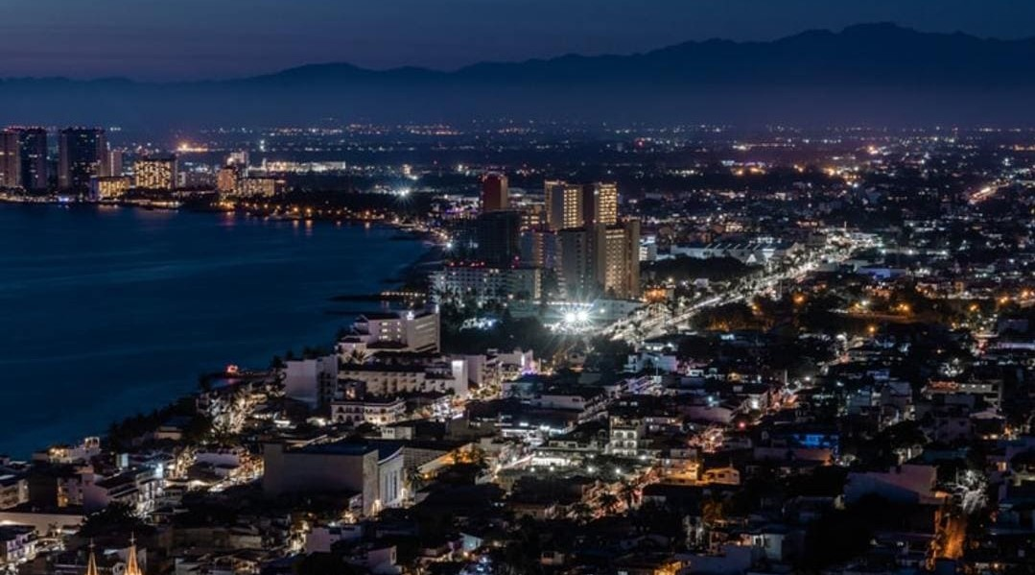
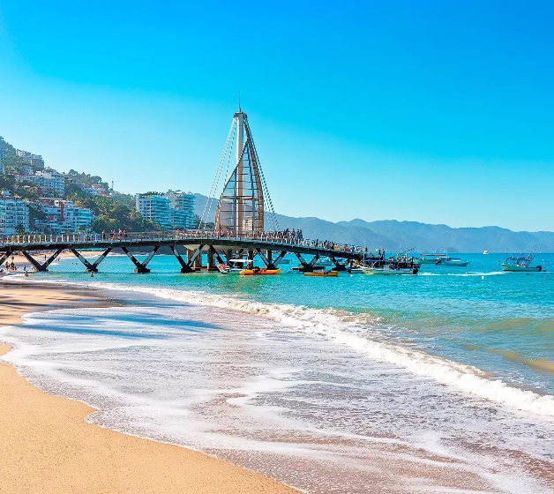
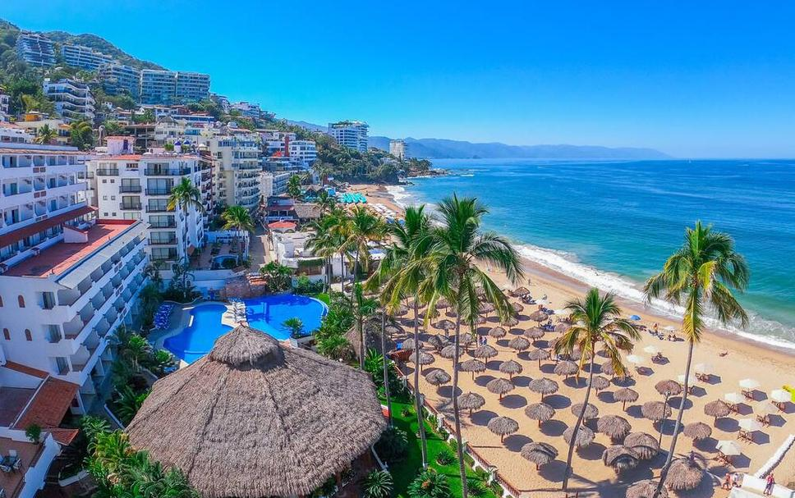
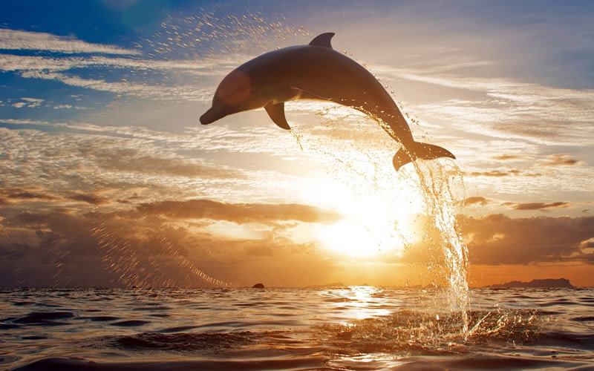
04 days/03 nights

(Puerto Vallarta, Mismaloya, Isla Marietas)

Minimum 2 persons.
Daily Departures

ITINERARY

DAY 01 – IN / PUERTO VALLARTA
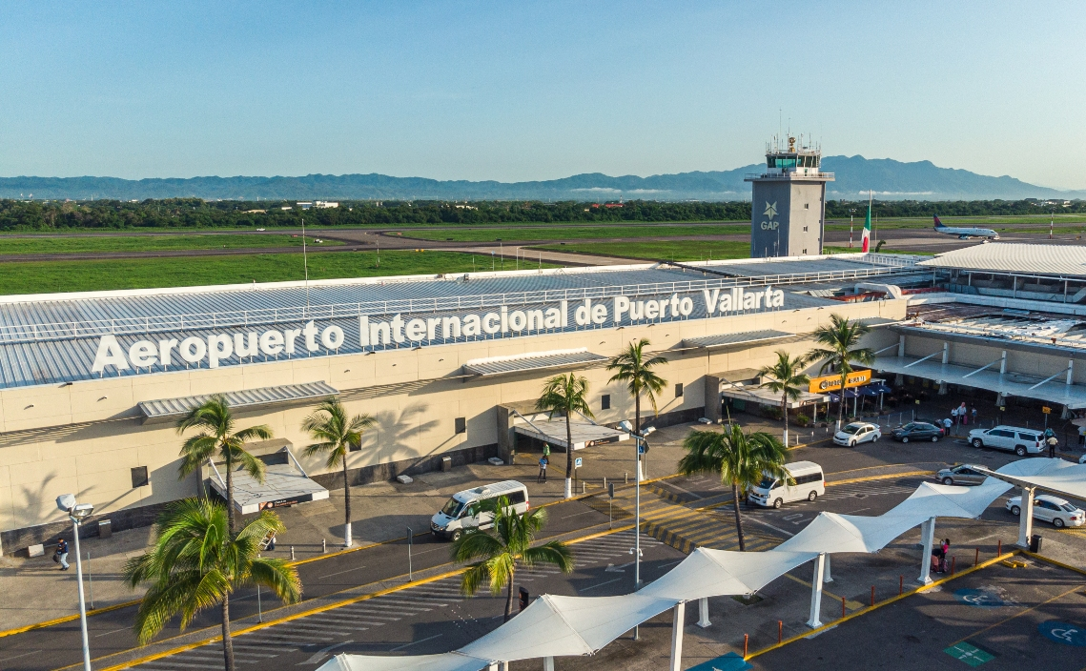
Arrival at Puerto Vallarta airport. Reception and transfer to hotel.
Check in at hotel. Rest of the day at leisure.
Lunch and dinner at leisure. Lodging

DAY 02 – PUERTO VALLARTA – Lo Mejor de Puerto Vallarta

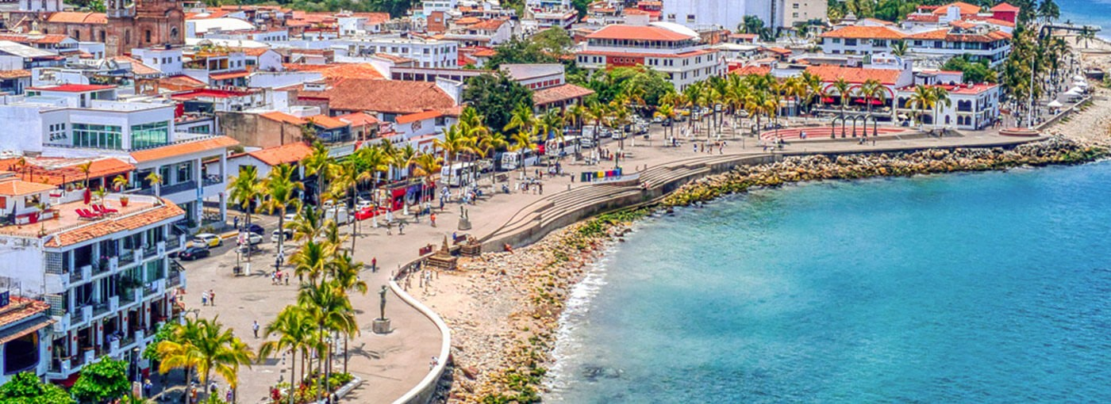

Breakfast at the hotel.

Great opportunity to get to know the picturesque city of Puerto Vallarta with its scenic South Coast of Banderas Bay and the history of the world famous "tequila" drink on this informative half day tour. We will start our tour aboard our comfortable bus traveling south along the coast passing through the exclusive residential section of the area admiring the green vegetation and the bright blue Pacific Ocean on this spectacular route until we reach "Mismaloya" where we will make a brief visit before continuing to a tequila distillery where we will enjoy a tour and tasting and continue back to "Downtown" Puerto Vallarta and the Malecon. It is time to leave the bus and follow our guide through cobblestone streets which will take us to visit the great attractions of the area, including the Cathedral of Our Lady of Guadalupe which stands out for its shining golden crown located at the top of its main tower. We will visit the "Rio Cuale" and its commercial area where you can buy handicrafts and gifts to take back home.

Lunch and dinner on your own. Lodging.

DAY 03 – PUERTO VALLARTA – Islas Marietas y delfines en Catamarán

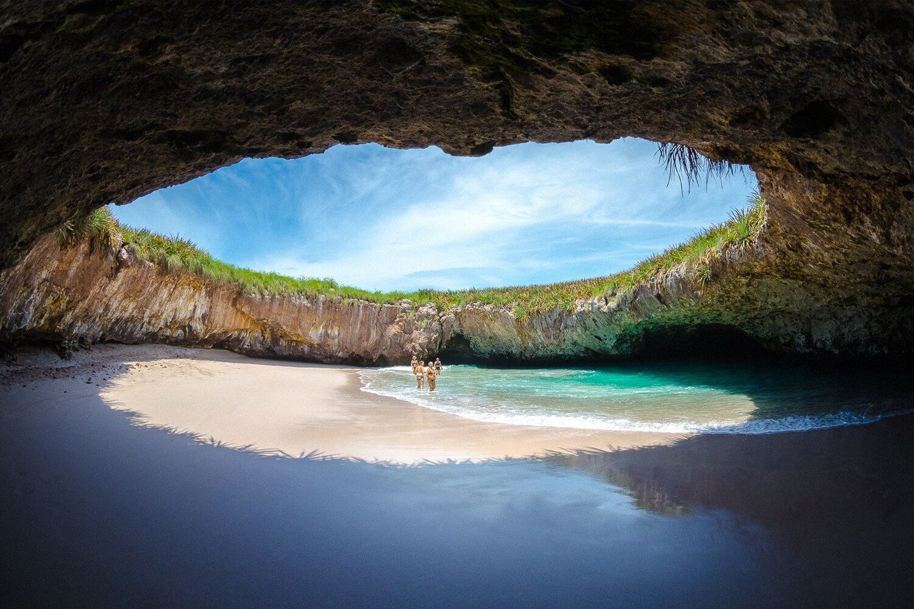

Breakfast at the hotel.

Let yourself be conquered by the marvelous marine life. This exquisite and diverse sea, unique in the world for its vast marine fauna, is home to an endless number of multicolored fish and dolphins, as well as the presence of humpback whales, which make the Marietas Islands their home between December and March. This unforgettable experience is full of fun from beginning to end, and you will be able to recreate it in your mind every time you tell your friends about your trip. During the catamaran tour of the Marietas Islands in Nayarit, our crew will take care of you as you deserve and will be attentive to your needs during the tour. Once you have arrived at your destination, you will be able to explore the surface of these wonderful places by kayak and paddle board or dive into the blue of the ocean practicing snorkeling and discovering the colorful and rich underwater world of the region.

Dinner at leisure. Lodging

Note: Water activities take place around the boat and do not include a visit to Playa Escondida. Whale watching is possible from December 15 to March 19.

DAY 04 – PUERTO VALLARTA / OUT

Breakfast at the hotel.

At a convenient time transfer from your hotel to the airport to take your flight to your destination.

END of SERVICES

NOTE: The day of operation of the tours may vary.
** VALIDATE RATES WITH YOUR TRAVEL AGENT

CITY | NIGHTS | HOTELS 4* | HOTELS 4**
Puerto Vallarta | 03 | Friendly Fun Vallarta | Krystal Puerto Vallarta

INCLUDED:
- TRANSPORTATION: Air-conditioned touristic unit
- ACCOMMODATION: Hotels according to your choice
- MEALS: All inclusive plan
- VISITS: Those mentioned in the program.
- ESCORT GUIDE: Bilingual, certified by the Ministry of Tourism
NOT INCLUDED:

- Air tickets
- Food or services not mentioned
- Taxes at the airport
- Tips to guides or drivers.

IMPORTANT OBSERVATIONS:
- Due to the multiple changes that occur daily in tourism, these prices must be confirmed at the time of requesting the reservation.
- Rates subject to availability and changes without prior notice.
- Credit card payments are subject to a % commission.
- Please contemplate the schedule of Check in 15:00 hrs and Check Out 12:00 hrs.
- TRIPLE rooms only have 2 double beds.
- Transfers airport-hotel-airport are quoted in shared service, please consider flights arriving and departing between 06:00 and 22:00 hrs, otherwise it must be provided in private service and it will be necessary to re-quote.
- The waiting time for arrival transfers is 2 hours and 15 minutes. Once this time has elapsed, the passenger must transfer at his/her own expense.
- The tolerance time for departure transfer is 10 minutes, after this time the unit is withdrawn and you must transfer on your own to the apartment. * Under no circumstances will we be responsible for any extra expenses arising from this situation.
- Tours may change order according to the operations of the correspondent.

