PROGRAM
OAXACA NATURALEZA Y CULTURA
04 days/03 nights

(Árbol del Tule, Mitla, Teotitlán, Hierve el Agua, Mezcal, Monte Albán, Arrazola, Cuilapam, Coyotepec)

Minimum 2 persons.
Daily Departures

ITINERARY

DAY 01 – IN / OAXACA
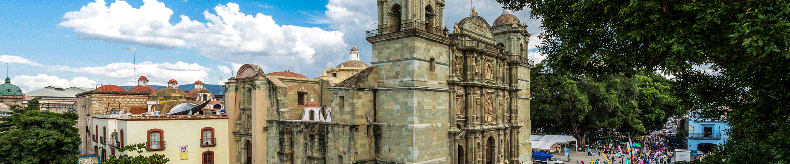

Arrival at Oaxaca's international airport. Reception and transfer to hotel.

Check in at hotel. Rest of the day at leisure.

Lunch and dinner at leisure.

Lodging

DAY 02 – OAXACA – Imperio Mixteca

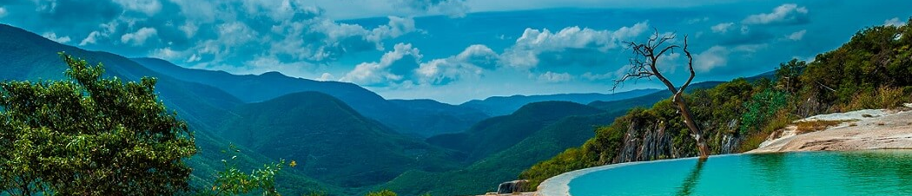

Breakfast at the hotel.

One of the natural wonders: the legendary Tule Tree, which is more than 2000 years old, in its trunk, branches and roots we will be able to observe animal figures; we will continue to the archaeological zone of Mitla, the city of the dead, incomparably beautiful for its varied ornamentation of its foundations, achieved through the system of geometric designs. Later we will go to Teotitlán del Valle, a place where the famous wool rugs are made with artisan processes and hand woven, we will continue our tour to Hierve el Agua, where you can admire the beautiful petrified waterfalls. To conclude our tour we will visit a Mezcal Distillery where you will be able to taste the varieties of flavors.

Lunch and dinner on your own.

Lodging.

DAY 03 – OAXACA – Imperio Zapoteca

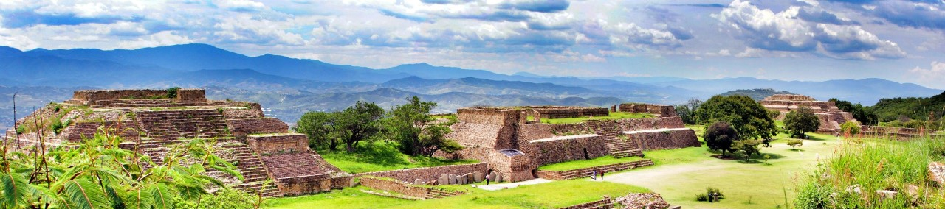

Breakfast at the hotel.

Enjoy a walk to the extraordinary archaeological zone of Monte Alban, which keeps testimonies of its empire of more than 1500 years. Our journey continues to the majestic Convent of Cuilapam de Guerrero where we can find a majestic set of Dominican convents of the sixteenth century. Then we will go to Arrazola, where the creativity of the artisans was seen in their beautiful pieces made of wood. Later in San Bartolo Coyotepec we will have a demonstration of black clay pottery.

Lunch and dinner on your own.

Lodging.

DAY 04 – OAXACA/ OUT

Breakfast at the hotel.

At a convenient time transfer from your hotel to the airport to take your flight to your destination.

END OF SERVICES

NOTE: The day of operation of the tours may vary.

**VALIDATE RATES WITH YOUR TRAVEL AGENT

CITY | NIGHTS | HOTELS 4* | HOTELS 4*
Oaxaca | 03 | Casa Conzatti | Oaxaca Real

INCLUDED:
- TRANSPORTATION: Air-conditioned touristic unit
- ACCOMMODATION: Hotels according to your choice
- MEALS: 03 Breakfast in Oaxaca
- VISITS: Those mentioned in the program.
- ESCORT GUIDE: Bilingual, certified by the Ministry of Tourism
NOT INCLUDED:

- Air tickets
- Food or services not mentioned
- Taxes at the airport
- Tips to guides or drivers.

IMPORTANT OBSERVATIONS:
- Due to the multiple changes that occur daily in tourism, these prices must be confirmed at the time of requesting the reservation.
- Rates subject to availability and changes without prior notice.
- Credit card payments are subject to a % commission.
- Please contemplate the schedule of Check in 15:00 hrs and Check Out 12:00 hrs.
- TRIPLE rooms only have 2 double beds.
- Transfers airport-hotel-airport are quoted in shared service, please consider flights arriving and departing between 06:00 and 22:00 hrs, otherwise it must be provided in private service and it will be necessary to re-quote.
- The waiting time for arrival transfers is 2 hours and 15 minutes. Once this time has elapsed, the passenger must transfer at his/her own expense.
- The tolerance time for departure transfer is 10 minutes, after this time the unit is withdrawn and you must transfer on your own to the apartment. * Under no circumstances will we be responsible for any extra expenses arising from this situation.
- Tours may change order according to the operations of the correspondent.

