PROGRAM
OAXACA, CALPULALPAM Y GUELATAO
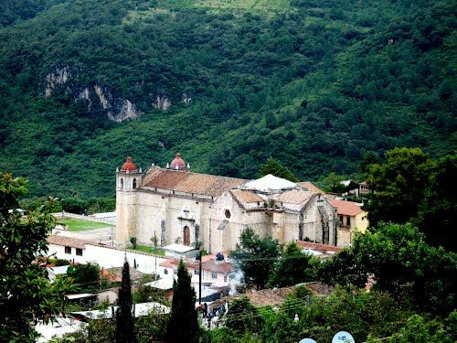
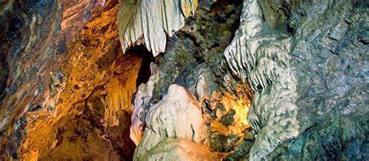
04 days/ 03 nights

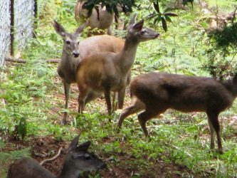
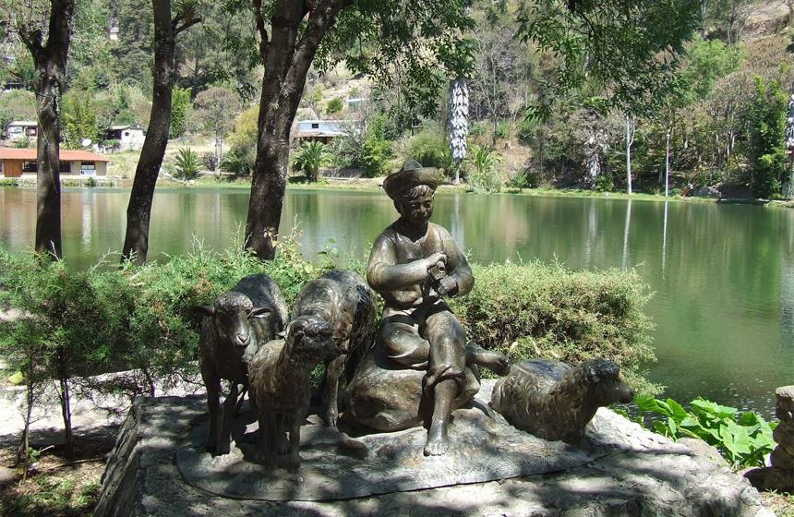

Guelatao, Calpulálpam, Sierra Juárez

Minimum 2 people.
Daily Departures

ITINERARY

DAY 01 – IN / OAXACA
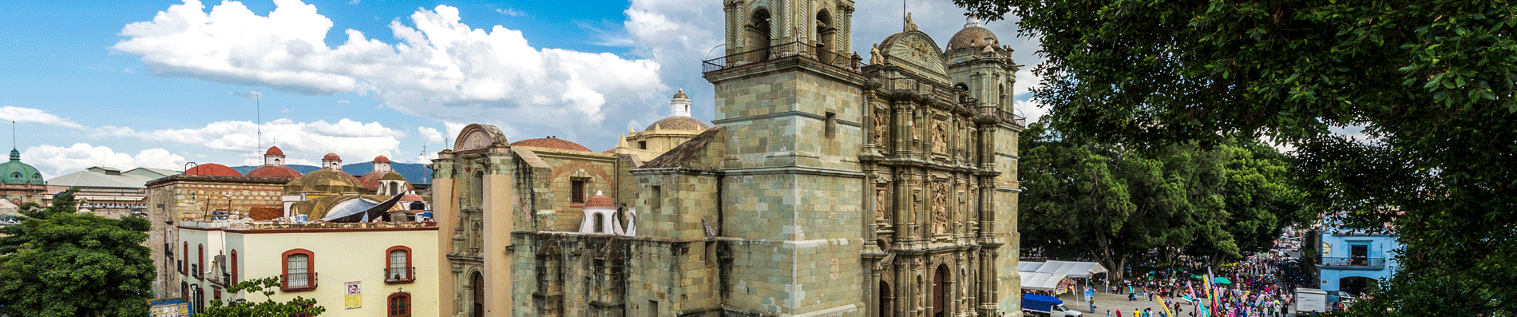
Arrival at Oaxaca's international airport. Reception and transfer to hotel.

Check in at hotel. Rest of the day at leisure.

Lunch and dinner at leisure.
Lodging

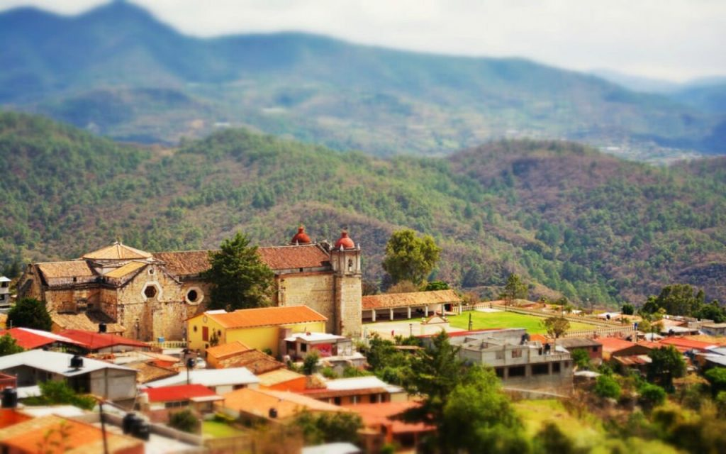
DAY 02 – OAXACA – Guelatao - Calpulálpam
Breakfast at the hotel.

We will start visiting a glass viewpoint in San Pablo de Guelatao, which is located on the top of a hill from where you can see part of the Sierra Juarez and the valleys of Oaxaca; upon arriving at the town of Guelatao we will visit the museum of the place, a replica model house of where Benito Juarez lived, in addition to the lagoon of Guelatao where it is said that he went to graze his sheep when he was a child. Then we will go to the temple of Ixtlán de Juárez where the "Benemérito de las Américas" was baptized. We will also visit the magical town of Calpulálpam de Méndez, there we will have time to eat in the community market, everything is delicious and organic, but a good recommendation is to taste the chichilo, characteristic dish of the region, also considered one of the seven moles of the state of Oaxaca; then we will take a walk in a cultural tour accompanied by a guide of the community, we can appreciate the main attractions of the town as: their houses, the market, their colorful embroidery, its temple, etc.. Then we will take a break in picturesque cabins where we will have a load of firewood to enjoy the warmth of the fire in the fireplace, sheltered from the cold.
Lunch and dinner at leisure.
Lodging

DAY 03 – OAXACA – Cueva del arroyo

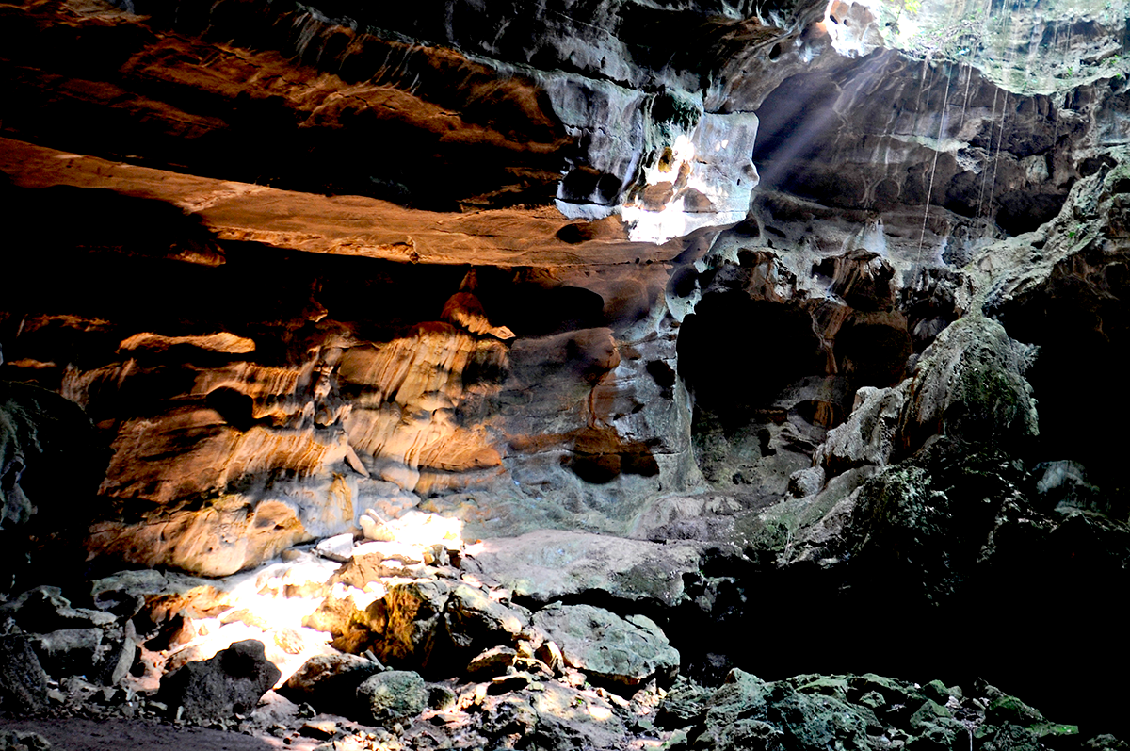

Breakfast at the hotel.

We will leave very early to visit a UMA (Environmental Management Unit) specialized in the conservation of white-tailed deer, we will have the pleasure to live with them, feeding them, observe them in their habitat and take a nice picture, then we will have time for lunch at the town market. We continue our tour walking to the caves "Cueva del Arroyo" where we will appreciate the three levels of the caves in complete darkness, the suggestion is to walk them with bare feet, this gives us a sense of connection with the earth since we sharpen our senses in the unknown; We return to the center of town to recharge our batteries with food and be ready to visit a beautiful Center of Traditional Indigenous Medicine, a place where natural medicine is made with plants of the region, there is also the opportunity to relax with a massage or take a bath in temazcal, this is our last activity of the excursion before leaving to Oaxaca City.

Lunch and dinner at leisure.
Lodging

DAY 04 – OAXACA/ OUT

Breakfast at the hotel.

At a convenient time transfer from your hotel to the airport to take your flight to your destination.

END OF SERVICES

NOTE: The day of operation of the tours may vary.

**VALIDATE RATES WITH YOUR TRAVEL AGENT
CITY | NIGHTS | HOTELS 4* | HOTELS 4*
Oaxaca | 02 | Casa Conzatti | Oaxaca Real
Sierra Juárez | 01 | Cabaña | Cabaña

INCLUDED:
- TRANSPORTATION: Air-conditioned touristic unit
- ACCOMMODATION: Hotels according to your choice
- MEALS: 03 Daily breakfasts
- VISITS: Those mentioned in the program.
- ESCORT GUIDE: Bilingual, certified by the Ministry of Tourism
NOT INCLUDED:

- Air tickets
- Food or services not mentioned
- Taxes at the airport
- Tips to guides or drivers.

IMPORTANT OBSERVATIONS:
- Due to the multiple changes that occur daily in tourism, these prices must be confirmed at the time of requesting the reservation.
- Rates subject to availability and changes without prior notice.
- Credit card payments are subject to a % commission.
- Please contemplate the schedule of Check in 15:00 hrs and Check Out 12:00 hrs.
- TRIPLE rooms only have 2 double beds.
- Transfers airport-hotel-airport are quoted in shared service, please consider flights arriving and departing between 06:00 and 22:00 hrs, otherwise it must be provided in private service and it will be necessary to re-quote.
- The waiting time for arrival transfers is 2 hours and 15 minutes. Once this time has elapsed, the passenger must transfer at his/her own expense.
- The tolerance time for departure transfer is 10 minutes, after this time the unit is withdrawn and you must transfer on your own to the apartment. * Under no circumstances will we be responsible for any extra expenses arising from this situation.
- Tours may change order according to the operations of the correspondent.

