PROGRAM

NATURALEZA TRADICION Y MODERNIDAD
06 days/05 nights

Cuatro Ciénegas, Parras, Saltillo y Monterrey

Minimum 2 persons
DAILY DEPARTURES

ITINERARY

DAY 01 – IN / MONTERREY – CUATRO CIÉNEGAS

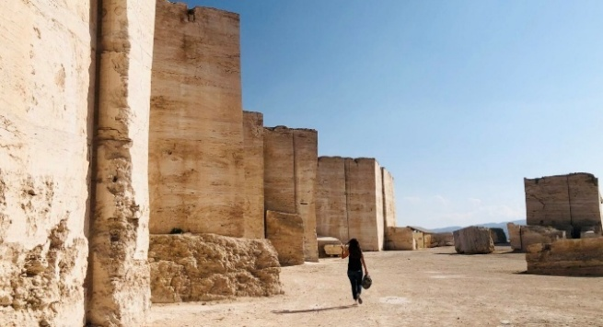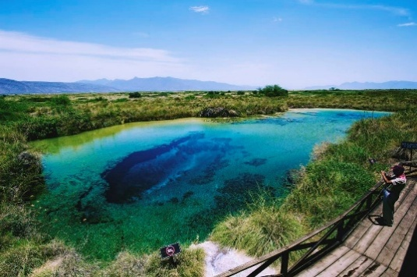Arrival at the airport. Reception and direct transfer to Cuatro Ciénegas, a beautiful Magical Town located in the heart of the Coahuila desert. The journey of approximately 4 hours will allow you to enjoy spectacular landscapes that lead to this natural paradise. Exploring the wonders of Cuatro Ciénegas: starting with a visit to the old Marble Mine, followed by the gypsum dunes, the emblematic Poza Azul, the San Marcos River, and ending with a walk through the historic center of Cuatro Ciénegas.
Check in at hotel.
Lunch and dinner at leisure.
Lodging

DAY 02 – CUATRO CIÉNEGAS – PARRAS DE LA FUENTE – SALTILLO

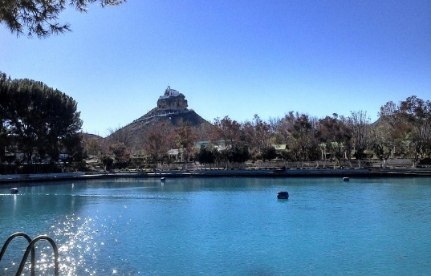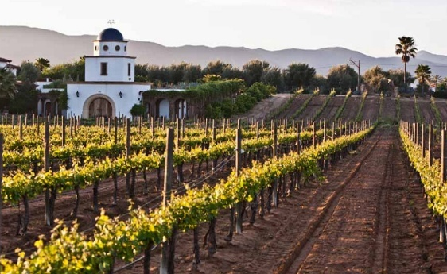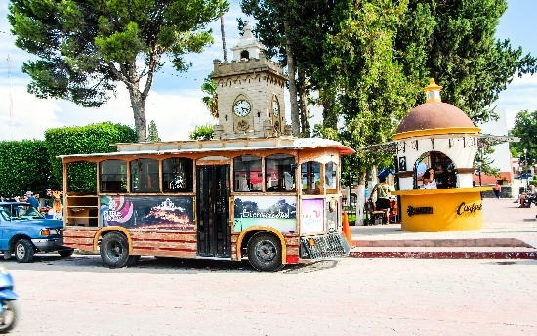Breakfast at the hotel
We will start the journey to our next destination: Parras de la Fuente, Coahuila. It is a destination full of charm, known for its centuries-old vineyards and rich winemaking tradition. This charming village offers cobblestone streets, majestic landscapes and the opportunity to disconnect while enjoying a good wine in a quiet atmosphere. From the Plaza del Reloj, we will board the tram that will take us to the most emblematic points of Parras; followed by a visit to Casa Madero and a tour of the historic center that offers a wide variety of attractions.
At the end of the activities in Parras, we will transfer to Saltillo
Lunch and dinner at leisure.
Lodging

DAY 03 – SALTILLO

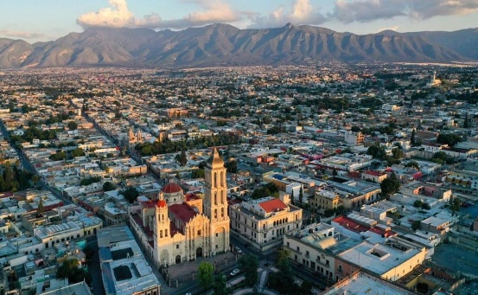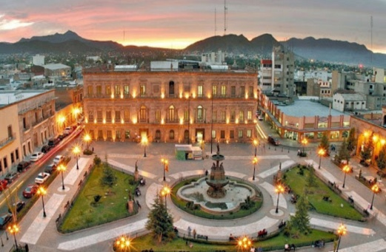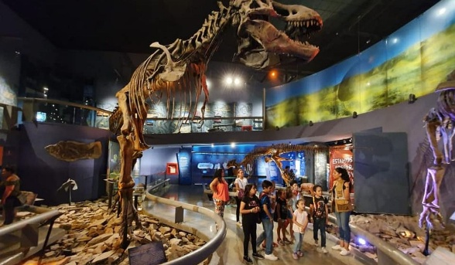
Breakfast at the hotel
We will begin our visit with a spectacular experience at the Museum of the Desert. After the museum, we will take a City Tour of Saltillo, exploring emblematic places such as the Plaza de Armas and the majestic Cathedral of Santiago.
In the afternoon, we will return to the hotel, where you can relax and enjoy some free time.
Lunch and dinner at leisure.
Lodging

DAY 04 – SALTILLO – MONTERREY

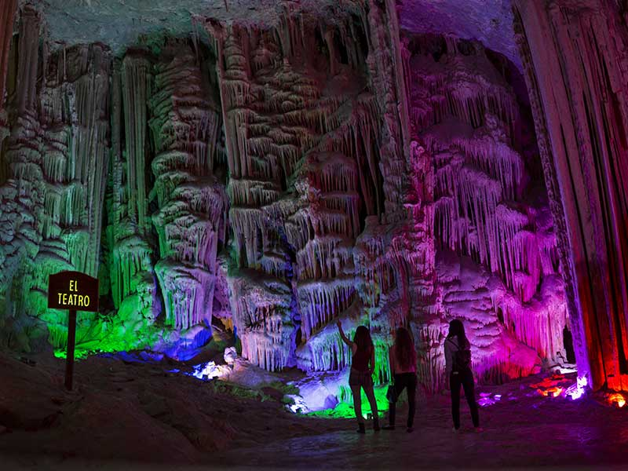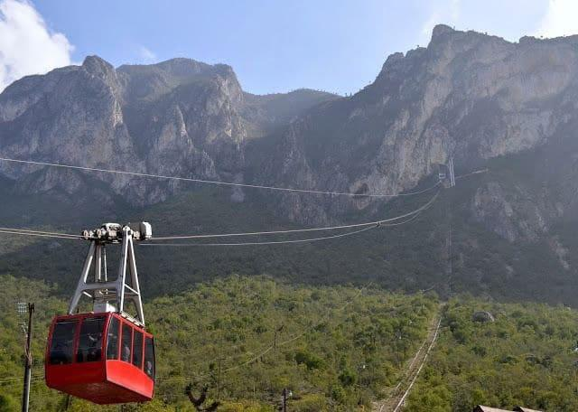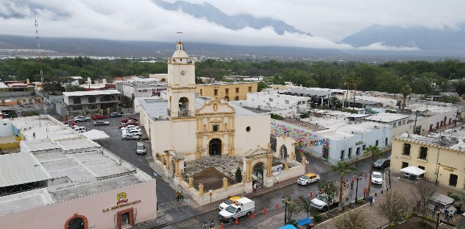
Breakfast at the hotel
We will depart from Saltillo to the municipality of García, Nuevo León, to visit one of the most impressive tourist attractions in the region: the Garcia Caves. You will have the opportunity to admire the impressive formations of stalactites and stalagmites. In addition, you can go up to more than 200 meters high in the cable car, from where you will enjoy panoramic views. At the end of the tour of the caves, we will move to the historic center of García, where you can enjoy the northeastern architecture that characterizes this municipality.
After the visit, we will transfer to the hotel located in Monterrey, where you will have the freedom to rest or explore the city on your own.
Dinner at leisure.
Lodging

DAY 05 – MONTERREY
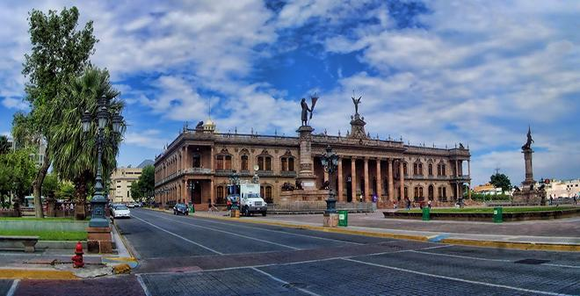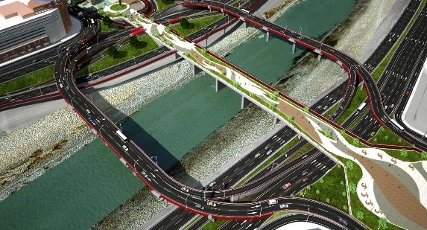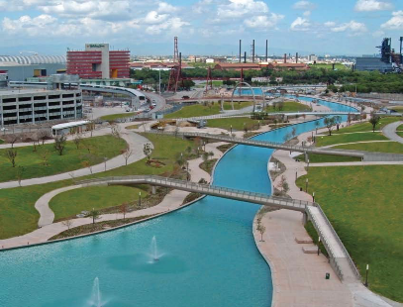
Breakfast at the hotel
City Tour of Monterrey: We will start by visiting the Cathedral of Monterrey and the Palace of the Municipal Government. Along the way, we will arrive at the Zaragoza Multimodal Bridge, from where you will have a privileged view of the majestic Santa Catarina River, the emblematic Cerro de la Silla and the imposing Cerro de las Mitras. Our next stop will be Plaza Hidalgo and the Nuevo Leon Artisans Market.
Next, we will visit the Santa Lucia Springs, where the city was founded; Here we will board a boat that will take us to Fundidora Park. The tour will conclude at Fundidora Park, after which we will return to the hotel.
Dinner at leisure.
Lodging

DAY 06 – MONTERREY – AEROPUERTO
Breakfast at the hotel
On the last day of our getaway, we will be transferred to the Monterrey International Airport at the scheduled time. We will make sure that your departure is comfortable and smooth.

END OF SERVICES

** VALIDATE RATES WITH YOUR TRAVEL AGENT

CITY | NIGHTS | HOTELS 3* | HOTELS 4*
Cuatro Ciénegas | 1 | Serena By Hacienda 1800 | Hacienda 1800 Hotel Cuatro Cienegas
Saltillo | 2 | One Saltillo | Fiesta Inn Saltillo
Monterrey | 2 | Comfort Valle | Courtyard Marriott

INCLUDED:
- TRANSPORTATION: Tourist with air conditioning
- ACCOMMODATION: Hotels according to your choice
- MEALS: 05 Breakfast
- VISITS: Those mentioned in the program
- ACCOMPANYING GUIDE: Bilingual, certified by the Ministry of Tourism
NOT INCLUDED:

- Air tickets
- Food or services not mentioned in the program
- Airport taxes
- Tips for guide and driver

IMPORTANT OBSERVATIONS:
1. Due to the multiple changes that occur daily in tourism, these prices must be confirmed at the time of requesting the reservation.
2. Rates subject to availability and changes without prior notice.
3. Credit card payments are subject to a % commission.
4. Please contemplate the schedule of Check in 15:00 hrs and Check Out 12:00 hrs.
5. TRIPLE rooms only have 2 double beds.
6. Transfers airport-hotel-airport are quoted in shared service, please consider flights arriving and departing between 06:00 and 22:00 hrs, otherwise it must be provided in private service and it will be necessary to re-quote.
7. The waiting time for arrival transfers is 2 hours and 15 minutes. Once this time has elapsed, the passenger must transfer at his/her own expense.
8. The tolerance time for departure transfer is 10 minutes, after this time the unit is withdrawn and you must transfer on your own to the apartment. * Under no circumstances will we be responsible for any extra expenses arising from this situation.
9. Tours may change order according to the operations of the correspondent.

