PROGRAM
MÉXICO, PLATA Y PLAYA
08 days/07 nights

(Ciudad México, Museo de Antropología, Teotihuacan, Basílica, Taxco, Acapulco)

Minimum 2 persons.
Daily departures

ITINERARY

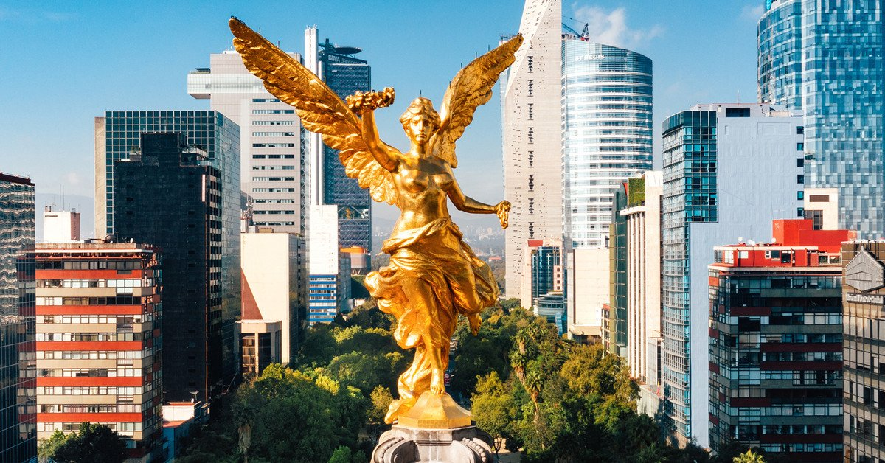
DAY 01 – IN / MEXICO CITY
Arrival at Mexico City International Airport. Reception and transfer to your hotel.
Check in at the hotel. Rest of the day at leisure.
Lunch and dinner on your own. Lodging.

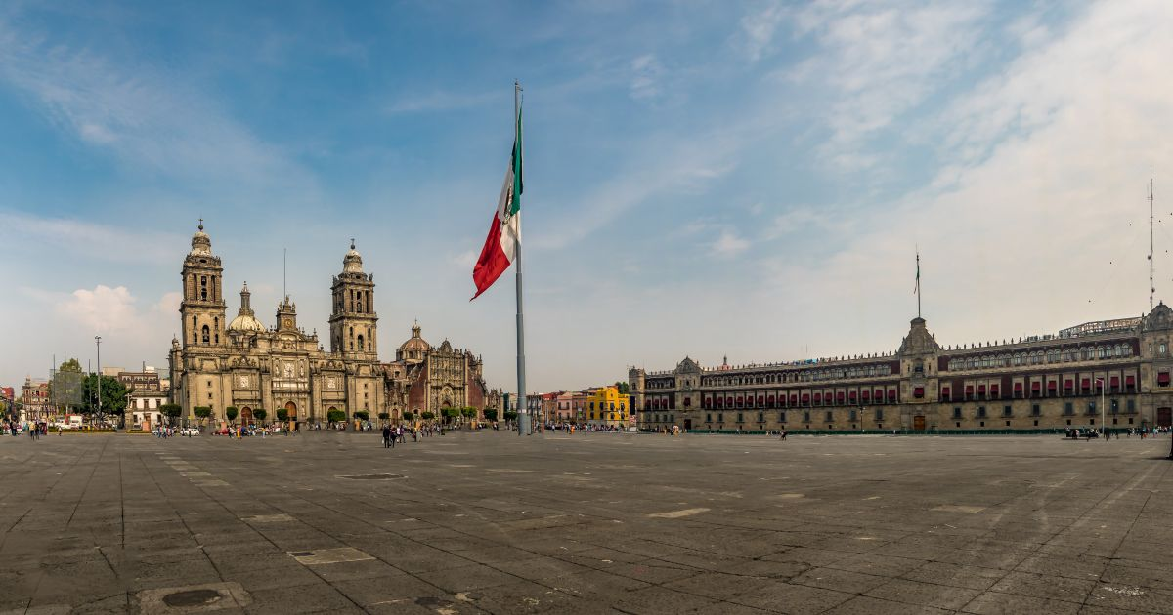
DAY 02 – CIUDAD DE MÉXICO – City Tour - Museum of Anthropology
Breakfast at the hotel.
We will visit the Zocalo, the National Palace (outside view). We will see the ruins of what was the Templo Mayor of the Aztecs and the Metropolitan Cathedral. We will take you to the historic Chapultepec forest surrounded by residential areas such as Las Lomas, where you will see the residences of famous artists. Visit the National Museum of Anthropology, where you will appreciate a mosaic of the most important cultures of the country. You can stay at the museum to visit it completely or be transferred to your hotel.

Lunch and dinner at leisure. Lodging

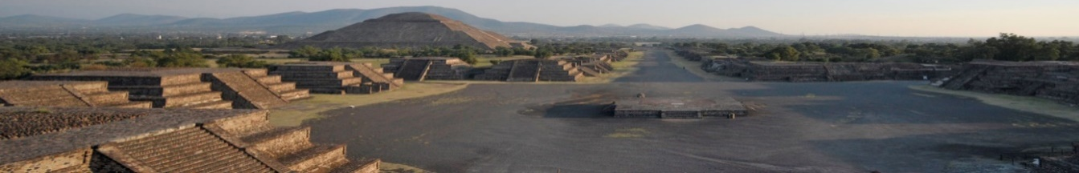
DAY 03 – MEXICO CITY – Basílica + Pyramids
Breakfast at the hotel.
Panoramic visit to the Plaza de las Tres Culturas; historical site where the last fight between Aztecs and Spaniards was fought and which symbolizes the fusion of 3 cultural eras represented by the Aztec ruins; the church of Tlatelolco and the building of the Ministry of Foreign Affairs. After a short stop, we will continue to the Basilica of Guadalupe, where we will see the original image of the Virgin of Guadalupe. You will learn the story of how it was captured on the mantle of the indigenous Juan Diego and see the ancient basilica at the foot of the Tepeyac hill. By a modern highway we will go directly to the archaeological zone of Teotihuacan; the city of the gods; 50 km away where we will be able to admire the impressive pyramids of the sun and the moon; walk along the avenue of the dead; we will visit an obsidian workshop for the demonstration of this and the maguey. Lunch

Dinner at leisure. Lodging

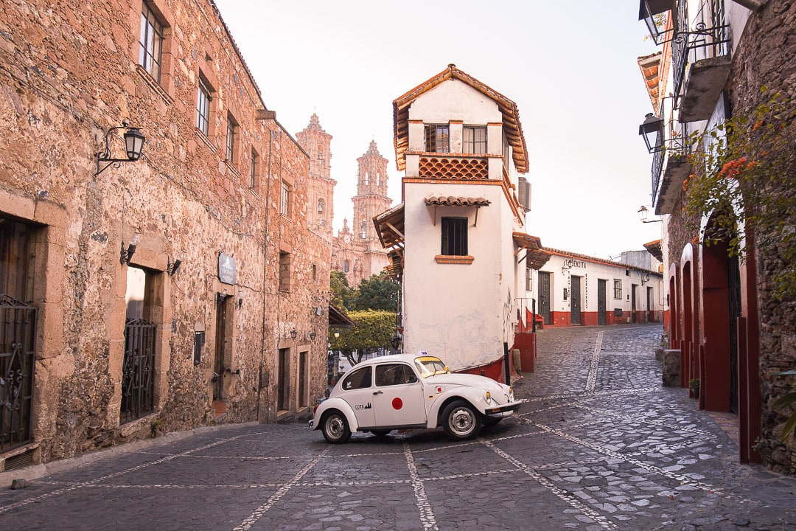
DAY 04 – CIUDAD DE MÉXICO – Cuernavaca + Taxco
Breakfast at the hotel.

Departure in the morning to Cuernavaca from the south of the city and continue along the modern highway that in approximately 1 hour will take us to the city of the bougainvilleas or the eternal spring; for its warm climate. We will visit the cathedral that was built as a mission in 1552 and in 1891 was elevated to a cathedral (representative of the viceroyalty era). We will continue our journey through winding roads through the mountain range of the Sierra Madre Occidental; flanked by valleys and pine forests and we will enter the mountains of the state of Guerrero until we reach the picturesque colonial mining town of Taxco; known as the city of silver. We will visit the famous church of Santa Prisca. It is said that it was built with silver from Taxco. Time to visit its silver shops walking through its squares and cobblestone streets framed by rustic and picturesque houses with red tile roofs that have been the inspiration of countless artists. Return to the hotel at approximately 8:00 pm.

Lunch and dinner at leisure. Lodging

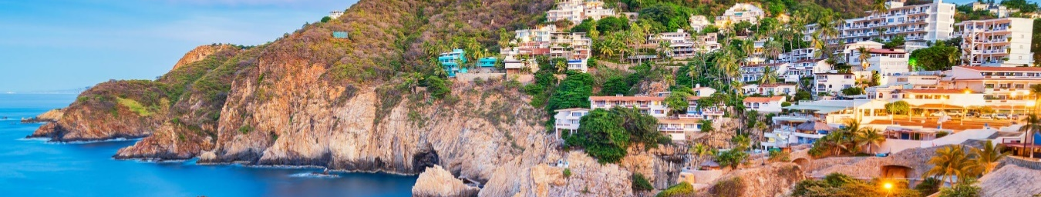
DAY 05 – Taxco - ACAPULCO
Breakfast at the hotel.

Transfer to Taxco bus station. Bus ticket Taxco-Acapulco. Departure to the paradisiacal port of Acapulco.

Accommodation in All Inclusive Plan.

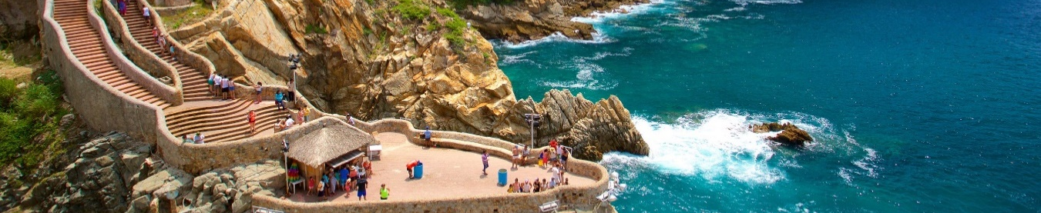
DAY 06 and 07 – ACAPULCO
All Inclusive Plan.

Free time to visit the beaches. It is recommended to go to the spectacle of the Quebrada where the divers are or take a yacht ride on the bay.

Lodging.

DAY 08 – ACAPULCO / OUT

Breakfast at the hotel.

At a convenient time, transfer from your hotel to Mexico's international airport or bus station.

END of SERVICES

CITY | NIGTHS | HOTELS 3** | HOTELS 4* & 3** | HOTELS 4**
Ciudad de México | 03 | Regente | Royal Reforma | Laila
Taxco | 01 | Agua Escondida | Agua Escondida | Monte Taxco
Acapulco | 03 | Ritz Acapulco | Ritz Acapulco | HS Hotsson Smart

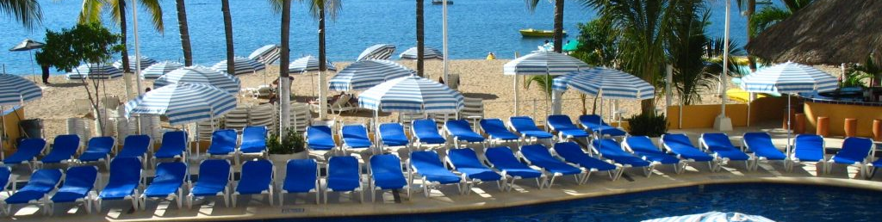
RITZ ACAPULCO – ALL INCLUSIVE PLAN

• Breakfast, Lunch and Dinner Buffet, Snack Bar from 1:00 p.m. to 6:00 p.m., Domestic Open Bar from 10:00 a.m. to 12:00 p.m., Full Beach and Pool Activities Program, Evening Entertainment Water Sports (Non-motorized) Children's Program with Taxes

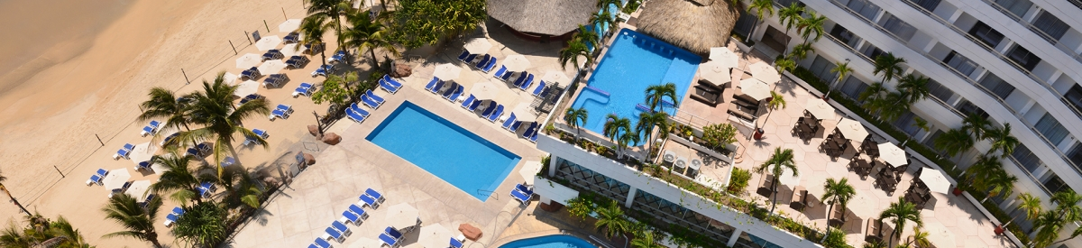
HOTSSON SMART – ALL INCLUSIVE PLAN

• Breakfast, lunch and dinner buffet style, at designated restaurant. Dinner a la carte, based on a three-course menu, at "Il Pagliacci" Italian Restaurant, upon reservation and subject to availability. Surcharge applies for fine cuts, lobster and additional dish (if required). National Drinks from 11:00 am to 11:00 pm (limited brands) Social Activities Program Snacks in the pool area, from 13:00 pm to 17:00 pm. Taxes and Gratuities

PRICES PER PERSON IN USD
 | 3** |  |  |  | 3** |  |  |  | 4**
HOTEL | REGENTE - AGUA ESCONDIDA - RITZ |  |  |  | ROYAL REFORMA - AGUA ESCONDIDA - RITZ |  |  |  | LAILA - MONTETAXCO - HOTSSON
VALIDITY | DBL | TPL | SGL | CHD | DBL | TPL | SGL | CHD | DBL | TPL | SGL | CHD
JAN 01 - MAR 27 & APR 12 - DEC 23, 2026 | 919 | 867 | 1,275 | 407
MAR 28 – APR 11, 2026 | 1,165 | 1,113 | 1,554 | 458
JAN 01 - APR 11 & APR 27 - DEC 23, 2025 |  |  |  |  | 962 | 922 | 1,378 | 462
MAR 28 – APR 11, 2026 |  |  |  |  | 1,208 | 1,168 | 1,657 | 513
JAN 05 – DEC 27, 2026 |  |  |  |  |  |  |  |  | 1,053 | 969 | 1,525 | 383
NOT APPLICABLE on Formula 1, Day of the Dead holidays or World Cup.

For Montetaxco hotel request a quote in case you wish to stay in the following dates:

Jan 01 – Jan 03, 2026
Ene 30 - Feb 01, 2026
Mar 28 - 31,2026
Apr 01 - 04, 2026
May 01 - 02, 2026
Sep 12 - 15, 2026
Oct 31 - Nov 02, 2026
Nov 13 - 15, 2026

INCLUDES:
- TRANSPORTATION: Air-conditioned tourist transportation..
- ACCOMMODATION: Hotels according to your choice.
- MEALS: 04 Breakfast at hotel, 01 Lunch and All Inclusive Plan in Acapulco.
- VISITS: As mentioned in the program.
- ACCOMPANYING GUIDE: Bilingual, certified by the Ministry of Tourism.

NOT INCLUDED:

- Air tickets
- Food or services not mentioned
- Taxes at the airport
- Tips to guides or drivers.

IMPORTANT REMARKS:

1. Please note that prices for children are as long as they are under 10 or 11 years old (please consult) and share room with 2 adults, otherwise, they will have to enter in 1 TRIPLE room paying as an adult.
2. TRIPLE rooms have only 2 double beds.
3. Please contemplate the schedule of Check in 15:00 hrs and Check Out 12:00 hrs.
4. Transfers airport-hotel-airport in Mexico City are quoted in shared service, please consider flights arriving and departing between 06:00 and 22:00 hrs, otherwise it must be provided in private service and it will be necessary to re-quote.
5. If flights arrive or depart from and to the new Felipe Angeles airport, they would have to be re-quoted as a supplement is generated.

General:
- Due to the multiple changes that occur daily in tourism, these prices must be confirmed at the time of requesting the reservation.

