PROGRAM
MÉXICO CULTURAL
04 days/03 nights

(Ciudad, Museo de Antropología, Plaza de las 3 Culturas, Basílica de Guadalupe, Pirámides de Teotihuacán)

Minimum 2 persons.
Daily departures

ITINERARY

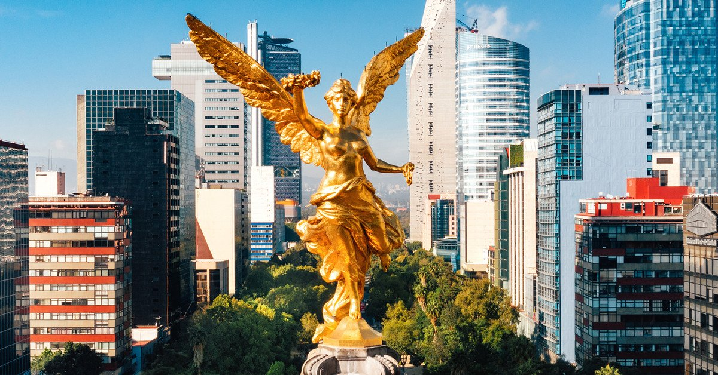
DAY 01 – IN / MEXICO CITY
Arrival at Mexico City International Airport. Reception and transfer to your hotel.
Check in at the hotel. Rest of the day at leisure.
Lunch and dinner on your own. Lodging.

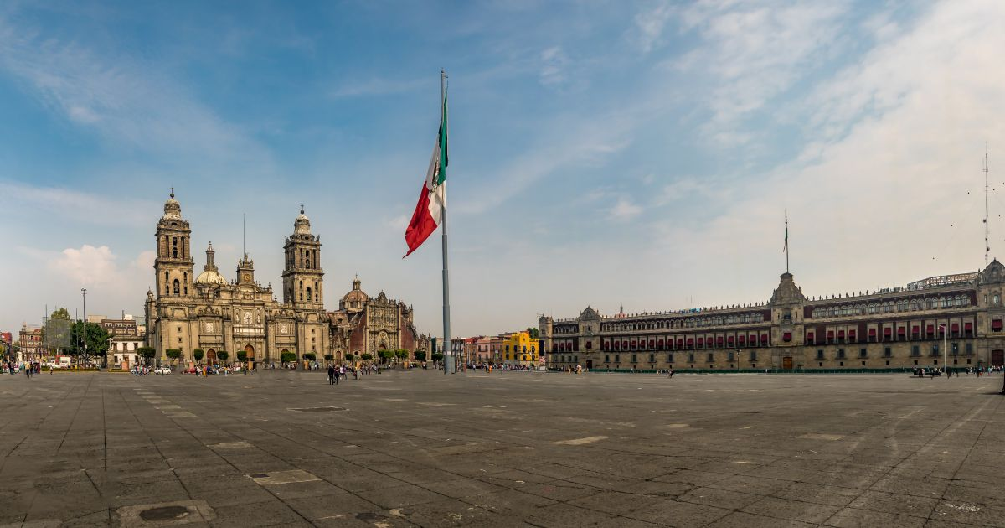
DAY 02 – CIUDAD DE MÉXICO – City Tour - Museum of Anthropology
Breakfast at the hotel.
We will visit the Zocalo, the National Palace (outside view). We will see the ruins of what was the Templo Mayor of the Aztecs and the Metropolitan Cathedral. We will take you to the historic Chapultepec Forest surrounded by residential areas such as Las Lomas, where you will see the residences of famous artists. Visit the National Museum of Anthropology, where you will appreciate a mosaic of the most important cultures of the country. You can stay at the museum to visit it completely or be transferred to your hotel.

Lunch and dinner at leisure. Lodging

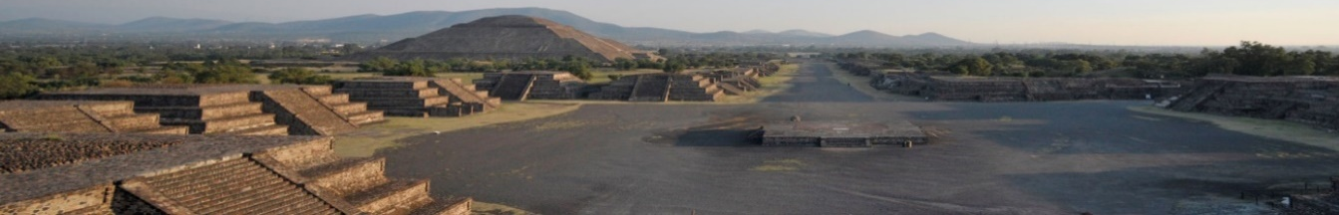
DAY 03 – MEXICO CITY – Basílica + Pyramids
Breakfast at the hotel.
Panoramic visit to the Plaza de las Tres Culturas; historical site where the last fight between Aztecs and Spaniards was fought and which symbolizes the fusion of 3 cultural eras represented by the Aztec ruins; the church of Tlatelolco and the building of the Ministry of Foreign Affairs. After a short stop, we will continue to the Basilica of Guadalupe, where we will see the original image of the Virgin of Guadalupe. You will learn the story of how it was captured on the mantle of the indigenous Juan Diego and see the ancient basilica at the foot of the Tepeyac hill. By a modern highway we will go directly to the archaeological zone of Teotihuacan; the city of the gods; 50 km away where we will be able to admire the impressive pyramids of the sun and the moon; walk along the avenue of the dead; we will visit an obsidian workshop for the demonstration of this and the maguey. Lunch

Dinner at leisure. Lodging

DAY 04 – CIUDAD DE MÉXICO / OUT

Breakfast at the hotel.

At a convenient time transfer from your hotel to Mexico's international airport or bus station.

END of SERVICES

CITY | NIGTHS | HOTELS 3** | HOTELS 4*
Ciudad de México | 03 | Premier/Regente | Royal Reforma / Casablanca / PF / Novotel

PRICES PER PERSON IN USD

HOTEL | PLAN ALIMENTOS |  |  |  | CAT. HABITACIÓN | SGL | DBL | TPL | CHD
PREMIER | AMERICAN BREAKFAST
 | 01/01/2026 |  | 31/12/2026 |  | Standard | 408.00 | 297.00 | 275.00 | 116.00
REGENTE CITY | BUFFET BREAKFAST
 | 01/01/2026 |  | 31/12/2026 |  | Standard | 435.00 | 308.00 | 279.00 | 117.00
ROYAL REFORMA | BUFFET BREAKFAST
 | 01/01/2026 |  | 31/12/2026 |  | Standard | 532.00 | 348.00 | 328.00 | 169.00
CASA BLANCA | BUFFET BREAKFAST
 | 01/01/2026 |  | 31/12/2026 |  | Deluxe | 513.00 | 349.00 | 342.00 | 117.00
PF HOTEL | BUFFET BREAKFAST
 | 01/01/2026 |  | 31/12/2026 |  | Standard | 473.00 | 324.00 | 303.00 | 153.00
NOVOTEL MEXICO CITY CENTRO HISTORICO | BUFFET BREAKFAST
 | 01/01/2026 |  | 31/12/2026 |  | Standard | 486.00 | 342.00 | 312.00 | 88.00

Rates do not apply to FIFA World Cup (June 08 – July 12), Formula 1 dates or Day of the Dead celebrations (October 26 – 05 November).

INCLUDES:
- TRANSPORTATION: Air-conditioned tourist transportation.
- ACCOMMODATION: Hotels according to your choice.
- MEALS: 03 Breakfast at hotel, 01 Lunch.
- VISITS: As mentioned in the program.
- ACCOMPANYING GUIDE: Bilingual, certified by the Ministry of Tourism.

NOT INCLUDED:

- Air tickets
- Food or services not mentioned
- Taxes at the airport
- Tips to guides or drivers.

IMPORTANT REMARKS:

1. Please note that prices for children are as long as they are under 10 or 11 years old (please consult) and share room with 2 adults, otherwise, they will have to enter in 1 TRIPLE room paying as an adult.
2. TRIPLE rooms have only 2 double beds.
3. Rates subject to availability and subject to change without notice.
4. Credit card payments are subject to a % commission.
5. If flights arrive or depart from and to the new Felipe Angeles airport, a supplement will be charged.
6. Please consider the check in time 15:00 hrs and check out time 12:00 hrs.
7. The waiting time for arrival transfers is 2 hours and 15 minutes. Once this time has elapsed, the passenger will have to transfer at his/her own expense.
8. The tolerance time for departure transfer is 10 minutes, after this time the unit is withdrawn and you will have to transfer to the apartment on your own. * Under no circumstances will we be responsible for any extra expenses that may arise from this situation.
9. We will NOT be able to provide services if a previous reservation is not made 7 days before the tour starts.
10. Tours may change order depending on the operations of the correspondent.

General:
- Due to the multiple changes that occur daily in tourism, these prices must be confirmed at the time of requesting the reservation.

