PROGRAM

MÉXICO / MÉRIDA /PLAYA DEL CARMEN
08 days/07 nights

(México Visita de ciudad, Basílica de Guadalupe, Pirámides de Teotihuacán, Mérida visita de ciudad, Uxmal, Chichen-Itzá, Playa del Carmen)

Minimum 2 persons.
Arrivals Sundays and Tuesdays

ITINERARY

DAY 01 – IN / CIUDAD DE MÉXICO

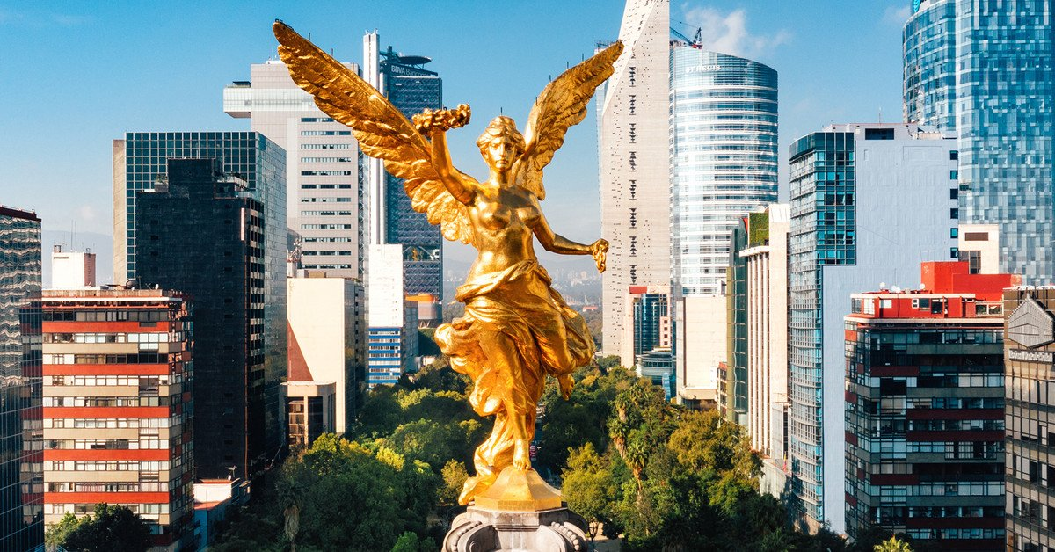
Arrival at the international airport in Mexico City. Reception and transfer to your hotel.
Check in at hotel. Rest of the day at leisure.
Lunch and dinner at leisure. Lodging

DAY 02 – CIUDAD DE MÉXICO – Basílica of Guadalupe and Pyramids of Teotihuacan

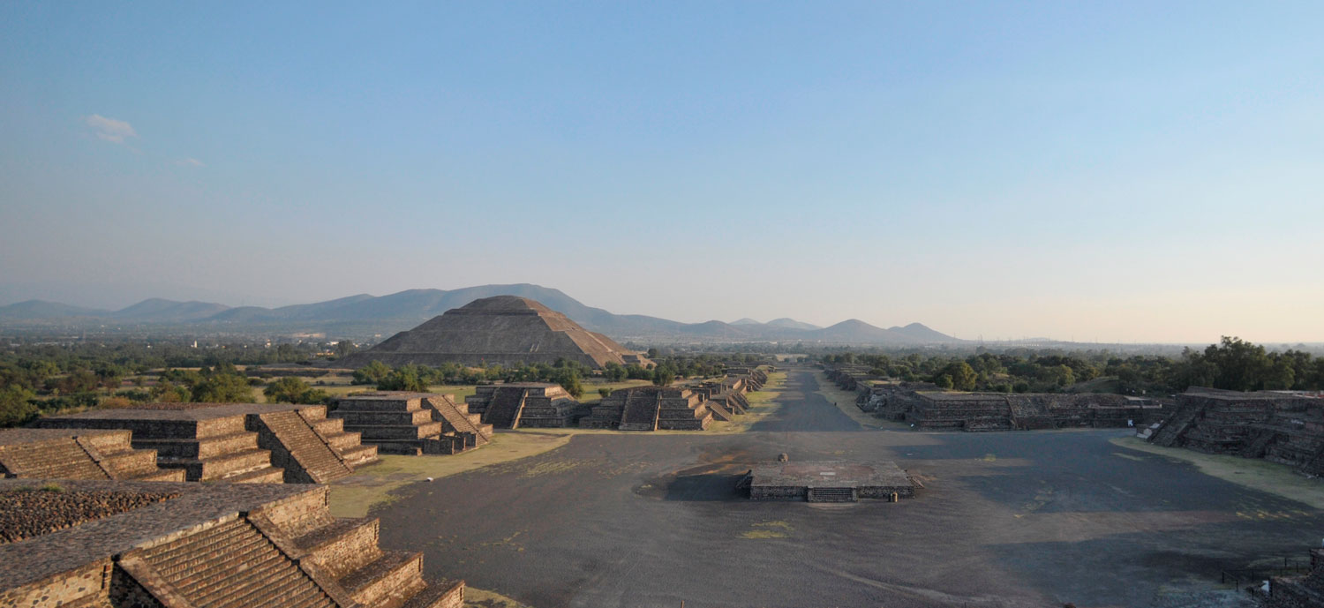

Breakfast at the hotel.

Panoramic tour of the Plaza de las Tres Culturas (Plaza of the Three Cultures), a historic site where the last battle between the Aztecs and the Spanish took place. This plaza symbolizes the fusion of three cultural eras, represented by the Aztec ruins, the Church of Tlatelolco, and the building of the Ministry of Foreign Affairs. We will continue to the Basilica of Guadalupe, where we will see the original image of the Virgin of Guadalupe. You will learn the story of how it appeared on the cloak of the indigenous man Juan Diego and see the old basilica at the foot of Tepeyac Hill. We will then travel via a modern highway directly to the archaeological site of Teotihuacan, the City of the Gods, 50 km away. There, we will admire the impressive Pyramids of the Sun and Moon, walk along the Avenue of the Dead, and visit an obsidian workshop for a demonstration of obsidian and maguey wood carving. Lunch (drinks not included).

Dinner on your own. Overnight stay.

DAY 03 – CIUDAD DE MÉXICO / MÉRIDA

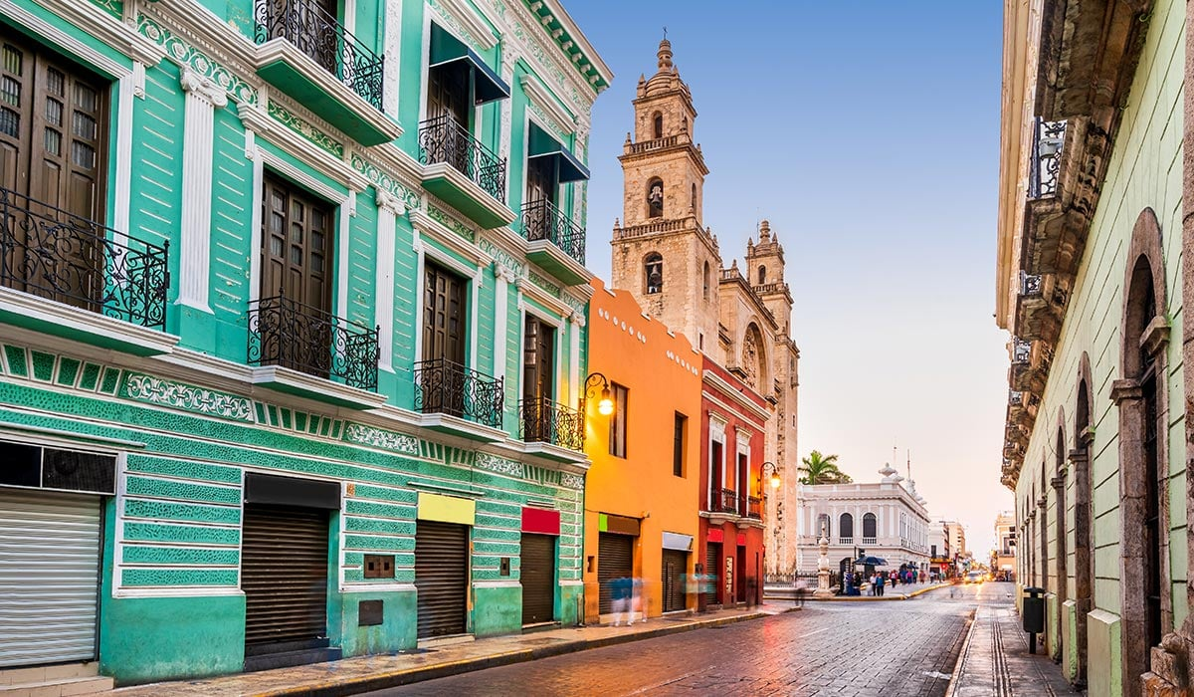

Breakfast at the hotel.

At a convenient time, transfer from your hotel to the Mexico City airport for your flight to Merida (flight not included). Upon arrival, assistance and transfer to your hotel.

Check in at the hotel.
Lunch and dinner at leisure. Lodging

DAY 04 – MÉRIDA – Las Joyas del Esplendor + Cenote
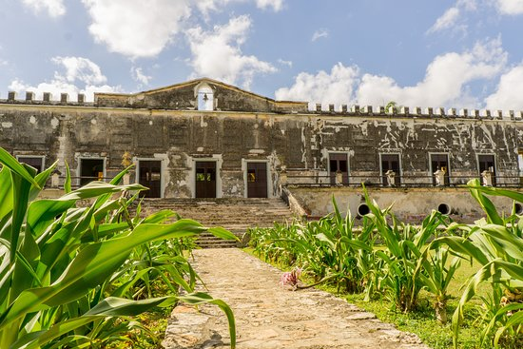
Breakfast at the hotel.

We will depart from the city of Mérida towards the Yaxcopoil Hacienda, where we will visit the interior. These haciendas originated from the encomienda system established by the Spanish upon their arrival. They typically included residences of significant architectural value and other smaller buildings focused on agricultural work, constructed during the heyday of cocaine production. We continue to Uxmal, a city rebuilt three times, located in the Puuc hills. It is the most important city in the region, a true gem with its distinctive style of plain friezes and decorated roofs. Highlights include the Pyramid of the Magician, the Nunnery Quadrangle, and the Governor's Palace. We will then visit a cenote, a type of underground water reservoir, where you can enjoy its crystal-clear waters, perfect for cooling off. Return to Mérida.
Lunch at leisure. Lodging

DAY 05 – MÉRIDA – Chichen Itza – PLAYA DEL CARMEN

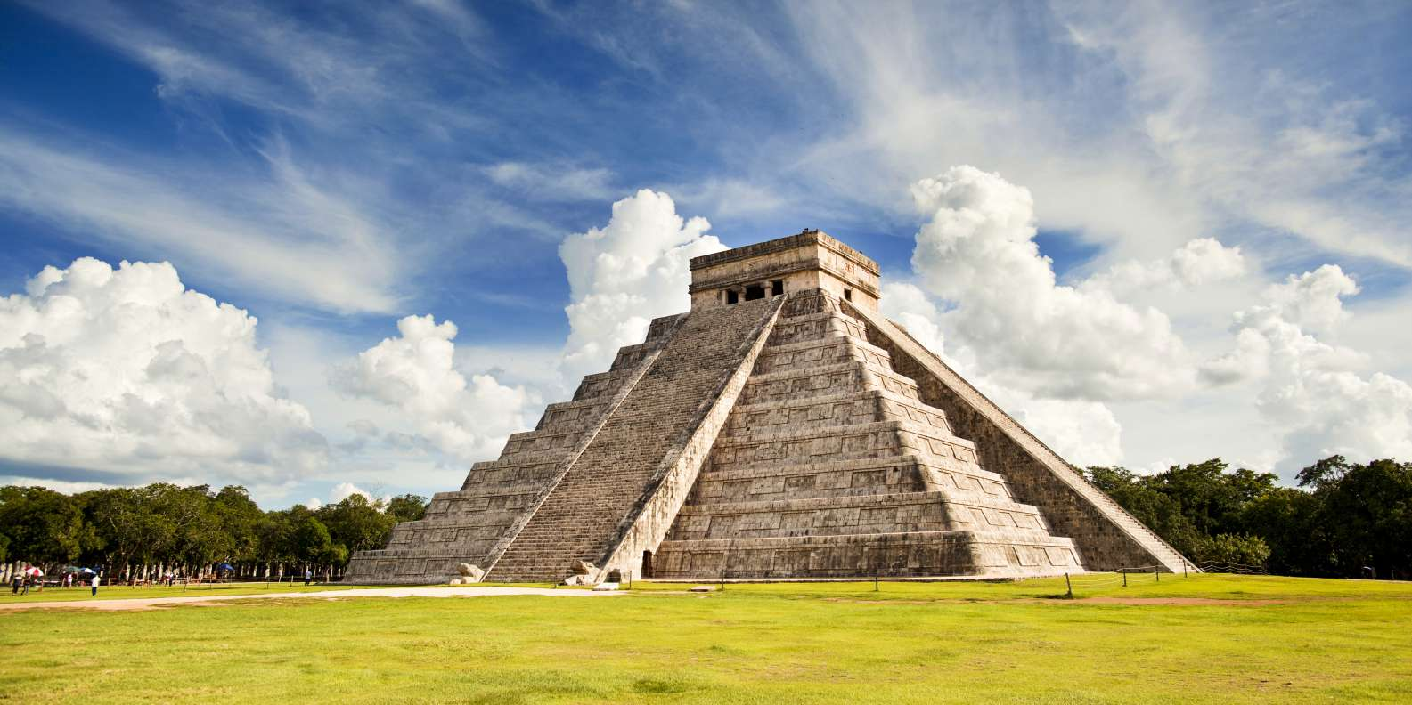

Breakfast at the hotel.

Leaving Merida we will go to one of the 7 new wonders, Chichen Itza (mouth of the well of the water sorcerers) was the most important city between the years 900 and 1300 of our era, highlighting the temple of Kukulkan or "the castle" that together with the temple of the warriors, the ball game, the astronomical observatory and the complex of the nuns show the great ceremonial character in which the city was managed. We will transfer to the restaurant where we will have our lunch, as well as time to relax, after which we will continue to Riviera Maya and/or Playa del Carmen with previously organized hotel logistics.

Check in at the hotel.

All Inclusive Plan. Lodging

DAY 06 & 07 – PLAYA DEL CARMEN

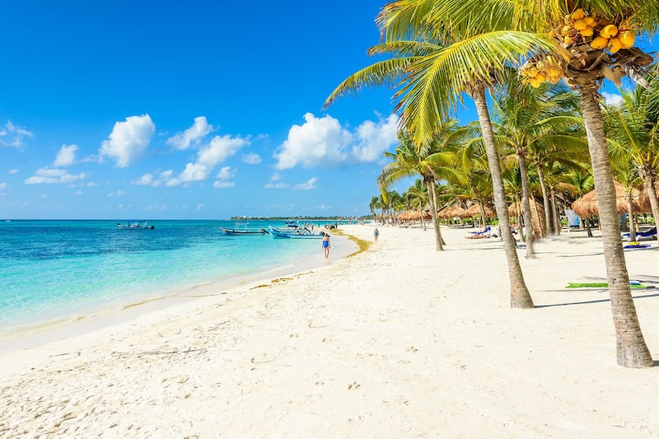

Breakfast at the hotel.

Free days for personal activities and enjoy the beautiful beaches of the Mexican Caribbean.

All Inclusive Plan. Lodging

DAY 08 – PLAYA DEL CARMEN - CANCÚN / OUT

Breakfast at the hotel.

At a convenient time, transfer from your hotel to the Cancun international airport to take your flight to your destination.

END of SERVICES

CITY | NIGHTS | HOTELS 3* | HOTELS 4* | HOTELS 4**
Ciudad de México | 2 | Regente | Casa Blanca | Galería Plaza
Mérida | 2 | El Conquistador | NH Paseo Montejo | Misión de Fray Diego
Playa del Carmen | 3 | Viva Wyndham Maya | Viva Wyndham Maya | Viva Wyndham Maya

PRICES PER PERSON IN USD

CATEGORY | 3* |  |  |  | 4* |  |  |  | 4**
VALIDITY | DBL | TPL | SGL | MNR | DBL | TPL | SGL | MNR | DBL | TPL | SGL | MNR
APR 20 - JUN 30, AUG 24 - OCT 31, 2026 | 1,301 | 1,210 | 1,772 | 738
JUL 01 - AUG 23, NOV 01 - DEC 23, 2026 | 1,358 | 1,261 | 1,865 | 738
APR 20 - JUN 30, AUG 24 - OCT 31, 2026 |  |  |  |  | 1,359 | 1,272 | 1,874 | 698
JUL 01 - AUG 23, NOV 01 - DEC 23, 2026 |  |  |  |  | 1,416 | 1,323 | 1,967 | 698
APR 20 - JUN 30, AUG 24 - OCT 31, 2026 |  |  |  |  |  |  |  |  | 1,407 | 1,318 | 1,996 | 678
JUL 01 - AUG 23, NOV 01 - DEC 23, 2026 |  |  |  |  |  |  |  |  | 1,464 | 1,369 | 2,089 | 716

*NOT applicable to Formula 1, Day of the death or World Cup dates

*RATES ONLY FOR LATAM

INCLUDES:
- TRANSPORTATION: Air-conditioned Bus/Minibus or Van
- ACCOMMODATION: Hotels according to your choice
- MEALS: 04 Breakfasts, 02 lunch and All Inclusive Plan in Playa del Carmen.
- VISITS: Those mentioned in the program.
- ESCORT GUIDE: Bilingual, certified by the Ministry of Tourism

NOT INCLUDED:

- Air tickets
- Food or services not mentioned
- Taxes at the airport
- Tips to guides or drivers.
- Charge of 3.00 USD per room per night under the concept of environmental sanitation fee implemented by the local government of Cancun.

IMPORTANT REMARKS:
  - Rates subject to availability and subject to change without notice.
  - Credit card payments are subject to a % commission.
  - Please contemplate the schedule of Check in 15:00 hrs and Check Out 12:00 hrs.
  - TRIPLE rooms only have 2 double beds.
  - Transfers airport-hotel-airport are quoted in shared service, please consider flights arriving and departing between 06:00 and 22:00 hrs, otherwise it must be provided in private service and it will be necessary to re-quote.
  - In Cancun Airport-hotel-airport transfers are quoted in shared service, please contemplate flights arriving and departing between 09:00 and 18:00 hours, otherwise it must be provided in private service and it will be necessary to re-quote.
  - The waiting time for arrival transfers is 2 hours and 15 minutes. Once this time has elapsed, the passenger must transfer at his/her own expense.
  - The tolerance time for departure transfer is 10 minutes, after this time the unit is withdrawn and you must transfer on your own to the apt. * Under no circumstances are we responsible for any extra expenses arising from this situation.
  - Tours may change order according to the operations of the correspondent.

