PROGRAM
MEXICO – GUADALAJARA – PUERTO VALLARTA
09 days/08 nights

(Ciudad de México, Ciudad de Guadalajara, Tlaquepaque, Tequila, Puerto Vallarta)

Minimum 2 persons.
Daily departures

ITINERARY

DAY 01 – IN / CIUDAD DE MÉXICO

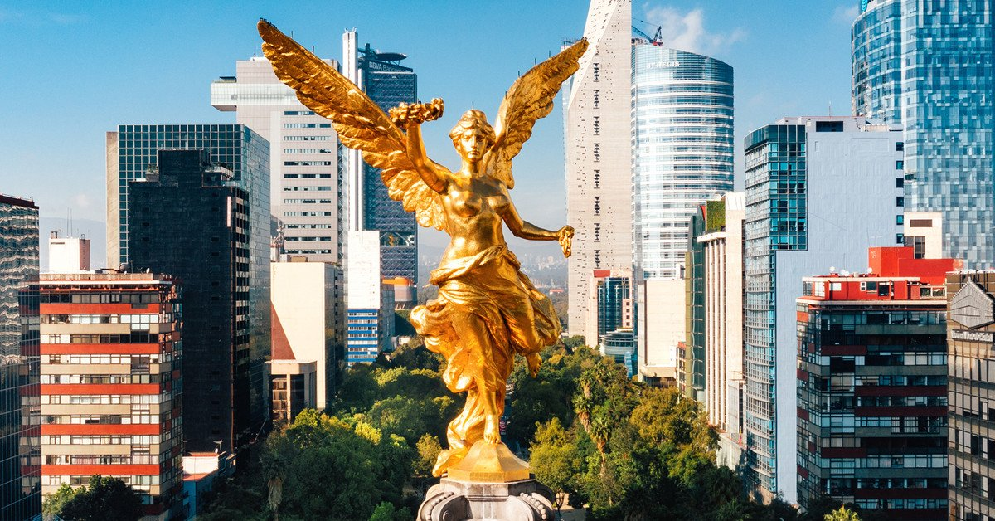
Arrival at Mexico City International Airport. Reception and transfer to your hotel.
Check in at the hotel. Rest of the day at leisure.
Lunch and dinner on your own. Lodging.

DAY 02 – CIUDAD DE MÉXICO – City Tour + Basílica de Guadalupe + Pirámides de Teotihuacán

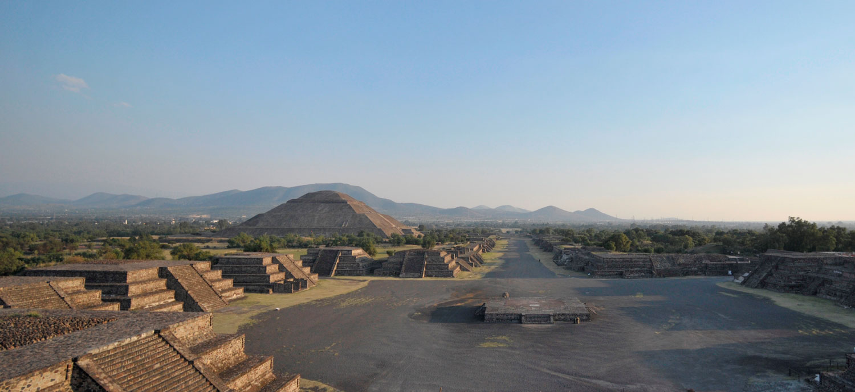

Breakfast at the hotel.

Panoramic visit to the Plaza de las Tres Culturas; historical site where the last struggle between Aztecs and Spaniards was fought and which symbolizes the fusion of 3 cultural eras represented by the Aztec ruins; the church of Tlatelolco and the building of the Ministry of Foreign Affairs. After a short stop; we will continue to the Basilica of Guadalupe; where we will see the original image of the Virgen of Guadalupe. You will learn the history of how it was embodied in the mantle of the indigenous Juan Diego and see the old basilica at the foot of the Tepeyac hill. By a modern highway we will go directly to the archaeological site of Teotihuacan; the city of the gods; 50 km away where we can admire the impressive pyramids of the sun and the moon; walk along the Avenue of the Dead; We will visit an obsidian workshop for the demonstration of this and the maguey. On the way back to Mexico City, a panoramic visit of the Zocalo, the ruins of what was once the main temple of the Aztecs and the Metropolitan Cathedral.

Lunch and dinner on your own. Lodging.

DAY 03 – CIUDAD DE MÉXICO/ GUADALAJARA

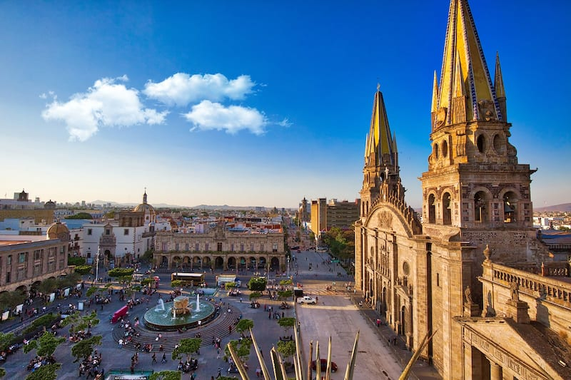

Breakfast at the hotel.

Transfer from the hotel to the airport or bus station (ticket not included). Reception at the airport or bus station, assistance and transfer to your hotel. Afternoon at leisure.

Lunch and dinner on your own. Lodging.

DAY 04 – GUADALAJARA – Tlaquepaque

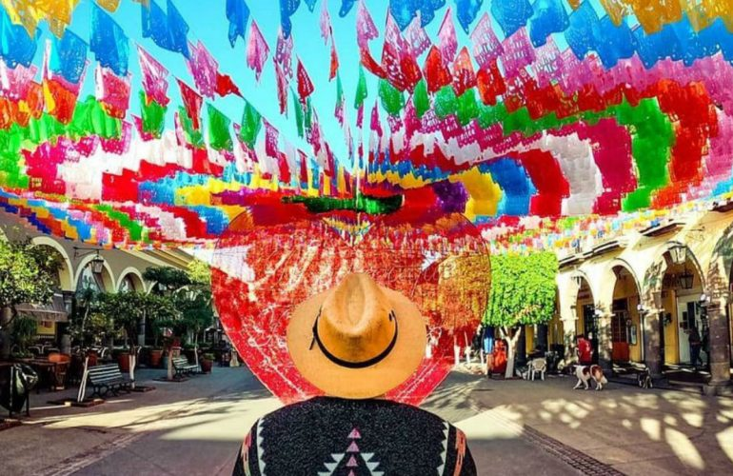

Breakfast at the hotel.

You will visit the government palace murals of Clemente Orozco, the Metropolitan Cathedral, the Expiatory Temple and Musa Museum, the Cross of Squares, the Slaughtered Theater, the Founders Square, the Tapatia Square, the Transfer to Tlaquepaque, the Art Galleries in Tlaquepaque, the Free time to eat in Tlaquepaque. (lunch not included) and Glorieta Minerva.

Lunch and dinner on your own. Lodging.

DAY 05 – GUADALAJARA - Tequila

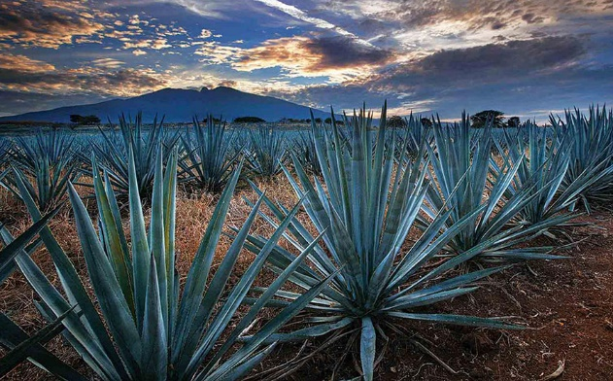
Breakfast at the hotel.

Visit the Agave Landscape, a World Heritage Site
• Professional Organoleptic Tequila Tasting and Pairing
•Visit Tequila's Magical Town Downtown Zone
• Visit to La Cofradia Distillery / Barrel Hotel
• Explanation of the tequila making process
• Tequila tasting in cava
• Visit to the pottery factory (weekdays)
Lunch Included Underground Restaurant + Margarita

Dinner on your own. Lodging

DAY 06 – GUADALAJARA/ PUERTO VALLARTA

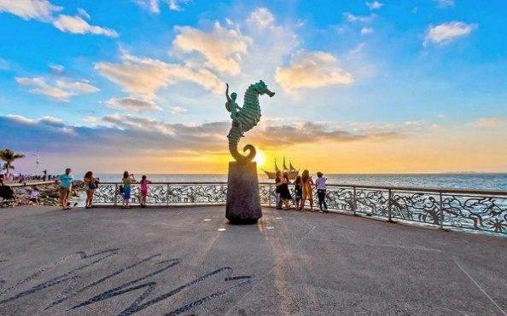
Breakfast at the hotel.

Transfer from the hotel to the bus terminal to board the unit bound for Puerto Vallarta, a place full of warmth, picturesque and full of history where you can enjoy relaxing beaches, world-class restaurants, ecotourism and extreme adventures. Its wonderful historic center will fascinate you and you can have a great time in its many cafes and nightclubs. A magnificent end to this beautiful walk through one of the most representative states of the country.

All-Inclusive Plan. Lodging

DAYS 07 & 08 – PUERTO VALLARTA

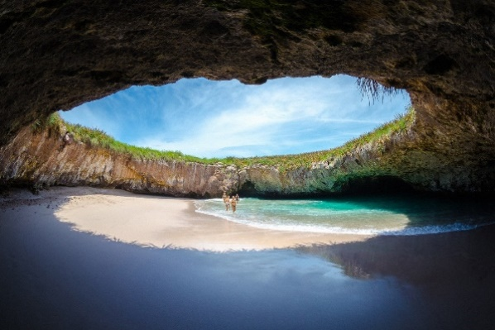
Breakfast at the hotel.

As we know that when you get there you won't want to leave anytime soon, we offer you two days to enjoy this wonderful place in the way you prefer.

All-Inclusive Plan. Lodging

DAY 09 – PUERTO VALLARTA / OUT

Breakfast at the hotel.

At the convenient time transfer from your hotel to the airport to catch the flight to your destination.

END of SERVICES

NOTE: The day of operation of the tours may vary.
** VALIDATE RATES WITH YOUR TRAVEL AGENT

CITY | NIGTHS | HOTELS 3** | HOTELS 4* | HOTELS 4**
MEXICO CITY | 2 | Premier / Regente | PF / Royal Reforma | Galeria Plaza
GUADALAJARA | 3 | Casino Plaza | De Mendoza / Morales | Doubletree By Hilton
PUERTO VALARTA | 3 | Friendly Vallarta | Friendly Vallarta | Sheraton Buganvilias

INCLUDES:
- TRANSPORTATION: Air-conditioned Bus/Minibus or Van
- ACCOMMODATION: Hotels according to your choice
- MEALS: 05 Breakfasts and all-inclusive plan in Puerto Vallarta.
- VISITS: Those mentioned in the program.
- ESCORT GUIDE: Bilingual, certified by the Ministry of Tourism

NOT INCLUDED:

- Air tickets
- Food or services not mentioned
- Taxes at the airport
- Tips to guides or drivers.

IMPORTANT REMARKS:
- Due to the multiple changes that occur daily in tourism, these prices must be confirmed at the time of booking request.
- Rates subject to availability and change without notice.
- Credit card payments apply a % commission.
- Please check in at 15:00 hrs and check out times at 12:00 hrs.
- The TRIPLE rooms only have 2 double beds.
- If flights arrive or depart to and from the new Felipe Ángeles airport, please inform your agent when requesting a quote, as a surcharge applies.
- The waiting time for arrival transfers is 2 hours and 15 minutes. Once the time has elapsed, the passenger must travel at their own expense.
- The tolerance time for departure transfer is 10 min., after this time the unit is removed and must move on its own to the apartment. * Under no circumstances are we responsible for the extra expenses that arise from this situation.
- Tours may change order depending on the correspondent's operations.

