PROGRAM
MÉRIDA. ARQUEOLOGÍA E HISTORIA
05 days/04 nights

(Mérida, Uxmal, Yaxcopoil, Chichen Itzá)

Minimum 2 persons.
Daily Departures

ITINERARY

DAY 01 – IN / MÉRIDA
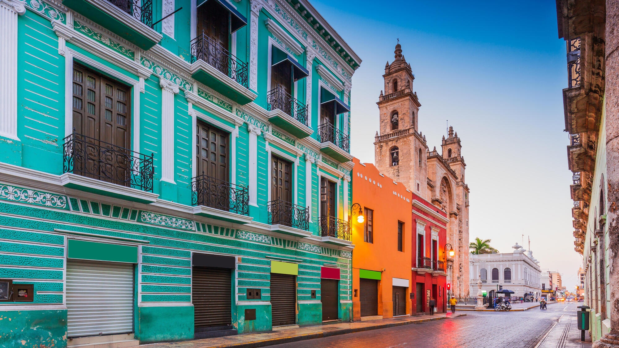

Arrival at Merida airport. Reception and transfer to hotel.

Check in at hotel. Rest of the day at leisure.

Lunch and dinner at leisure.
Lodging

DAY 02 – MÉRIDA – City Tour (Panoramic). Operates from Monday to Saturday

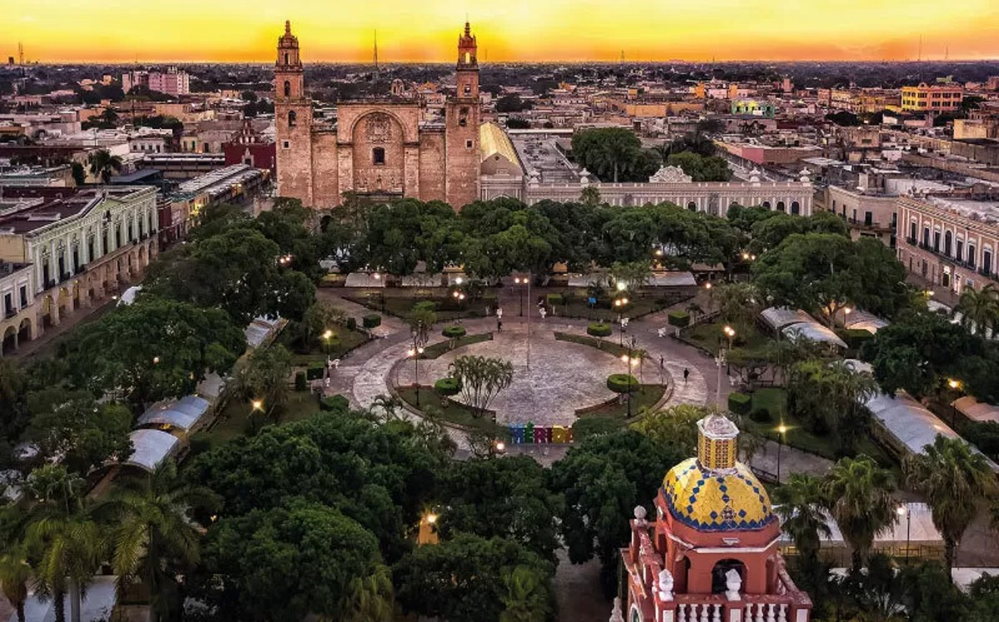

Breakfast at the hotel.

We started observing the important points of the city, such as the historic center, the 60th street to the north according to the direction of the cars, where we see the university building, theaters like the Peón Contreras, streets that have numbers and names, the Paseo Montejo, museums like the house of Canton, twin houses, the fifth montes molina, the minaret, among many more, we visited the main points of historical interest in the city of Merida, such as the old neighborhoods of Merida, museums like the house of Canton, twin houses, the fifth montes molina, the minaret, among many more, we visit the main points of historical interest of the city of Merida, as the old neighborhoods, after this tour we will be amazed and well located in our white city, we finish in their hotels.

Lunch and dinner on your own.
Lodging.

DAY 03 – MÉRIDA – Yaxcopoil + Uxmal + Cenote (Operates from Tuesday to Saturday)

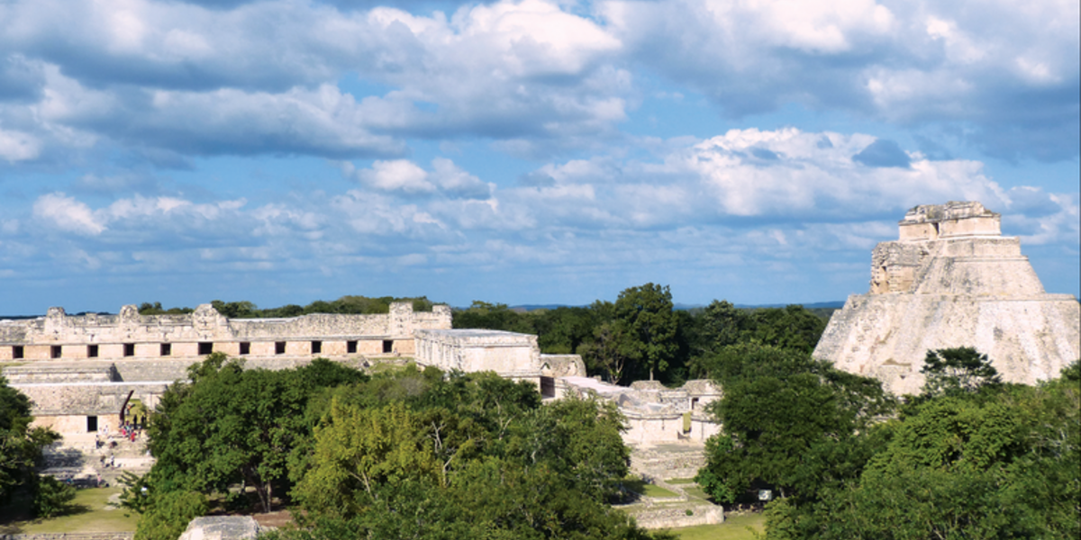

Breakfast at the hotel.

Leaving the city of Merida towards the hacienda Yaxcopoil, where you can visit the interior of the hacienda, these have their origin in the encomiendas at the arrival of the Spaniards, is usually included houses of important architectural value and other minor buildings focused on the work of the field, We continue to the three times built, Uxmal, which is located in an area of hills called Puuc, is the most important city in the area for being a real jewel for its style of friezes and decorated ceilings. Highlights include the pyramid of the soothsayer, the quadrangle of the nuns and the governor's palace. Later we will visit a cenote which is a subway water deposit, where you can enjoy its crystalline waters, ideal for refreshment. Finally we will return to the white city of Merida.

Lunch and dinner on your own.
Lodging.

DAY 04 – MÉRIDA – Chichen Itza with lunch (Operates from Tuesday to Sunday)

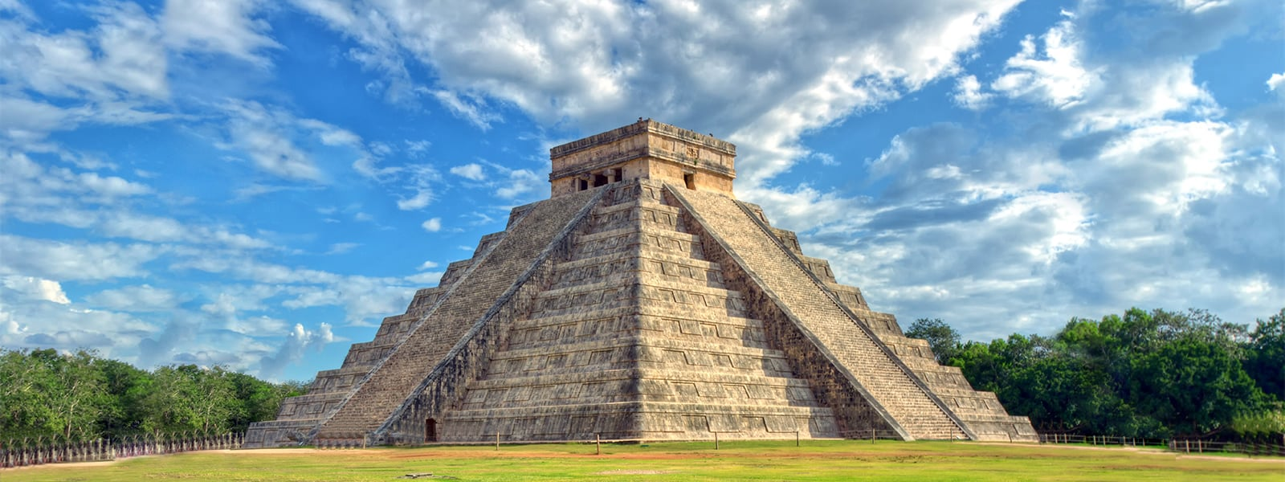

Breakfast at the hotel.

Leaving Merida we will go to one of the 7 new wonders, Chichen Itza (mouth of the well of the water sorcerers) was the most important city between the years 900 and 1300 of our era, highlighting the temple of Kukulkan or "the castle" that together with the temple of the warriors, the ball game, the astronomical observatory and the complex of the nuns show the great ceremonial character in which the city was managed. After visiting the site we will have lunch at a restaurant in the modern Mayan village of Piste. After lunch we head to visit the gateway to the Mayan underworld, a cenote near the town, where we will have the opportunity to refresh ourselves in its crystalline waters.

Dinner at leisure.
Lodging.

DAY 05 – MÉRIDA / OUT
Breakfast at the hotel.

At a convenient time transfer from your hotel to the airport to take your flight to your destination.

END OF SERVICES

NOTE: The day of operation of the tours may vary.

** VALIDATE RATES WITH YOUR TRAVEL AGENT

CITY | NIGHTS | HOTELS 3* | HOTELS 4* | SP
Mérida | 04 | Marionetas | Villa Mercedes Curio | Rosas & Xocolate

INCLUDED:
- TRANSPORTATION: Air-conditioned touristic unit
- ACCOMMODATION: Hotels according to your choice
- MEALS: Daily breakfasts, 01 lunch
- VISITS: Those mentioned in the program.
- ESCORT GUIDE: Bilingual, certified by the Ministry of Tourism
NOT INCLUDED:

- Air tickets
- Food or services not mentioned
- Taxes at the airport
- Tips to guides or drivers.

IMPORTANT OBSERVATIONS:
- Due to the multiple changes that occur daily in tourism, these prices must be confirmed at the time of requesting the reservation.
- Rates subject to availability and changes without prior notice.
- Credit card payments are subject to a % commission.
- Please contemplate the schedule of Check in 15:00 hrs and Check Out 12:00 hrs.
- TRIPLE rooms only have 2 double beds.
- Transfers airport-hotel-airport are quoted in shared service, please consider flights arriving and departing between 06:00 and 22:00 hrs, otherwise it must be provided in private service and it will be necessary to re-quote.
- The waiting time for arrival transfers is 2 hours and 15 minutes. Once this time has elapsed, the passenger must transfer at his/her own expense.
- The tolerance time for departure transfer is 10 minutes, after this time the unit is withdrawn and you must transfer on your own to the apartment. * Under no circumstances will we be responsible for any extra expenses arising from this situation.
- Tours may change order according to the operations of the correspondent.

