PROGRAM

MARIPOSA MONARCA EN MICHOACAN
05 days/04 nights

(City Tour, Paricutín, Sierra Chincua)

Minimum 2 persons.
Daily Departures

ITINERARY

DAY 01 – IN / MORELIA
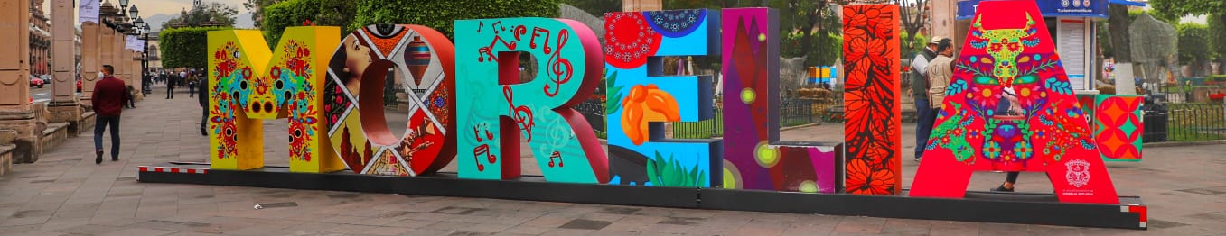

Arrival at Morelia's international airport. Reception and transfer to your hotel.

Check in at hotel. Rest of the day at leisure.

Lunch and dinner at leisure. Lodging

DAY 02 – MORELIA – City Tour

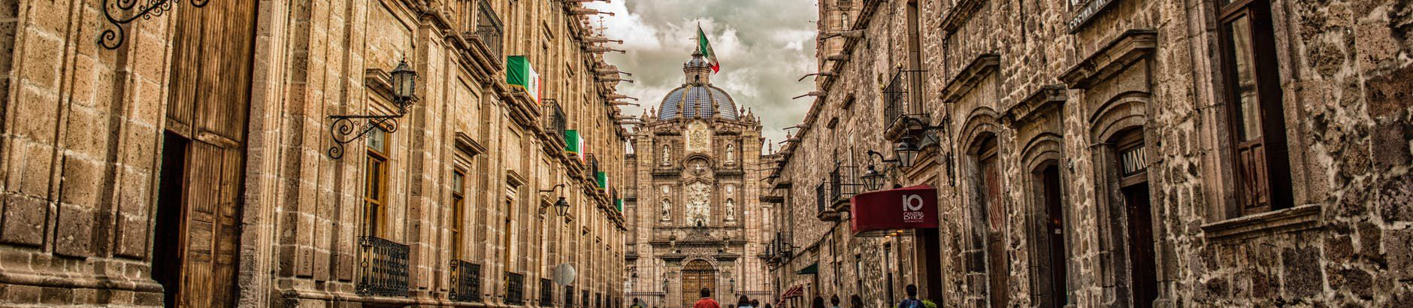

Breakfast at the hotel.

Walk through the streets of the Historic Center of Morelia, Michoacán and the interior of several colonial buildings, learning about its history and marveling at its unique architecture. You will have the fortune to see the famous aqueduct of Morelia, the Sanctuary of the Virgin of Guadalupe, the Fray Antonio de San Miguel Causeway, Fuente de las Tarascas, and finally walk through the great Cathedral, Government Palace, Palace of Justice, Birthplace of Morelos, Colegio de San Nicolas, Library and Clavijero Palace, the Temple and Conservatory of the Roses.

Lunch and dinner at leisure. Lodging

DAY 03 – MORELIA – Paricutin

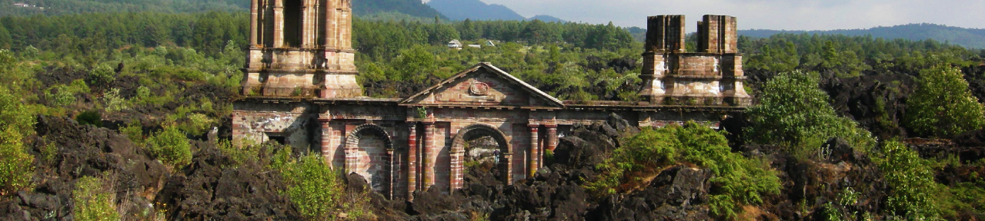

Breakfast at the hotel.

In this tour we will visit 2 places; San Juan Viejo Parangaricutiro, a town buried by lava, surviving only the towers and the altar of the temple, and the Barrancas de Cupatitzio National Park, where you can observe its majestic spring, waterfalls, streams and bridges within a wooded environment.

Lunch and dinner at leisure. Lodging

DAY 04 – MORELIA – Monarch Butterfly

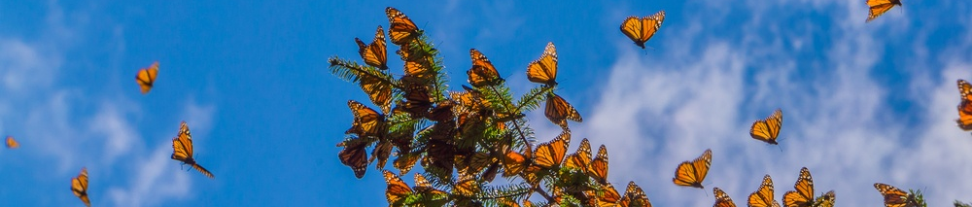

Breakfast at the hotel.

In this tour we will visit the Rosario Sanctuary or the Sierra Chincua Sanctuary, the most beautiful places in the world, both located in Michoacan at an altitude of 3000 meters above sea level and located 03 hours from Morelia. In this spectacular tour we will observe the monarch butterflies, we will also visit one of the renowned restaurants in the area. (Food not included)

Lunch and dinner on your own. Lodging

DAY 05 – MORELIA/OUT

Breakfast at the hotel.

At a convenient time transfer from your hotel to the airport to take the flight to your destination.

END OF SERVICES

** VALIDATE RATES WITH YOUR TRAVEL AGENT

CITY | NIGHTS | HOTELS 3* | HOTELS 4*
Morelia | 04 | Casino Morelia | De la Soledad

INCLUDED:
- TRANSPORTATION: Air-conditioned touristic unit
- ACCOMMODATION: Hotels according to your choice
- MEALS: 04 Breakfast
- VISITS: Those mentioned in the program.
- ESCORT GUIDE: Bilingual, certified by the Ministry of Tourism
NOT INCLUDED:

- Air tickets
- Food or services not mentioned
- Taxes at the airport
- Tips to guides or drivers.
IMPORTANT OBSERVATIONS:
- Due to the multiple changes that occur daily in tourism, these prices must be confirmed at the time of requesting the reservation.
- Rates subject to availability and changes without prior notice.
- Credit card payments are subject to a % commission.
- Please contemplate the schedule of Check in 15:00 hrs and Check Out 12:00 hrs.
- TRIPLE rooms only have 2 double beds.
- Transfers airport-hotel-airport are quoted in shared service, please consider flights arriving and departing between 06:00 and 22:00 hrs, otherwise it must be provided in private service and it will be necessary to re-quote.
- The waiting time for arrival transfers is 2 hours and 15 minutes. Once this time has elapsed, the passenger must transfer at his/her own expense.
- The tolerance time for departure transfer is 10 minutes, after this time the unit is withdrawn and you must transfer on your own to the apartment. * Under no circumstances will we be responsible for any extra expenses arising from this situation.
- Tours may change order according to the operations of the correspondent.

