PROGRAM
MARAVILLAS NATURALES DE PUEBLA
04 days/03 nights

(Ciudad de Puebla, Cholula)

Minimum 2 persons.
Daily Departures

ITINERARY

DAY 01 – IN / PUEBLA
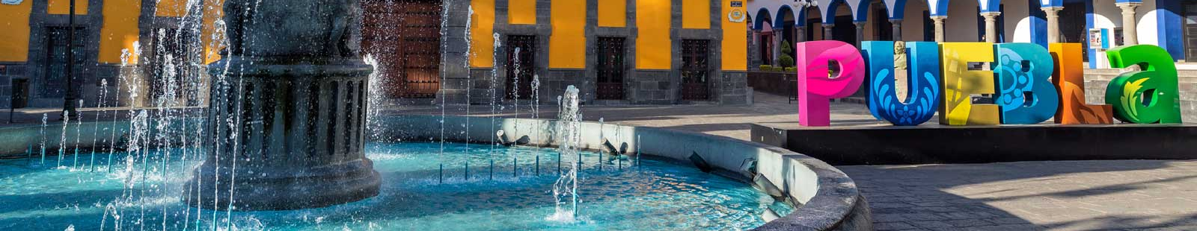

Arrival at CAPU Bus Station. Reception and transfer to your hotel.

Check in at hotel. Rest of the day at leisure.

Lunch and dinner at leisure.
Lodging

DAY 02 – PUEBLA– Puebla Centro y Zona de los Fuertes

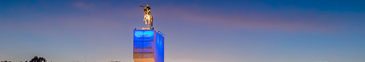

Breakfast at the hotel.

During this pedestrian tour we will visit the Cathedral, which has the tallest towers in the country, also the Palafoxiana Library, which was the first public library on the continent. We will continue through the facade of the Municipal Palace, a historic monument of Renaissance characteristics; the Chapel of the Rosary, admiring its decoration covered with 23k gold laminate; the Street of Sweets, where we will find various stores offering popular and rich traditional sweets and the Craft Market "Parián", where we can buy beautiful typical crafts of Puebla. We will finish in the Historical Zone of the Forts, site of the Battle of Puebla, where we will admire great panoramic views of the city, as well as the Mausoleum dedicated to General Ignacio Zaragoza.

Lunch and dinner at leisure.
Lodging

DAY 03 – PUEBLA – Cholula Pueblo Mágico

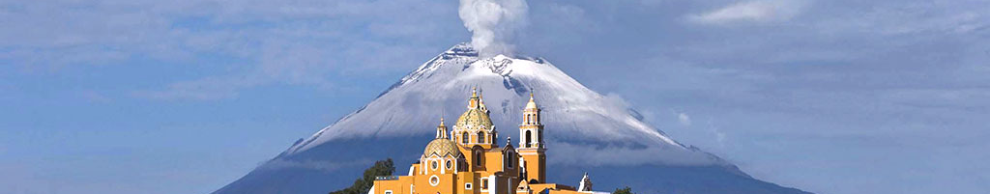

Breakfast at the hotel.

During this tour we will visit the oldest Living Town in Latin America. We will visit the temples of Santa María Tonantzintla and San Francisco Acatepec, excellent examples of Mexican baroque and distinctive for their beautiful facades decorated with tile and brick, where we can also marvel at the local crafts, highlighting the palm figures, popotillo paintings, corn crackers, cocoa, soy bread, among others. We will visit the exterior of the Archaeological Zone of Cholula, where we will admire the largest pyramid in the world in terms of base crowned by the Sanctuary of Our Lady of Remedies. We will end at the Ex Convent of San Gabriel, one of the oldest sites in this ancient city.

Lunch and dinner at leisure.
Lodging

DAY 04 –PUEBLA / OUT

Breakfast at the hotel.

At a convenient time transfer from your hotel to the CAPU bus station.

END OF SERVICES

NOTE: The day of operation of the tours may vary.

** VALIDATE RATES WITH YOUR TRAVEL AGENT

CITY | NIGHTS | HOTELS 3* | HOTELS 4*
Puebla | 03 | Colonial Puebla | NH Puebla Centro Histórico

INCLUDED:
- TRANSPORTATION: Air-conditioned touristic unit
- ACCOMMODATION: Hotels according to your choice
- MEALS: 03 Breakfast
- VISITS: Those mentioned in the program.
- ESCORT GUIDE: Bilingual, certified by the Ministry of Tourism
NOT INCLUDED:

- Air tickets
- Food or services not mentioned
- Taxes at the airport
- Tips to guides or drivers.

IMPORTANT OBSERVATIONS:
- Due to the multiple changes that occur daily in tourism, these prices must be confirmed at the time of requesting the reservation.
- Rates subject to availability and changes without prior notice.
- Credit card payments are subject to a % commission.
- Please contemplate the schedule of Check In 15:00 hrs and Check Out 12:00 hrs.
- TRIPLE rooms only have 2 double beds.
- The tours may change order according to the operations of the correspondent.

