PROGRAM
LOS PUEBLOS MAGICOS DEL ESTADO DE MEXICO
06 days/05 nights

(Valle de Bravo, Tonatico, Grutas la Estrella, Metepec, Aculco, El Oro)

Minimum 2 persons.
Daily Departures

ITINERARIO

DAY 01 – IN / TOLUCA
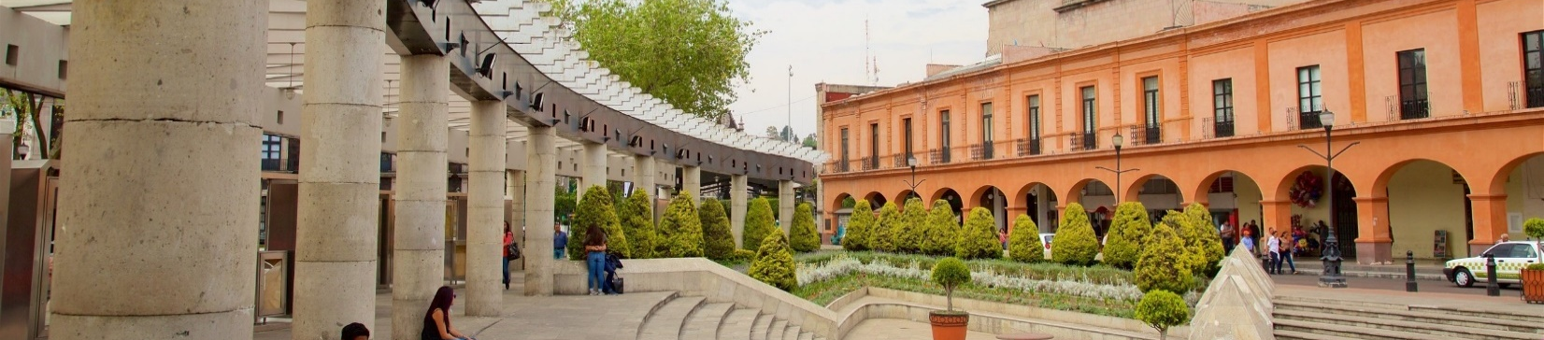

Arrival at Toluca International Airport. Reception and transfer to your hotel.

Check in at hotel. Rest of the day at leisure.

Lunch and dinner at leisure.
Lodging

DAY 02 – TOLUCA – Valle de Bravo

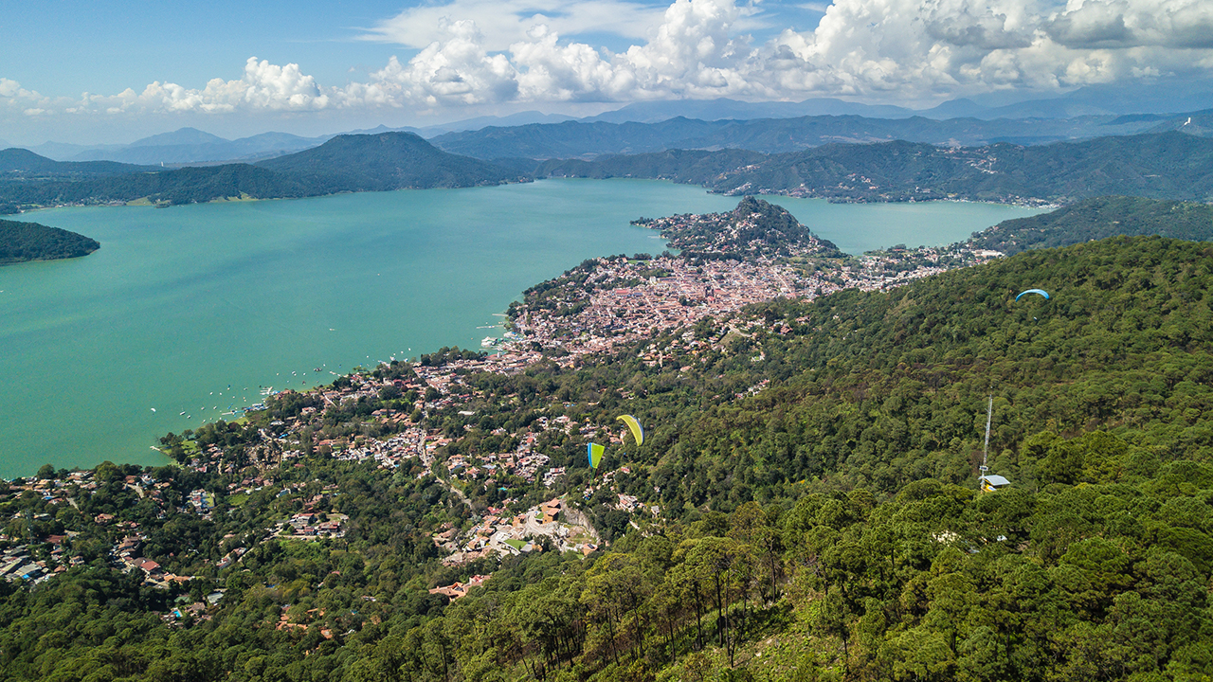

Breakfast at the hotel.

Enjoy the beauty and culture of Valle de Bravo on this one-day getaway from Mexico City, enjoying activities that include exploring the world of the Carmelite order, admiring the Velo de Novia waterfall, strolling the town's cobblestone streets and savoring a delicious complimentary lunch.

Explore the nature and history of Valle de Bravo on this full-day guided excursion. Discover more about the “Black Christ” and the Carmelites from an expert guide Capture memorable photos of the Velo de Novia and enjoy an authentic meal, make the most of the limited time with a convenient hotel pick-up and drop-off service.

Lunch and dinner at leisure.
Lodging

DAY 03 – TOLUCA – Tonatico (Grutas la Estrella) -Metepec

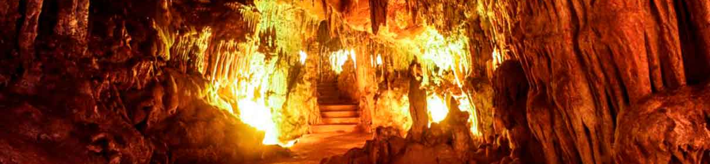

Breakfast at the hotel.

Its magic, In the south of the state lies the town of Tonatico; like few others, here natural beauties, historical monuments and ancestral traditions coexist under the same landscape. The Nahua people said that it was the place where the sun was born and perhaps that is why its climate is semi-tropical throughout the year. Whoever steps on its soil full of charm falls in love with its hot springs, its forests full of mysteries, the attachment of their beliefs and worship. Next, we headed to Grutas de la Estrella, located within the Grutas Estrella State Park. Experts estimate that they are approximately 500 million years old. They are 2 kilometers long and have a mysterious subway river. It is believed that they were a site of worship to Tlaloc, the God of Rain, due to the pre-Hispanic objects found. From a 15-meter cliff it is possible to rappel down. On the way back we stop at the magical town of Metepec. This town preserves its cobblestone streets with colorful houses and tile roofs. The Calvario Church watches from above, surrounded by palm trees and magueys. Below is the plaza with the mythical Tlanchana, as well as several craft stores, museums and restaurants. The Trees of Life stand out, whose work and level of detail is exquisite and admired worldwide. The Clay Museum exhibits pieces that have won national and international pottery contests. In the Artisan Market they sell catrinas, suns, moons, mermaids, pots and flowerpots. Admire the Tlanchana fountain and the mural in the Calvario gardens.

Lunch and dinner at leisure.
Lodging

DAY 04 – TOLUCA – Aculco

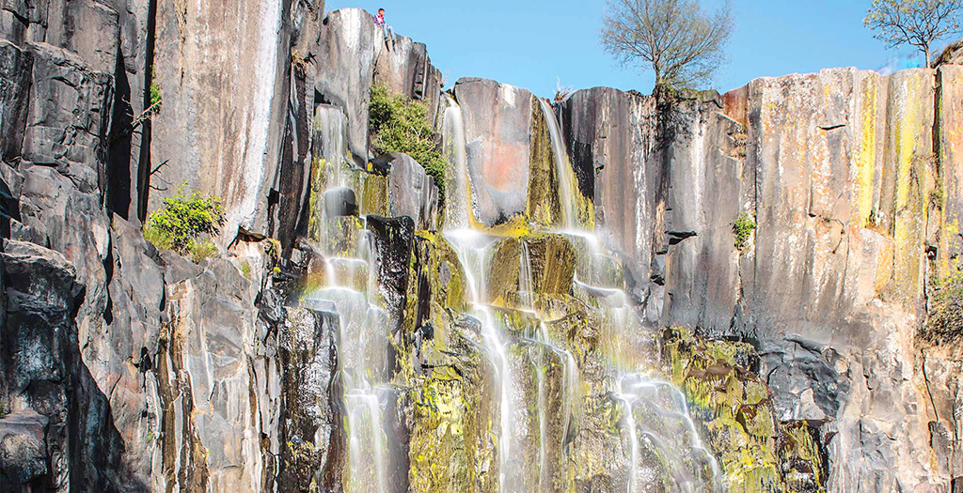

Breakfast at the hotel.

Aculco; a place full of Otomí tradition. Learn about the process of making quarry figures. You will have the opportunity to walk the main streets of the town and meet the Lele doll in the museum of the handmade doll. We also travel to the fabulous town of Aculco where you will enjoy the delicious cheeses produced in the area.

Lunch and dinner at leisure.
Lodging

DAY 05 – TOLUCA – El Oro

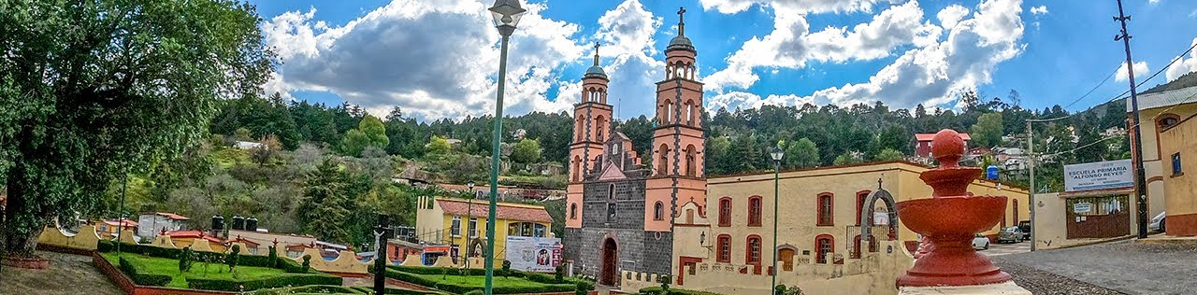

Breakfast at the hotel.

Located on the border of the State of Mexico with Michoacan, El Oro was inhabited by Mazahuas; its charm comes from the past when the mining boom attracted hundreds of people from the old world who left a European touch in the gastronomy, you will find this town called El Oro, beautiful Magical Town, where you will visit the Juarez Theater with French neoclassical style. At the time of the mining splendor it was the stage for shows of the highest level with important artists of those times. In its interior it maintains a Moorish decoration, with vegetal motifs in gilded art nouveau style; but its carved wood halls make it exceptional; The Mining Museum, here you can admire a photographic collection of the main mines such as La Esperanza, La Providencia, La Descubridora and Dos Estrellas; as well as of its miners in times of bonanza. You will also see an exhibition of machinery and extraction equipment and samples of minerals obtained in the mines of the region, from which the purest gold in the world was extracted; The Train Station, the station of El Oro preserves its architectural physiognomy of the late nineteenth century; The Municipal Palace, one of the main attractions is this building, whose architecture exemplifies the styles: art nouveau and neoclassical with its two towers in the English style.
In the facade, the railings, the lamps and the planters the neoclassical style is clearly manifested; while the portico, the auction and the Salón de Cabildos reflect the art nouveau; The Chapel of Santa María de Guadalupe, is from the middle of the XIX century, with a simple facade with two towers, some openings and sculptures of saints, and a cultural house next to it. In its interior it keeps a Virgin of Guadalupe famous for its gold inlays. At the end of the tour, return to your hotel.

Lunch and dinner at leisure.
Lodging

DAY 06 – TOLUCA / OUT

Breakfast at the hotel.

At a convenient time transfer from your hotel to the airport to take your flight to your destination.

END OF SERVICES

** VALIDATE RATES WITH YOUR TRAVEL AGENT

INCLUDED:
- TRANSPORTATION: Air-conditioned touristic unit
- ACCOMMODATION: Hotels according to your choice
- MEALS: 05 Breakfast
- VISITS: Those mentioned in the program.
- ESCORT GUIDE: Bilingual, certified by the Ministry of Tourism
NOT INCLUDED:

- Air tickets
- Food or services not mentioned
- Taxes at the airport
- Tips to guides or drivers.

IMPORTANT OBSERVATIONS:
- Due to the multiple changes that occur daily in tourism, these prices must be confirmed at the time of requesting the reservation.
- Rates subject to availability and changes without prior notice.
- Credit card payments are subject to a % commission.
- Please contemplate the schedule of Check in 15:00 hrs and Check Out 12:00 hrs.
- TRIPLE rooms only have 2 double beds.
- Transfers airport-hotel-airport are quoted in shared service, please consider flights arriving and departing between 06:00 and 22:00 hrs, otherwise it must be provided in private service and it will be necessary to re-quote.
- The waiting time for arrival transfers is 2 hours and 15 minutes. Once this time has elapsed, the passenger must transfer at his/her own expense.
- The tolerance time for departure transfer is 10 minutes, after this time the unit is withdrawn and you must transfer on your own to the apartment. * Under no circumstances will we be responsible for any extra expenses arising from this situation.
- Tours may change order according to the operations of the correspondent.

