PROGRAM
LOS PUEBLOS MAGICOS DE MONTERREY
06 days /05 nights

(Bustamante, Linares, General Terán, General Zaragoza)

Minimum 2 persons.
Daily Departures

ITINERARY

DAY 01 – IN / MONTERREY
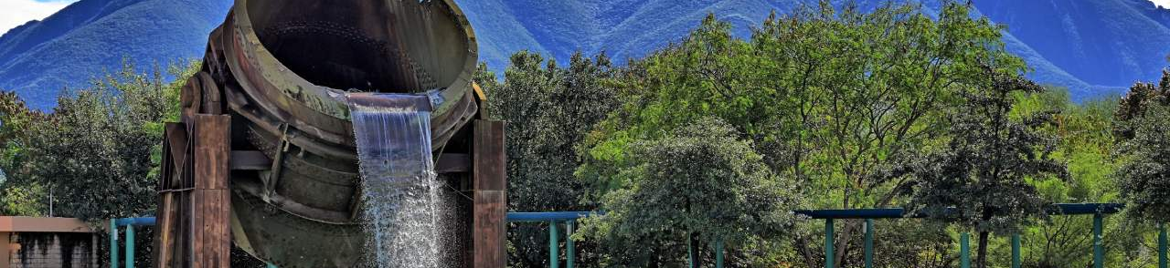
Arrival at Monterrey International Airport. Reception and transfer to your hotel.

Check in at hotel. Rest of the day at leisure.

Lunch and dinner at leisure. Lodging

DAY 02 – MONTERREY – Grutas de Bustamante

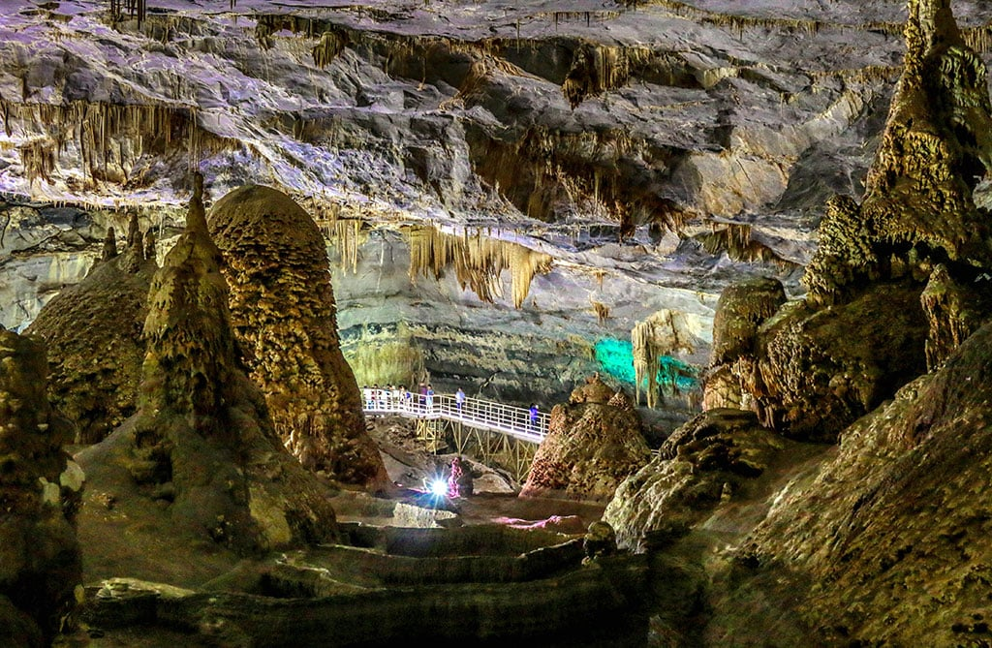

Breakfast at the hotel.

Visiting this town is like entering an oasis in the middle of a barren environment, lined with trees and old houses of typical architecture. Grutas de Bustamante It is one of the most complete caves in the world; geologists affirm that the space is still “alive” because it continues its formation. It has 42 vaults open to the public. Acquire local products such as handicrafts made with braided palm leaves. It is an endemic palm of the Sierra Madre Oriental. Enter the Parish of San Miguel de Arcángel.

Lunch and dinner at leisure. Lodging

DAY 03 – MONTERREY - Linares

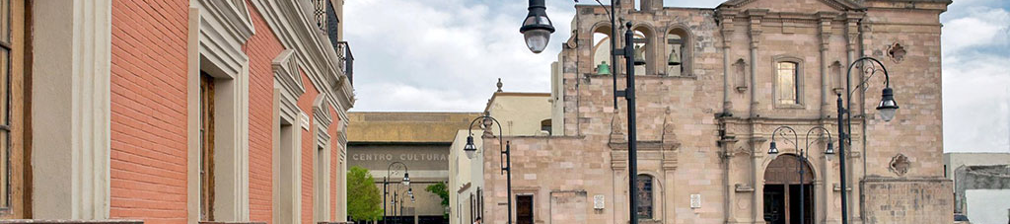

Breakfast at the hotel.

Undoubtedly, the leading role of the ancient Villa de San Felipe de Linares in the formation of northeastern Mexico makes it an unavoidable destination. But beyond history, Linares is also architecture, color, hospitality and intense flavors. The original architecture of the Plaza de Armas concentrates emblematic buildings that have given it a primordial place in the history of northeastern Mexico. On the east side rises the Cathedral of San Felipe Apostle that gathers baroque and neoclassical elements. It was the first episcopal see in the northeast. Next to it stands the elegant British-style Municipal Palace, one of the most notable Porfirian structures in the area.
On the other side is the Casino de Linares, with a European air. Its design is inspired by the Paris Opera House.
See the Botica Morelos, of indigenous style, which creates a curious architectural counterpoint.

Lunch and dinner at leisure. Lodging

DAY 04 – MONTERREY – General Terán

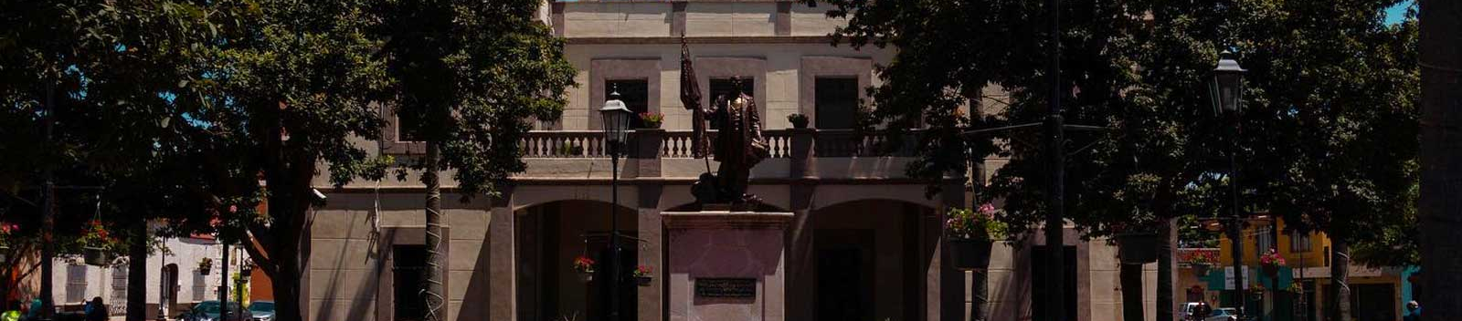
Breakfast at the hotel

Less than two hours from the metropolitan area of Monterrey, is located the Magical Town of General Teran, named after General Manuel Mier y Teran.

It belongs to the citrus growing region of Nuevo Leon and has the highest percentage of production in all varieties of oranges. Therefore, the scent of orange blossom will welcome you to this beautiful town that becomes a perfect getaway to escape the city traffic. General Teran is an oasis in the middle of the Nuevo Leon desert. Surrounded by the municipalities of Los Ramones, Linares, Montemorelos, China and Cadereyta Jimenez. It has ample vegetation and the Pilón River flows through its territory. If you are looking for an escape from the noise and pollution of the city, a little farther from the Magic Town of Santiago, you have to visit General Teran.

It has several natural, historical and cultural attractions that will accompany your tour through the citrus region of Nuevo Leon. In addition, it offers the visitor delicious typical gastronomy of the state. Here you will be able to taste dishes of freshly made barbecue, kid or mashed.

Walk around Juarez Square where you can admire the Municipal Palace.

Lunch and dinner at leisure. Lodging

DAY 05 – MONTERREY – General Zaragoza

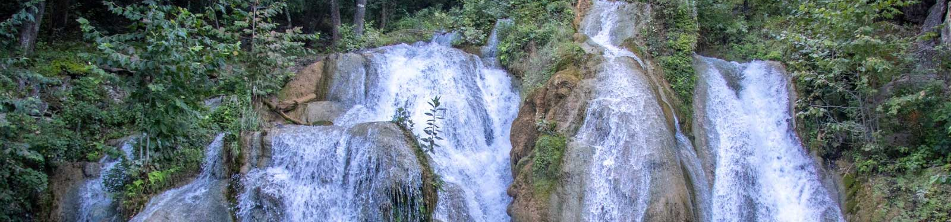
Breakfast at the hotel.

Zaragoza is a beautiful Magic Town surrounded by imposing mountains, lush forests, rivers and waterfalls with fresh and crystalline waters. It is a perfect place for nature lovers and, like many places in Nuevo León, it is a paradise for ecotourism and adventure. It is located in the south of the state, less than five hours from the city of Monterrey, in the Sierra Madre Oriental. Thanks to its privileged position, it offers beautiful postcards to all its visitors, with green forests and bodies of water that make this place the perfect getaway.

If you are looking to get away from the city and enjoy a place rich in culture, gastronomy and surrounded by natural wonders, Zaragoza is the best option. Since the route is long. Despite being a road of approximately five hours, the road becomes a perfect setting to observe the mountains of the state, so you will definitely enjoy the journey. In addition, if you pay attention and are lucky, you will be able to admire the fauna of the region from time to time.

Here you will also breathe clean air and enjoy the shade provided by the trees. In addition, you can go hiking, admire the mountains, cool off in crystal clear pools or simply stroll through the main square of the town and enjoy a pleasant afternoon.

Walk around the main square and discover the typical buildings of the town, such as the San José church. If you want to learn more about the history of the region, visit the Rio Blanco Museum. Here you will find samples of fossils and historical pieces that will take you on a journey through the past.

Lunch and dinner at leisure. Lodging

DAY 06 – MONTERREY / OUT

Breakfast at the hotel.

At a convenient time transfer from your hotel to the airport to take your flight to your destination.

END of SERVICES

NOTE: The day of operation of the tours may vary.
** VALIDATE RATES WITH YOUR TRAVEL AGENT

INCLUDED:
- TRANSPORTATION: Air-conditioned touristic unit
- ACCOMMODATION: Hotels according to your choice
- MEALS: 05 Breakfast
- VISITS: Those mentioned in the program.
- ESCORT GUIDE: Bilingual, certified by the Ministry of Tourism
NOT INCLUDED:

- Air tickets
- Food or services not mentioned
- Taxes at the airport
- Tips to guides or drivers.

IMPORTANT OBSERVATIONS:
- Due to the multiple changes that occur daily in tourism, these prices must be confirmed at the time of requesting the reservation.
- Rates subject to availability and changes without prior notice.
- Credit card payments are subject to a % commission.
- Please contemplate the schedule of Check in 15:00 hrs and Check Out 12:00 hrs.
- TRIPLE rooms only have 2 double beds.
- Transfers airport-hotel-airport are quoted in shared service, please consider flights arriving and departing between 06:00 and 22:00 hrs, otherwise it must be provided in private service and it will be necessary to re-quote.
- The waiting time for arrival transfers is 2 hours and 15 minutes. Once this time has elapsed, the passenger must transfer at his/her own expense.
- The tolerance time for departure transfer is 10 minutes, after this time the unit is withdrawn and you must transfer on your own to the apartment. * Under no circumstances will we be responsible for any extra expenses arising from this situation.
- Tours may change order according to the operations of the correspondent.

