PROGRAM
LOS CABOS Y SUS PUEBLITOS
05 days/04 nights

(Ciudad, Todo Santos, Camellos, Arco, Cabo San Lucas, San Jose del Cabo)

Minimum 2 persons.
Daily Departures

ITINERARY

DAY 01 – IN / LOS CABOS
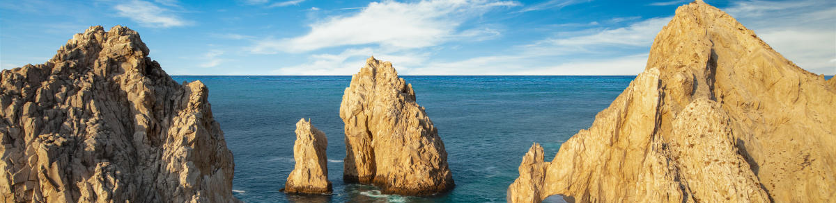

Arrival at Los Cabos International Airport. Reception and transfer to your hotel.

Check in at hotel. Rest of the day at leisure.

Lunch and dinner at leisure. Lodging


DAY 02 –LOS CABOS– Visita de Ciudad Magical Todos Santos

Breakfast at the hotel.

Be part of an unforgettable journey to the magical town of Todos Santos, where you will explore the historic center, the Mission, the iconic Hotel California, an exclusive jewelry store where you will learn about pearl farming and enjoy free time for shopping. Continue this adventure along the scenic Pacific Ocean highway to the town of Pescadero, where you will meet a family of artisans dedicated to the production of handmade blankets. Next you will visit our Tierra Sagrada ranch, where you will meet our friendly camels and take some adorable pictures with them. Finish your day with a delicious Mexican buffet and tequila tasting at our beachfront restaurant. Lunch included.

Lodging all inclusive.

DAY 03 –LOS CABOS– Visita de Ciudad San Jose del Cabo y Cabo San Lucas

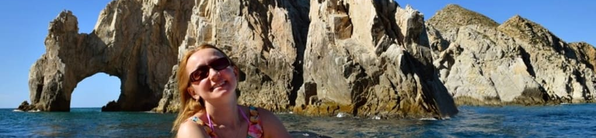 Breakfast at the hotel.

The day begins with an exciting inflatable boat ride to the iconic Cabo San Lucas arch. Next, we will head to the glass factory to witness the process of the art of glass blowing. Then we will head to downtown San Jose del Cabo to visit a chocolate factory and discover the rich history of cocoa and its connection to Mexican culture. after a break walk through downtown, visit the main square and church and have free time to take pictures and shop for souvenirs. finally we will end the day with an authentic Mexican lunch with handmade tortillas and tequila tasting.

Lodging all inclusive.

DAY 04 – LOS CABOS – Camello Safari

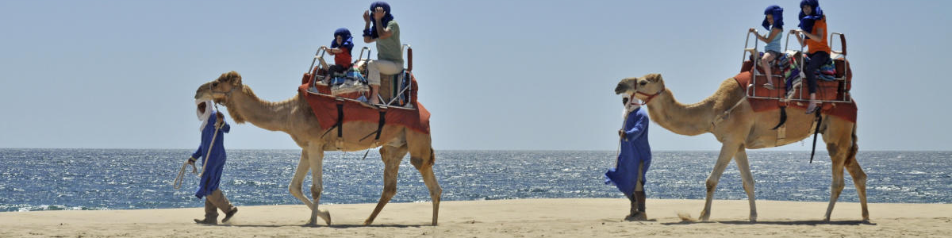

Breakfast at the hotel.

Get ready for a spectacular ride on a virgin beach of the Pacific Ocean aboard a camel while enjoying the view on this unforgettable eco tour. Meet our camels in person and capture the moment with a photo. Discover the wonders of Baja California Sur's desert flora and fauna, history and regional culture on an interactive tour with an expert guide. Learn about the culture of Tequila and Damiana, a regional liquor, while savoring a delicious Mexican meal. Lunch included.

Lodging all inclusive.

DAY 05 – LOS CABOS/ OUT

Breakfast at the hotel.

At a convenient time transfer from your hotel to the airport to take your flight to your destination.

END of SERVICES

NOTE: The day of operation of the tours may vary.
** VALIDATE RATES WITH YOUR TRAVEL AGENT

CITY | HOTELS | HOTELS 4** o 5*
Los Cabos | 04 | Grand Fiesta Americana Los Cabos Golf & Spa o Similar

INCLUDED:
- TRANSPORTATION: Air-conditioned touristic unit
- ACCOMMODATION: Hotels according to your choice
- MEALS: All Inclusive
- VISITS: Those mentioned in the program.
- ESCORT GUIDE: Bilingual, certified by the Ministry of Tourism
NOT INCLUDED:

- Air tickets
- Food or services not mentioned
- Taxes at the airport
- Tips to guides or drivers.

IMPORTANT OBSERVATIONS:
- Due to the multiple changes that occur daily in tourism, these prices must be confirmed at the time of requesting the reservation.
- Rates subject to availability and changes without prior notice.
- Credit card payments are subject to a % commission.
- Please contemplate the schedule of Check in 15:00 hrs and Check Out 12:00 hrs.
- TRIPLE rooms only have 2 double beds.
- Transfers airport-hotel-airport are quoted in shared service, please consider flights arriving and departing between 06:00 and 22:00 hrs, otherwise it must be provided in private service and it will be necessary to re-quote.
- The waiting time for arrival transfers is 2 hours and 15 minutes. Once this time has elapsed, the passenger must transfer at his/her own expense.
- The tolerance time for departure transfer is 10 minutes, after this time the unit is withdrawn and you must transfer on your own to the apartment. * Under no circumstances will we be responsible for any extra expenses arising from this situation.
- Tours may change order according to the operations of the correspondent.

