PROGRAM
LOS CABOS, AVENTURA REFRESCANTE
05 days/04 nights

(Ciudad, Cabo San Lucas, San Jose del Cabo)

Minimum 2 persons.
Daily Departures

ITINERARY

DAY 01 – IN / LOS CABOS
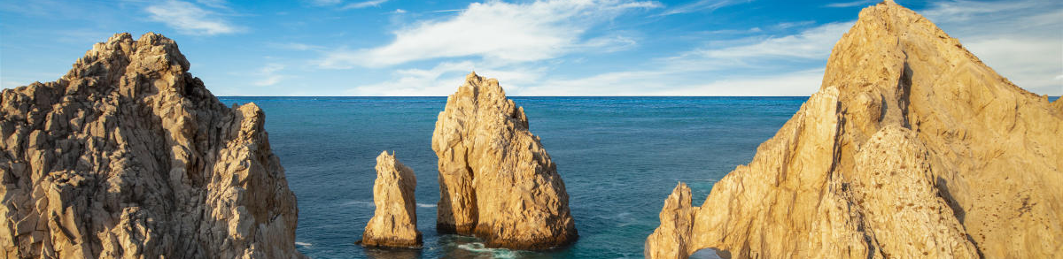

Arrival at Los Cabos International Airport. Reception and transfer to your hotel.

Check in at hotel. Rest of the day at leisure.

Lunch and dinner at leisure. Lodging

DAY 02 –LOS CABOS– Visita de Ciudad - Descubre los Cabos

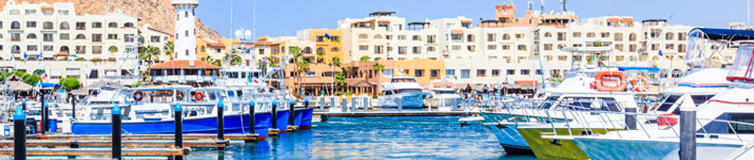

Breakfast at the hotel.

Los Cabos is a magical land full of contrasts, from breathtaking seas, to deserts and mountains. Also known as "Land's End" for being located at the southern tip of the Baja California peninsula. No one is prepared for the stunning scenery that Los Cabos has to offer. To arrive and see the immensity of a blue sea colliding with large granite rocks shimmering, is a natural spectacle that leaves every visitor speechless. If you add to this the richness of two seas and the underwater universe that surrounds the destination, there is no doubt that nothing is by chance and Los Cabos and its great tourist development are a product of its own nature: a true paradise.

Lodging all inclusive.

DAY 03 – LOS CABOS – Al Final de la Tierra

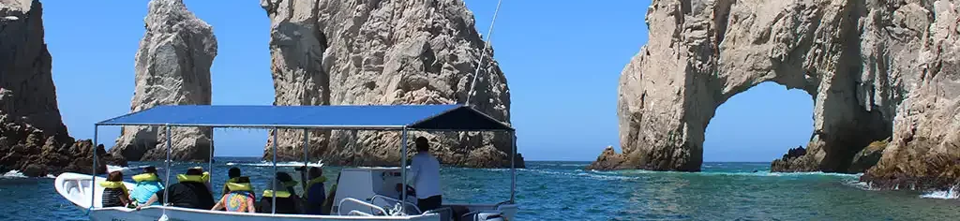

Breakfast at the hotel.

You will be able to appreciate the contrast between the calm waters of the Sea of Cortez and the swell of the Pacific Ocean. The experience of the fusion between the Sea of Cortez and the Pacific Ocean is a rare phenomenon of Mother Nature worldwide. This exciting and enjoyable tour focuses on the main attractions of our sea and combines beach time at Pelicano Rock, and if conditions allow to disembark you can explore La Playa del Amor, Playa del Divorcio, La Cueva de San Andres, the window to the Pacific. Finally you can enjoy shopping time in Cabo San Lucas.

Lodging all inclusive.

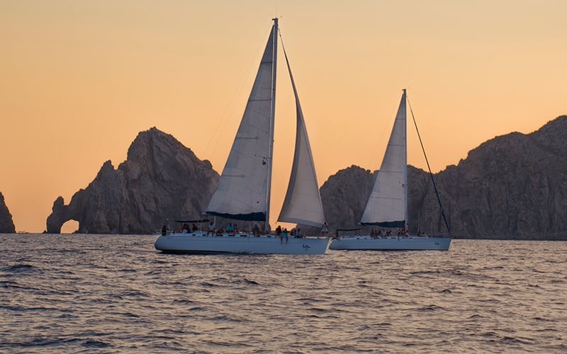
DAY 04 –LOS CABOS– Snorkel Day Sailing

Breakfast at the hotel.

Experience luxury aboard our sailboats and catamarans designed for comfortable and smooth sailing. See the famous Arch, Love Beach and the colony of sea lions watching over the coastline. Our attentive crew will be on hand to provide world-class service with freshly made gourmet snacks and drinks from our open bar. Sunbathe, snorkel and stand up paddle before savoring a delicious lunch on deck. Don't miss the incredible marine life such as dolphins, rays and during the winter humpback whales.

Lodging all inclusive.

DAY 05 – LOS CABOS/ OUT

Breakfast at the hotel.

At a convenient time transfer from your hotel to the airport to take your flight to your destination.

END of SERVICES

NOTE: The day of operation of the tours may vary.
** VALIDATE RATES WITH YOUR TRAVEL AGENT

CITY | HOTELS | HOTELS 4** o 5*
Los Cabos | 04 | Grand Fiesta Americana Los Cabos Golf & Spa o Similar

INCLUDED:
- TRANSPORTATION: Air-conditioned touristic unit
- ACCOMMODATION: Hotels according to your choice
- MEALS: All Inclusive
- VISITS: Those mentioned in the program.
- ESCORT GUIDE: Bilingual, certified by the Ministry of Tourism
NOT INCLUDED:

- Air tickets
- Food or services not mentioned
- Taxes at the airport
- Tips to guides or drivers.

IMPORTANT OBSERVATIONS:
- Due to the multiple changes that occur daily in tourism, these prices must be confirmed at the time of requesting the reservation.
- Rates subject to availability and changes without prior notice.
- Credit card payments are subject to a % commission.
- Please contemplate the schedule of Check in 15:00 hrs and Check Out 12:00 hrs.
- TRIPLE rooms only have 2 double beds.
- Transfers airport-hotel-airport are quoted in shared service, please consider flights arriving and departing between 06:00 and 22:00 hrs, otherwise it must be provided in private service and it will be necessary to re-quote.
- The waiting time for arrival transfers is 2 hours and 15 minutes. Once this time has elapsed, the passenger must transfer at his/her own expense.
- The tolerance time for departure transfer is 10 minutes, after this time the unit is withdrawn and you must transfer on your own to the apartment. * Under no circumstances will we be responsible for any extra expenses arising from this situation.
- Tours may change order according to the operations of the correspondent.

