PROGRAM

LA VUELTA POR JALISCO EN 7 NOCHES
08 days/07 nights

(Guadalajara, Tlaquepaque, Chapala, Ajijic, Guachimontes, Minas de Ópalo, Amatitán, Tequila, Mazamitla)

Minimum 2 persons.
Daily Departures

ITINERARY

DAY 01 – IN / GUADALAJARA
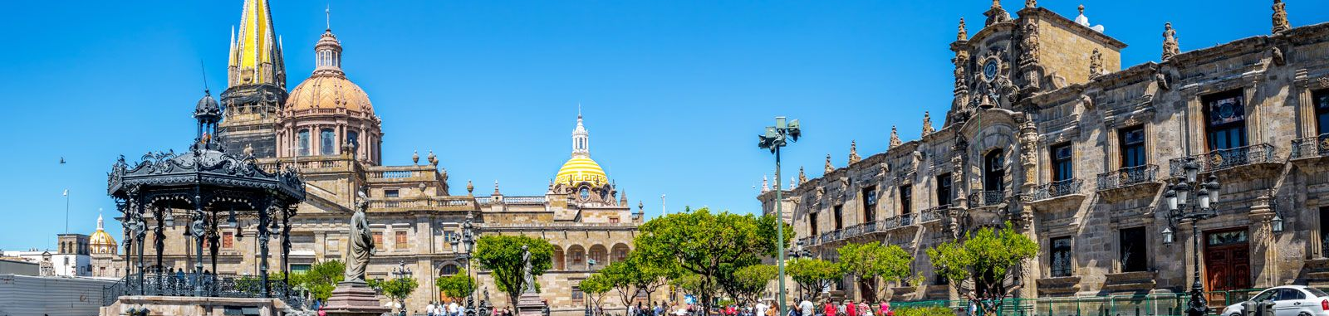

Arrival at Guadalajara's international airport. Reception and transfer to your hotel.

Check in at the hotel. Rest of the day at leisure.

Lunch and dinner on your own. Lodging.

DAY 02 – GUADALAJARA – Guadalajara + Tlaquepaque

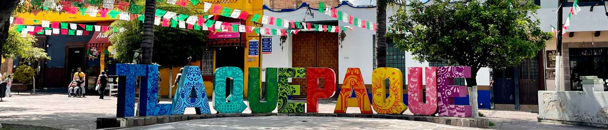

Breakfast at the hotel.

We start our day with a tour of the Historic Center of Guadalajara, we will begin our walking tour in front of the Government Palace, during our tour we will have the opportunity to see the famous murals of José Clemente Orozco in the Government Palace, the Plaza "de Armas", the rotunda of Illustrious men and women of Jalisco who are buried there and you can see the sculptures of them around the circle. We will visit the Metropolitan Cathedral, the catacombs chapels, we continue our tour to the Liberation Square, passing by the Degollado Theater of neoclassical construction founders square. We visit the Expiatory Temple of the Blessed Sacrament, a beautiful neoclassical construction that took 75 years to build. We move to San Pedro Tlaquepaque, a town adjacent to Guadalajara, famous for its craftsmanship, we will walk along the main avenue where all the art galleries of various artisans as the art gallery Bustamante of Sergio artisan known worldwide, for his beautiful and eccentric sculptures. Free time for lunch. Return to the hotel.

Lunch and dinner on your own. Lodging

DAY 03 – GUADALAJARA – Chapala + Ajijic

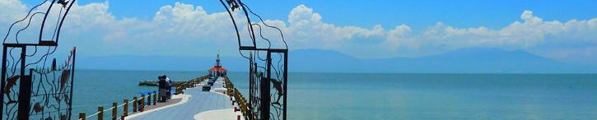

Breakfast at the hotel.

Departure to the Chapala riverside, we pass by the outside of Vicente Fernandez's ranch, we have time to visit the biggest cowboy store in Mexico. We arrive to the town of Chapala, this town was baptized as the little corner of love for being the honeymoon place of several personalities of the Mexican golden cinema among them Mrs. Maria Felix. We visit the malecon of Chapala and we will have time for shopping, we will tell the history of the island of Mezcala where one of the most important battles in the Mexican war of independence took place. Free time to explore the surroundings and shop at the handicraft market. At the time indicated by the guide, we continue to Ajijic, this town was named Pueblo Magico by the Mexican Secretary of Tourism, typical village of cobblestone streets and adobe houses, we will have a pedestrian tour, we will visit the boardwalk, art galleries, wall of the dead, free time for lunch, then at the agreed time return to Guadalajara.

Lunch and dinner on your own. Lodging.

DAY 04 – GUADALAJARA – Guachimontes con Ex Hacienda

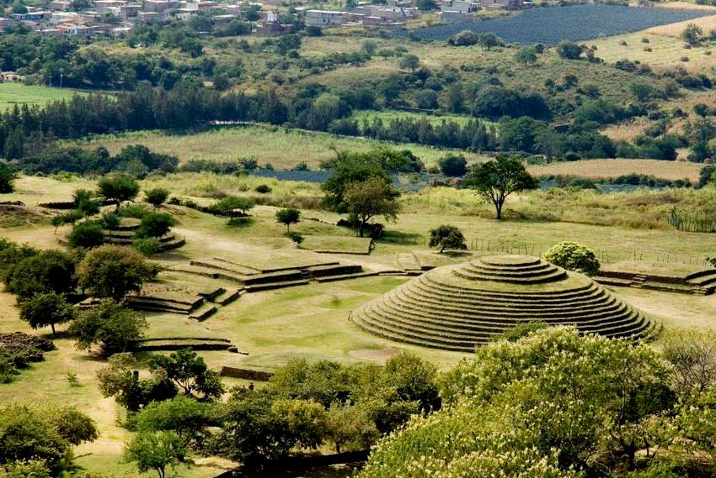

Breakfast at the hotel.

After a 60 minute drive we are ready to start our tour in the archaeological center of the Guachimontones on the tequila route, tradition, history, lots of fun and above all the mysticism that is palpable in every rock and building in this site after more than 2000 years. The main structures of the archaeological zone are the famous circular pyramidal buildings that this culture paid tribute to the God of the Wind. This area is known for having several former haciendas, the visit is an unforgettable experience. We will be fascinated with the visit, imagining what happened in the last century and falling in love with the customs, traditions and the gastronomy of Jalisco. We will have time for lunch on site. Return to Guadalajara.

Lunch and dinner on your own. Lodging.

DAY 05 – GUADALAJARA – Minas de Ópalo

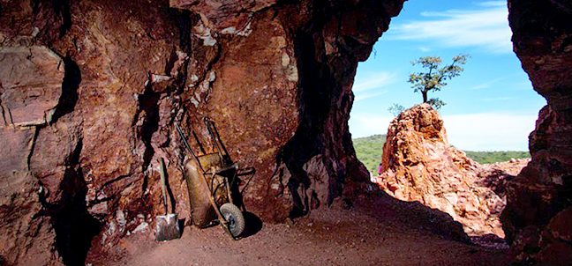

Breakfast at the hotel.

We move to the town of Magdalena, and visit its extraordinary opal mines, in this place there are more than 200 mines are responsible for this small town of just 30,000 inhabitants, is the second largest producer of opal worldwide. We will visit a Gallery where you will be able to observe it in jewelry handicraft to later continue to an open pit mine to look for our opal, before entering we will explain the security rules and we will carry security equipment, with pickaxe and maso we will have time to break some rocks waiting to find the mineral vein, the agreed time return to Guadalajara.

Lunch and dinner on your own. Lodging.

DAY 06 – GUADALAJARA – Amatitán + Tequila

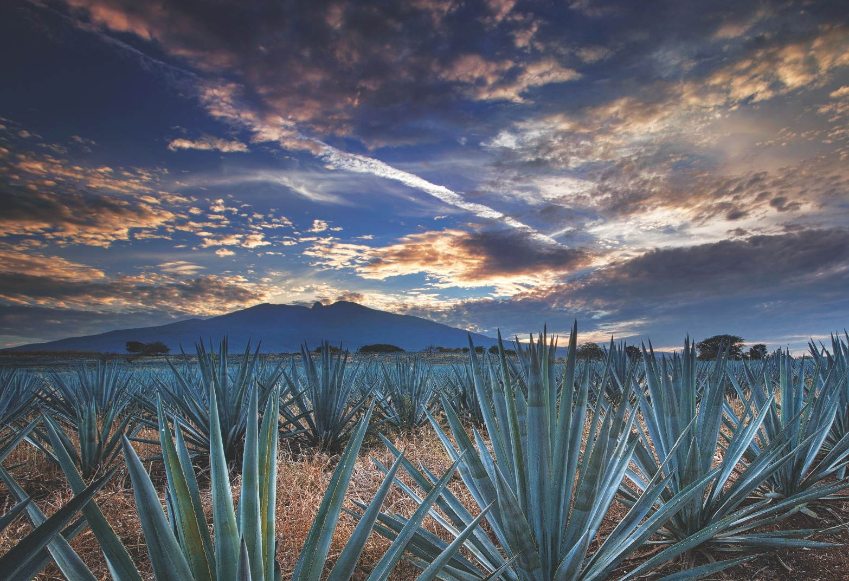

Breakfast at the hotel.

In the morning we will travel to the tequila route to learn more about the history and origin of our traditional Mexican drink. Our first point is Amatitán, we will visit the viewpoint of the agave landscape and our guide will give us a complete explanation about the blue agave Tequilana Weber. We will have a professional organoleptic tasting of Tequila with pairing of Tequilas produced in the region in an exclusive set up, then we will move to the magical town of Tequila we will visit its downtown area and its most iconic streets, we continue to a distillery of greater tradition in tequila called Casa Cofradia, we will have an explanation of the process of making tequila in its production line, tasting of cooked agave and tequila at 55 degrees of alcohol, also we will taste tequilas produced on site. We will have lunch (included) in the subway restaurant "La Taberna del Cofrade" with the "Treasures of Mexico" Distinctive "pre-established menu". At the agreed time we will return to Guadalajara.

Dinner on your own. Lodging

DAY 07 – GUADALAJARA – Mazamitla

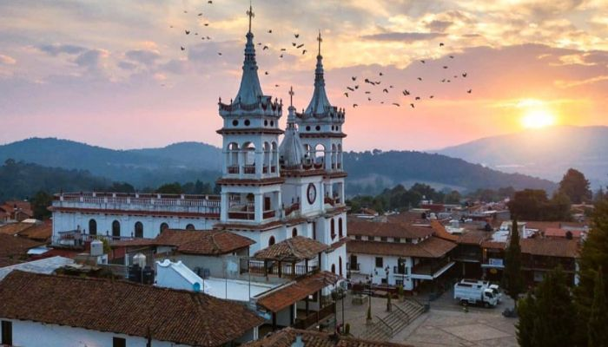

Breakfast at the hotel.

Departure from Guadalajara to Mazamitla located at 2250 meters above sea level in the mountains in the Sierra del Tigre, typical for its cobblestone streets and tile-roofed houses, white walls and wooden doors. The word Mazamitla is of pre-Hispanic origin and means in Nahuatl "Place where arrows are made to hunt deer. Very nice to visit as a couple to walk through its streets and taste its typical gastronomy of a highland town. We will visit the temple of San Cristobal and visit one of the adventure parks where we will enjoy a nice walk, time for lunch and return to Guadalajara.

Lunch and dinner on your own. Lodging.

DAY 08 – GUADALAJARA / OUT

Breakfast at the hotel.

At a convenient time transfer from your hotel to the airport to take your flight to your destination.

END of SERVICES

NOTE: The day of operation of the tours may vary.
** VALIDATE RATES WITH YOUR TRAVEL AGENT

CITY | NIGHTS | HOTELS 3* | HOTELS 4*
Guadalajara | 07 | Casino Plaza | Morales / Doubletree Centro Histórico

INCLUDED:
- TRANSPORTATION: Air-conditioned touristic unit
- ACCOMMODATION: Hotels according to your choice
- MEALS: 07 Breakfast in Guadalajara, 01 Lunch in Tequila
- VISITS: Those mentioned in the program.
- ESCORT GUIDE: Bilingual, certified by the Ministry of Tourism

NOT INCLUDED:

- Air tickets
- Food or services not mentioned
- Taxes at the airport
- Tips to guides or drivers.

IMPORTANT OBSERVATIONS:
- Due to the multiple changes that occur daily in tourism, these prices must be confirmed at the time of requesting the reservation.
- Rates subject to availability and changes without prior notice.
- Credit card payments are subject to a % commission.
- Please contemplate the schedule of Check in 15:00 hrs and Check Out 12:00 hrs.
- TRIPLE rooms only have 2 double beds.
- The waiting time for arrival transfers is 2 hours and 15 minutes. Once this time has elapsed, the passenger must transfer at his/her own expense.
- The tolerance time for departure transfer is 10 minutes, after this time the unit is withdrawn and you must transfer on your own to the apartment. * Under no circumstances will we be responsible for any extra expenses arising from this situation.
- Tours may change order according to the operations of the correspondent.

