PROGRAM
LA NATURALEZA DE MONTERREY
05 days/04 nights

(Grutas de García, Centro Histórico de García, Aguas termales de San Joaquín, Cascada Cola de Caballo, Centro Histórico de Santiago)

Minimum 3 persons.
Daily Departures

ITINERARY

DAY 01 – IN / MONTERREY
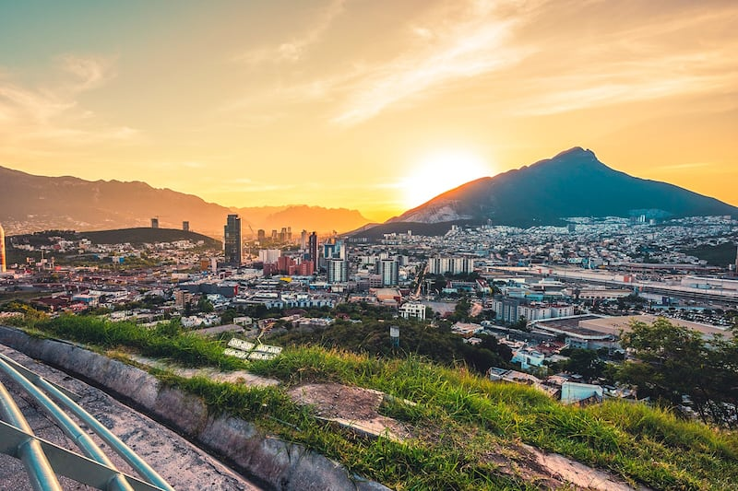

Arrival at the international airport of Monterrey Reception and transfer to your hotel.

Check in at hotel. Rest of the day at leisure.

Lunch and dinner at leisure. Lodging

DAY 02 – MONTERREY – Grutas de Garcia (Tuesday to Sunday)

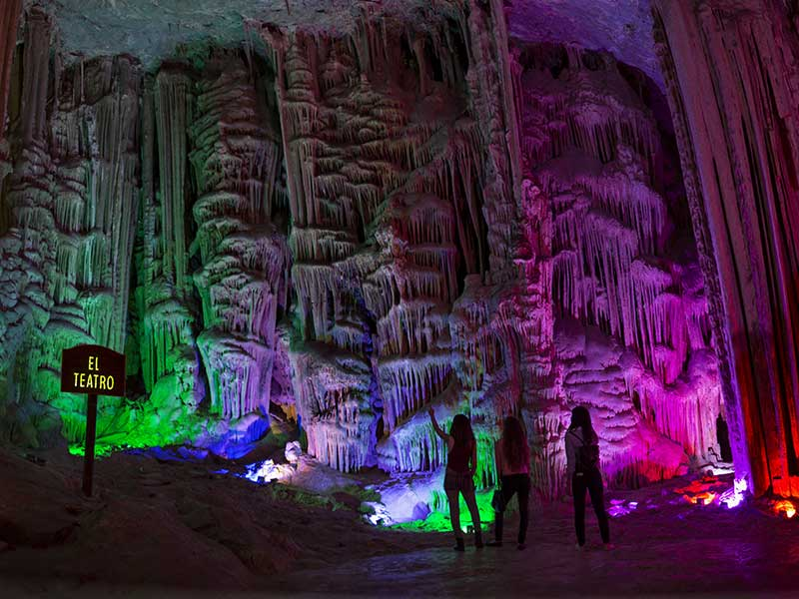

Breakfast at the hotel.

The Caves of Garcia is one of the most visited attractions of Nuevo Leon, located in the municipality of Garcia, in this tour you can admire the different formations of stalactites and stalagmites in a tour of more than 45 minutes inside, also we will climb more than 200 meters in the cable car. Inside the caves we will find some impressive balconies where we will observe the formations that are millions of years old and some of them are still growing. We will see some formations such as El Mirador de la Mano, Salón del Aire, La Octava Maravilla, El Nacimiento, La Fuente Congelada, La Torre China, El Teatro and El Árbol de Navidad among others. We will finish in the historic center to enjoy the non-restored architecture that characterizes this municipality.

Lunch and dinner at leisure. Lodging

DAY 03 – MONTERREY – Aguas termales de San Joaquín (Tuesday to Sunday) (only over 12 years old)

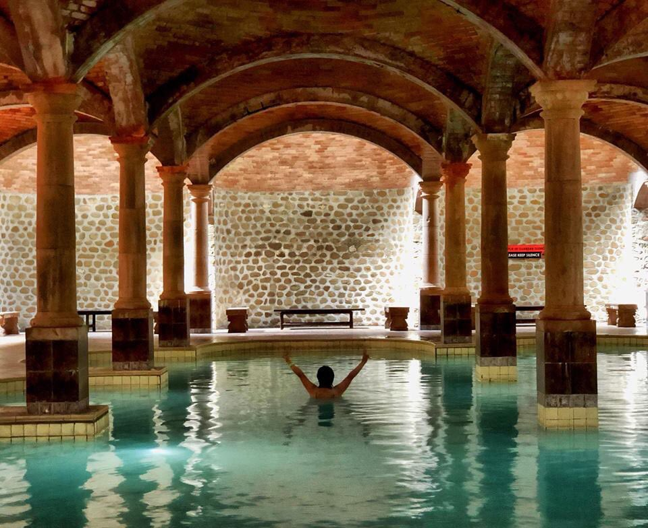

Breakfast at the hotel.

In Mexico, along with the temazcal, hot springs are part of indigenous medicine for their therapeutic and cosmetic properties. As they spring from the earth, they are rich in mineral components, especially sulfur, which give them unique and special characteristics of temperature, aroma and a characteristic bluish-green color. The temperature is maintained between 40°C and 42°C, which gives us a unique feeling of relaxation. In the middle of the desert we will visit the San Joaquin Hot Springs, where the spaces destined for the thermal water pools are subway, under the charm of vaults that resemble Roman style baths, which in turn are the ideal element for the aromatherapy generated by the vapors of the thermal waters themselves. We will continue to the Historic Center of the municipality of Garcia where its mansions from the beginning of the last century are part of the colorful and elegant north-east of this region. We will finish in a traditional bakery where bread is still baked in the oven in the traditional way.

Lunch and dinner at leisure. Lodging

DAY 04 – MONTERREY – Cola de Caballo

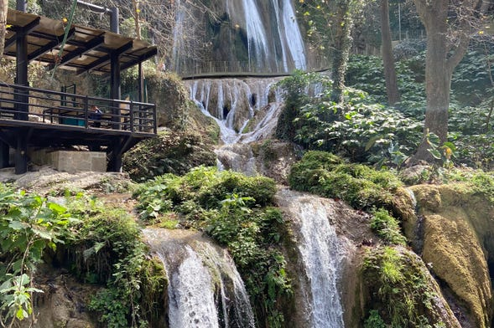

Breakfast at the hotel.

In Villa de Santiago, named Magical Town since 2006, is distinguished by its beautiful landscapes, sheltered by the Sierra Madre Oriental; This beautiful town surrounded by beautiful mountains of dense pine-oak forests, where we will visit the most famous waterfall in the state of Nuevo Leon, the Cascada Cola de Caballo, which is located within the state park of the same name, in addition to the waterfall we will find beautiful handicrafts, and extra activities (NOT included) Continue to the historic center of Santiago, where we can appreciate the traditional colonial architecture of the region. Finally, we will make a stop at a typical mill where you will find regional sweets, corn bread, glorias, dried meat, snow and more typical delicacies.

Lunch and dinner at leisure. Lodging

DAY 05 – MONTERREY / OUT

Breakfast at the hotel.

At a convenient time transfer from your hotel to the airport to take the flight to your destination.

END OF SERVICES

NOTE: The day of operation of the tours may vary.
** VALIDATE RATES WITH YOUR TRAVEL AGENT

CITY | NIGHTS | HOTELS 4*
Monterrey | 04 | NH Collection Monterrey  San Pedro

INCLUDED:
- TRANSPORTATION: Air-conditioned touristic unit
- ACCOMMODATION: Hotels according to your choice
- MEALS: 04 Breakfast
- VISITS: Those mentioned in the program.
- ESCORT GUIDE: Bilingual, certified by the Ministry of Tourism
NOT INCLUDED:

- Air tickets
- Food or services not mentioned
- Taxes at the airport
- Tips to guides or drivers.

IMPORTANT OBSERVATIONS:
- Due to the multiple changes that occur daily in tourism, these prices must be confirmed at the time of requesting the reservation.
- Rates subject to availability and changes without prior notice.
- Credit card payments are subject to a % commission.
- Please contemplate the schedule of Check in 15:00 hrs and Check Out 12:00 hrs.
- TRIPLE rooms only have 2 double beds.
- Transfers airport-hotel-airport are quoted in shared service, please consider flights arriving and departing between 06:00 and 22:00 hrs, otherwise it must be provided in private service and it will be necessary to re-quote.
- The waiting time for arrival transfers is 2 hours and 15 minutes. Once this time has elapsed, the passenger must transfer at his/her own expense.
- The tolerance time for departure transfer is 10 minutes, after this time the unit is withdrawn and you must transfer on your own to the apartment. * Under no circumstances will we be responsible for any extra expenses arising from this situation.
- Tours may change order according to the operations of the correspondent

