PROGRAM

LA MAGIA DE YUCATÁN
06 days/05 nights

Mérida, Valladolid, Izamal, Acanceh, Tecoh, Chumayel, Mani, Chuburná Puerto, Isla Columpios, Sisal

Mínimo 2 personas
Salidas Diarias

ITINERARY

DAY 01 – IN / MÉRIDA

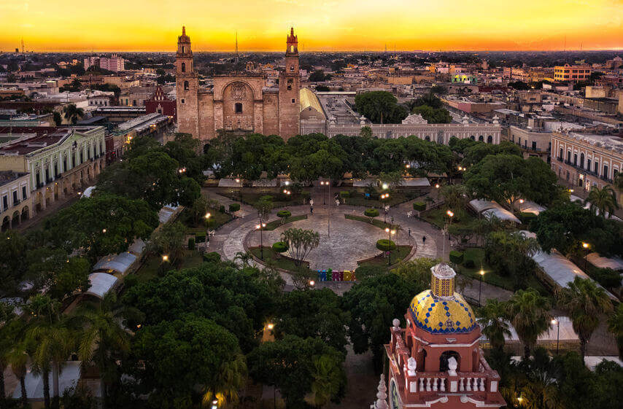
Arrival at the airport or bus station. Reception and transfer to your hotel.

Check in at hotel. Rest of the day at leisure.

Lunch and dinner at leisure.

Lodging

DAY 02 – MÉRIDA – Visita de Ciudad (Panorámica). Opera de lunes a sábado

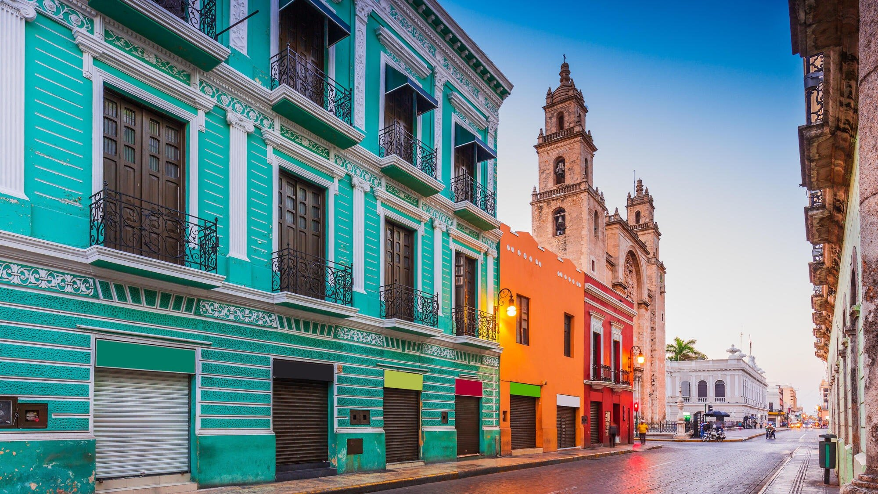
Breakfast at the hotel

We start observing the important points of the city, such as the historic center, the 60th street to the north according to the direction of the cars, where we see the university building, theaters like the peon contreras, streets that bear number and names, the Montejo walk, museums like the house of Canton, twin houses, the fifth montes molina, the minaret, among many more, we visit the main points of historical interest of the city of Merida, as the old neighborhoods, after this tour we will be amazed and well located in our white city, we finish in their hotels.

Lunch and dinner at leisure.

Lodging

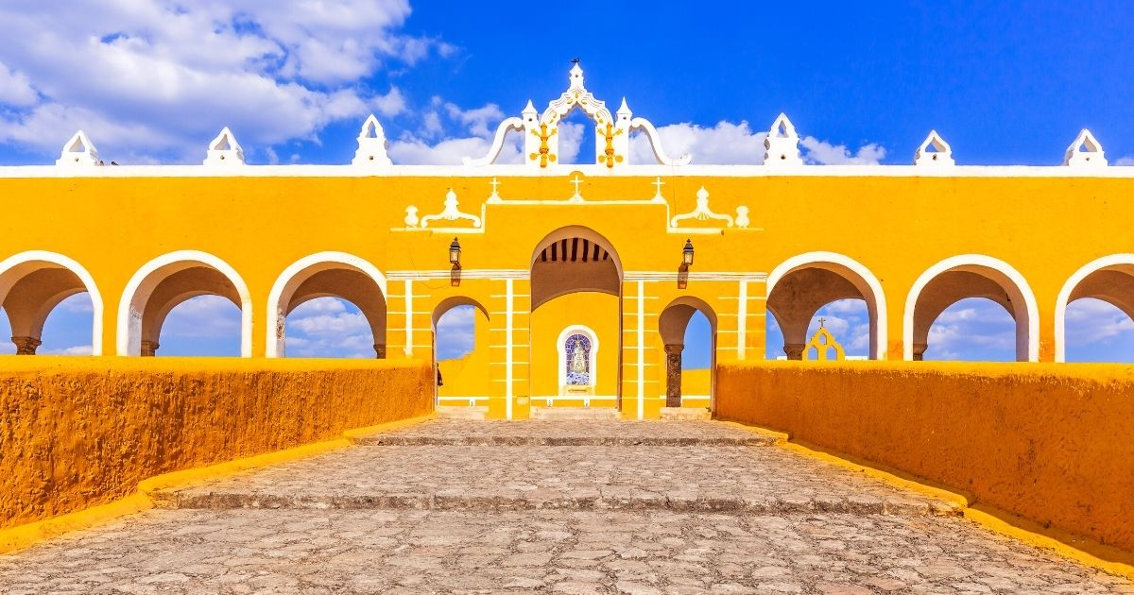
DAY 03 – MÉRIDA – Pueblos Mágicos + Cenote.
Breakfast at the hotel

We will have the opportunity to visit Valladolid, historic and heroic city, capital of the east located 160km from the city of Merida, here happened two great passages in the history of Mexico, the caste war in which the Mayans did not recognize the policies of that system, The first spark of the Mexican revolution in 1910, conquered by Francisco de Montejo the nephew in 1543, here we can taste real Yucatecan cuisine, such as the famous lomitos de Valladolid, called magical town. Afterwards we will refresh ourselves in a cenote, 80 km after Valladolid we arrive to visit the city of Izamal first magical town, 45 min from Merida, called the city of the three cultures, since in it coexist the three historical periods, its archaeological pyramids as a pillar of its Mayan heritage, the convent that is indelible imprint of the Spanish influence and its Yucatecan inhabitants proud of their culture, kind and gentle, at the end we return to the White Merida. Lunch (no drinks). Start of tour 08:00 hrs. End of tour 17:30 hrs.

Dinner at leisure.
Lodging

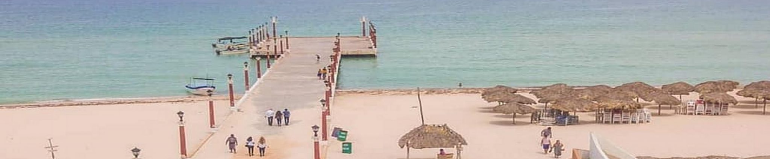
DAY 04 – MÉRIDA – Chuburná Puerto – Isla Columpios + Sisal Paseo en Pontón o Kayak
Breakfast at the hotel
The 'island of the swings' is a true paradise in Mexico, hidden in the state of Yucatan in the municipality of Chuburna, this small but magnificent site offers the opportunity to relax peacefully on swings hanging over the water. This little corner of paradise is surrounded by a completely natural mangrove swamp, which not only allows you to appreciate its beauty peacefully, but also to go kayaking -or even swimming- through its space. To get there you must leave by boat from the port of Abrigo in Chuburna, a fairly quick trip in which you can also take advantage of the opportunity to glimpse the endemic species of the destination.

Then we will visit Sisal, so named because of its port where the first henequen exports were made, also called Sisal. We will visit the legendary port of cabotage, its white sandy beaches and exotic natural scenery are among the must-see things in Yucatan, here we will observe, depending on the time of year, migratory birds such as the Canadian duck, who arrives punctually every year seeking the shelter of the warm waters of the Gulf of Mexico. Its tranquility, beaches and fishing will make us discover another side of Yucatan. After the visit we will have time for lunch (at your own expense) at a local restaurant and free time to enjoy the beach. Continuation to your hotel.

Lunch and dinner at leisure.

Lodging

DAY 05 – MÉRIDA – Acanceh + Tecoh + Chumayel + Mani Ruta de Conventos

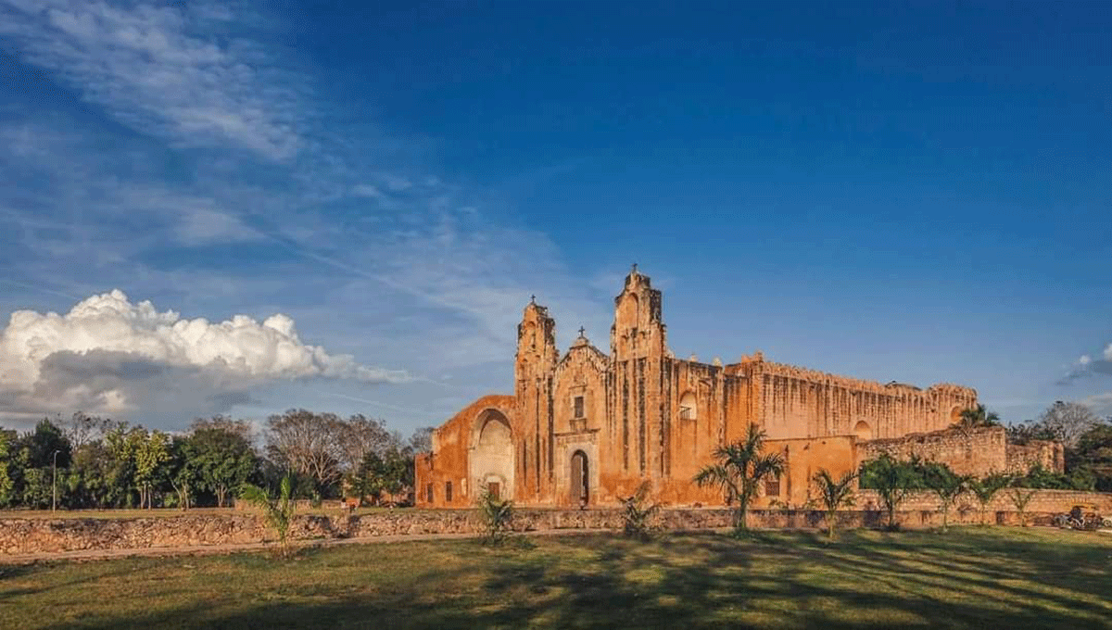

Breakfast at the hotel.

This unique route will take you to know the heart of Yucatan, its villages, convents, churches, colonial temples and atriums. Tecoh, has a market, a church and a convent dedicated to the Virgin of the Assumption. Built on the base of a Maya pyramid, the church has lots of carved stone, an impressive altar and many paintings. Chumayel, (place of the seeds), cradle of one of the most important documents, the Chilam Balam, sacred book of the Mayas. In this town you can appreciate the Temple of the Immaculate Conception, built in the XVI century, it is a clear example of the medieval crenellated religious architecture, transplanted to Yucatan by the first Spaniards. Maní, the most important point on the Convent Route, where you will find an enormous church and convent. It is here that Fray Diego de Landa ordered the burning and destruction of many Mayan documents and statues during the Franciscan movement to convert the indigenous people to Christianity.

Lunch and dinner at leisure.

Lodging

DAY 06 – MÉRIDA / OUT

Breakfast at the hotel.

At a convenient time transfer from your hotel to the airport to take your flight to your destination.

END OF SERVICES

CITY | NIGHTS | HOTELS 3* | HOTELE 4*
Mérida | 05 | El Conquistador | NH Mérida Paseo Montejo

**VALIDATE RATES WITH YOUR TRAVEL AGENT

INCLUDED:
- TRANSPORTATION: Air-conditioned touristic unit
- ACCOMMODATION: Hotels according to your choice
- MEALS: 05 Daily breakfasts, 01 Lunch
- VISITS: Those mentioned in the program.
- ESCORT GUIDE: Bilingual, certified by the Ministry of Tourism
NOT INCLUDED:

- Air tickets
- Food or services not mentioned
- Taxes at the airport
- Tips to guides or drivers.

