PROGRAM
IXTAPA NATURAL
05 days/04 nights

(Ixtapa Zihuatanejo, Liberación de tortugas y Tour de Bahías)

Minimum 4 persons.
Daily Departures

ITINERARY

DAY 01 – IN / IXTAPA ZIHUATANEJO
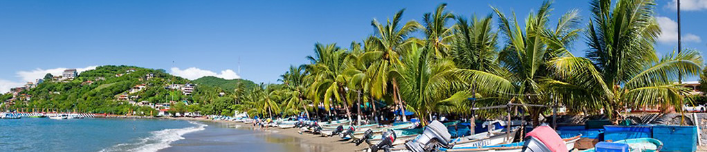
Arrival at the international airport in Zihuatanejo. Reception and transfer to your hotel.
Check in at hotel. Rest of the day at leisure.
Lunch and dinner at leisure.
Lodging

DAY 02 – IXTAPA ZIHUATANEJO – Living Ixtapa & Zihuatanejo

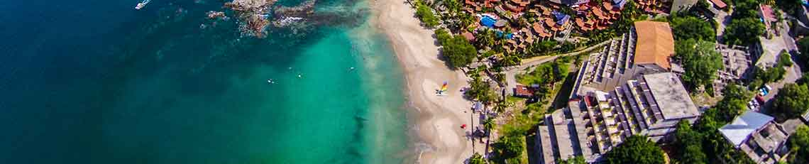

Morning tour of Ixtapa and Zihuatanejo, known for its beautiful beaches and spectacular swimming spots, as well as its beautiful streets full of beauty and culture. Ixtapa Zihuatanejo is a doubly pleasurable place for a weekend trip. Visit the main points of downtown and the Ixtapa lookout point to take panoramic photos. Free time at leisure.

Lodging all inclusive.

DAY 03 – IXTAPA ZIHUATANEJO – Liberación de Tortugas

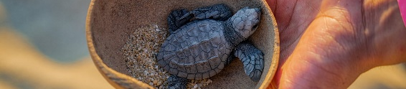

Three types of turtles come to nest on the beaches of Ixtapa Zihuatanejo: leatherback, olive ridley and black; the females will remember the beach where they were born and on their way to the sea, they will always return to nest on the same beach where they were born after they are fifteen years old. Interact with them in the extraction of the nests and release of the turtles. A truly unique experience. Snacks and 2 drinks included. Return to the hotel.

Lodging all inclusive.

DAY 04 – IXTAPA ZIHUATANEJO – Tour de Bahias

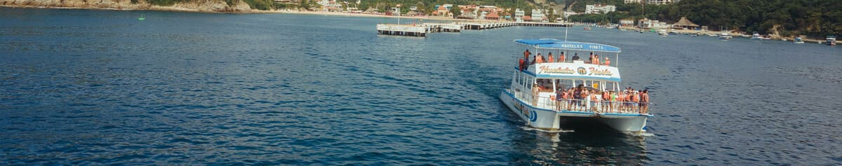

Visit to Las Gatas beach with snacks included and snorkeling activity, stop at Manzanillo beach for snorkeling as well.
snorkel as well. Tour through bays until you reach the island of Ixtapa to swim and enjoy a delicious meal of fish fillet with garnish and tortillas delicious meal of fish fillet with garnish and tortillas. The perfect closing will be a visit to the crocodile visit to the crocodile farm where you will be able to admire different species of reptiles and birds. Lunch, snacks and 01 drink included. Return to the hotel.

Lodging all inclusive.

DAY 05 – IXTAPA ZIHUATANEJO / OUT

Breakfast at the hotel.

At a convenient time transfer from your hotel to the airport to take the flight to your destination.
END OF SERVICES

NOTE: The day of operation of the tours may vary.

** VALIDATE RATES WITH YOUR TRAVEL AGENT

CITY | NIGHTS | 5*
Ixtapa Zihuatanejo | 04 | Barceló Ixtapa

NCLUDED:
Air – conditioned touristic unit
Hotels according to your choice
All Inclusive plan, Sancks with 02 drinks, 01 Lunch, Snack and 01 drink
Those mentioned in the program
Bilingual, certified by the Ministry of Tourism

- TRANSPORTATION:
- ACCOMMODATION:
- MEALS:
- VISITS:
- ESCORT GUIDE:

NOT INCLUDED:

- Air tickets
- Food or services not mentioned
- Taxes at the airport
- Tips to guides or drivers
IMPORTANT OBSERVATIONS:

1. Due to the multiple changes that occur daily in tourism, these prices must be confirmed at the time of requesting the reservation.
2. Rates subject to availability and changes without prior notice.
3. Credit card payments are subject to a % commission.
4. Please contemplate the schedule of Check in 15:00 hrs and Check Out 12:00 hrs.
5. TRIPLE rooms only have 2 double beds.
6. Transfers airport-hotel-airport are quoted in shared service, please consider flights arriving and departing between 06:00 and 22:00 hrs, otherwise it must be provided in private service and it will be necessary to re-quote.
7. The waiting time for arrival transfers is 2 hours and 15 minutes. Once this time has elapsed, the passenger must transfer at his/her own expense.
8. The tolerance time for departure transfer is 10 minutes, after this time the unit is withdrawn and you must transfer on your own to the apartment. * Under no circumstances will we be responsible for any extra expenses arising from this situation.
9. Tours may change order according to the operations of the correspondent.

