PROGRAM
HISTORIA Y MEZCAL
05 days/04 nights

(Ciudad de Oaxaca, Monte Albán, Árbol del Tule, Mitla, Teotitlán, Hierve el Agua, Mezcal)

Minimum 2 persons.
Daily Departures

ITINERARY

DAY 01 – IN / OAXACA
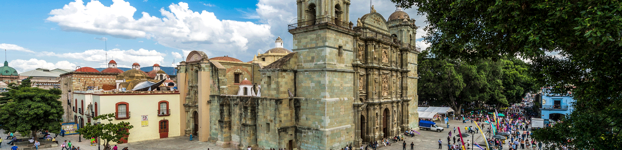

Arrival at Oaxaca's international airport. Reception and transfer to hotel.

Check in at hotel. Rest of the day at leisure.

Lunch and dinner at leisure.
Lodging

DAY 02 – OAXACA – City Tour

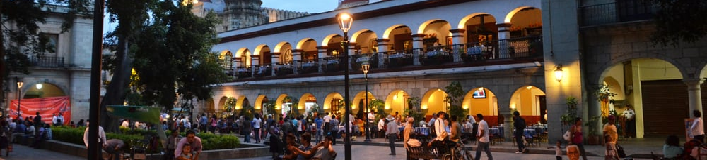

Breakfast at the hotel.

Learn about the history and culture of Oaxaca through a walk through the historic center of the city, where you can appreciate this wonderful temple decorated with gold of the sixteenth century baroque style. Then we will walk through the streets Macedonio Alcalá to reach the famous traditional markets "Benito Juárez and 20 de November" full of color, flavor and tradition of Oaxacan. We will visit a chocolate mill in Oaxaca where you can see the process of elaboration, learn about its history and taste a bit of this traditional delicacy.

Lunch and dinner on your own.
Lodging.

DAY 03 – OAXACA – Monte Albán

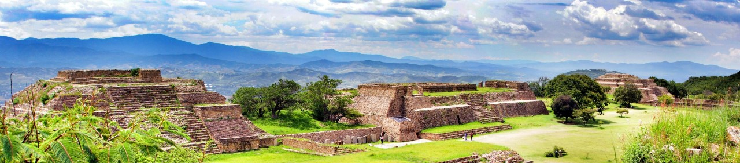

Breakfast at the hotel.

We will visit the amazing archaeological site of Monte Alban, one of the most impressive in Mexico which was inhabited by sages, warriors and astronomers. In 1987 UNESCO declared it a World Heritage Site. The astronomical observatory, the ball game, the palace, the sculpted stelae of the dancers, tombs 7 and 104 of the south platform are some of the most remarkable buildings of this complex.
Lunch and dinner on your own.
Lodging.

DAY 04 – OAXACA – Imperio Mixteca

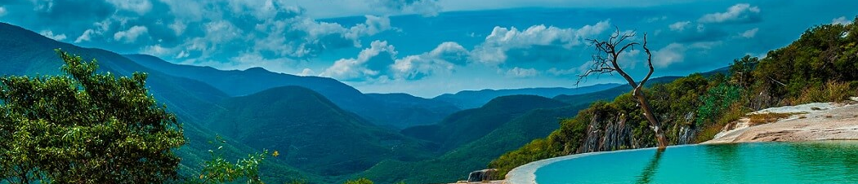

Breakfast at the hotel.

One of the natural wonders: the legendary Tule Tree, which is more than 2000 years old, in its trunk, branches and roots we will be able to observe animal figures; we will continue to the archaeological zone of Mitla, the city of the dead, incomparably beautiful for its varied ornamentation of its foundations, achieved through the system of geometric designs. Later we will go to Teotitlán del Valle, a place where the famous wool rugs are made with artisan processes and hand woven, we will continue our tour to Hierve el Agua, where you can admire the beautiful petrified waterfalls. To conclude our tour we will visit a Mezcal Distillery where you will be able to taste the varieties of flavors.
Lunch and dinner on your own.
Lodging.

DAY 05 – OAXACA/ OUT
Breakfast at the hotel.

At a convenient time transfer from your hotel to the airport to take your flight to your destination.

END OF SERVICES

NOTE: The day of operation of the tours may vary.
**VALIDATE RATES WITH YOUR TRAVEL AGENT

CITY | NIGHTS | HOTELS 4* | HOTELS 4*
Oaxaca | 04 | Casa Conzatti | Oaxaca Real

INCLUDED:
- TRANSPORTATION: Air-conditioned touristic unit
- ACCOMMODATION: Hotels according to your choice
- MEALS: 04 Breakfast in Oaxaca
- VISITS: Those mentioned in the program.
- ESCORT GUIDE: Bilingual, certified by the Ministry of Tourism
NOT INCLUDED:

- Air tickets
- Food or services not mentioned
- Taxes at the airport
- Tips to guides or drivers.

IMPORTANT OBSERVATIONS:
- Due to the multiple changes that occur daily in tourism, these prices must be confirmed at the time of requesting the reservation.
- Rates subject to availability and changes without prior notice.
- Credit card payments are subject to a % commission.
- Please contemplate the schedule of Check in 15:00 hrs and Check Out 12:00 hrs.
- TRIPLE rooms only have 2 double beds.
- Transfers airport-hotel-airport are quoted in shared service, please consider flights arriving and departing between 06:00 and 22:00 hrs, otherwise it must be provided in private service and it will be necessary to re-quote.
- The waiting time for arrival transfers is 2 hours and 15 minutes. Once this time has elapsed, the passenger must transfer at his/her own expense.
- The tolerance time for departure transfer is 10 minutes, after this time the unit is withdrawn and you must transfer on your own to the apartment. * Under no circumstances will we be responsible for any extra expenses arising from this situation.
- Tours may change order according to the operations of the correspondent.

