PROGRAM
HISTORIA Y COMPRAS
04 days/03 nights

(Guanajuato, Compras León)

Minimum 2 persons.
Daily Departures

ITINERARY

DAY 01 – IN / GUANAJUATO

Arrival at Guanajuato international airport. Reception and transfer to hotel.

Check in at hotel. Rest of the day at leisure.

Lunch and dinner at leisure. Lodging

DAY 02 – GUANAJUATO – City Tour

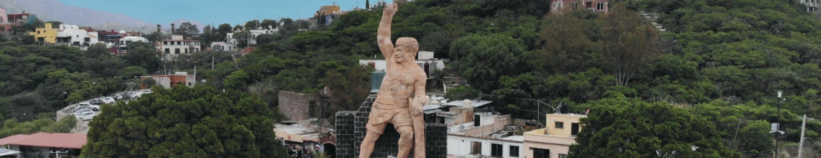

Breakfast at the hotel.

We visited
- Museum of the Mummies of Guanajuato
- Temple of La Valenciana
- Mine
- Tasting of sweets and liquors
- Pípila Viewpoint
- We pass in front of the Castillo de Santa Cecilia Hotel
- Subway street
- Typical tunnel of Guanajuato
- Paseo de la Presa (old residential area)
- La Olla Dam
- Escuela Normal Superior para Maestros (Teachers' College)

- We finish the tour in the center of the city, where we invite you to tour the beautiful Historic Center of Guanajuato, Cultural Heritage of Humanity.
Lunch and dinner on your own. Lodging.

DAY 03 – GUANAJUATO – Tour Compras León

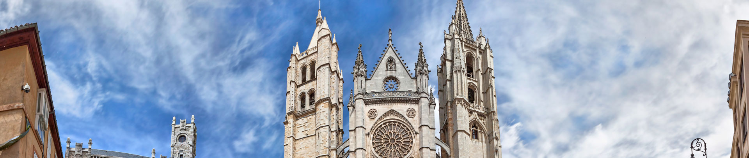

Breakfast at the hotel.

We visited
- Expiatory Temple
- Benedict XVI Square
- Cathedral of Leon
- Pedestrian Zone and Main Garden
- Tasting of Cebadina (traditional drink of Leon)
- Time for shoe and leather goods shopping in Zona Piel or Outlets Plaza Mulza

Lunch and dinner on your own. Lodging.

DAY 04 – GUANAJUATO/ OUT

Breakfast at the hotel.

At a convenient time transfer from your hotel to the airport to take your flight to your destination.

END of SERVICES

** VALIDATE RATES WITH YOUR TRAVEL AGENT

NOTE: The day of operation of the tours may vary

CITY | NIGHTS | HOTELS 3*
Guanajuato | 03 | Misión Guanajuato

INCLUDED:
- TRANSPORTATION: Air-conditioned touristic unit
- ACCOMMODATION: Hotels according to your choice
- MEALS: 03 Breakfasts
- VISITS: Those mentioned in the program.
- ESCORT GUIDE: Bilingual, certified by the Ministry of Tourism
NOT INCLUDED:

- Air tickets
- Food or services not mentioned
- Taxes at the airport
- Tips to guides or drivers
IMPORTANT OBSERVATIONS:
- Due to the multiple changes that occur daily in tourism, these prices must be confirmed at the time of requesting the reservation.
- Rates subject to availability and changes without prior notice.
- Credit card payments are subject to a % commission.
- Please contemplate the schedule of Check in 15:00 hrs and Check Out 12:00 hrs.
- TRIPLE rooms only have 2 double beds.
- Transfers airport-hotel-airport are quoted in shared service, please consider flights arriving and departing between 06:00 and 22:00 hrs, otherwise it must be provided in private service and it will be necessary to re-quote.
- The waiting time for arrival transfers is 2 hours and 15 minutes. Once this time has elapsed, the passenger must transfer at his/her own expense.
- The tolerance time for departure transfer is 10 minutes, after this time the unit is withdrawn and you must transfer on your own to the apartment. * Under no circumstances will we be responsible for any extra expenses arising from this situation.
- Tours may change order according to the operations of the correspondent.

