PROGRAM
HISTORIA REFRESCANTE
06 days/05 nights

(Grutas de Xoxafi, Real del Monte, Huasca de Ocampo, Huichapan, Mineral el Chico)

Minimum 2 persons.
Daily Departures

ITINERARY

DAY 01 – IN / HIDALGO
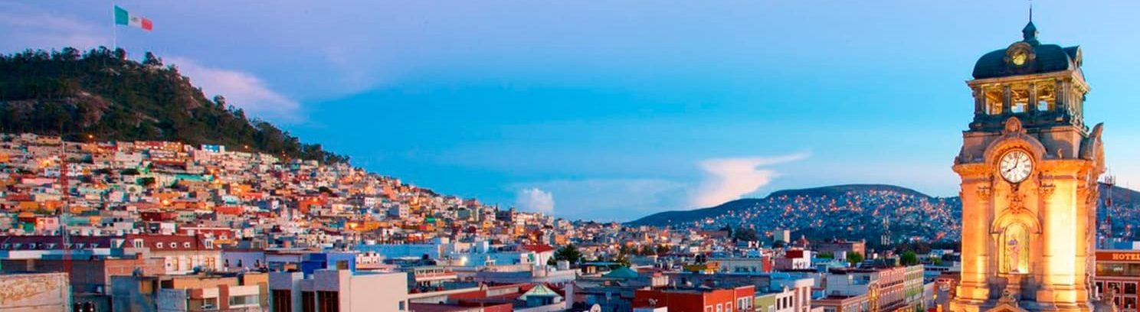

Arrival at the bus station in Hidalgo. Reception and transfer to your hotel.

Check in at hotel. Rest of the day at leisure.

Lunch and dinner at leisure.

Lodging

DAY 02 – HIDALGO – Grutas de Xoxafi

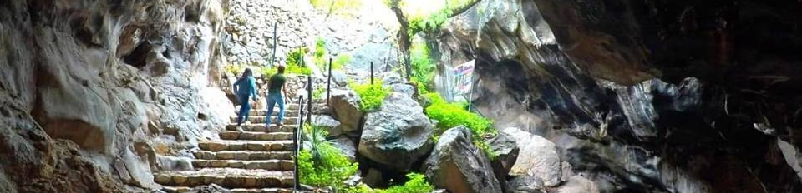

Breakfast at the hotel.

Challenge yourself in our extreme adventure tours where you will enjoy great caving challenges, in a journey of more than 2 hrs inside the “Grutas de Xoxafi”, to continue we challenge you to finish the circuit of 3 extreme zip lines, which go from hill to hill in a journey of 300, 250 and 800 meters through the air. This tour does NOT require experience, but it does require a lot of courage!

Lunch and dinner on your own.
Lodging

DAY 03 – HIDALGO – Vive Huichapan

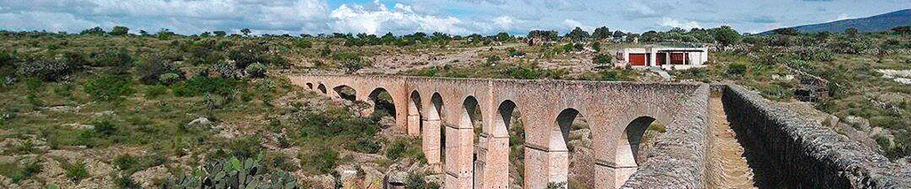
Breakfast at the hotel.

We take you to one of the richest municipalities of Hidalgo in history and culture, where you will fall in love with the attractions that this magical town has for you, you can visit “El chapitel”, this historic place was where the commemoration of the cry of independence was celebrated for the first time. There are also beautiful religious buildings of baroque style. On one side of the Boyé stream and only four kilometers from Huichapan, you can find the most outstanding cave paintings in the area. On the wall of a hill a testimony of the nomads that passed through the region was captured, consisting of human figures with their arms extended and joined together forming a row. Take a walk through the center and you will find the local museum which preserves a large collection of archaeological pieces of the state.

Lunch and dinner at leisure.
Lodging

DAY 04 – HIDALGO – Magia en la Montaña - Pueblos Mágicos Real del Monte y Huasca de Ocampo

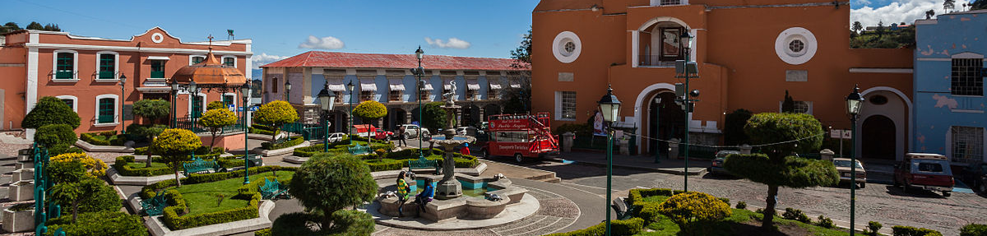
Breakfast at the hotel.

Let yourself fall in love with the beauty of these two magical towns and their natural, cultural and historical attractions, where you will visit the “Prismas Basalticos”, unique geological formations in Mexico, and considered one of the 13 natural wonders. We will visit the Hacienda of “Santa María Regla” where its beauty and mystery will captivate you, you will also visit the “Casa del Rompope” where you will taste exquisite samples of rompope and traditional sauces. You will live the experience of entering a mine with 400 meters of horizontal shot, where you will make a tour while they tell you about the evolution of this great activity in the museum of “Mina Acosta”. Afterwards we will tour the streets of this wonderful town in the turibus that will fill you with emotion.

Lunch and dinner at leisure.
Lodging.

DAY 05 – HIDALGO– Mineral el Chico – Vía Ferrata

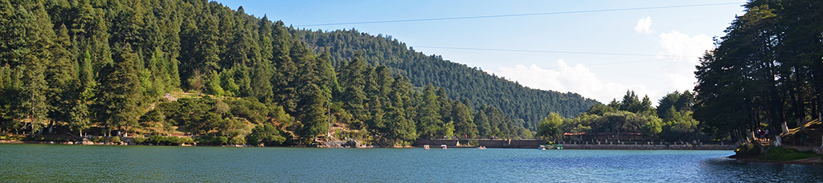

Breakfast at the hotel.

Conquer your fears by climbing a mountain with more than 200m high, in a way you never imagined, live this unique experience that Mineral del Chico offers you in “Via Ferrata” and fill your mind with great achievements by reaching this challenge that will fill you with unforgettable moments, capturing the magical views of this great adventure.

Lunch and dinner on your own.
Lodging

DAY 06 – HIDALGO / OUT

Breakfast at the hotel.

At a convenient time transfer from your hotel to the airport to take your flight to your destination.

END OF SERVICES

**VALIDATE RATES WITH YOUR TRAVEL AGENT

INCLUDED:
- TRANSPORTATION: Air-conditioned touristic unit
- ACCOMMODATION: Hotels according to your choice
- MEALS: 05 Breakfast
- VISITS: Those mentioned in the program.
- ESCORT GUIDE: Bilingual, certified by the Ministry of Tourism
NOT INCLUDED:

- Air tickets
- Food or services not mentioned
- Taxes at the airport
- Tips to guides or drivers.

IMPORTANT OBSERVATIONS:
- Due to the multiple changes that occur daily in tourism, these prices must be confirmed at the time of requesting the reservation.
- Rates subject to availability and changes without prior notice.
- Credit card payments are subject to a % commission.
- Please contemplate the schedule of Check in 15:00 hrs and Check Out 12:00 hrs.
- TRIPLE rooms only have 2 double beds.
- Transfers airport-hotel-airport are quoted in shared service, please consider flights arriving and departing between 06:00 and 22:00 hrs, otherwise it must be provided in private service and it will be necessary to re-quote.
- The waiting time for arrival transfers is 2 hours and 15 minutes. Once this time has elapsed, the passenger must transfer at his/her own expense.
- The tolerance time for departure transfer is 10 minutes, after this time the unit is withdrawn and you must transfer on your own to the apartment. * Under no circumstances will we be responsible for any extra expenses arising from this situation.
- Tours may change order according to the operations of the correspondent.

