PROGRAM
FIN DE SEMANA EN GUADALAJARA Y
JOSE CUERVO EXPRESS
03 days/02 nights

(Tequila, Jose Cuervo Express Tequila Train)

Minimum 2 persons.
Departure on Friday

DAY 01 – IN / GUADALAJARA

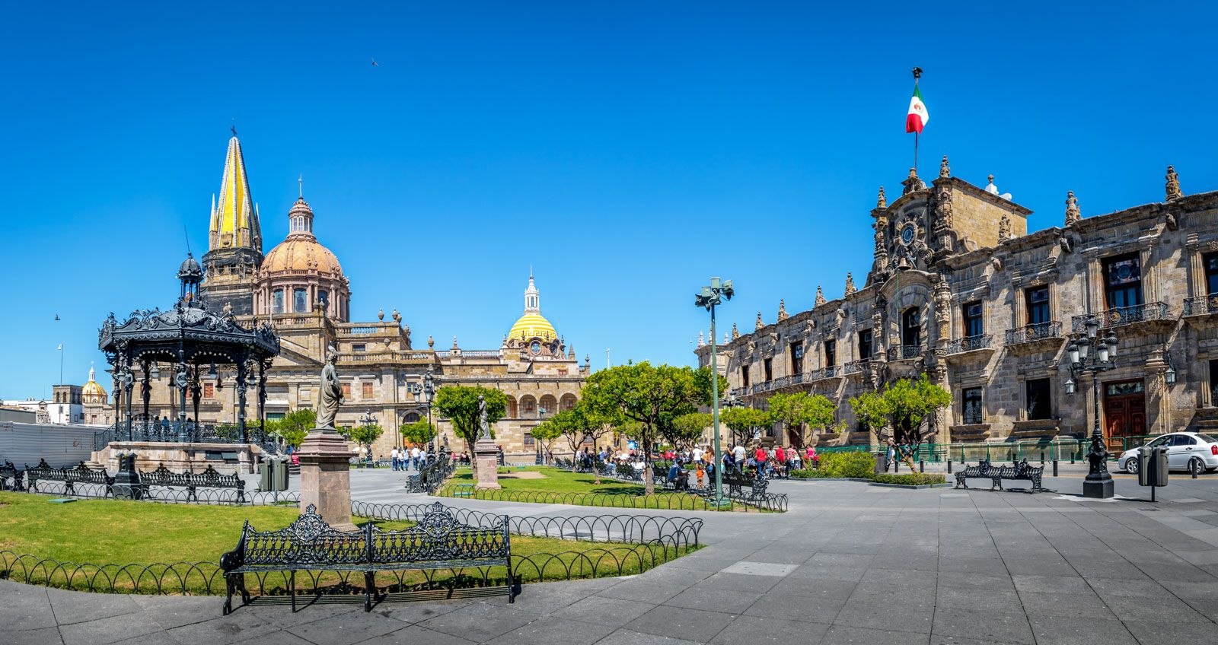

Arrival at Guadalajara's international airport. Reception and transfer to your hotel.

Check in at the hotel. Rest of the day at leisure.

Lunch and dinner on your own. Lodging.

DAY 02 – GUADALAJARA – Tequila + José Cuervo Express

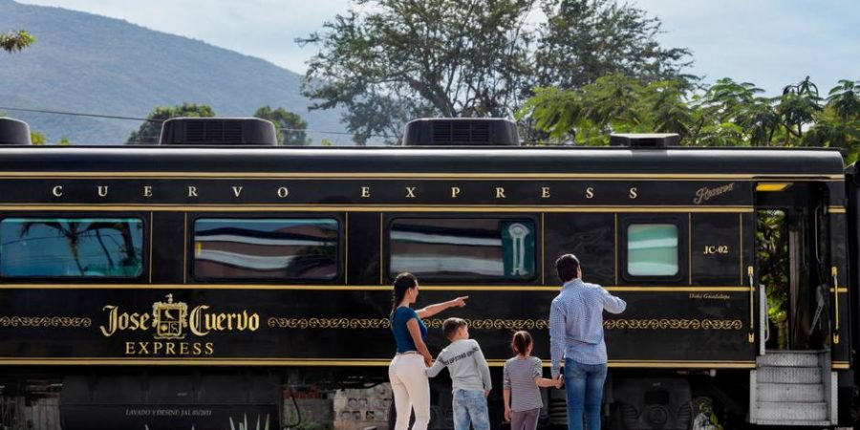

Breakfast at the hotel.

We move to the starting place to Casa Cuervo to its facilities in Periferico Sur to board the bus that will take us to the agave landscape, we will visit the fields of Los Buenos Aires where we will have an exhibition of Jima, the way we harvest the agave, the raw material to make tequila, we continue to La Rojeña de Jose Cuervo, the oldest distillery in Latin America in the town of tequila, we will know the process of making tequila, we will have tequila tasting straight from the still at 55 degrees alcohol, we will know the different types of tequila, you will have a few hours free in the town of tequila to eat and taste the best dishes of the local cuisine (food not included). At 4:00 p.m. (or at the time indicated by your guide) we will meet at the Jose Cuervo forum to close the day with folkloric dances and mariachi music, and a toast with premium tequila of the house. Finally it's time to board the Jose Cuervo Express, the train that will take you back to Guadalajara, tequila-based drinks included. Upon arrival at the train station, our staff will be waiting for you to return you to your hotel.

Lunch and dinner on your own. Lodging.

DAY 03 – GUADALAJARA / OUT

Breakfast at the hotel.
At a convenient time transfer from your hotel to the airport to take your flight to your destination.

END of SERVICES

NOTE: The day of operation of the tours may vary.
** VALIDATE RATES WITH YOUR TRAVEL AGENT

CITY | NIGHTS | HOTELS 3* | HOTELS 4*
Guadalajara | 02 | Casino Plaza | Morales/ Doubletree Centro Histórico

- The Jose Cuervo Express Experience operates every Saturday of the year,
- Subject to availability without prior notice.
- Supplement applies in high season or holidays with a closed date in the crow calendar of 110 usd per person per portion of the train.
INCLUDED:
- TRANSPORTATION: Air-conditioned touristic unit
- ACCOMMODATION: Hotels according to your choice
- MEALS: 02 Breakfast
- VISITS: Those mentioned in the program.
- ESCORT GUIDE: Bilingual, certified by the Ministry of Tourism
NOT INCLUDED:
- Air tickets
- Food or services not mentioned
- Taxes at the airport
- Tips to guides or drivers.

IMPORTANT OBSERVATIONS:
- Due to the multiple changes that occur daily in tourism, these prices must be confirmed at the time of requesting the reservation.
- Rates subject to availability and changes without prior notice.
- Credit card payments are subject to a % commission.
- Please contemplate the schedule of Check in 15:00 hrs and Check Out 12:00 hrs.
- TRIPLE rooms only have 2 double beds.
- Transfers airport-hotel-airport are quoted in shared service, please consider flights arriving and departing between 06:00 and 22:00 hrs, otherwise it must be provided in private service and it will be necessary to re-quote.
- The waiting time for arrival transfers is 2 hours and 15 minutes. Once this time has elapsed, the passenger must transfer at his/her own expense.
- The tolerance time for departure transfer is 10 minutes, after this time the unit is withdrawn and you must transfer on your own to the apartment. * Under no circumstances will we be responsible for any extra expenses arising from this situation.
- Tours may change order according to the operations of the correspondent.

