PROGRAM
EXPERIENCIAS SAN MIGUEL
05 days/04 nights

(San Miguel de Allende, Aguas termales)

Minimum 2 persons.
Daily Departures

ITINERARY

DAY 01 – IN / GUANAJUATO – SAN MIGUEL DE ALLENDE
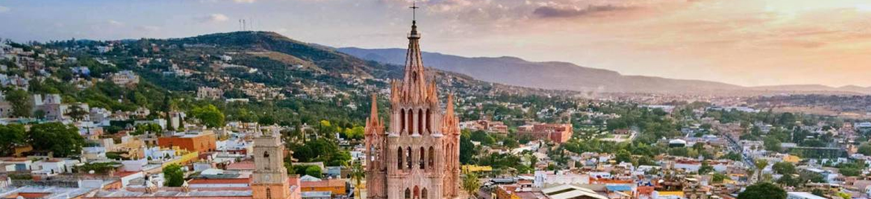
Arrival at Guanajuato international airport. Reception and transfer to hotel in San Miguel de Allende.

Check in at hotel. Rest of the day at leisure.

Lunch and dinner at leisure. Lodging

DAY 02 – SAN MIGUEL DE ALLENDE– City Tour

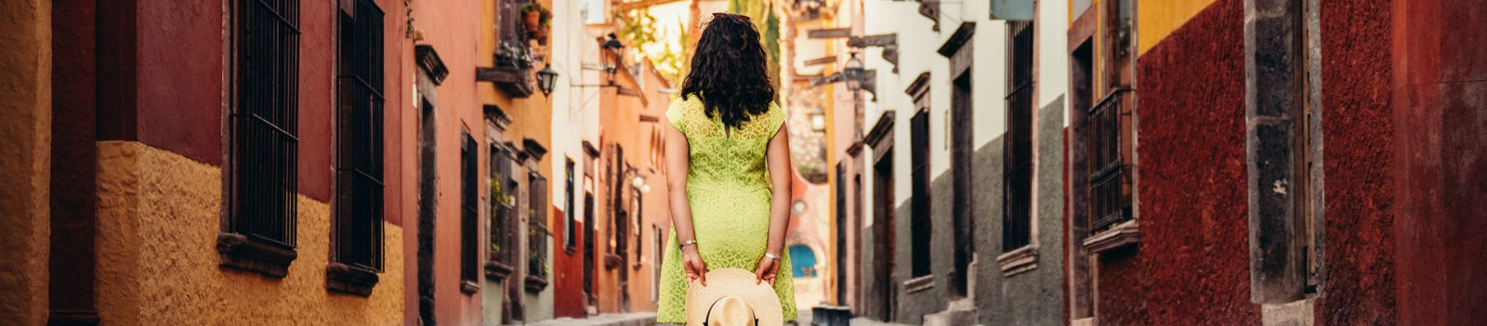

Breakfast at the hotel.

We will take a walk through the most interesting monuments of the city such as the Parish of San Miguel Arcangel with the incredible story of Zeferino Gutierrez, the house of Captain Ignacio Allende, the Temple of the Immaculate Conception and its ancient cloister, the Angela Peralta Theater, the old Laza de la Soledad, the Paso del Camino Real, the Franciscan Monastic Complex and learn about the tireless work of the religious.

Lunch and dinner on your own. Lodging.

DAY 03 – SAN MIGUEL DE ALLENDE – Cabalgata

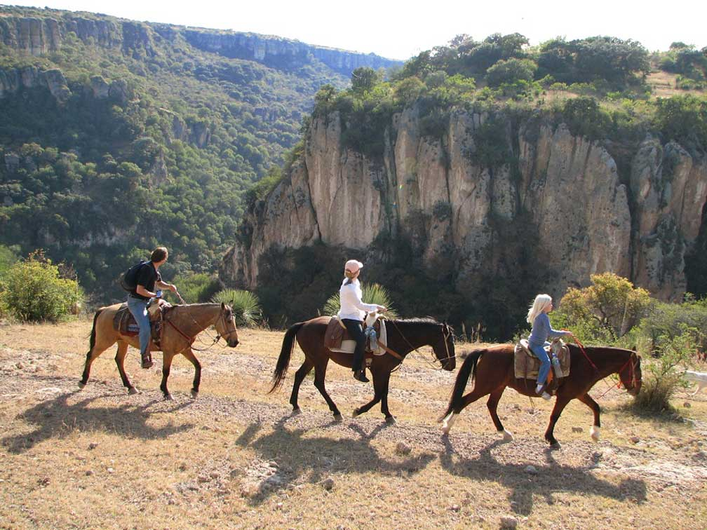

Breakfast at the hotel.

We will start by getting to know the ranch and learning about the tasks that are performed daily. In the first part of the excursion we will climb up to the top of the ravine, admiring spectacular scenery. In the river we gallop at several points and dismount to enjoy a rest and refresh ourselves. We go up the canyon and skirt its impressive 50-meter cliffs, with the most spectacular views of the excursion and with the option of rappelling down these rocks.
Finally, a delicious traditional homemade lunch will be waiting for us. Lunch (included) The menu includes tortillas al comal, fresh ranchero cheese and organic beans from the ranch, quesadillas, nopales, rice, fresh salsas, guacamole and salad, among other typical dishes.

Dinner at leisure. Lodging

DAY 04 – SAN MIGUEL DE ALLENDE – Caminata + Aguas Termales

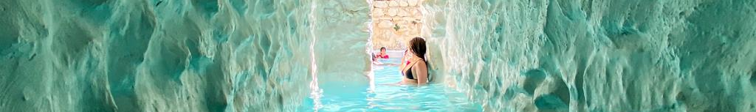 Breakfast at the hotel.

Starting the hike in the canyon we will explore a group of cattle ranches located west of San Miguel. The wonderful thing is that the main canyon of the region crosses the area we hike through. The ranch guides accompany us and share with us their anecdotes and their knowledge of the local flora and fauna. We start at the bottom of the canyon crossing the river, we rest to refresh ourselves. Afterwards, a delicious traditional homemade meal will be waiting for us. The menu includes fresh cheese and organic beans from the ranch, quesadillas, nopales, rice, fresh salsas, guacamole and salad, among other typical dishes. Finally, you can relieve your tensions and relax your muscles in one of the 10 thermal pools of the Escondido Place spa. In a privileged setting, enjoy its gardens, lakes and water lilies, and of course its relaxing indoor and outdoor pools. For a truly healing experience, take advantage of the excellent spa and massage services available.

Dinner at leisure. Lodging

DAY 05 – SAN MIGUEL DE ALLENDE/ OUT

Breakfast at the hotel.

At a convenient time transfer from your hotel to the airport to take your flight to your destination.

END of SERVICES

NOTE: The day of operation of the tours may vary

** VALIDATE RATES WITH YOUR TRAVEL AGENT

CITY | NIGHTS | HOTELS 3* | HOTELS 4* | HOTELS 4*
San Miguel de Allende | 04 | Misión San Miguel | Real de Minas San Miguel | Casa Primavera

INCLUDED:
- TRANSPORTATION: Air-conditioned touristic unit
- ACCOMMODATION: Hotels according to your choice
- MEALS: 04 Breakfasts in San Miguel Allende + 02 Lunch
- VISITS: Those mentioned in the program.
- ESCORT GUIDE: Bilingual, certified by the Ministry of Tourism

NOT INCLUDED:

- Air tickets
- Food or services not mentioned
- Taxes at the airport
- Tips to guides or drivers

IMPORTANT OBSERVATIONS:
- Due to the multiple changes that occur daily in tourism, these prices must be confirmed at the time of requesting the reservation.
- Rates subject to availability and changes without prior notice.
- Credit card payments are subject to a % commission.
- Please contemplate the schedule of Check in 15:00 hrs and Check Out 12:00 hrs.
- TRIPLE rooms only have 2 double beds.
- Transfers airport-hotel-airport are quoted in shared service, please consider flights arriving and departing between 06:00 and 22:00 hrs, otherwise it must be provided in private service and it will be necessary to re-quote.
- The waiting time for arrival transfers is 2 hours and 15 minutes. Once this time has elapsed, the passenger must transfer at his/her own expense.
- The tolerance time for departure transfer is 10 minutes, after this time the unit is withdrawn and you must transfer on your own to the apartment. * Under no circumstances will we be responsible for any extra expenses arising from this situation.
- Tours may change order according to the operations of the correspondent.

