PROGRAM
ESPLENDOR MAYA
05 days/04 nights

(Ticul, Santa Elena, Calcehtok, Uxmal, Kabah, Sayil, Labna, Chichen Itzá, Cenote)

Minimum 2 persons.
Daily Departures

ITINERARY

DAY 01 – IN / MÉRIDA
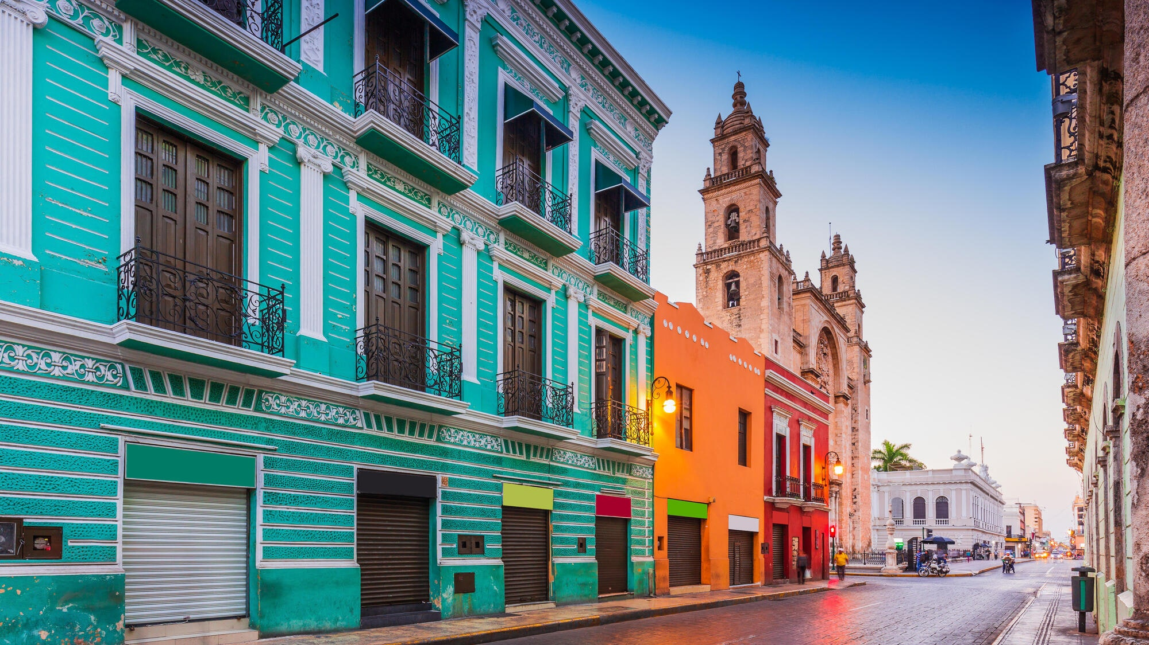

Arrival at merida airport. Reception and transfer to your hotel.

Check in at the hotel. Rest of the day at leisure.

Lunch and dinner on your own.

Lodging.

DAY 02 – MÉRIDA – Pueblos Mayas

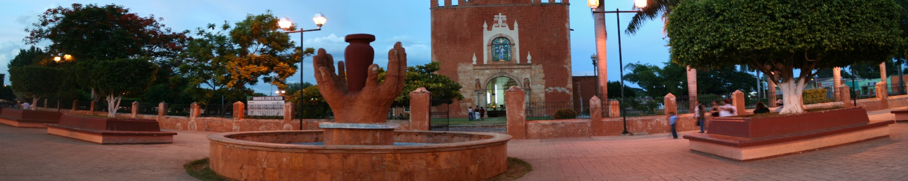
Breakfast at the hotel.

Ticul (the pearl of the south) is a quiet and beautiful city located 83 km from the city of Merida, we will visit ceramic workshops of classic and popular type, as well as the footwear industry for women, which have put it in a special place. We arrive in just 15 minutes to Santa Elena, among its attractions are the typical houses, traditional oval shape, which predominate in the village, immediately we realize that in so few km the villagers only speak the Mayan language and Spanish as a second language, we visit outside the majestic colonial style church built on a natural elevation, We visit the house of Don Hernan and Doña Asaria in Santa Elena, they will give us a lecture on how to live a happy life in contact with nature and culture, with them we will make handmade tortillas. We will arrive at 18 km to the restaurant area near Uxmal. Then we will go to the Calcehtok caves, it means "flint deer gorge" of 5 km, every day you can observe one of the most extraordinary events of nature: thousands of bats coming out of this cavern in search of their food in a natural way at sunset, after a space of patience we will observe for a few minutes.

Lunch and dinner on your own.
Lodging.

DAY 03 – MÉRIDA – Extraordinaria Ruta Puuc

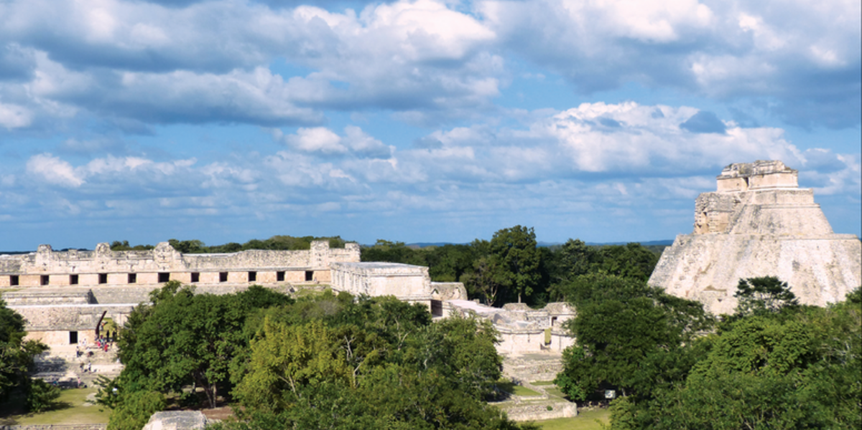

Breakfast at the hotel.

We visit the Mayan city of Uxmal known as the thrice built, which is located in an area of hills called Puuc, is the most important city in the area. in which the pyramid of the soothsayer, the quadrangle of the nuns and the governor's palace. In Kabah (hand that sculpts or powerful hand) we will walk beside the famous codz poop to appreciate its dozens of masks of the narigudo god; in Sayil we will see the three-story palace with its more than 90 rooms and in Labna we will walk from the palace to the famous arch of Labna. The archaeological sites of the Puuc area will impress us with their extraordinary architectural beauty that reflects the beliefs of the ancient Mayan civilization. We will stop at the local restaurant and after lunch and a short rest we will return to Merida to our hotels.

Lunch and dinner on your own.
Lodging.

DAY 04 – MÉRIDA – Chichen Itzá + La Puerta al Inframundo

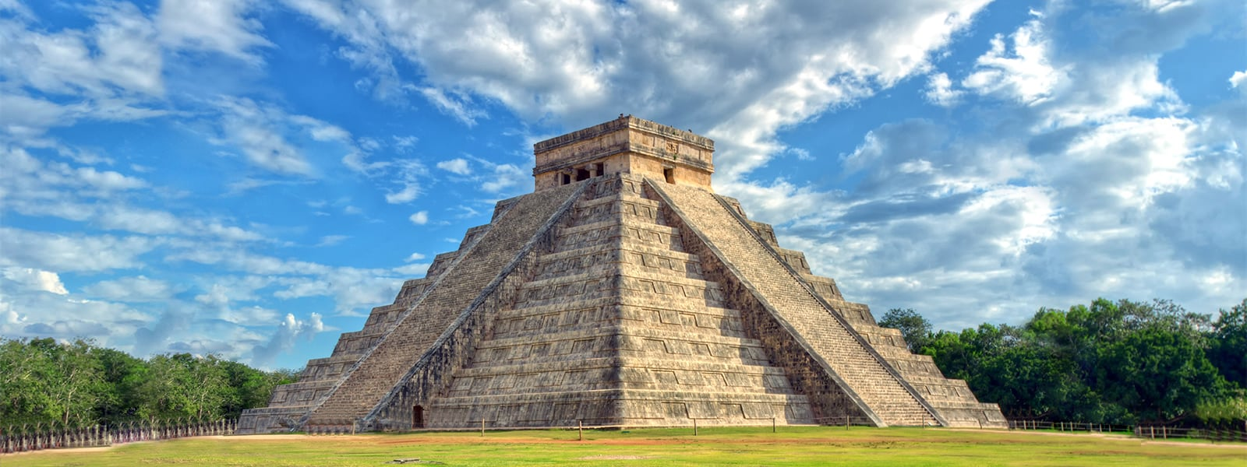
Breakfast at the hotel.

Leaving Merida we will go to one of the 7 new wonders, Chichen Itza (mouth of the well of the water sorcerers) was the most important city between the years 900 and 1300 of our era, highlighting the temple of Kukulkan or "the castle" that together with the temple of the warriors, the ball game, the astronomical observatory and the complex of the nuns show the great ceremonial character in which the city was managed. After visiting the site we will have lunch at a restaurant in the modern Mayan village of Piste. After lunch we head to visit the gateway to the Mayan underworld, a cenote near the town, where we will have the opportunity to refresh ourselves in its crystalline waters.

Lunch and dinner on your own.
Lodging

DAY 05 – MÉRIDA / OUT
Breakfast at the hotel.

At a convenient time transfer from your hotel to the airport to take your flight to your destination.

END OF SERVICES

NOTE: The day of operation of the tours may vary

** VALIDATE RATES WITH YOUR TRAVEL AGENT

CITY | NIGHTS | HOTELS 3* | HOTELS 4** | HOTELS SP*
Mérida | 04 | Marionetas | Villa Mercedes Curio | Rosas & Xocolate

INCLUDED:
- TRANSPORTATION: Air-conditioned touristic unit
- ACCOMMODATION: Hotels according to your choice
- MEALS: Daily Breakfast
- VISITS: Those mentioned in the program.
- ESCORT GUIDE: Bilingual, certified by the Ministry of Tourism
NOT INCLUDED:

- Air tickets
- Food or services not mentioned
- Taxes at the airport
- Tips to guides or drivers.

IMPORTANT OBSERVATIONS:
- Due to the multiple changes that occur daily in tourism, these prices must be confirmed at the time of requesting the reservation.
- Rates subject to availability and changes without prior notice.
- Credit card payments are subject to a % commission.
- Please contemplate the schedule of Check in 15:00 hrs and Check Out 12:00 hrs.
- TRIPLE rooms only have 2 double beds.
- Transfers airport-hotel-airport are quoted in shared service, please consider flights arriving and departing between 06:00 and 22:00 hrs, otherwise it must be provided in private service and it will be necessary to re-quote.
- The waiting time for arrival transfers is 2 hours and 15 minutes. Once this time has elapsed, the passenger must transfer at his/her own expense.
- The tolerance time for departure transfer is 10 minutes, after this time the unit is withdrawn and you must transfer on your own to the apartment. * Under no circumstances will we be responsible for any extra expenses arising from this situation.
- Tours may change order according to the operations of the correspondent.

