PROGRAM
ESPECTÁCULOS Y PLAYA
04 days/03 nights

(Puerto Vallarta, Bahía de Banderas, Mismaloya)

Minimum 2 persons.
Daily Departures

ITINERARY

DAY 01 – IN / PUERTO VALLARTA
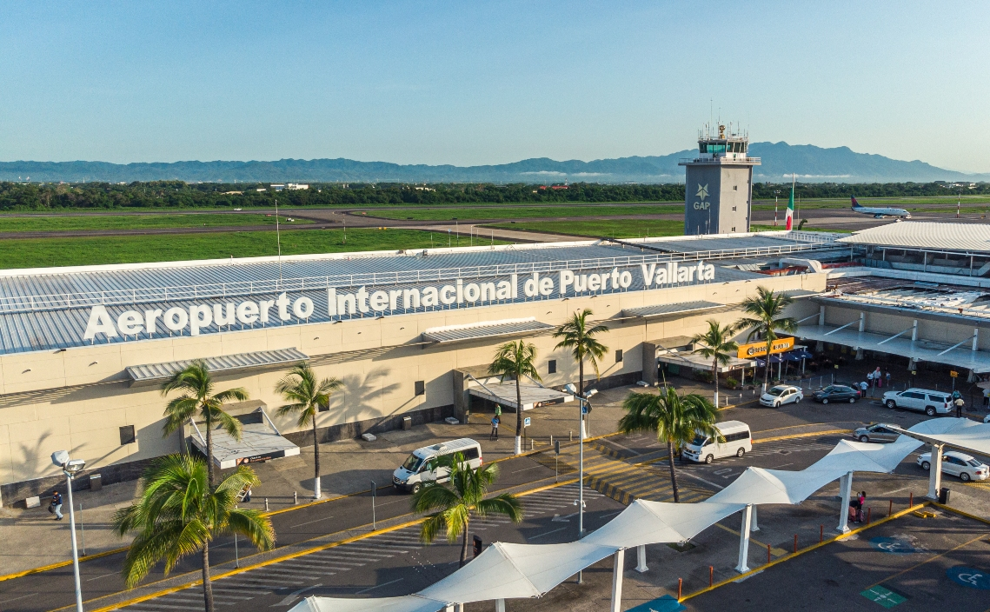
Arrival at Puerto Vallarta airport. Reception and transfer to hotel.
Check in at hotel. Rest of the day at leisure.
Lunch and dinner at leisure. Lodging

DAY 02 – PUERTO VALLARTA – Lo Mejor de Puerto Vallarta

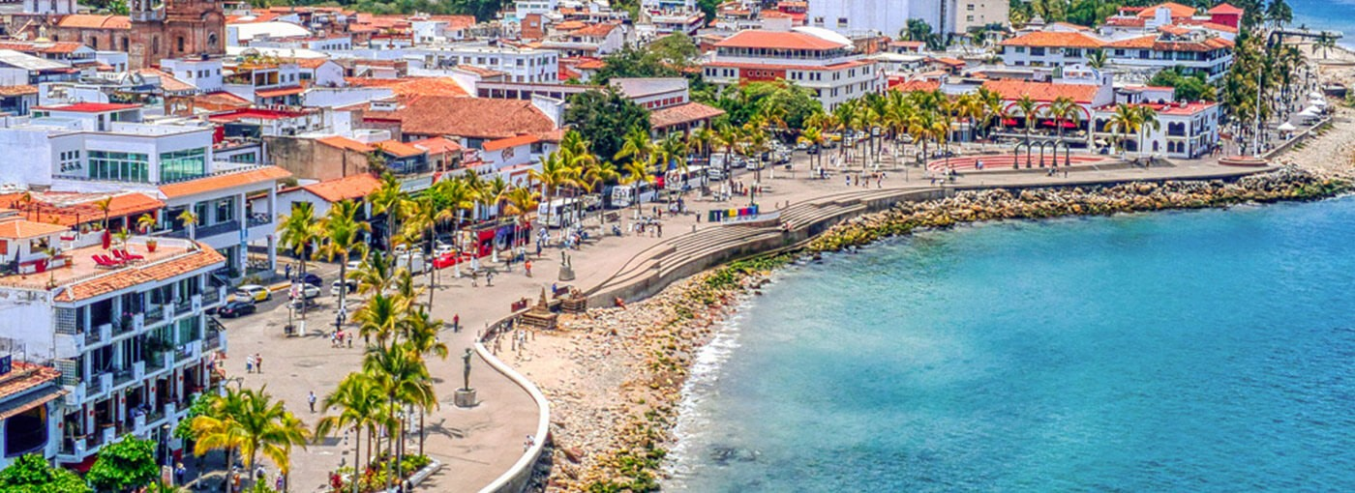

Breakfast at the hotel.

Great opportunity to get to know the picturesque city of Puerto Vallarta with its scenic South Coast of Banderas Bay and the history of the world famous "tequila" drink on this informative half day tour. We will start our tour aboard our comfortable bus traveling south along the coast passing through the exclusive residential section of the area admiring the green vegetation and the bright blue Pacific Ocean on this spectacular route until we reach "Mismaloya" where we will make a brief visit before continuing to a tequila distillery where we will enjoy a tour and tasting and continue back to "Downtown" Puerto Vallarta and the Malecon. It is time to leave the bus and follow our guide through cobblestone streets which will take us to visit the great attractions of the area, including the Cathedral of Our Lady of Guadalupe which stands out for its shining golden crown located at the top of its main tower. We will visit the "Rio Cuale" and its commercial area where you can buy handicrafts and gifts to take back home.

Lunch and dinner on your own. Lodging.

DAY 03 – PUERTO VALLARTA – Ritmos de Noche

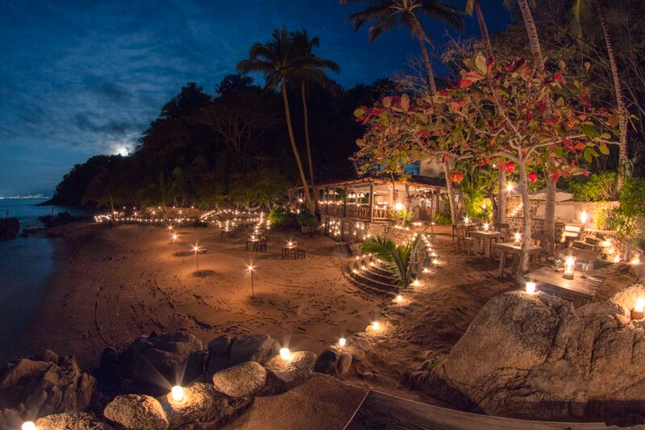

Breakfast at the hotel.

Our adventure begins with a scenic catamaran cruise along the beautiful shores of Banderas Bay; admire how the sun sets into the ocean as darkness descends framing a wonderful sunset. Our cruise continues under the starlight until we find the glow of the torches that will guide us to what will be our private refuge for the night, "Las Caletas". Enjoy your dinner while the sea caresses your feet and your waiter pampers you with dessert and coffee. At the end of dinner the sound of rhythmic drumming will guide you to the outdoor amphitheater where you will find, hidden in the jungle, a fabulous pyramid beautifully illuminated with torches providing this moment with a special atmosphere that will only be the beginning of an impressive and spectacular pre-Hispanic and contemporary show. Get ready to enjoy your relaxing cruise back dancing under the stars.

Lunch on your own. Lodging.

DAY 04 – PUERTO VALLARTA / OUT

Breakfast at the hotel.

At a convenient time transfer from your hotel to the airport to take your flight to your destination.

END of SERVICES

NOTE: The day of operation of the tours may vary.
** VALIDATE RATES WITH YOUR TRAVEL AGENT

CITY | NIGHTS | HOTELS 4* | HOTELS 4**
Puerto Vallarta | 03 | Friendly Fun Vallarta | Sheraton Buganvilias

INCLUDED:
- TRANSPORTATION: Air-conditioned touristic unit and bus ticket from Guadalajara to
Puerto Vallarta
- ACCOMMODATION: Hotels according to your choice
- MEALS: All inclusive plan
- VISITS: Those mentioned in the program.
- ESCORT GUIDE: Bilingual, certified by the Ministry of Tourism
NOT INCLUDED:

- Air tickets
- Food or services not mentioned
- Taxes at the airport
- Tips to guides or drivers.

IMPORTANT OBSERVATIONS:
- Due to the multiple changes that occur daily in tourism, these prices must be confirmed at the time of requesting the reservation.
- Rates subject to availability and changes without prior notice.
- Credit card payments are subject to a % commission.
- Please contemplate the schedule of Check in 15:00 hrs and Check Out 12:00 hrs.
- TRIPLE rooms only have 2 double beds.
- Transfers airport-hotel-airport are quoted in shared service, please consider flights arriving and departing between 06:00 and 22:00 hrs, otherwise it must be provided in private service and it will be necessary to re-quote.
- The waiting time for arrival transfers is 2 hours and 15 minutes. Once this time has elapsed, the passenger must transfer at his/her own expense.
- The tolerance time for departure transfer is 10 minutes, after this time the unit is withdrawn and you must transfer on your own to the apartment. * Under no circumstances will we be responsible for any extra expenses arising from this situation.
- Tours may change order according to the operations of the correspondent.

