PROGRAM
ENAMORATE DE COAHULIA
05 days/04 nights

(Viesca, Parras de la Fuente, Arteaga, General de Cepeda)

Minimum 2 persons.
Daily Departures

ITINERARY

DAY 01 – IN / SALTILLO
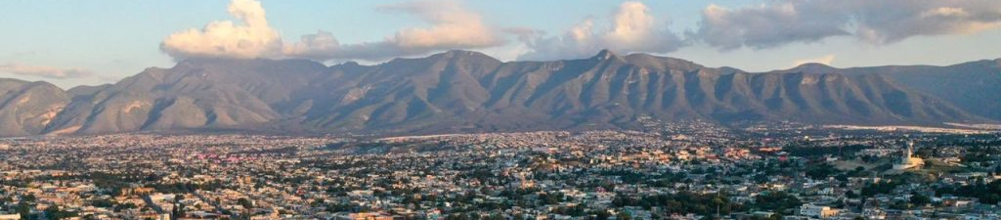
Arrival at Saltillo International Airport. Reception and transfer to your hotel.
Check in at hotel. Rest of the day at leisure.
Lunch and dinner at leisure. Lodging

DAY 02 – SALTILLO – Viesca y Parras de la Fuente

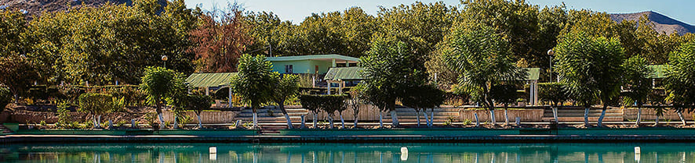

Breakfast at the hotel.

In the morning we will visit the Magical Town of Viesca where we will visit the Dunes of Bilbao, the Church of Santiago Apostle, the Main Square, the Old Tree where Miguel Hidalgo rested. At the end of the afternoon transfer to the town of Parras. Where we will have the opportunity to visit the oldest winery in America visiting the Historic Center and other attractions of Pueblo Magico: Casa Madero, Fuantos Segovia Wines, the World's Largest Pants, La Parvada Wines, Campechanas Factory, Plaza de Reloj, Presidency, Alameda, Santo Madero Church, El Perote Wines, Purchase of Sotol.

Lunch and dinner at leisure. Lodging

DAY 03 – SALTILLO - Arteaga

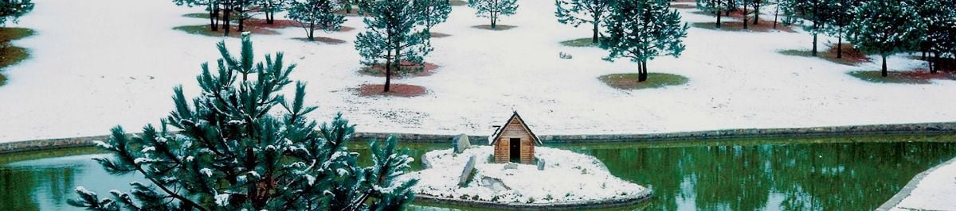

Breakfast at the hotel.

You will visit this peaceful and cheerful town full of orchards, located in the middle of the Sierra de Coahuila, where it rises like an island in the middle of the great desert that identifies this northern region of the country, to conquer you with beautiful wooded landscapes, a delicious smell of fruits and a spectacular mountain range.
First you will visit the Temple of San Isidro Labrador de las Palomas, this one presents in its facade two bodies decorated with thick pilasters that frame three niches, in the first one you can appreciate some little angels, in the second one the window of the choir and in the third one the image of Jesus Christ is housed, while an old clock tops the tower; Carranza house, has a collection of historical photos of the place; the Municipal Presidency and the mural Canto de Esperanza by Eloy Cerecero, dedicated to the manifesto. To the Mexican town of Venustiano Carranza.

Lunch and dinner at leisure. Lodging

DAY 04 – SALTILLO – General de Cepeda

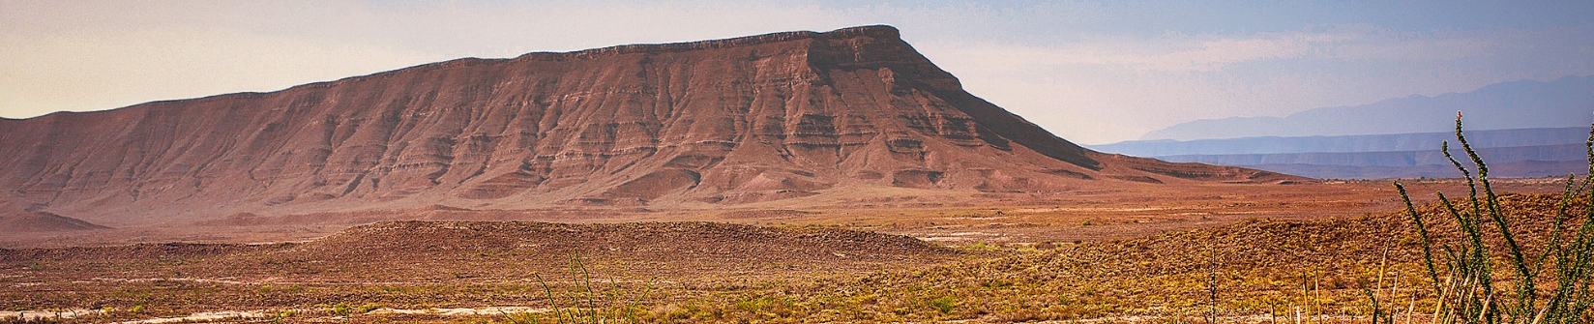
Breakfast at the hotel.

Tour of the Municipal Presidency, which was once the main house of the Hacienda de San Francisco de Patos, Administrative Headquarters of the Marquis of Aguayo, visit the Temple of San Francisco and the Molino Quemado, a site where the apparitions of the Marquis are recurrent and to finish our tour in this interesting town we will visit the Museum of History Atlahuaco.

Lunch and dinner at leisure. Lodging

DAY 05 – SALTILLO / OUT

Breakfast at the hotel.

At a convenient time transfer from your hotel to the airport to take your flight to your destination.

END OF SERVICES

** VALIDATE RATES WITH YOUR TRAVEL AGENT
INCLUDED:
- TRANSPORTATION: Air-conditioned touristic unit
- ACCOMMODATION: Hotels according to your choice
- MEALS: 05 Breakfast
- VISITS: Those mentioned in the program.
- ESCORT GUIDE: Bilingual, certified by the Ministry of Tourism
NOT INCLUDED:
- Air tickets
- Food or services not mentioned
- Taxes at the airport
- Tips to guides or drivers.

IMPORTANT OBSERVATIONS:
- Due to the multiple changes that occur daily in tourism, these prices must be confirmed at the time of requesting the reservation.
- Rates subject to availability and changes without prior notice.
- Credit card payments are subject to a % commission.
- Please contemplate the schedule of Check in 15:00 hrs and Check Out 12:00 hrs.
- TRIPLE rooms only have 2 double beds.
- Transfers airport-hotel-airport are quoted in shared service, please consider flights arriving and departing between 06:00 and 22:00 hrs, otherwise it must be provided in private service and it will be necessary to re-quote.
- The waiting time for arrival transfers is 2 hours and 15 minutes. Once this time has elapsed, the passenger must transfer at his/her own expense.
- The tolerance time for departure transfer is 10 minutes, after this time the unit is withdrawn and you must transfer on your own to the apartment. * Under no circumstances will we be responsible for any extra expenses arising from this situation.
- Tours may change order according to the operations of the correspondent.

