PROGRAM
EL MONOLITO DE QUERÉTARO
04 days/03 nights

(Mitos y Leyendas, Bernal)

Minimum 2 persons.
Daily Departures

ITINERARY

DIAY 01 – IN / QUERÉTARO
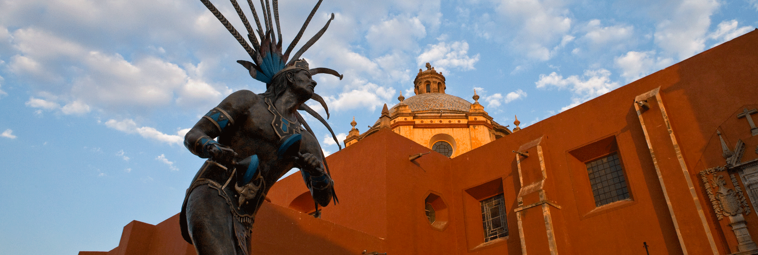
Arrival at the airport or bus station in Queretaro. Reception and transfer to hotel.
Check in at hotel. Rest of the day at leisure.
Lunch and dinner at leisure.
Lodging

DAY 02 – QUERÉTARO – Mitos y Leyendas (Night pedestrian tour) Thursday - Saturday

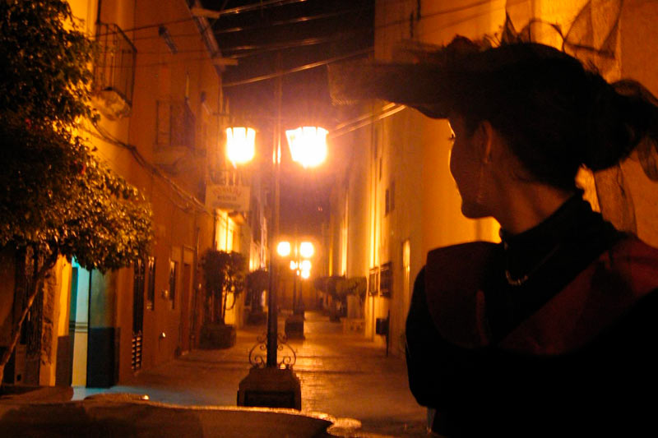

Breakfast at the hotel.

Walk through the mansions and alleys of the city of Queretaro, where you will learn the most impressive stories of fear and mysteries. During the tour, professional actors will bring to life the characters that became legends, such as Don Bartolo, La Llorona, Los dos fríos, El Marqués, La Zacatecana, among others, and will take you back to many years ago, making this an unforgettable experience.

Lunch and dinner on your own.
Lodging.

DAY 03 – QUERÉTARO – Peña de Bernal

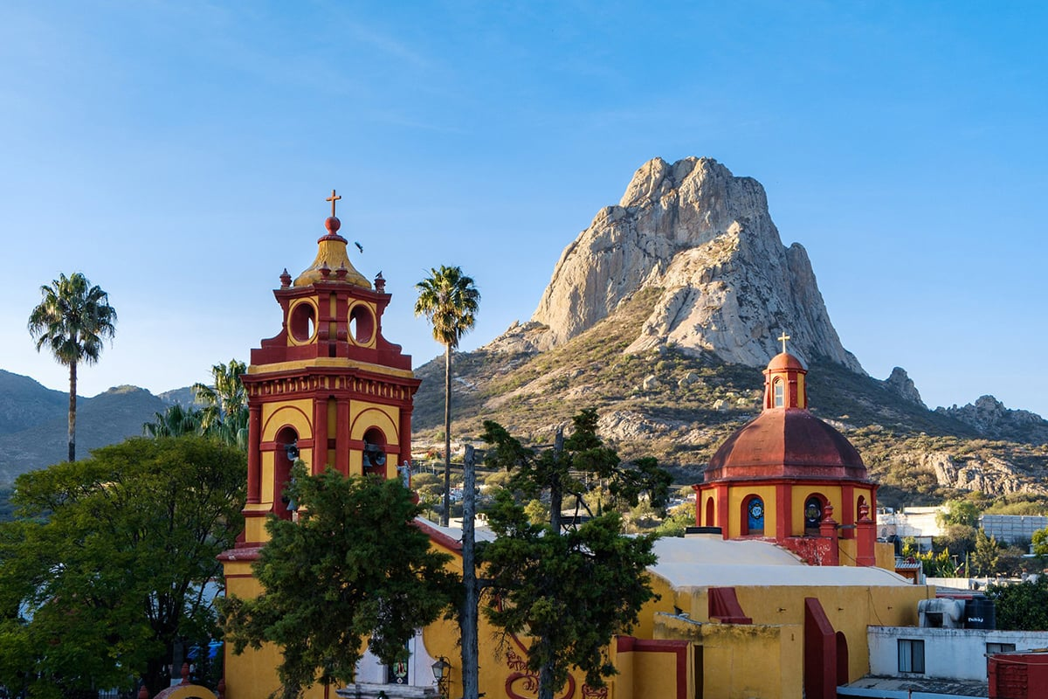

Breakfast at the hotel.

The Peña de Bernal is the third largest monolith in the world and is 350 meters high, weighs 4,000,000 tons and is 10,000,000 years old. Enjoy the flora and fauna of the place and taste the delicious gastronomy that you will find, tour the Peña not before strolling through the magical town of Bernal and enjoy its colorful handicrafts.

Lunch and dinner on your own.
Lodging.

DAY 04 – QUERÉTARO / OUT

Breakfast at the hotel.

At a convenient time transfer from your hotel to the airport to take your flight to your destination.

END OF SERVICES

NOTE: The day of operation of the tours may vary.

** VALIDATE RATES WITH YOUR TRAVEL AGENT

CITY | NIGHTS | HOTELS 3** | HOTELS 4* | HOTELS 5*
Querétaro | 03 | Señorial | NH Querétaro | Grand Hotel (breakfasts from Monday to Friday)

INCLUDED:
- TRANSPORTATION: Air-conditioned touristic unit
- ACCOMMODATION: Hotels according to your choice
- MEALS: Daily Breakfast
- VISITS: Those mentioned in the program.
- ESCORT GUIDE: Bilingual, certified by the Ministry of Tourism
NOT INCLUDED:

- Air tickets
- Food or services not mentioned
- Taxes at the airport
- Tips to guides or drivers.

IMPORTANT OBSERVATIONS:
- Due to the multiple changes that occur daily in tourism, these prices must be confirmed at the time of requesting the reservation.
- Rates subject to availability and changes without prior notice.
- Credit card payments are subject to a % commission.
- Please contemplate the schedule of Check in 15:00 hrs and Check Out 12:00 hrs.
- TRIPLE rooms only have 2 double beds.
- The waiting time for arrival transfers is 2 hours and 15 minutes. Once this time has elapsed, the passenger must transfer at his/her own expense.
- The tolerance time for departure transfer is 10 minutes, after this time the unit is withdrawn and you must transfer on your own to the apartment. * Under no circumstances will we be responsible for any extra expenses arising from this situation.
- Tours may change order according to the operations of the correspondent.

