PROGRAM
DURANGO HISTORICO
06 days/05 nights

(Ciudad, Tierra de Villa, San Juan del Rio Durango, Mapimi, Nombre de Dios)

Minimum 2 persons.
Daily Departures

ITINERARY

DAY 01 – IN / DURANGO
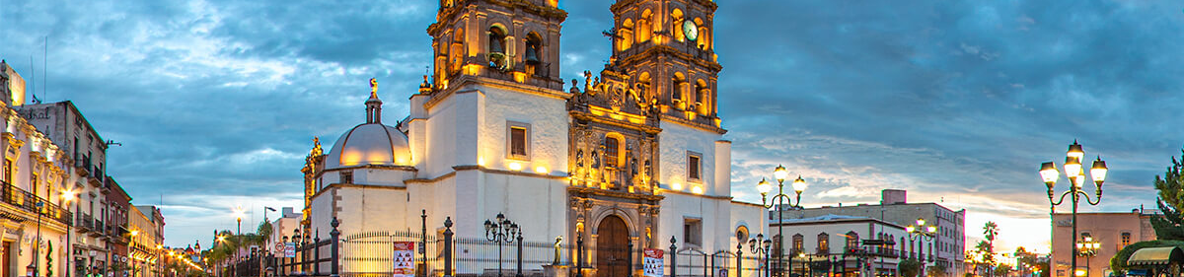

Arrival at Durango International Airport. Reception and transfer to your hotel.

Check in at hotel. Rest of the day at leisure.

Lunch and dinner at leisure. Lodging

DAY 02 – Durango – Visita de Ciudad (Museo Nacional Francisco Villa y Museo de Arte Sacro)

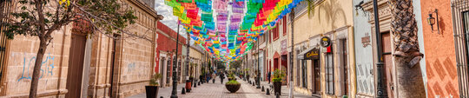

Breakfast at the hotel.

The building known as “El Palacio de Zambrano” was owned by the miner Juan José Zambrano and later became the headquarters of the Durango State Government for more than 150 years. The Palace was given to the Institute of Culture of the State of Durango to house the museum. Extraordinary exhibition of collection objects and history. This museum transports us, thanks to all its rooms, to the colonial era, a transcendental time in the Americas and the Christianization of the colony. This museum contains touches of “mystery” and surprise enough to project the splendor and Christian influence and faith. A museum cannot the only one of its kind in the north of the country!

Lunch and dinner at leisure. Lodging

DAY 03 – DURANGO – Tierra de Villa (San Juan del Río Durango)

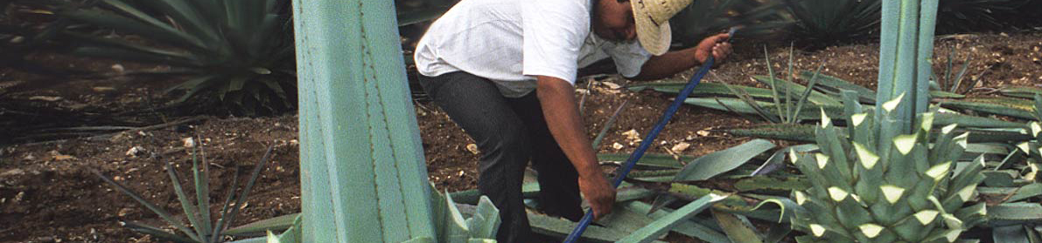

Breakfast at the hotel.

We visit the region and towns that are the birthplace of the Centauro del Norte. The region includes four municipalities in the heart of the state of Durango. Coneto de Comonfort, Nuevo Ideal, Canatlan, the Mennonite colony and San Juan del Rio. As well as the emblematic spot of La Coyotada where the birthplace and growing place of Pancho Villa is located. Tourist attractions such as: The Cañón de Catedral, is formed by the San Juan River, it is located in the community of Ignacio López Rayón. The Paso Artesiano del Sauz de Abajo well, which has thermal waters. The Convent and Church of San Francisco, dating from the XVII and XVIII centuries. The General Francisco Villa community museum located in La Coyotada, and the Casa de Cultura that houses the San Juan en la Historia community museum. Valleys, ravines, mountains, rivers, mines and hot springs make its nest. A place of warm and friendly people with a gastronomy where the art of good bread, as well as the preserves and candies made from walnuts are the delight of locals and passers-by. Only 45 minutes north of the capital towards the city of Parral Chihuahua, Durango shows us how much it has been appreciated by foreigners such as John Wayne, mythical Hollywood actor, who, without being a coincidence, made a residence and film set in these places.

Lunch and dinner at leisure. Lodging

DAY 04 – DURANGO – Pueblo Mágico de Mapimi

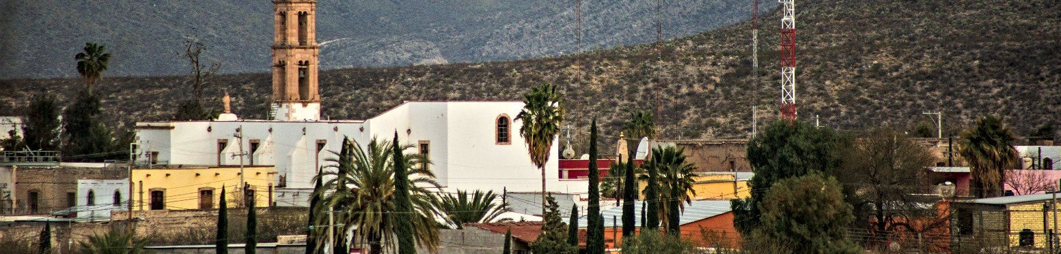

Breakfast at the hotel.

We invite you to discover Durango. On this occasion, a municipality that offers you the most beautiful landscapes of the semi-desert.
desert. Declared a “Pueblo Magico” (Magic Town), it is a place for lovers of adventure, nature, tranquility and photography. Witness of historical events such as the Independence and the Revolution invites us to know:
Templo de Santiago Apostol, Temple of Santiago Apostle, House of Miguel Hidalgo y Costilla, Municipal Museum “Benito Juarez”, Hanging Bridge of Ojuela, Mina de Ojuela Tour.

Lunch and dinner at leisure. Lodging

DAY 05 – DURANGO – Pueblo Mágico Nombre de Dios

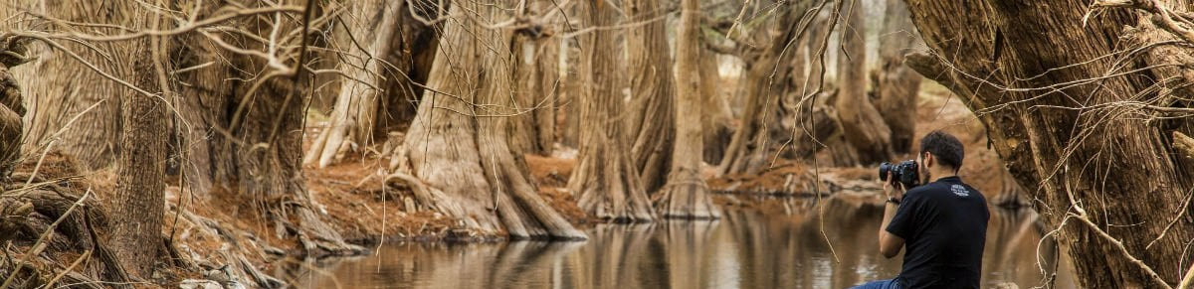

Breakfast at the hotel.

Get to know the cradle of mestizaje in the old kingdom of the new Vizcaya. This time, the municipality of Nombre de Dios, Durango, just 30 minutes away, on the way to Zacatecas, you will visit: The First Franciscan temple, the royal road inland or silver road, declared a World Heritage Site by UNESCO. You will taste its extraordinary gastronomy and delicious mezcal made from local fruits. Landscapes that include the imposing Sabinos and landscapes that have been immortalized in various period films.

Lunch and dinner at leisure. Lodging

DAY 06 – DURANGO / OUT

Breakfast at the hotel.

At a convenient time transfer from your hotel to the airport to take your flight to your destination.

END of SERVICES

NOTE: The day of operation of the tours may vary.
** VALIDATE RATES WITH YOUR TRAVEL AGENT

INCLUDED:
- TRANSPORTATION: Air-conditioned touristic unit
- ACCOMMODATION: Hotels according to your choice
- MEALS: 05 Breakfast
- VISITS: Those mentioned in the program.
- ESCORT GUIDE: Bilingual, certified by the Ministry of Tourism
NOT INCLUDED:

- Air tickets
- Food or services not mentioned
- Taxes at the airport
- Tips to guides or drivers.

IMPORTANT OBSERVATIONS:
- Due to the multiple changes that occur daily in tourism, these prices must be confirmed at the time of requesting the reservation.
- Rates subject to availability and changes without prior notice.
- Credit card payments are subject to a % commission.
- Please contemplate the schedule of Check in 15:00 hrs and Check Out 12:00 hrs.
- TRIPLE rooms only have 2 double beds.
- Transfers airport-hotel-airport are quoted in shared service, please consider flights arriving and departing between 06:00 and 22:00 hrs, otherwise it must be provided in private service and it will be necessary to re-quote.
- The waiting time for arrival transfers is 2 hours and 15 minutes. Once this time has elapsed, the passenger must transfer at his/her own expense.
- The tolerance time for departure transfer is 10 minutes, after this time the unit is withdrawn and you must transfer on your own to the apartment. * Under no circumstances will we be responsible for any extra expenses arising from this situation.
- Tours may change order according to the operations of the correspondent.

