PROGRAM
CONOCE LOS RINCONES DE MORELOS
04 days/03 nights

(Tepoztlán, Tlayacapan, Xochitepec, Tlaltizapán de Zapata)

Minimum 2 persons.
Daily Departures

ITINERARY

DAY 01 – IN / CIUDAD DE MEXICO

Arrival at Mexico City International Airport. Reception and transfer to your hotel.

Check in at hotel. Rest of the day at leisure.

Lunch and dinner at leisure. Lodging

DAY 02 – CIUDAD DE MEXICO – Tepoztlán - Tlayacapan

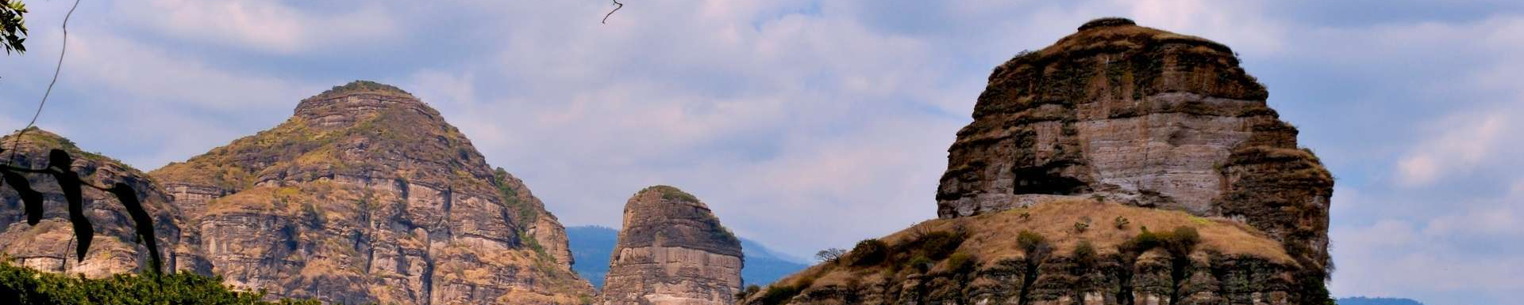
Breakfast at the hotel.

Under the protection of the Cerro del Tepozteco and with a history that seduces any visitor, Tepoztlán attracts with its mystique, its warm climate and its energy. Getting here can result in rest and meditation as well as in effort and purification, Tepoztlán is the magical town par excellence! But it is also a town of festivities, with its dance of the Chinelos and those vigorous jumps that cheer and give vitality to the neighborhoods at different times of the year. The Tepozteco Hill Its pyramid was built 800 years ago by the Xochimilcas. It was a place of worship and a place of great pilgrimages. Here they worshipped Ometochtli Tepoztécatl, the god of pulque associated with plant fertility and the winds. The sierra where it is located has been a Protected Natural Area since 1937. Around 54 endemic species live here and it is home to a large number of avian species. Visit the pre-Hispanic structure at the top of the hill and appreciate the view of the town from that height. If you want to relax and enjoy nature, Tepoztlán is the right place. The imposing Tepozteco and the delicious snows of the region await you. In addition, we will visit Tlayacapan, a place where a series of wonders are hidden, including its Municipal Palace, considered the oldest in Mexico. Hidden here is a whole series of wonders that include an incredible mountainous landscape, dozens of beautiful neighborhood chapels, traditions, gastronomy and a superb 16th century convent.
Templo y Ex Convento de San Juan Bautista Completed in 1572, it was erected by the Augustinian friars. It has an open chapel, a pilgrims' portal and a formidable cloister with Gothic vaults. Its sala de profundis preserves one of the best mural ensembles of the center of the country.

Lunch and dinner at leisure. Lodging

DAY 03 – CIUDAD DE MEXICO – Xochitepec - Tlaltizapán de Zapata

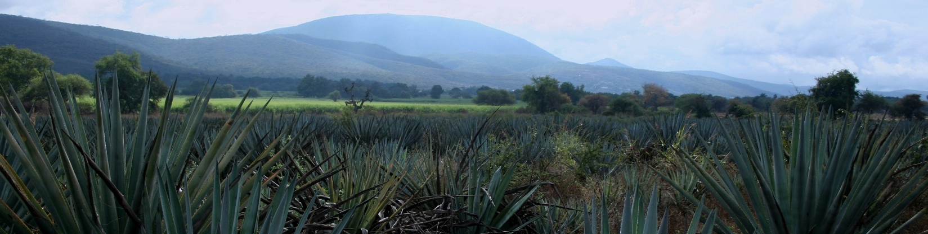

Breakfast at the hotel.

Xochitepec with colorful streets, delicious gastronomy, architectural precincts and an atmosphere that seems stopped in time, Xochitepec is a great option for a weekend getaway. It is less than two hours from Mexico City and is located in the west of the state of Morelos, offering a great tourist proposal to its visitors. Its name means “Cerro de las Flores”, coming from the Nahuatl words, xōchi 'flower', tepē 'hill' and c 'in'.This beautiful Magical Town is rich in traditions, gastronomy, culture, architecture and history. It enjoys an excellent climate, rustic landscapes and natural spaces that give a moment of disconnection and tranquility. In addition, like other places in Morelos, in the region you will be able to enjoy incredible spas with crystal clear waters. In addition, one of the most representative corners of the Magical Town is the Cerrito, an emblematic place that serves as the base of a beautiful clock. It was created by the villagers with the belief that it would serve to prevent diseases and to protect grains and food. The locals say that the Cerrito is essential because it receives the positive energy of cosmic rays and manifests harmony, prosperity and health. Taste the delicious gastronomy of Xochitepec in the municipal market. In addition to tasting antojitos, you will find socio-cultural events and typical crafts of the region. Then we headed to Tlaltizapán de Zapata is known for being the Magical Town of the Southern Revolution and for its beautiful springs with crystal clear waters. These springs are fed by water that thaws in the distant volcanoes, thus creating beautiful spas. Rich in culture, tradition and historical monuments, this destination is ideal for a weekend getaway, as it is only a two-hour drive from Mexico City. Located in the heart of the diverse state of Morelos, this Magical Town offers some of the best spas and water parks in the state. To visit Tlaltizapán de Zapata is to connect with the history and nature characteristic of Morelos. The history of this town is linked to the caudillo of the south, Emiliano Zapata, who fought during the Mexican Revolution with the firm conviction that the land belongs to those who work it. The reason is that the caudillo chose this town as his headquarters of operations, thanks to its strategic location. Therefore, in this place there are several monuments that narrate some of the historical events of the town and Zapata, such as the Zapatista Mausoleum and the Museum of the Southern Revolution.

Lunch and dinner at leisure. Lodging

DAY 04 – CIUDAD DE MEXICO / OUT

Breakfast at the hotel.

At a convenient time transfer from your hotel to the airport to take your flight to your destination.

END OF SERVICES

** VALIDATE RATES WITH YOUR TRAVEL AGENT

INCLUDED:
- TRANSPORTATION: Air-conditioned touristic unit
- ACCOMMODATION: Hotels according to your choice
- MEALS: 03 Breakfast
- VISITS: Those mentioned in the program.
- ESCORT GUIDE: Bilingual, certified by the Ministry of Tourism
NOT INCLUDED:

- Air tickets
- Food or services not mentioned
- Taxes at the airport
- Tips to guides or drivers.

IMPORTANT OBSERVATIONS:
- Due to the multiple changes that occur daily in tourism, these prices must be confirmed at the time of requesting the reservation.
- Rates subject to availability and changes without prior notice.
- Credit card payments are subject to a % commission.
- Please contemplate the schedule of Check in 15:00 hrs and Check Out 12:00 hrs.
- TRIPLE rooms only have 2 double beds.
- Transfers airport-hotel-airport are quoted in shared service, please consider flights arriving and departing between 06:00 and 22:00 hrs, otherwise it must be provided in private service and it will be necessary to re-quote.
- The waiting time for arrival transfers is 2 hours and 15 minutes. Once this time has elapsed, the passenger must transfer at his/her own expense.
- The tolerance time for departure transfer is 10 minutes, after this time the unit is withdrawn and you must transfer on your own to the apartment. * Under no circumstances will we be responsible for any extra expenses arising from this situation.
- Tours may change order according to the operations of the correspondent.

