PROGRAM
CHIHUAHUA Y LOS MOCHIS CON TREN CHEPE
05 days/04 nights

(Ciudad, Creel, Chepe, Parque Aventura y Teleférico, El fuerte, Los Mochis)

Minimum 2 persons.
Daily Departures

ITINERARIO

DAY 01 – IN / CHIHUAHUA – City Tour


Arrival at Chihuahua International Airport. Reception and transfer to your hotel.

Check in at hotel. Guided tour day (the time of your tour will be assigned upon arrival) through the main points of interest of the city visiting the Pancho Villa Museum (closed on Mondays), the Government Palace and its murals describing the history of the state, the Cathedral, the Colonial Aqueduct and the residential area.

Light dinner included and free lunch.
Lodging

DAY 02 – CHIHUAHUA – Creel

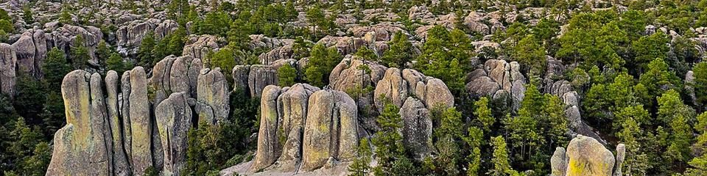
Breakfast at the hotel.

In the morning at 6:00 am you will be transferred to the Autotransportes Turísticos del Noroeste station (local line/continuous stops) to board your bus at 7:00 am to Creel. Experience a unique hike through the southern region of Creel to enjoy and observe the natural beauty of its valleys. Within them you will see rocks that are shaped like mushrooms, frogs and monks. These valleys have volcanic rocks that were sculpted by the erosion of nature. Besides appreciating the rocks, you will find yourself in a beautiful forest with several species of pine and oak trees inhabited by various species of birds, wild animals and carnivores. Arrival at approximately 11:00 am and transfer to the hotel. Free day.

Lunch and dinner on your own.Lodging.

DAY 03 – CHIHUAHUA – Creel – Parque Aventura y Teleférico - DIVISADERO

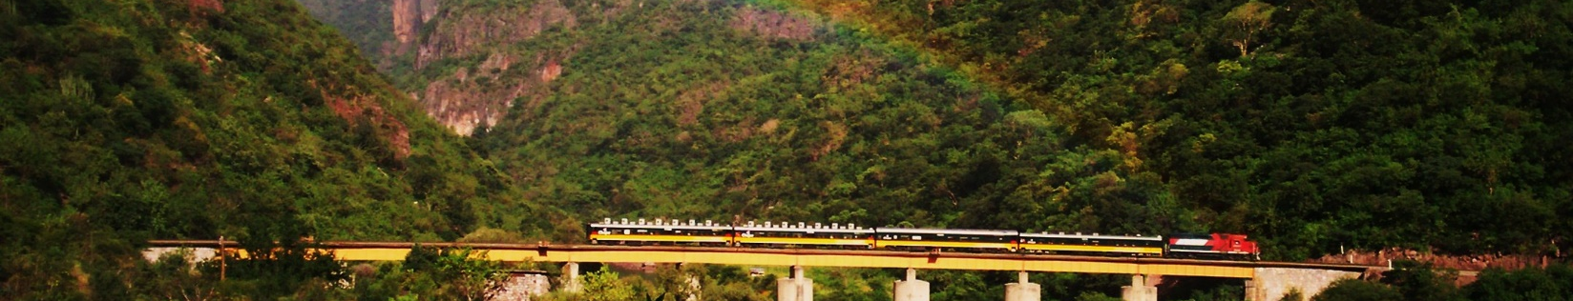
Breakfast at the hotel.

At 10:30 AM. transfer to the Autotransportes Turísticos Noroeste bus station (local line/continuous stops) by your hotel staff to board at 11:00 am your bus to Divisadero. Arrival at approximately 12:00 pm at Divisadero station, please locate your hotel transportation for your transfer to your hotel.
In the afternoon; visit the Barrancas del Cobre Adventure Park located in the area and where you can visit the different viewpoints, flying stone viewpoint, challenge your adventurous spirit on the suspension bridge that crosses a small canyon, ride the cable car or zip lines.

Lunch and dinner on your own.
Lodging.

DAY 04 –DIVISADERO – El Chepe - El Fuerte

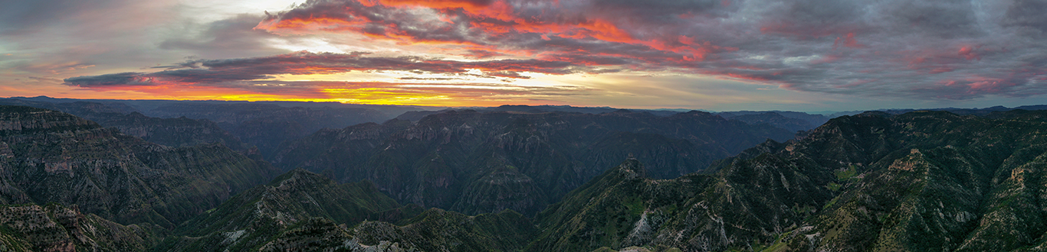
Breakfast at the hotel.

Transfer to the train station by hotel staff to board the tourist class Chepe Express Train at 9:55 am to the colonial city of El Fuerte. Enjoy the most interesting part of the train ride as you cross several bridges and tunnels that adorn the impressive views that the Sierra Madre mountain range offers.
Arrival at El Fuerte "Pueblo Magico" at 2:35 pm where you will be met by Mr. Pedro Bernal (transfer driver) and transferred to your hotel. This afternoon; walk on your own through the cobblestone streets, visit its colonial church, the municipal palace, the market, the local museum, also take a relaxing walk along the banks of the river that crosses by the side of your hotel or simply enjoy the beautiful facilities of your hotel. We also recommend that you delight your palate with delicious seafood dishes offered by the various local restaurants or your own hotel; our recommendation: Cauque or river prawns!

Lunch and dinner on your own.
Lodging.

DAY 05 – EL FUERTE – LOS MOCHIS / OUT
Breakfast at the hotel.

Transfer to Los Mochis airport by Mr. Pedro Bernal (transfer driver), please consider two hours of road transfer and two hours of prior registration that the airlines request.

END OF SERVICES

NOTE: The day of operation of the tours may vary.

**VALIDATE RATES WITH YOUR TRAVEL AGENT

CITY | NIGHTS | HOTELS 4*
Chihuahua | 01 | Hampton By Hilton
Creel | 01 | Villa Santa Cruz Plus
Divisadero | 01 | Barrancas del Cobre
El Fuerte | 01 | La Choza

INCLUDED:
- TRANSPORTATION: Air-conditioned touristic unit
- ACCOMMODATION: Hotels according to your choice
- MEALS: Daily breakfasts
- VISITS: Those mentioned in the program.
- ESCORT GUIDE: Bilingual, certified by the Ministry of Tourism
NOT INCLUDED:

- Air tickets
- Food or services not mentioned
- Taxes at the airport
- Tips to guides or drivers.

IMPORTANT OBSERVATIONS:
- Due to the multiple changes that occur daily in tourism, these prices must be confirmed at the time of requesting the reservation.
- Rates subject to availability and changes without prior notice.
- Credit card payments are subject to a % commission.
- Please contemplate the schedule of Check in 15:00 hrs and Check Out 12:00 hrs.
- TRIPLE rooms only have 2 double beds.
- Transfers airport-hotel-airport are quoted in shared service, please consider flights arriving and departing between 06:00 and 22:00 hrs, otherwise it must be provided in private service and it will be necessary to re-quote.
- The waiting time for arrival transfers is 2 hours and 15 minutes. Once this time has elapsed, the passenger must transfer at his/her own expense.
- The tolerance time for departure transfer is 10 minutes, after this time the unit is withdrawn and you must transfer on your own to the apartment. * Under no circumstances are we responsible for any extra expenses arising from this situation.
- Tours may change order according to the operations of the correspondent.

