PROGRAM
CHIHUAHUA CREEL – DIVISADERO Y TREN CHEPE
05 days/04 nights

(Ciudad, Creel, Chepe, Parque Aventura y Teleférico)

Minimum 2 persons.
Daily Departures

ITINERARY

DAY 01 – IN / CHIHUAHUA – City Tour

Arrival at Chihuahua International Airport. Reception and transfer to your hotel.

Check in at hotel. Guided tour day (the time of your tour will be assigned upon arrival) through the main points of interest of the city visiting the Pancho Villa Museum (closed on Mondays), the Government Palace and its murals describing the history of the state, the Cathedral, the Colonial Aqueduct and the residential area.

Light dinner included and free lunch.
Lodging

DAY 02 – CHIHUAHUA – Creel

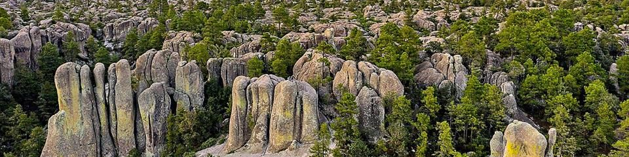
Breakfast at the hotel.

In the morning at 6:00 am you will be transferred to the Autotransportes Turísticos del Noroeste station (local line/continuous stops) to board your bus at 7:00 am to Creel. Experience a unique hike through the southern region of Creel to enjoy and observe the natural beauty of its valleys. Within them you will see rocks that are shaped like mushrooms, frogs and monks. These valleys have volcanic rocks that were sculpted by the erosion of nature. Besides appreciating the rocks, you will find yourself in a beautiful forest with several species of pine and oak trees inhabited by various species of birds, wild animals and carnivores. Arrival at approximately 11:00 am and transfer to the hotel. Free day.

Lunch and dinner on your own.
Lodging

DAY 03 – CHIHUAHUA – Creel - Tren Chepe – Parque Aventura y Teleférico - DIVISADERO

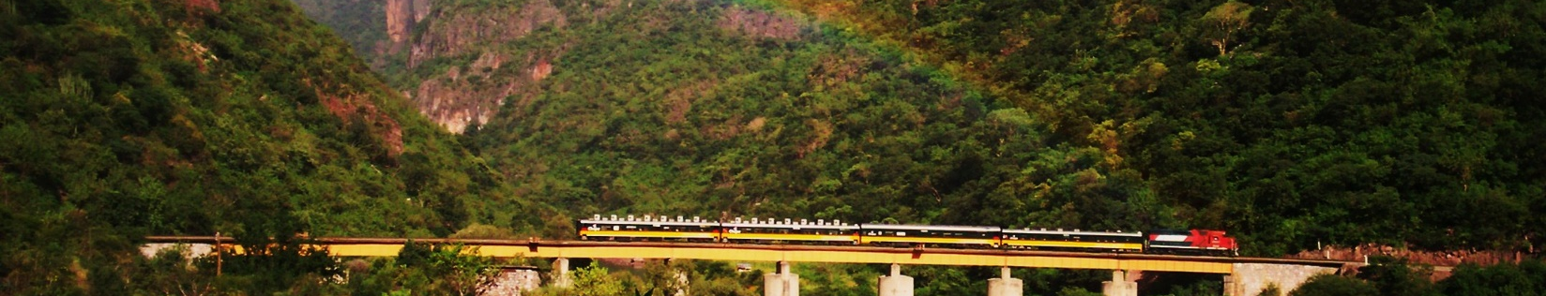
Breakfast at the hotel.

Transfer at 7:15 am to the train station by your hotel staff to board at 8:00 am the tourist class Chepe Express train bound for Divisadero. During the trip of this fabulous train, the Chepe Express passes through different towns in the state of Chihuahua. Arrival at 9:55 am and visit to the Barrancas del Cobre Adventure Park located in the area where you can visit the different viewpoints, flying stone viewpoint, challenge your adventurous spirit on the suspension bridge that crosses a small canyon, ride on the cable car or zip lines. Transfer to your hotel by hotel staff.

Lunch and dinner on your own.
Lodging.

DAY 04 – DIVISADERO - Chihuahua

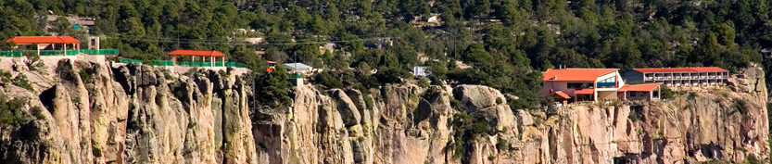
Breakfast at the hotel.

Free morning to hike on your own or simply buy nice Tarahumara handicrafts.
At 12:45 pm you should go to your hotel reception for assistance to board your Autotransportes Turisticos del Noroeste bus (local line/continuous stops) to Chihuahua departing at 1:15 pm. Arrival at approximately 6:30 pm where you will be met and transferred to your hotel.

Lunch and dinner on your own.
Lodging.

DAY 05 – CHIHUAHUA/ OUT
Breakfast at the hotel.

At a convenient time transfer from your hotel to the airport to take your flight to your destination.
END OF SERVICES

NOTE: The day of operation of the tours may vary.

** VALIDATE RATES WITH YOUR TRAVEL AGENT
CITY | NIGHTS | HOTELS 4*
Chihuahua | 02 | Hampton By Hilton
Creel | 01 | Villa Santa Cruz Plus
Divisadero | 01 | Barrancas del Cobre

INCLUDED:
- TRANSPORTATION: Air-conditioned touristic unit
- ACCOMMODATION: Hotels according to your choice
- MEALS: Daily breakfasts
- VISITS: Those mentioned in the program.
- ESCORT GUIDE: Bilingual, certified by the Ministry of Tourism
NOT INCLUDED:

- Air tickets
- Food or services not mentioned
- Taxes at the airport
- Tips to guides or drivers.

IMPORTANT OBSERVATIONS:
- Due to the multiple changes that occur daily in tourism, these prices must be confirmed at the time of requesting the reservation.
- Rates subject to availability and changes without prior notice.
- Credit card payments are subject to a % commission.
- Please contemplate the schedule of Check in 15:00 hrs and Check Out 12:00 hrs.
- TRIPLE rooms only have 2 double beds.
- Transfers airport-hotel-airport are quoted in shared service, please consider flights arriving and departing between 06:00 and 22:00 hrs, otherwise it must be provided in private service and it will be necessary to re-quote.
- The waiting time for arrival transfers is 2 hours and 15 minutes. Once this time has elapsed, the passenger must transfer at his/her own expense.
- The tolerance time for departure transfer is 10 minutes, after this time the unit is withdrawn and you must transfer on your own to the apartment. * Under no circumstances are we responsible for any extra expenses arising from this situation.
- Tours may change order according to the operations of the correspondent.

