PROGRAM
CHIAPAS… A GIFT FROM NATURE
06 days/05 nights

(Tuxtla Gutierrez, Cañón del Sumidero, Chamula, Zinacatan, Agua Azul, Misol-Ha, Palenque, Uxmal, Mérida, Chichen Itza)

Minimum 2 persons.
Daily Departures

ITINERARY

DAY 01 – IN / TUXTLA GUTIERREZ – Cañon del Sumidero + Chiapa de Corzo – SAN CRISTOBAL DE LAS CASAS

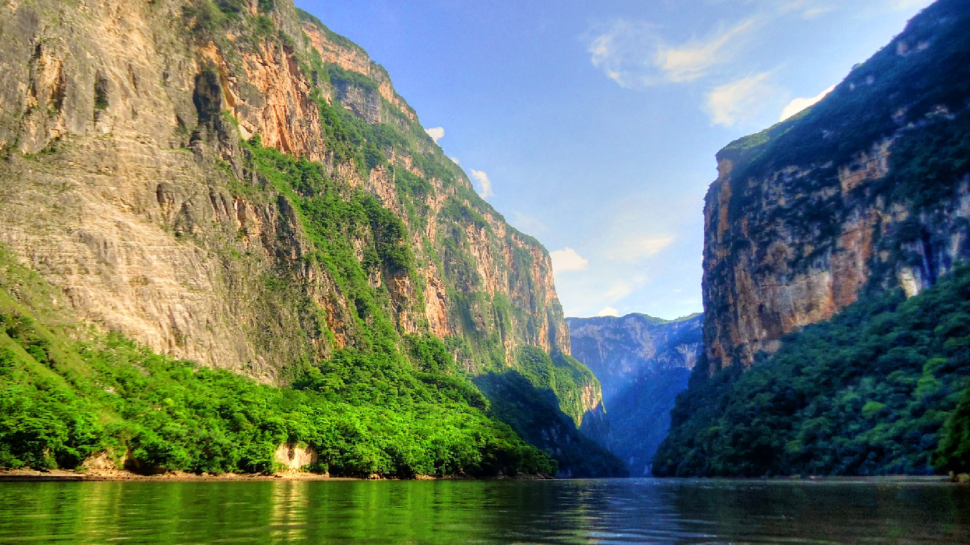
Arrival at Tuxtla airport before 13:00 hours.

Transfer to the pier for a boat tour of the CAÑON DEL SUMIDERO, one of the most spectacular nature reserves in Mexico, it is a geological fault formed 36 million years ago, with limestone walls that rise to more than 1000 meters. At the end of the tour we will visit CHIAPA DE CORZO, a city that was the first settlement founded by the Spaniards with its Mudejar fountain, better known as "La Pila", it was built in the XVI century and is a great example of colonial architecture with a marked Spanish-Arabic influence. Continuation to San Cristobal de las Casas.

Check in at the hotel.
Lunch and dinner on your own.
Lodging.

DAY 02 – SAN CRISTOBAL DE LAS CASAS – Chamula + Zinacatan

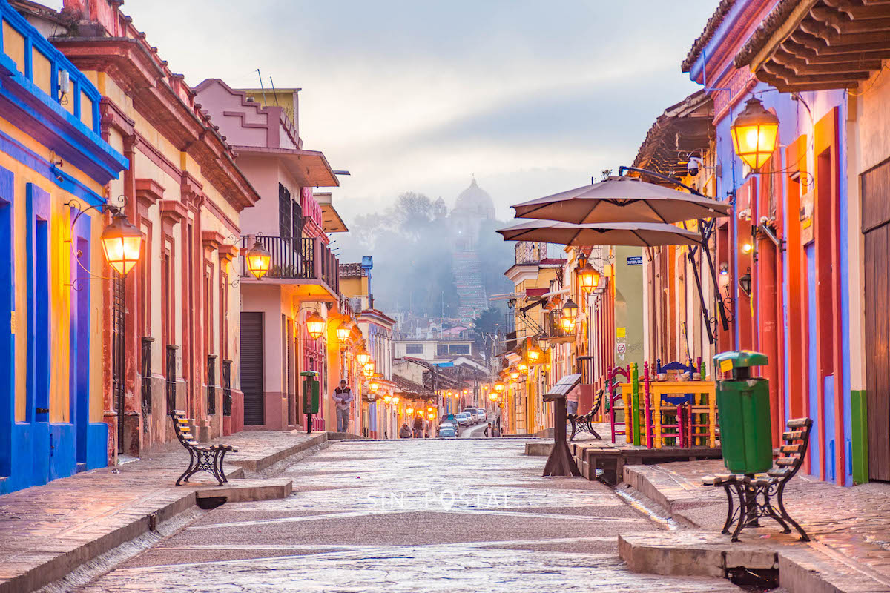

Breakfast at the hotel.

We will visit San Juan Chamula and Zinacantán, indigenous communities that still preserve their language, traditions, religious beliefs and social organization. It is essential to visit their churches, their homes and their clothing to get an idea of the love these people have for their culture. On the way back to San Cristobal, we will visit the Typical Market, Santo Domingo, the Cathedral. Rest of the afternoon at leisure. We recommend a visit to the Jade Museum, where there is a copy of the Tomb of King Pakal.

Lunch and dinner on your own.
Lodging.

DAY 03 – SAN CRISTOBAL DE LAS CASAS – Agua Azul – Misol Ha – PALENQUE

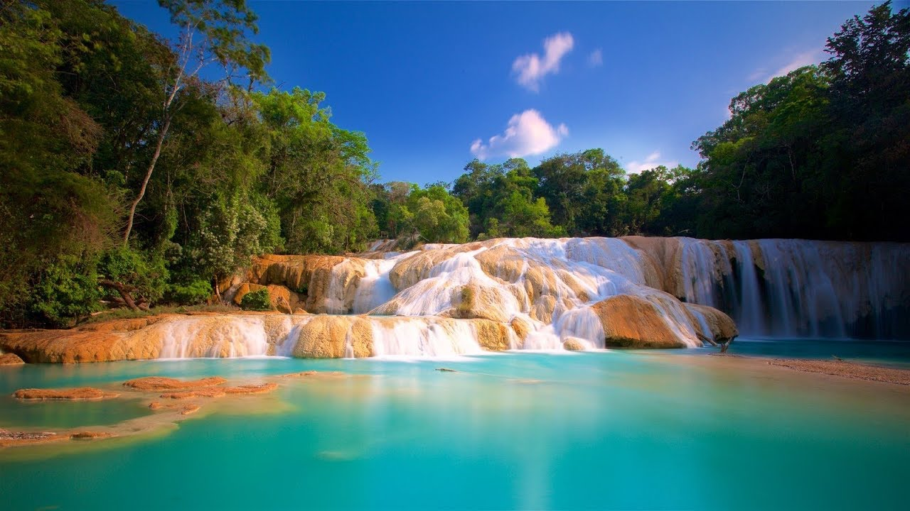

Breakfast at the hotel.

Departure at 06:00 hours from the hotel to Palenque, on the way we will make a technical stop before arriving in Ocosingo, then we will visit the Cascadas de Agua Azul set of rapids, falls and backwaters of a tributary of the Tulijá River, captivates the beauty of the river, its brightness and intense turquoise color. Transfer to your hotel in Palenque.

Check in at the hotel.
Lunch and dinner on your own.
Lodging.

DAY 04 – PALENQUE – CAMPECHE
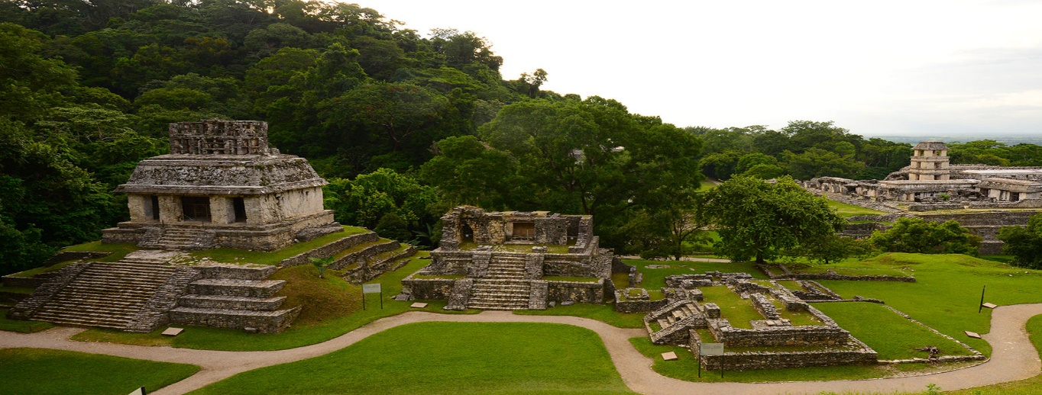

Breakfast at the hotel.

Visit to the Archaeological Zone of Palenque, one of the most remarkable Mayan cities for its beautiful sculptural art and its important architecture in the middle of the green jungle. After a beautiful panoramic view of the Gulf of Mexico, we will continue to the beautiful walled city of CAMPECHE; we will visit the walls that were built in the 17th century to protect the city from pirate attacks; the bastions can still be seen, some of which are used as museums. Inside the walls you will see alleys, multicolored colonial mansions and temples; the main square with its beautiful kiosk and the imposing cathedral in front.

Check in at the hotel.
Lunch and dinner on your own.
Lodging.

DAY 05 – CAMPECHE – Uxmal – MÉRIDA

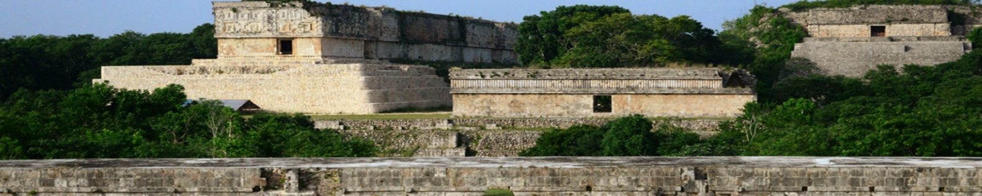

Box Lunch

En route Visit UXMAL archaeological site of great architectural beauty: the Pyramid of the Soothsayer, the Quadrangle of the Nuns, the Governor's Palace, the Ball Game. Continuation to MERIDA "The White City" where we will make a panoramic tour: Paseo de Montejo, Monument to the Homeland, Main Square with the Cathedral and the Government Palaces.

Check in at the hotel.

Lunch and dinner on your own.
Lodging.

DAY 06 – MÉRIDA – Chichen Itza / OUT

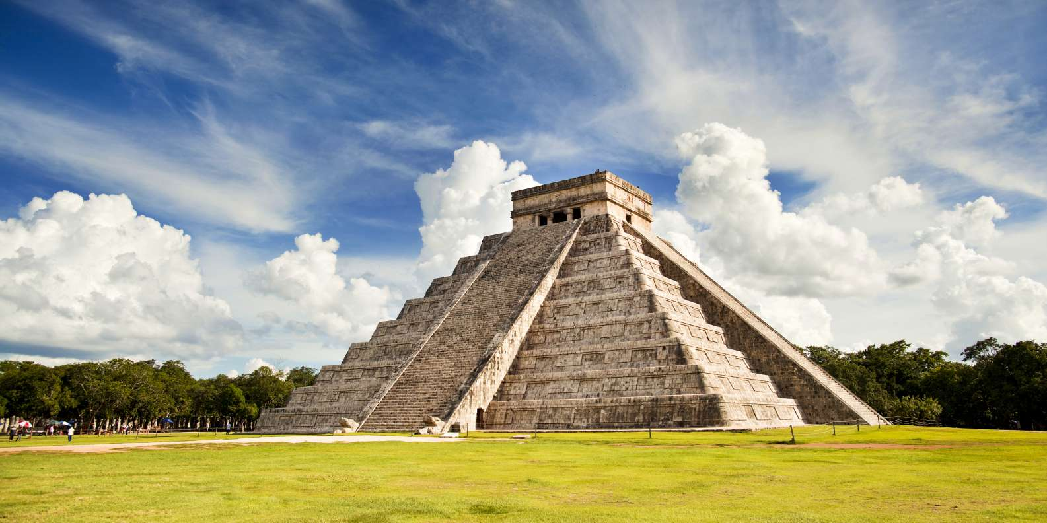

Breakfast at the hotel

Departure to CHICHEN ITZA, the most renowned Mayan city in Mexico. Archaeological site where advanced archaeo-astronomical knowledge is revealed. It has the stepped pyramid called the Castle or Temple of Kukulcan, the Ball Game, the platform of the Skulls, the Temple of the Jaguars, the Observatory, the Plaza of the Thousand Columns, the Sacred Cenote, time for lunch and transfer to hotel in Cancun.

END OF SERVICES

** VALIDATE RATES WITH YOUR TRAVEL AGENT

CITY | NIGHTS | HOTELS 3** | HOTELS 4*
San Cristóbal de las Casas | 02 | Junvay | Mansión de Valle
Palenque | 01 | Nututun | Chan Kah
Campeche | 01 | Plaza Campeche | Plaza Campeche
Mérida | 01 | El Conquistador | El Conquistador

INCLUDED:
- TRANSPORTATION: Air-conditioned touristic unit
- ACCOMMODATION: Hotels according to your choice
- MEALS: 05 Breakfast
- VISITS: Those mentioned in the program.
- ESCORT GUIDE: Bilingual, certified by the Ministry of Tourism
NOT INCLUDED:

- Air tickets
- Food or services not mentioned
- Taxes at the airport
- Tips to guides or drivers.

IMPORTANT OBSERVATIONS:
1. Due to the multiple changes that occur daily in tourism, these prices must be confirmed at the time of requesting the reservation.
2. Rates subject to availability and changes without prior notice.
3. Credit card payments are subject to a % commission.
4. Please contemplate the schedule of Check in 15:00 hrs and Check Out 12:00 hrs.
5. TRIPLE rooms only have 2 double beds.
6. Transfers airport-hotel-airport are quoted in shared service, please consider flights arriving and departing between 06:00 and 22:00 hrs, otherwise it must be provided in private service and it will be necessary to re-quote.
7. The waiting time for arrival transfers is 2 hours and 15 minutes. Once this time has elapsed, the passenger must transfer at his/her own expense.
8. The tolerance time for departure transfer is 10 minutes, after this time the unit is withdrawn and you must transfer on your own to the apartment. * Under no circumstances will we be responsible for any extra expenses arising from this situation.
9. Tours may change order according to the operations of the correspondent.

