PROGRAM

BASIC CHIAPAS
03 days/02 nights

(Tuxtla Gutierrez, Cañón del Sumidero, Cascada Chiflón, Chamula, Zinacantan )

Minimum 2 persons.
Daily Departures

ITINERARY

DAY 01 – IN / TUXTLA GUTIERREZ – Cañon del Sumidero + Chiapa de Corzo – SAN CRISTOBAL DE LAS CASAS

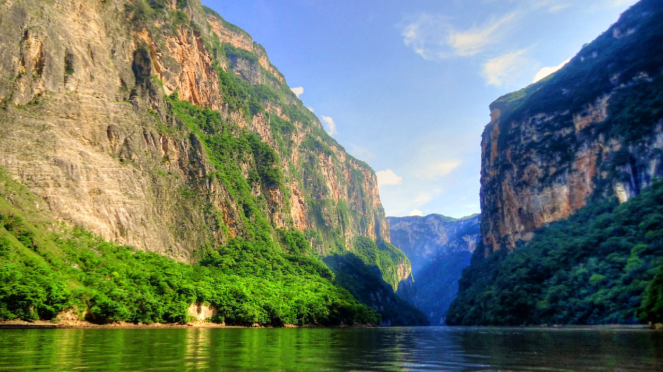
Arrival at Tuxtla airport before 13:00 hours.

Transfer to the pier for a boat tour of the CAÑON DEL SUMIDERO, one of the most spectacular nature reserves in Mexico, it is a geological fault formed 36 million years ago, with limestone walls that rise to more than 1000 meters. At the end of the tour we will visit CHIAPA DE CORZO, a city that was the first settlement founded by the Spaniards with its Mudejar fountain, better known as "La Pila", it was built in the XVI century and is a great example of colonial architecture with a marked Spanish-Arabic influence. Continuation to San Cristobal de las Casas.

Check in at the hotel.
Lunch and dinner on your own.
Lodging.

DAY 02 – SAN CRISTOBAL DE LAS CASAS – Lagunas de Montebello + Cascadas del Chiflón

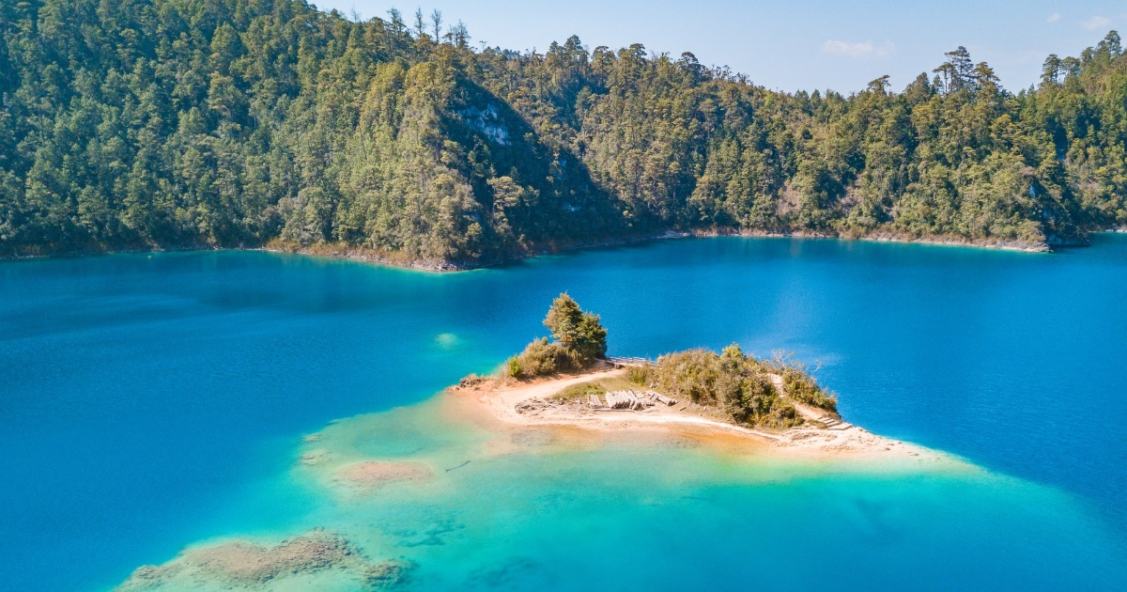

Breakfast at the hotel.

Visit five of the fifty-six lagoons of MONTEBELLO, famous for the colors of its waters that are due to the combination of the type of soil at the bottom, the vegetation and the refraction of light, we will also visit the impressive waterfall of CHIFLON with approximately 150 meters high.

Lunch and dinner on your own.
Lodging.

DAY 03 – SAN CRISTOBAL DE LAS CASAS – Chamula + Zinacantan

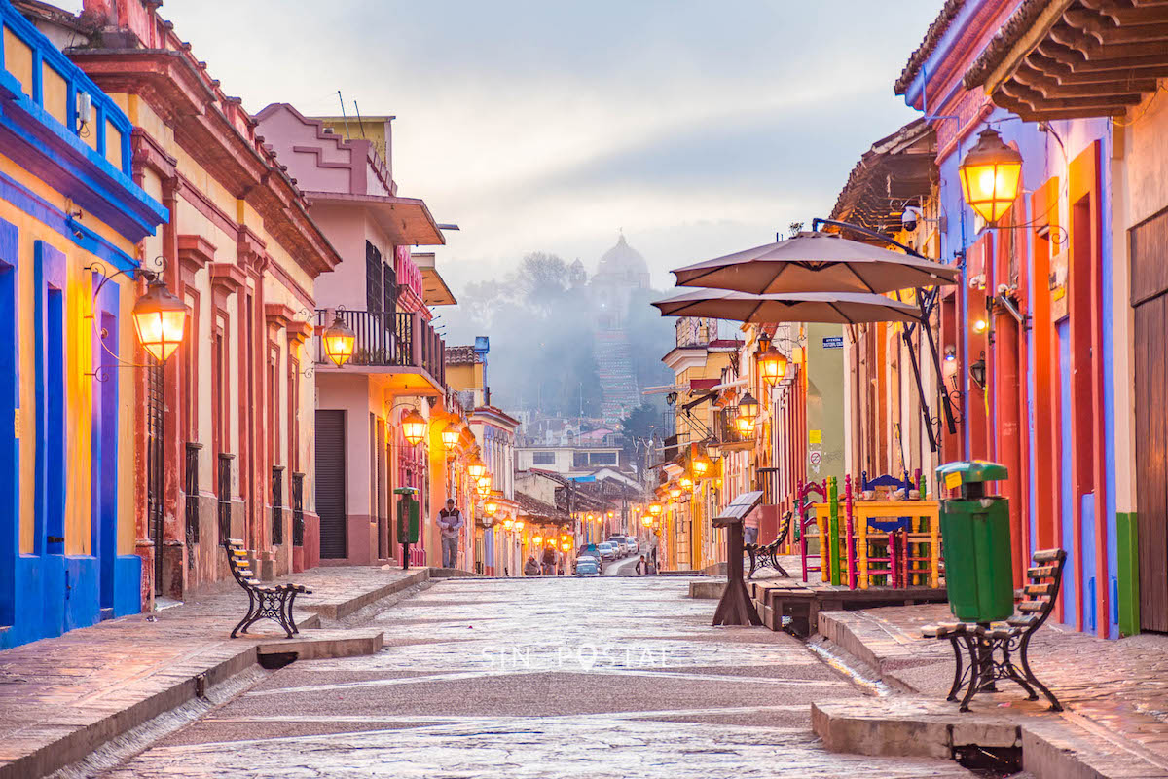

Breakfast at the hotel.

Visit the Tzotzil community of SAN JUAN CHAMULA famous for its traditions and festivities, has one of the most enigmatic churches in the country, inside the Chamulas participate in syncretic rituals creating a magical atmosphere. At the end we go to ZINACANTAN another important Tzotzil community, the temple dates from colonial times, although it was remodeled in the nineteenth century in the neoclassical style. In its interior it is possible to appreciate the curious mixture of indigenous and catholic beliefs. The Zinacantecos are mostly dedicated to the cultivation of flowers, which explains the impressive colorful costumes. In the afternoon, transfer to the Tuxtla Gutierrez airport.

END OF SERVICES

** VALIDATE RATES WITH YOUR TRAVEL AGENT

CITY | NIGHTS | HOTELS 3** | HOTELS 4* | HOTELS 4**
San Cristóbal de las Casas | 02 | Junvay | Mansión del Valle | Casa del Alma

INCLUDED:

- TRANSPORTATION: Air-conditioned touristic unit
- ACCOMMODATION: Hotels according to your choice
- MEALS: 03 Breakfast
- VISITS: Those mentioned in the program.
- ESCORT GUIDE: Bilingual, certified by the Ministry of Tourism

NOT INCLUDED:
- Air tickets
- Food or services not mentioned
- Taxes at the airport
- Tips to guides or drivers.

IMPORTANT OBSERVATIONS:
- Due to the multiple changes that occur daily in tourism, these prices must be confirmed at the time of requesting the reservation.
- Rates subject to availability and changes without prior notice.
- Credit card payments are subject to a % commission.
- Please contemplate the schedule of Check In 15:00 hrs and Check Out 12:00 hrs.
- TRIPLE rooms only have 2 double beds.
- The tours may change order according to the operations of the correspondent.

