PROGRAM

CD DE MEXICO -SAN MIGUEL DE ALLENDE Y GUANAJUATO
04 days/ 03 nights

(CDMX - Querétaro, San Miguel de Allende, Guanajuato- CDMX)

Minimum 2 persons/ Minimum 4 persons
Daily departures

ITINERARY

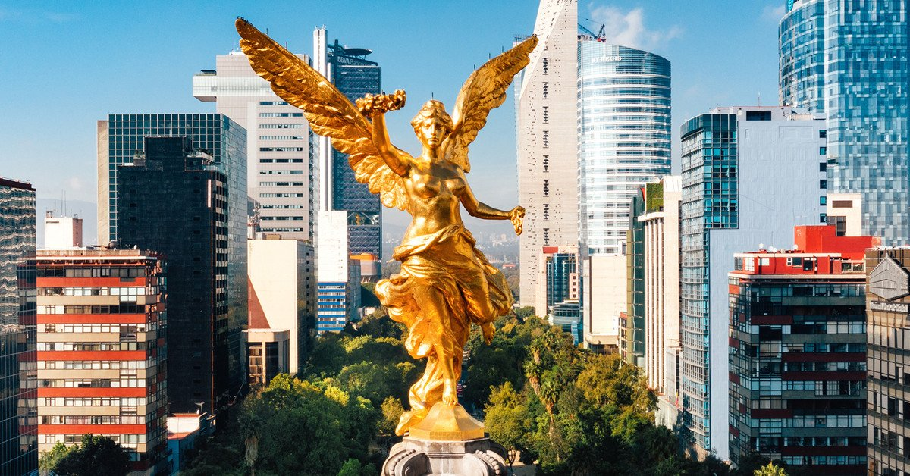
DAY 01– IN / CIUDAD DE MÉXICO
Arrival at Mexico City International Airport. Reception and transfer to your hotel.
Check in at the hotel. Rest of the day at leisure.
Lunch and dinner on your own. Lodging.

DAY 02 – CIUDAD DE MÉXICO – Querétaro – SAN MIGUEL DE ALLENDE

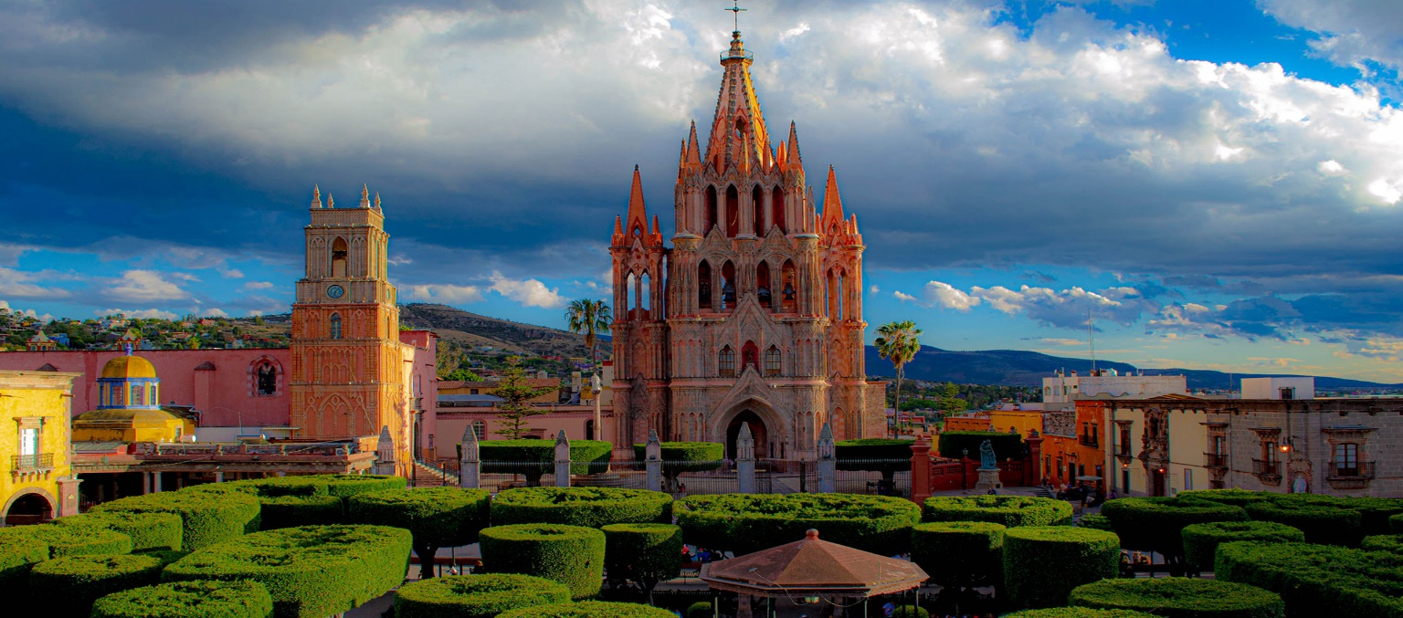
Breakfast at the hotel.

Departure to Queretaro, a World Heritage City, where we will visit the Aqueduct, the Ex-Convent of the Cross and the Historic Center. We will continue on to San Miguel de Allende. Afternoon to visit this peaceful city where the great comedian Mario Moreno "Cantinflas" lived and a place of residence for artists and intellectuals. Highlights include the Parish of San Miguel Arcangel, the Chapel of the Holy House, the Convent of the Conception, the Church of San Francisco and the Allende House and Institute. You will find a wide variety of cafes and restaurants to choose from.

Check in at the hotel

Lunch and dinner on your own. Lodging.

DAY 03 – SAN MIGUEL DE ALLENDE – Dolores Hidalgo – GUANAJUATO

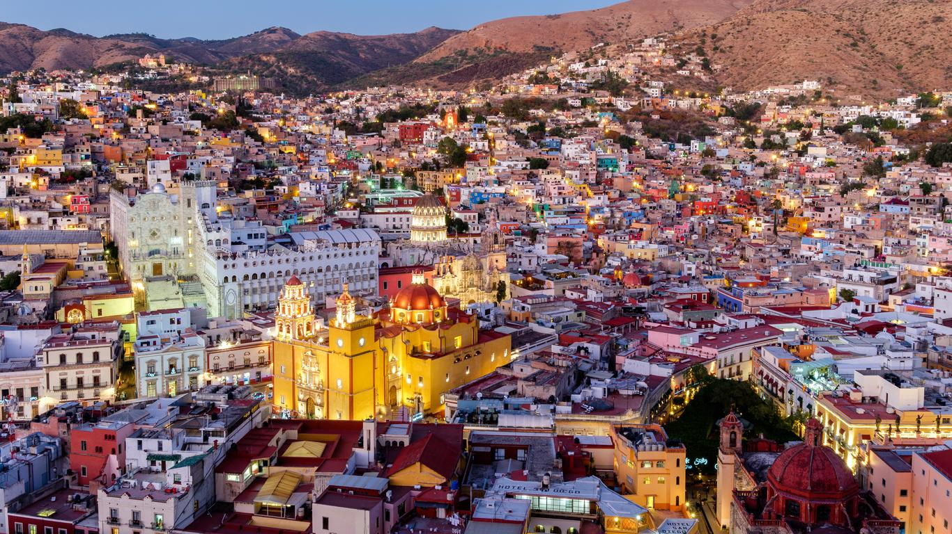
Breakfast at the hotel.

Departure to Dolores Hidalgo, where the priest Don Miguel Hidalgo gave the "Cry of Independence" of Mexico in 1810. There we will find the house-museum of this national hero. We will continue to Guanajuato, a World Heritage City, home of the annual Cervantino International Festival. In the afternoon we will enjoy this beautiful city, full of alleys and squares, which offers us very interesting places such as the University, the Juarez Theater, the Kiss Alley, the house-museum of the muralist Diego Rivera, husband of Frida Kahlo. Its streets and subway avenues are unique in the country. Other attractive options are: the "callejoneada" accompanied by a musical estudiantina or tuna valenciana, the house of Jorge Negrete, the museum of Don Quixote and the Mummies.

Check in at the hotel

Lunch and dinner on your own. Lodging.

DAY 04 – GUANAJUATO – CIUDAD DE MÉXICO

Breakfast at the hotel.

At a convenient time transfer from your hotel in Guanajuato to the Mexico City International Airport (approximately 04 hours) to take your flight to your destination. We recommend a flight after 17:00hrs.

END of SERVICES

** VALIDATE RATES WITH YOUR TRAVEL AGENT

HOTELS

CITY | NIGHTS | HOTELS
Ciudad de México | 01 | Casa Blanca
San Miguel de Allende | 01 | Real de Minas o similar
Guanajuato | 01 | Holiday Inn Express o similar

MINIMUM BASE 2 PAX
MINIMUM BASE 4 PAX
Not applicable on Formula 1, Cervantino Festival and Easter Week dates.

INCLUDES:
- TRANSPORTATION: Air-conditioned Bus/Minibus or Van
- ACCOMMODATION: Hotels according to your choice
- MEALS: 03 Breakfasts
- VISITS: Those mentioned in the program.
- ESCORT GUIDE: Bilingual, certified by the Ministry of Tourism
NOT INCLUDED:
- Air tickets
- Food or services not mentioned
- Taxes at the airport
- Tips to guides or drivers.

IMPORTANT OBSERVATIONS:
  - Due to the multiple changes that occur daily in tourism, these prices must be confirmed at the time of requesting the reservation.
  - Rates subject to availability and changes without prior notice.
  - Credit card payments are subject to a % commission.
  - Please contemplate the schedule of Check in 15:00 hrs and Check Out 12:00 hrs.
  - TRIPLE rooms only have 2 double beds.
  - Transfers airport-hotel-airport are quoted in shared service, please consider flights arriving and departing between 06:00 and 22:00 hrs, otherwise it must be provided in private service and it will be necessary to re-quote.
  - The waiting time for arrival transfers is 2 hours and 15 minutes. Once this time has elapsed, the passenger must transfer at his/her own expense.
  - The tolerance time for departure transfer is 10 minutes, after this time the unit is withdrawn and you must transfer on your own to the apartment. * Under no circumstances will we be responsible for any extra expenses arising from this situation.
  - Tours may change order according to the operations of the correspondent.

