PROGRAM

CANCÚN, AVENTURA Y PLAYA
05 days / 04 nights

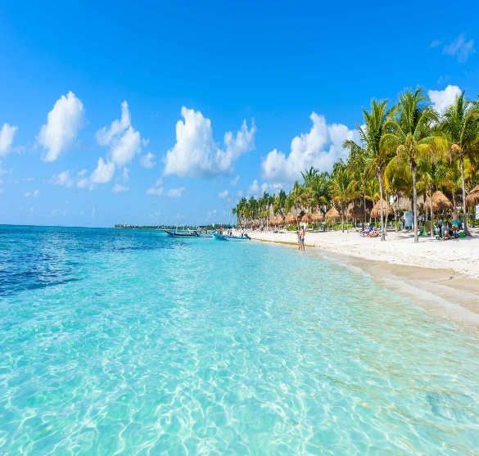
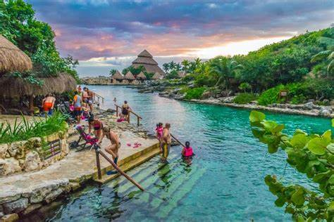
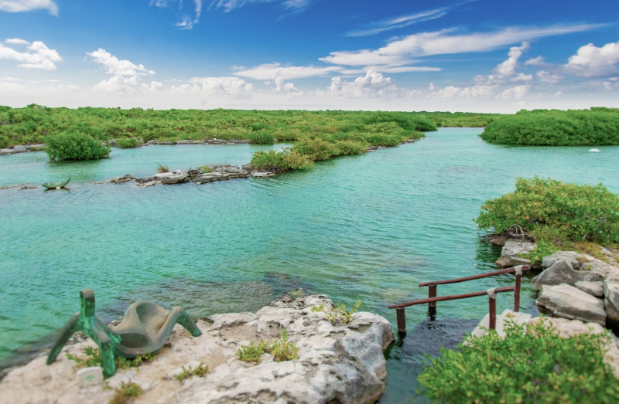
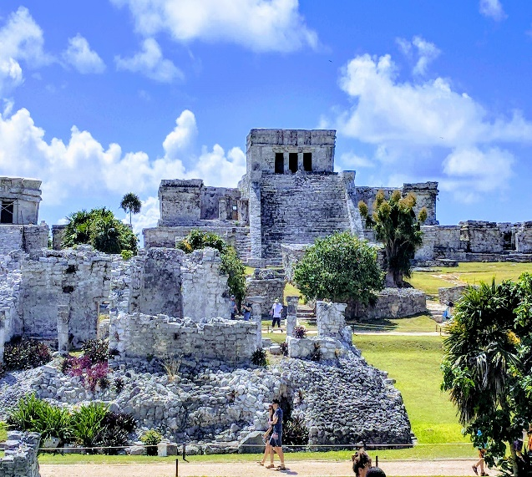

Xcaret, Tulum, Yalkú, Isla Mujeres

DAILY DEPARTURES
Minimum 2 persons

ITINERARY

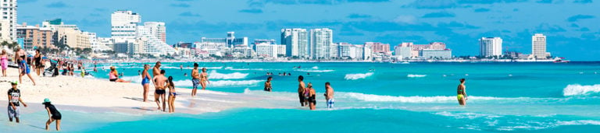
DAY 01 / CANCÚN

Reception at the airport. Assistance and transfer to your hotel.

Check in at hotel. Rest of the day at leisure.

Lunch and dinner at leisure.
Lodging

DAY 02 – CANCÚN – Xcaret Plus

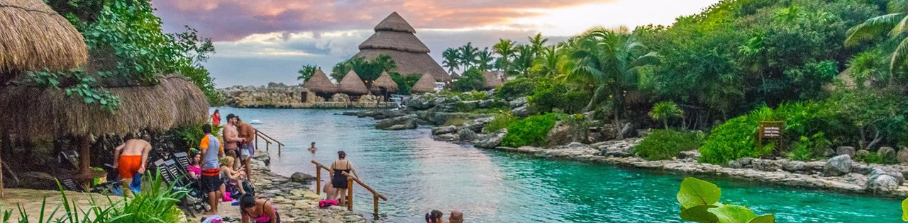

Breakfast at the hotel

More than 50 natural and cultural attractions in the Majestic Paradise of Mexico. Spend a whole day among subway rivers, jungle, the Caribbean Sea, shows, tropical fauna and much more. Enjoy more than 50 activities in Cancun included in your ticket to Xcaret Park. Fall in love with Mexico at the presentation of Xcaret Mexico Espectacular, a show in Cancun with more than 300 artists on stage that takes you on a journey through the history and historical legacy of an entire country. And of course, be sure to visit the Coral Reef Aquarium, the Aviary and the Butterfly Farm. Xcaret Park, one of the must-see tourist attractions in Cancun, Playa del Carmen and Riviera Maya.

Dinner on your own.
Lodging.

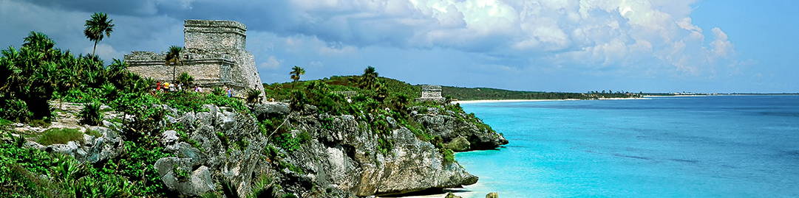
DAY 03 – CANCÚN – Tulum - Yalkú
Breakfast at the hotel

Let yourself be amazed by the imposing ruins of Tulum declared World Heritage Site by UNESCO, where a certified guide will make you feel part of the history while you walk with him the most important buildings of this ancient ceremonial center located on a cliff overlooking the Caribbean Sea. Then we take you to live a wonderful experience through our private access to the Yalkú lagoon, where we will dive in turquoise waters surrounded by exotic marine life, our guides will accompany you at all times, they will share with you the best snorkeling techniques.
Lunch and dinner on your own.
Lodging

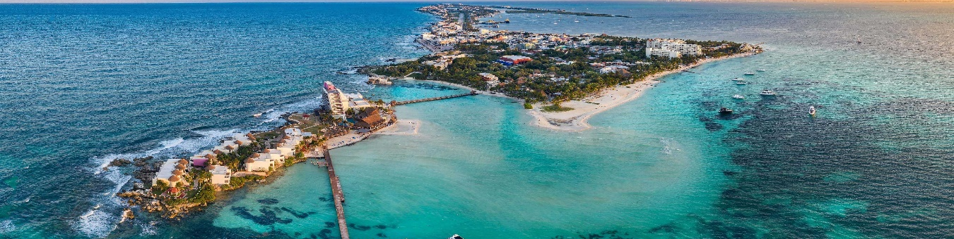
DAY 04 – CANCÚN -Luxury Sailing Isla Mujeres
Breakfast at the hotel

Relax and let us take you to Isla Mujeres on our luxury catamaran. We will explore Cancun's most beautiful scenery along this stunning coastline and go snorkeling in its warm crystal clear waters. Once on the island, stroll through the highlights, go shopping, taste the local food or walk on the beach. Back on the catamaran, relax under the tropical sun while enjoying a gourmet lunch and refreshing drinks from our open bar, sailing the Caribbean under the power of the wind.
Dinner on your own.
Lodging

DAY 05 – CANCUN/
Breakfast at the hotel.

At a convenient time transfer from your hotel to the airport to take your flight to your destination.
END OF SERVICES

** VALIDATE RATES WITH YOUR TRAVEL AGENT

CITY | NIGHTS | HOTELS 3** | HOTELS 4**
Cancún | 04 | Krystal Cancún | Beachscape

INCLUDED:
- TRANSPORTATION: Air-conditioned touristic unit
- ACCOMMODATION: Hotels according to your choice
- MEALS: Daily breakfasts
- VISITS: Those mentioned in the program.
- ESCORT GUIDE: Bilingual, certified by the Ministry of Tourism
NOT INCLUDED:

- Air tickets
- Food or services not mentioned
- Taxes at the airport
- Tips to guides or drivers.
IMPORTANT OBSERVATIONS:
- Due to the multiple changes that occur daily in tourism, these prices must be confirmed at the time of requesting the reservation.
- Rates subject to availability and changes without prior notice.
- Credit card payments are subject to a % commission.
- Please contemplate the schedule of Check in 15:00 hrs and Check Out 12:00 hrs.
- TRIPLE rooms only have 2 double beds.
- Transfers airport-hotel-airport are quoted in shared service, please consider flights arriving and departing between 06:00 and 22:00 hrs, otherwise it must be provided in private service and it will be necessary to re-quote.
- The waiting time for arrival transfers is 2 hours and 15 minutes. Once this time has elapsed, the passenger must transfer at his/her own expense.
- The tolerance time for departure transfer is 10 minutes, after this time the unit is withdrawn and you must transfer on your own to the apartment. * Under no circumstances will we be responsible for any extra expenses arising from this situation.
- Tours may change order according to the operations of the correspondent.

