PROGRAM
CAMPECHE HISTORIA Y ARTE
06 days/05 nights

(Ciudad de Campeche, Camino Real, Edzná, Kabah, Uxmal)

Minimum 2 persons.
Daily Departures

ITINERARY

DAY 01 – IN / CAMPECHE
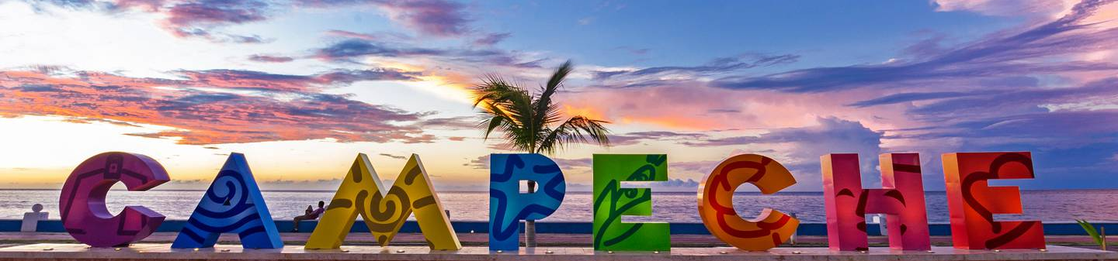
Arrival at Campeche Airport. Reception and transfer to your hotel.
Check in at hotel. Rest of the day at leisure.
Lunch and dinner at leisure. Lodging

DAY 02 – CAMPECHE – Visita de Ciudad

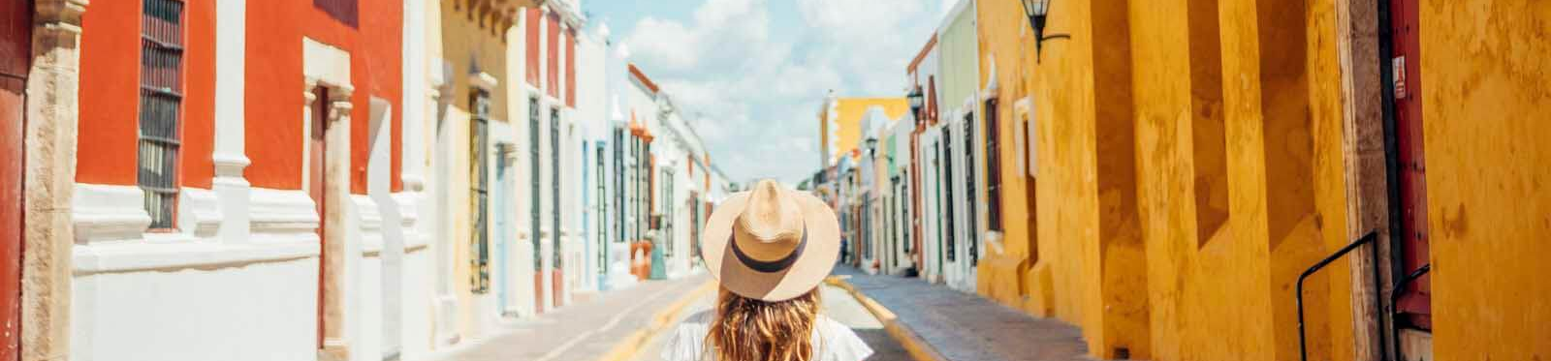

Breakfast at the hotel.

Campeche, cultural heritage of humanity offers a wide variety of attractions that will awaken in you a deep interest in the history of its walls. We begin with a guided tour of the main attractions of the city of Campeche. Colonial mansions, fortresses, museums and legends. Visit the walled city with its plaza, museums and bastions. Its fortresses and traditional neighborhoods.

Lunch and dinner on your own. Lodging.

DAY 03 – CAMPECHE – Camino Real Artesanal

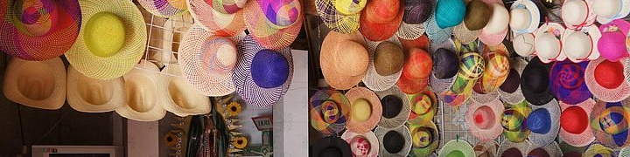

Breakfast at the hotel.

Artisan, Gastronomic and Archaeological Tour. Guided tour through the main attractions of the so-called Camino Real or Artisan Route. We will see the weaving of hats in caves, an archaeological zone just being rescued, and you will have the chance to taste the traditional bread made in stone ovens of Pomuch. Lunch (no drinks).

Dinner at leisure. Lodging

DAY 04 –CAMPECHE – Edzná

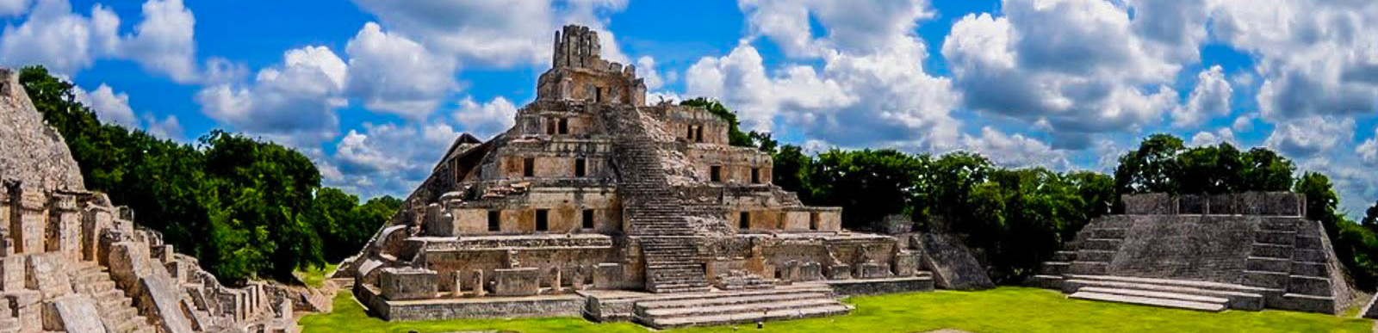

Desayuno en el hotel.

Visitaremos la zona arqueológica de Edzná. Situada a 45 min. al sureste de la ciudad capital, la Antigua ciudad maya presente desde 600 a.c. aproximadamente se mantuvo presente a lo largo de casi 1800 años. Se puede admirar su variedad en arquitectura y temporalidades constructivas coronadas por su Templo Pirámide de los Cinco Pisos, su plaza principal, juego de pelota y Nohoch Ná, muestras de la arquitectura Petén, Chenes, Río Bec y Puuc.

Lunch and dinner on your own. Lodging

DAY 05 –CAMPECHE – Kabah - Uxmal

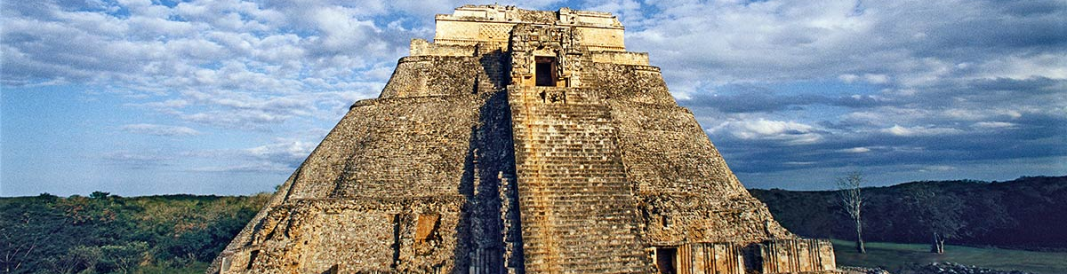

Breakfast at the hotel.

Located 80 km from Merida, it shows what the Puuc art, built in the parallelepiped shapes of its buildings, with smooth walls and ornate friezes, most of the buildings of Uxmal, belong to the classic Maya period and some to the late middle phase, Chaac is represented in multiple buildings, in the governor's palace, quadrangle of the nuns, the temple of the soothsayer, among others. Kabah, where we find a quadrangle called Codz-pop which means rolled up mat, the arch, the masks of Chaac, the temple of the columns and the house of the witch.

Lunch and dinner on your own. Lodging.

DAY 06 – CAMPECHE/ OUT

Breakfast at the hotel.

At a convenient time transfer from your hotel to the airport to take your flight to your destination.

END of SERVICES

NOTE: The day of operation of the tours may vary.
** VALIDATE RATES WITH YOUR TRAVEL AGENT

CITY | NIGHTS | HOTELS 3* | HOTELS 4*
Campeche | 05 | Castelmar | Plaza Campeche

INCLUDED:
- TRANSPORTATION: Air-conditioned touristic unit
- ACCOMMODATION: Hotels according to your choice
- MEALS: 05 Breakfast, 01 Lunch
- VISITS: Those mentioned in the program.
- ESCORT GUIDE: Bilingual, certified by the Ministry of Tourism
NOT INCLUDED:

- Air tickets
- Food or services not mentioned
- Taxes at the airport
- Tips to guides or drivers.

IMPORTANT OBSERVATIONS:
- Due to the multiple changes that occur daily in tourism, these prices must be confirmed at the time of requesting the reservation.
- Rates subject to availability and changes without prior notice.
- Credit card payments are subject to a % commission.
- Please contemplate the schedule of Check in 15:00 hrs and Check Out 12:00 hrs.
- TRIPLE rooms only have 2 double beds.
- Transfers airport-hotel-airport are quoted in shared service, please consider flights arriving and departing between 06:00 and 22:00 hrs, otherwise it must be provided in private service and it will be necessary to re-quote.
- The waiting time for arrival transfers is 2 hours and 15 minutes. Once this time has elapsed, the passenger must transfer at his/her own expense.
- The tolerance time for departure transfer is 10 minutes, after this time the unit is withdrawn and you must transfer on your own to the apartment. * Under no circumstances will we be responsible for any extra expenses arising from this situation.
- Tours may change order according to the operations of the correspondent.

